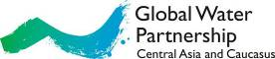

GWP Central Asia and Caucasus (GWP CACENA) c/o ICARDA-CAC (GWP CACENA/IWMI), Apt 123, Block 6, Osiyo str, Tashkent, 100000, Uzbekistan Tel: +998 712 652 555, Fax: +998 711 665 097 Website: www.gwp.org
Global Water Partnership Central Asia and Caucasus (GWP CACENA)

www.gwp.org
Report
For August 2015

1. GWP CACENA Regional Council Meeting
The GWP CACENA Regional Council Meeting was held on 3-7 August 2015 in Batumi, Georgia (Hotel Alik).
The meeting was attended by the RC members, GWPO representatives, the Regional Secretariat and invited persons.
The meeting began with self-introduction by participants and discussion of the meeting agenda. After agreeing of the agenda Mr. Francois Brikke on behalf of GWPO has informed participants on 4 matters:
- GWPO decided to rotate the regions in the Steering Committee. From now on, each region will have its representative in the Steering Committee. Executive Secretary – Mr. Rudolph Cleveringa.
- On information sharing.
- On financing: there are several sponsors to ensure basic network budget. GWPO has done some work on the continuation of funding for WACDEP, and now the application for funding of the second phase of the program is under consideration by the British government. When results will be, Ms. Nino Chkhobadze (GWP CACENA Chair) will be informed.
- On the General Assembly in New York, dedicated to the new development strategy (SDGs). GWPO intends to be a partner in all areas of new vision, new goals related to water, etc. SDGs should be implemented in each country.

Then the following issues were considered:
- 7th World Water Forum Outcomes;
- Financial discipline: Audit 2014 - lessons learnt ;
- GWP CACENA self-assessment;
- Finalizing the WACDEP project. Preparing the WACDEP Final Report for 2013-2015;
- Preparing regional outlook on water security;
- Amendments to the GWP CACENA Statute;
- Organizational issues, future events, suggestions to the Work Plan for 2016;
- Project preparation and fundraising.

After discussions the RC members decided as follows:

- Revised Statute of GWP CACENA will be sent to the RC members.
- Budget (amended item on trips) will be sent to the RC members.
- Report on WACDEP CACENA has to be prepared up to September 1, 2015.
- The content of the 4th bulletin on WACDEP CACENA has to come into agreement with the RC members prior to its publication.
- Skype-conference will be held every first Tuesday of each month at 17:00 Tashkent time.
- Records on WACDEP CACENA reporting will being collected and kept (a table with dates of receipt of CWPs reports).
- GWP CACENA Financial Manager will monitor implementation of his tasks on financial discipline.

At the end of the meeting the RC members thanked CWP-Georgia for excellent organization of the meeting in Batumi and mentioned the warm hospitality of Georgian partners.
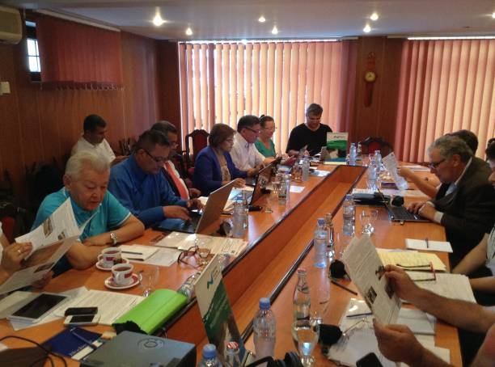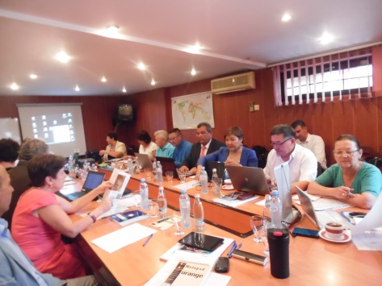
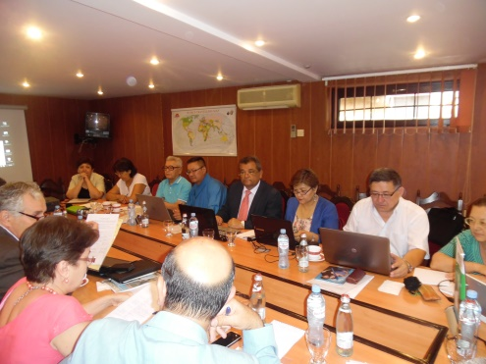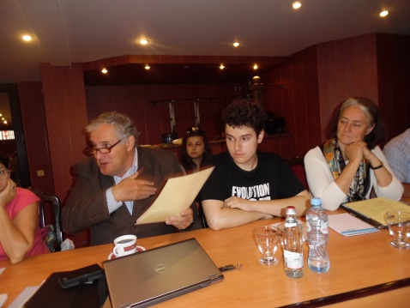

2. IWRM seminar in Gabalinsky region of Azerbaijan
CWP-Azerbaijan organized the workshop "Integrated Water Resources Management as a tool to Climate Change Adaptation" on 5 August 2015 in Gabalinsky region. This workshop was attended by representatives of UNDP, the Ministry of Emergency Situations of Azerbaijan, Public Corporation "Land Reclamation and Water Management of Azerbaijan", local administration, municipalities and local community.
The CWP-Azerbaijan partner Mr. Mamedov informed participants about implementation of IWRM principles in Azerbaijan.

3. Meeting on the Protocol on Water and Health
The Ministry of Health, Labor and Social Welfare invited NGOs (total: 12 people) involved into the process on the Protocol on Water and Health to discuss relevant issues and readiness of Georgia to adhere to the Protocol. This meeting was held on 2 July 2015 in Tbilisi. CWP-Georgia actively participated.
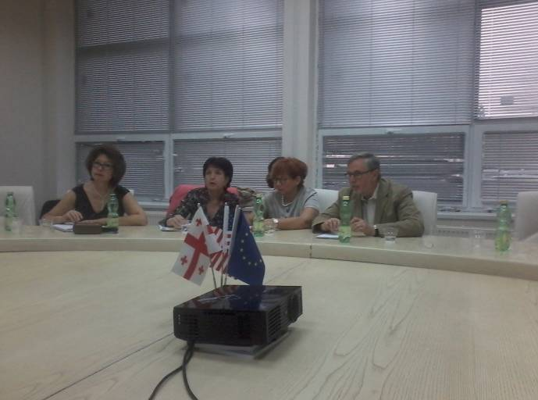

4. III Georgia-Russia Forum "Role NGOs in protection of environmental rights"
On 3 July 2015 in Tbilisi, III Georgia-Russia Forum "Role NGOs in protection of environmental rights" gathered more than 130 NGOs.
The goal:
- Continue dialogue between NGOs of Georgia and Russia to strengthen potential for protection of environmental rights;
- Promote realization of bilateral projects by NGOs of both countries.

Forum participants - NGOs of Russia and Georgia - discussed possible ways of solving the existing problems of non-governmental organizations in Russia and Georgia, their stability, independence and opportunity to become a subject of change.

Ms. Nino Chkhobadze and Mr. George Dzamukashvili took part in the forum. Mr. George Dzamukashvili made presentation "Transboundary water cooperation between Southern Caucasus countries".
The Forum adopted a resolution.
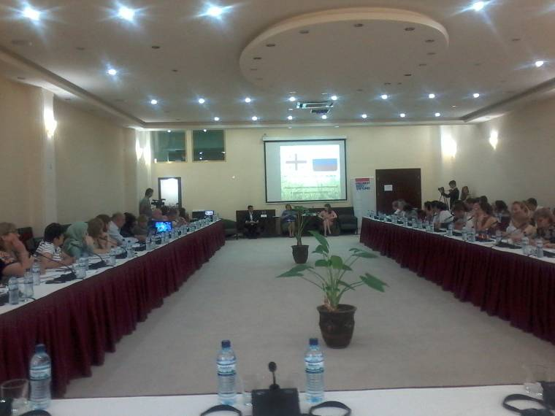

5. Meeting of stakeholders

The meeting of stakeholders was held on 16 July 2015 in the Hotel Betsy in Tbilisi.
Participants (total: 30 people) discussed the documents of new project - UNDP/GEF Kura 2 that is being implemented by Georgia and Azerbaijan.

5 project components were considered:

- Development of efficient multi-sectoral protocols on IWRM;
- Strengthening state organizations to implement IWRM plans;
- Decrease a stress in the critical areas;
- Target educational projects and events to strengthen participation.

The project managers and CWP-Georgia also discussed possible involvement of CWP-Georgia to the project component 1: Regional Dialogues on Water Policy; and Institutional assistance to local administration and basin organizations on NEXUS approaches.
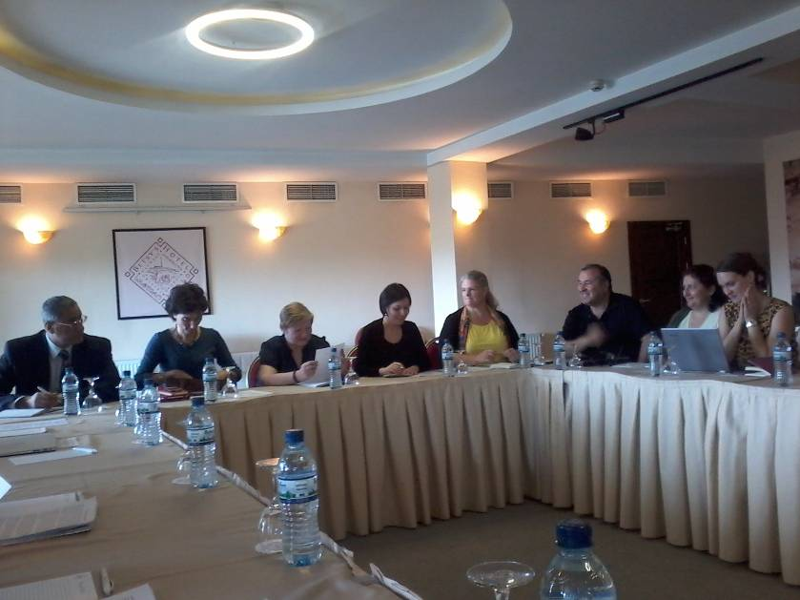

6. Water Goal Campaign in Georgia

On 30 July 2015, CWP-Georgia submitted to the Ministry of Foreign Affairs of Georgia the letter in support for a dedicated water goal throughout the Post-2015 Development negotiations.

7. Meeting on the EU Association Agreement with Georgia
The Meeting on the EU Association Agreement with Georgia organized by the Ministry of Environment Protection and Nature Resources of Georgia was held on 10 August 2015 in the CORTYARD Marriot Hotel in Tbilisi.
Stakeholders invited (incl. CWP-Georgia) were informed about new water law of Georgia that will be considered by the Parliament of Georgia in autumn.
Because CWP-Georgia coordinated NPDs on water the First Deputy Minister especially emphasized contribution of CWP-Georgia for development of new water law.
This meeting finalized discussions on new water law of Georgia.

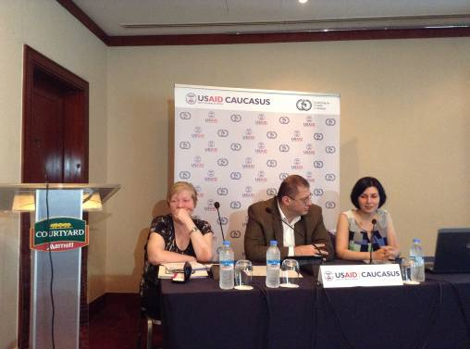

8. Workshop "Green innovation and environmental economy"
CWP-Mongolia participated in the workshop "Green innovation and environmental economy" organized by the National Development Institute /NDI/ and Japanese Universities. This workshop was held in Ulaanbaatar in the Conference Hall of NDI on 16-17 August 2015.
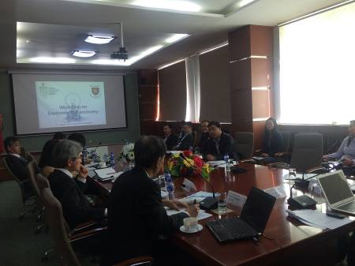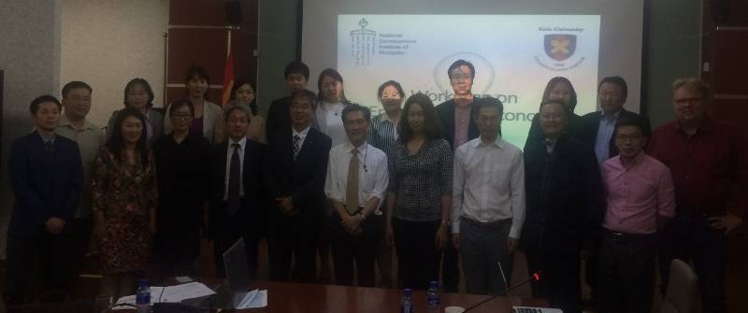
About 20 participants from the Ministry of Green Development and Environment, the Ministry of Construction and Urban Development, academic institutions and NGOs discussed "green ideas" and eco-efficient water infrastructure development in Mongolia.
Prof. Basandorj suggested "green innovation projects" such as Zero wastewater treatment technology, and introducing and piloting 3R (reuse, recycle and recover) principles as well as promoting water management in Mongolia.

9. Meeting on drinking water quality
On 21 August 2015 at the CWP-Mongolia's office in Ulaanbaatar, Prof. Basandorj Davaa met Mr. Felix in order to discuss how to improve drinking water quality in Ger area of Mongolia. He suggested to test nano-filtration technology for water quality improvement.
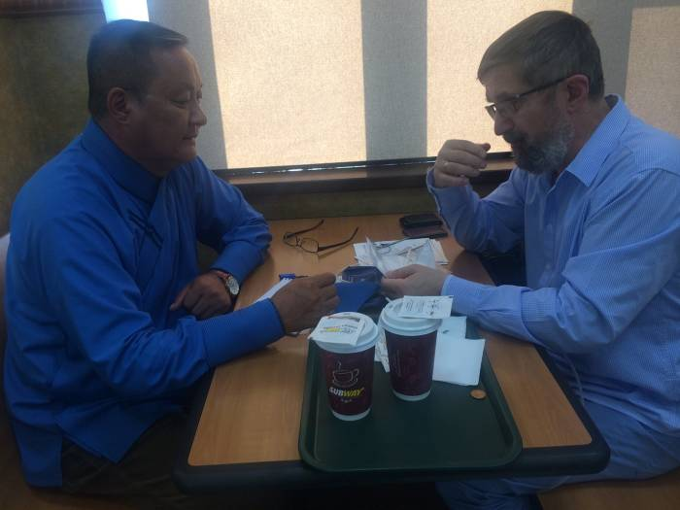
They arrived at the conclusion that it is rational to use micro-filter for water treatment. And water of springs can be used for drinking by people.

10. Internet discussion on organizing the IUWM meeting
CWP-Mongolia has discussed with Mr. Francois Brikke the organizational issues of planned high level meeting on IUWM to be held in Mongolia in Ulaanbaatar late September 2015, as well as the meeting on water management improvement to be held on 31 September 2015.

11. Demonstration of irrigation technology

CWP-Tajikistan together with its partners (the Institute "TajikNIIGiM", Gissarsky research centre, Tajik Agrarian University, Institute of Agriculture of the Academy of Sciences) created the pilot plots for demonstrating water saving technologies in the Rudaki province, Gissar region. Researches of young scientists are supported; the trainings on cropping technology and the field lessons on water measuring are being conducted.

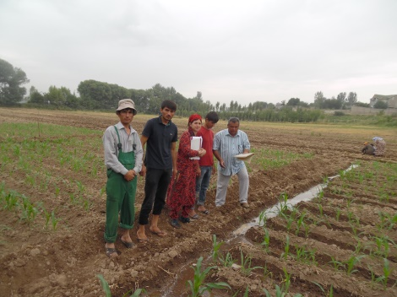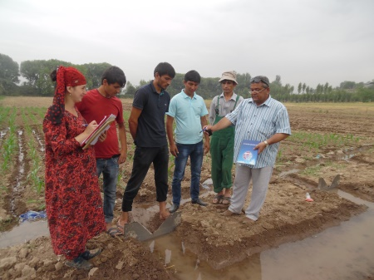

12. 3d practical seminar on developing the National Strategy on Adaptation to Climate Change in the Republic of Tajikistan

This seminar was organized by the Committee on Environment Protection under the Government of the Republic of Tajikistan, the Climate Investment Funds, and the ADB project TA8090 "Building Capacity on Adaptation to Climate Change". The seminar was held on 27 August 2015 in the Istiklol Hotel in Dushanbe. More than 40 people from various state and public organizations including CWP-Tajikistan, as well members of the Steering Committee of the ADB project took part in this seminar. The following issues were considered:
- Implementing the Strategy on Adaptation;
- Involving stakeholders;
- Disseminating information;
- Strengthening potential;
- Indicators of progress of adaptation to climate change.

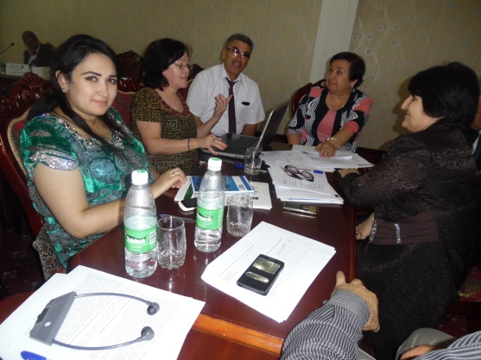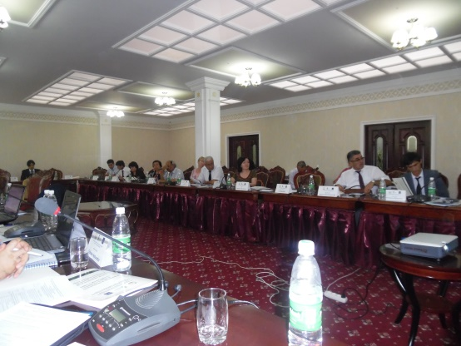
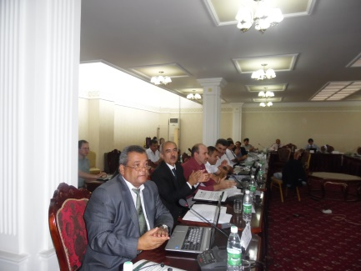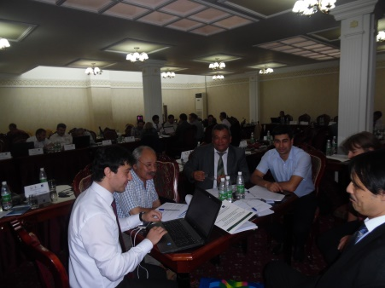

www.gwp.org
The Global Water Partnership’s vision is for a water secure world. Our mission is to advance governance and management of water resources for sustainable and equitable development.

