Draft Terms of Reference (Organizational Guidelines) for organizing the
DRIN DAY celebration 2017

In the framework of:

Memorandum of Understanding
for the Management of the Extended Transboundary Drin Basin

GEF Project “Enabling Transboundary Cooperation and Integrated Water Resources Management in the Extended Drin River Basin”

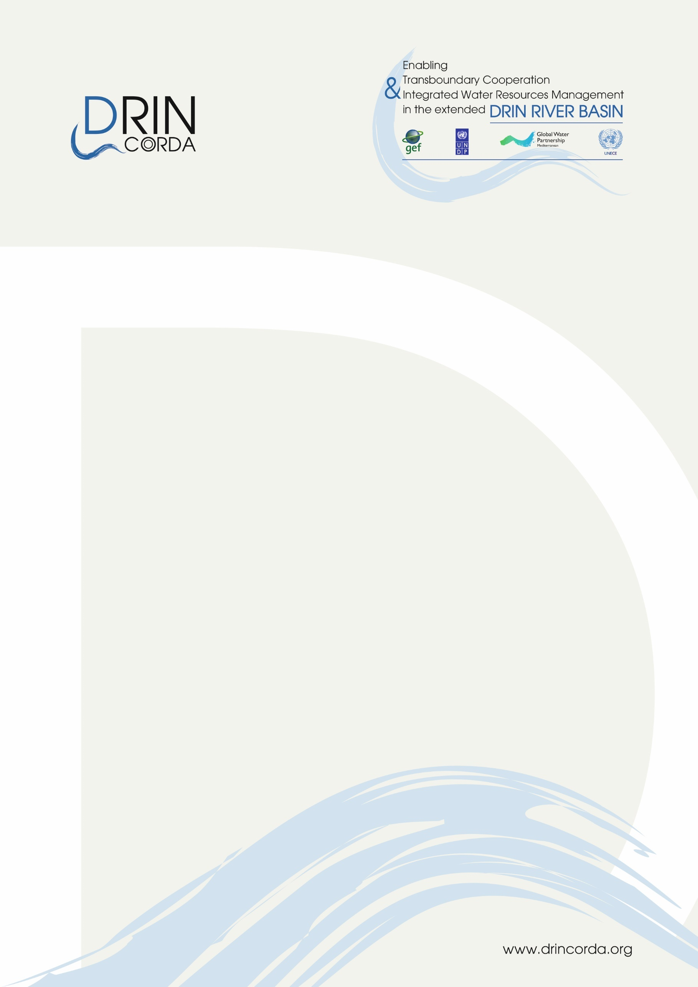
1 March 2017

The Coordinated Action for the implementation of the Memorandum of Understanding for the management of the Drin basin (Drin CORDA) is supported by the GEF Drin Project. The latter is implemented by the United Nations Development Programme (UNDP) and executed by the Global Water Partnership (GWP) through GWP-Mediterranean (GWP-Med), in cooperation with the United Nations Economic Commission for Europe (UNECE). GWP-Med serves as the Secretariat of the Drin Core Group, the multilateral body responsible for the implementation of the Memorandum of Understanding.

Disclaimer: The document adheres to the UN rules and policies regarding the names and international status of countries and/or other geographical areas etc. The use of characterizations, names, maps or other geographical statements in this document in no way implies any political view or positions of the Parties which are executing and implementing the Project.

For more information, please contact

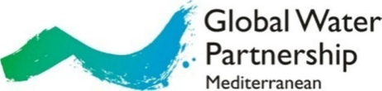

Web: www.gwpmed.org

Headquarters:
12, Kyrristou str., 10556
Athens, Greece
T: +30210-3247490, -3247267, F: +30210-3317127
E-mail: secretariat@gwpmed.org

Introduction - Background

The Drin Memorandum of Understanding

Coordinated action at the Drin Basin level has been absent until the development of the Shared Vision for the sustainable management of the Drin Basin and the signing of a related Memorandum of Understanding (Tirana, 25 November 2011) by the Ministers of the water and environment management competent ministries of the Drin Riparians i.e. Albania, The Former Yugoslav Republic of Macedonia, Greece, Kosovo* and Montenegro. This was the outcome of the Drin Dialogue coordinated by the Global Water Partnership Mediterranean (GWP-Med) and UNECE.

The main objective of the Drin MoU is the attainment of the Shared Vision: “Promote joint action for the coordinated integrated management of the shared water resources in the Drin Basin, as a means to safeguard and restore, to the extent possible, the ecosystems and the services they provide, and to promote sustainable development across the Drin Basin”.

The ultimate goal of the work in the Drin Basin is to reach a point in the future where the scale of management lifts from single water bodies to the hydrological interconnected system of the Drin Basin, eventually leading from the sharing of waters among Riparians and conflicting uses, to the sharing of benefits among stakeholders.

The Drin Coordinated Action

A process called the “Drin CORDA”, Drin Coordinated Action for the implementation of the Drin MoU, was put in place after the signing of the latter.

Following the provisions of the Drin MoU an institutional structure was established. It includes:
- The Meeting of the Parties.
- The Drin Core Group (DCG). This body is given the mandate to coordinate actions for the implementation of the MoU.
- Three Expert Working Groups (EWG) to assist the DCG in its work:
- Water Framework Directive implementation EWG.
- Monitoring and Information exchange EWG.
- Biodiversity and Ecosystem EWG.

The DCG Secretariat provides technical and administrative support to the DCG; Global Water Partnership – Mediterranean (GWP-Med) serves by appointment of the Parties through the MoU as the Secretariat.

An Action Plan was prepared to operationalize the Drin CORDA. This has been subject to updates and amendments in accordance with the decisions of the Meeting of the Parties to the Drin MoU and the DCG. The DCG and its Secretariat guides the implementation of the action plan while its implementation is currently being supported by the Global Environment Facility (GEF); see below.

The GEF Drin Project

The GEF supported Full Size Project “Enabling transboundary cooperation and integrated water resources management in the extended Drin River Basin” (GEF Drin Project) is aligned in content, aims and objectives with the Action Plan and the activities under the Drin CORDA.

The objective of the project is to promote joint management of the shared water resources of the transboundary Drin River Basin, including coordination mechanisms among the various sub-basin joint commissions and committees. Albania, The Former Yugoslav Republic of Macedonia, Kosovo and Montenegro are the Project beneficiaries.

The GEF Drin Project is structured around five components:
Component 1: Consolidating a common knowledge base
Component 2: Building the foundation for multi-country cooperation
Component 3: Institutional strengthening for Integrated River Basin Management (IRBM)
Component 4: Demonstration of technologies and practices for IWRM and ecosystem management
Component 5: Stakeholder Involvement, Gender Mainstreaming and Communication Strategies

The Project is implemented by UNDP and executed by the Global Water Partnership (GWP) through GWP-Mediterranean (GWP-Med) in cooperation with the United Nations Economic Commission for Europe (UNECE); GWP-Med is responsible for the realization of the Project. The Drin Core Group is the Steering Committee (SC) of the Project.

It is managed by a Project Coordination Unit (PCU), based in Tirana, Albania; staff is stationed also in Podgorica, Ohrid, Pristina, and Athens. The duration of the two Projects is four years.

Background: The Drin Day, 5 May 2017

The Drin Day is established by the decision of Drin Core Group. The Drin Day is celebrated each year on 5 May in all sub-basins of the extended transboundary Drin Basin under the auspices of the Drin CORDA and the Drin Core Group.

The overarching aim of the Drin Day events is to raise the awareness of local communities and the wider public on the importance of the sustainable management of the Drin River Basin and its ecosystems and to raise awareness amongst the wider public about the declining state of the environment of the Drin watershed and coastal areas and of the benefits of adopting an integrated multi-country approach to their management. The specific objective is to inform and raise awareness amongst specific categories of stakeholders about the aims of the project as well as the Drin’s resources and the necessary action needed to move towards sustainable management of the Basin. Therefore, the plan is to make information, resources and products developed during the Drin Project easily accessible to the public and to promote the benefits and lessons from the Project to key audiences.

The events will act as vehicles to expand people’s understanding, and especially of youth, on the intrinsic values of habitats and species of the region and promote concrete, comprehensive and continuous actions towards the safeguarding the biodiversity of the Drin River Basin and its invaluable ecosystem services.

The main/core event will be held on the 5 May 2017 (Friday), however activities in some sub-basins may take place on the following weekend on 6-7 May 2017 (Saturday / Sunday). The events will take place across the Drin Basin in all Riparians.

CALL OF INTEREST

The Drin Day events will be organized in partnership with NGO or Civil society organizations, in the local communities located along the Drin River Basin in the following Drin Riparians: Albania, Kosovo, the Former Yugoslav Republic of Macedonia and Montenegro.

Each partner NGO/CSO will have the initiative and responsibility for the type and methodology used to conduct the event within the framework of the guidelines included herewith.

In this regard the Drin Project requests NGOs and Civil society organizations interested to organize Drin Day events, to submit Application Form (see Annex 1) in which they should describe the events that they propose to organize.

The following terms of reference should be followed in the preparation of the applications:

Type of Activities:

The Drin Day events may include these activities; the list is indicative and the NGOs applying for support under this call should use these for inspiration:
- Organization of festivals with interactive workshops for children promoting the need to care for freshwater resources, both as our natural/cultural heritage and valuable for our future.
- Organization of an eco-products fair.
- Organization of sports activities (cycling, kayaking, rowing, climbing etc.).
- Organization of field trips for groups of youth to the Drin River Basin, which could include clean-up actions, bird watching activities, freshwater ‘monitoring’, etc.
- Organization of a seminar/meeting with emphasis on ways to safeguard the biodiversity of the Drin River Basin and its invaluable ecosystem services.
- Organization of environmental exhibitions/competitions with pictures, videos, presentations, drawings and essays or projects implemented by students inspired by the Drin River, as well as theatrical performances.
- Launching a survey to capture the views and perceptions of citizens living along the Drin River Basin on the key values and threats of the region and use the results as a mean to raise awareness.
- Combining the theme with activities (e.g. school visits) relating to Education for Sustainable Development, aiming to supply youth with simple tips on sustainable consumption behaviors in relation to the freshwater resources of the Drin River Basin.
- Launching an awareness raising campaign on social media making best use also of the project’s targeted tools (brochure, documentary, TV spots).

Targets:

The proposals should be such to enable the achievement of the following targets:
- The involvement of as many people and sectors as possible.
- Extensive coverage by electronic media and press.
- Institutions participate in the opening of the events.

Audience:
The event can be targeted to:
- Institutional Framework including Ministries or other high level governmental authorities;
• Entities/ Regional or Local Government Bodies/ Authorities;
• River Basin District Agencies;
• Protected Area Authorities;
• State owned utilities;
• Research institutes;
• Land and Water Use Associations / Cooperatives including Farmers’/Livestock Breeding/Fishermen/Water Boards);
• Private sector (land owners, navigation, industry) including their Chambers;
• Tourism Agencies/Boards;
• NGOs;, Civil society, Local communities; and
• Media.

Gender Equality:

Analysis of the Drin project shows that there are various entry points for gender mainstreaming. The objective of the gender mainstreaming strategy is to support the implementation of the GEF Drin project: “Enabling Transboundary Cooperation and Integrated Water Resources Management in the Extended Drin River Basin” by providing input to how the project can integrate gender considerations in a practical and strategic manner.

Awareness raising of a wider public should consider women as part of the target group and part of organization and participation of the Drin Day celebration, as they may be reached better via specific channels. Strategic communication towards specific groups, pictures, language and visibility should be considered. Documented lessons learned should consider pictures, language and visibility as above. They could also consider specific learning as regards gender in the project.

Financial Support

An amount from 5000 - 7000 $ is available as seed funding to support the organization for each selected NGO/CSO

Eligible promotional costs include:
- costs for filming and/or broadcasting of the Drin Day events in order to enhance impact;
- costs for printing material;
- costs for purchasing eco-promotional products giving out an environment protection related message such as a thermos to advocate against single use plastic bottles, bags made of organic cotton to replace single use plastic bags, binoculars for bird watching etc.

Financial monitoring and reporting will be carried according GWP Med financial rules and procedures

Indicative timeline of actions and deliverables:
The successful applicants should be able to deliver the deliverables included in the indicative list below following the timeline.

Deliverables | Corresponding Tasks and steps for preparation | Date of delivery
1. Agenda of activities in English and in local languages | 1. Preparation of a draft Agenda in English with the program of activities to take place on Drin Day 2017 and delivery to GWP-Med.  2. Incorporate comments by GWP-Med and preparation of final draft Agenda in English.  3. Translation in country language(s) and printing of a number of copies as necessary. | 21 April 2017
2. Invitations to Mayors, representatives of local and regional authorities, cabinet of respective Ministries | 1. Preparation of draft Invitation .  2. Comments from GWP-Med incorporated, Translation of invitation to country language(s).  3. Sending out invitations to Mayors, representatives of local and regional authorities, cabinet of respective Ministries. | 21 April 2017
3. Material to be printed / produced | 1. Preparation of the draft text / design etc. and delivery to GWP-Med;  2. Incorporating comments by GWP-Med and making necessary changes;  3. Production and distribution of the material;  4. Delivery of electronic copies and hard copies to GWP-Med. | 21 April 2017  5 (6,7) May 2017  12 May 2017
4. Engaging media of local and national level | 1. Invitation of media to events.  2. Sending information note for the Drin Day 2017 celebrations to TV news, newspaper and web portals.  3. Uploading video on YouTube and disseminating it through social media. | 28 April 2017  1 May 2017  5 (6,7) May 2017
5. Implementation of activities for the Drin Day 2017 | DRIN DAY CELEBRATION EVENT(S) | 5 May 2017 , possibly 6 and 7 May
6. Press release | 1. Providing information to GWP-Med about activities of the Drin Day 2017 including photos as well as number of participants in events, results of activities in numbers etc.;  2. Finalization of the press release by GWP-Med;  3. Translation of final press release to country language(s);  4. Sending press release after the Drin Day 2017 celebrations to TV news, newspaper and web portals. | 5 May 2017  8 May 2017
Reporting | 1. Delivery of Report to GWP-Med including:  a. brief description of activities;  b. any specific information expressly requested by GWP-Med for reporting of activities;  c. all material and deliverables 1 – 6 above;  d. proof from media coverage including articles in the press, TV coverage and web articles;  e. photos from the Drin Day celebrations;  f. video produced. | 12 May 2017

Monitoring

Monitoring of activities will be realised on the basis of deliverables being finalised as specified under Deliverables.

Timeframe

The Activity will be implemented on 5 May 2017 (eventually 6 and 7 May). Tasks will be implemented throughout the period April 2017 to May 2017.

Annex 1: APPLICATION FORM

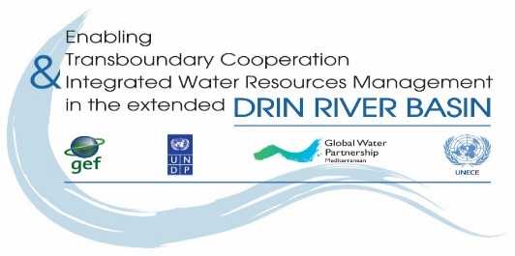
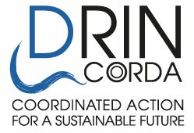

THE DRIN DAY CELEBRATION 2017

Expression of interest

- Name of NGO/CSO:__________________________

- Country: _______________________________________________________________________

- Drin Sub-basin the NGO is active/work at: _____________________________________________

- Our NGO would like to participate in the proposed activity

Name of person in charge: _____________________________________________
Address: _______________________________________________
Tel.: ___________________________________________________
Fax: ___________________________________________________
e-mail: _________________________________________________
web-site: _______________________________________________

- Title of proposed activity:

_______________________________________________________________________

- Description of proposed activity(s) (use max 2 pages):
_______________________________________________________________________________
________________________________________________________________________________
________________________________________________________________________________
________________________________________________________________________________
________________________________________________________________________________
________________________________________________________________________________
________________________________________________________________________________
________________________________________________________________________________
________________________________________________________________________________

Date foreseen for the event to be held (5 May 2017, possibly 6-7 May 2017):
________________________________________________________________________________

Having read and understood the attached Guidelines, I undertake the responsibility of organizing the event.

Signature: __________________________ Date: _______________________

Function in your NGO: ___________________________

This form must be sent by e-mail (dejan.panovski@gwpmed.org; secretariat@gwpmed.org ) to GWP-Med.

ANNEX 2 : SUSTAINABILITY

A sustainable event is one that is designed, organized and implemented with a view to minimizing its ecological footprint and maximizing its positive impact on society. To reduce the general impacts of our events or their ecological footprint, we should therefore always consider the life cycle when we organize an event, in order to identify the points that will have a bigger negative impact on the environment.
Below are listed some useful tips that should be used wherever applicable in order to minimize the ecological footprint of our event to the extent possible.
Sustainability target | How
Reduce energy use and the resulting greenhouse gas emissions | - Select venues and accommodation that implement energy efficiency measures, comply with green building standards and/or use renewable energy sources.  - Choose locations and venues minimizing local and long-distance transportation needs for participants and products.  - Where long-distance travel is unavoidable, offset GHG emissions.  - Apply energy-saving office practices during the organisation and hosting of the event.
Reduce materials consumption and waste generation | - Minimize materials provided to participants and used by service providers (e.g. caterer, exhibitors), before, during and after the event.  - Avoid the use of disposable items, use pre-used/ recycled and reusable/recyclable products and reduce packaging needs to a minimum  - Separate and recycle waste where possible.
Reduce water use | - Select venues and accommodation that implement water conservation practices and use water-efficient appliances.  - Implement water-conscious measures such as avoid bottled water and re-filling glasses only upon request.
Reduce indirect environmental impacts on air, water and soil | - Minimize the need to transport food and other products and favour local organic food.  - Use products manufactured with or containing fewer harmful substances, such as chlorine-free paper and non-toxic cleaning products.
Increase the social benefits for all involved | - Involve local and regional level as much as possible by, for example, recruiting local people (social integration), supporting SMEs (catering, energy, cleaning, IT supply, family-run accommodation), and showcasing successful local projects.  - Contribute to the Sustainable Development Goals and the core ILO Conventions through compliance with labour standards, and requiring social integration (reducing unemployment), Fair Trade products and social criteria along the supply chain.  - Assure security and health aspects (e.g., noise level).

www.thegef.org
References to Kosovo shall be understood to be in the context of Security Council Resolution 1244 (1999).

