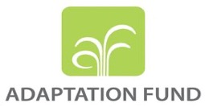

**Project: “Integrating Flood and Drought Management and Early Warning for Climate Change Adaptation in the Volta Basin”**

**(VFDM Project)**

**NATIONAL STAKEHOLDERS WORKSHOP ON THE FLOOD AND DROUGHT RISK PROFILES IN THE VOLTA BASIN**

(From 04 to 06 April 2022 in Accra)

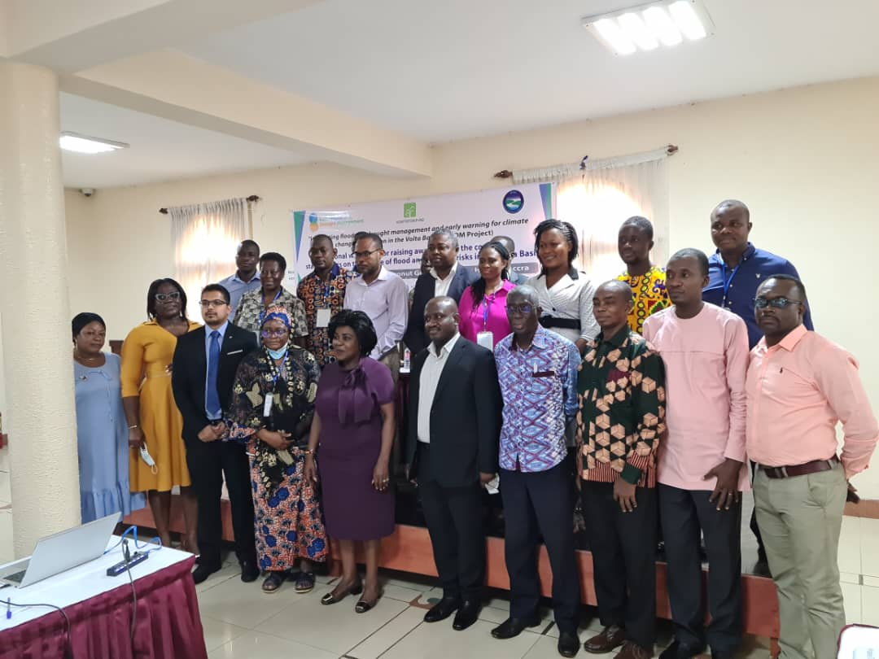

**Final report**

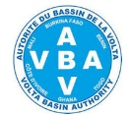

**Partners:**

*****

**Summary**

List of tables 3

List of figures 3

List of acronyms and abbreviations 4

1. Introduction 5

1.1. Background 5

1.2. Methodology and approach of the national workshop 5

2. Getting started with the national workshop 7

2.1. Opening of the national workshop 7

2.2. National workshop objectives and agenda 8

2.3. Establishment of the presidium 9

3. Progress of the work of the national workshop 9

3.1. Session 1: Introduction to Disaster Risk Assessment, Risk Components and Probabilistic Risk Analysis 9

3.2. Session 2: Understanding Risk Metrics: AAL and PML 12

3.3. Session 3: Understanding the flood risk profile 15

3.4. Session 4: Understanding the drought risk profile 17

3.5. Session 5: Communicating the results of the Volta Basin Risk Profile 22

3.6. Session 6: Recommendations for policies based on knowledge of flood and drought risks 22

3.7. Session 7: Presentation of the VOLTALARM early warning system 23

4. Closing ceremony of the national workshop 24

Annex1: List of participants 25

Annex2: National workshop agenda 27

Annex3: Recommendations of the workshop formulated by team 28

# 

# **List of tables**

Table 1:Results of group work on the evaluation of the stock and the exposed value 11

Table 2:Summary of AAL for each series and half-series 14

Table 3:Summary of PMP calculated for each series and half-series 15

# **List of figures**

Figure 1: Satellite images of hazards / blue, green and yellow team 10

Figure 2: Determination of the stock exposed to the risk of flooding 11

Figure 3: Table of hazard-prone are sanitation facilities 12

Figure 4: Vulnerabil curves 12

Figure 5:Time series of disaster losses 1 and 2 14

Figure 6:Methodology for determining PML curves 15

Figure 7:Population affected by flooding in the Ghana Volta Basin 17

Figure 8:Average annual agricultural yield losses 18

Figure 9:Livestock in drought-affected areas 22

Figure 10:Overview of the myDEWETRA / VOLTALARM platform 24

**List of acronyms and abbreviations**

|  |  |
| --- | --- |
| **Acronyms/ abbreviations** | **Meaning** |
| 2IE | International Institute of Water and Environmental Engineering |
| AAL | Average Annual Loss |
| CBO | Community-Based Organizations |
| CERSGIS | Centre for Remote Sensing and Geographic Information Services |
| CIMA Foundation | International Environmental Monitoring Center |
| CSIR | Council for Scientific and Industrial Research – Ghana |
| CWP-GH | Ghana Country Water Partnership |
| DEA | Deputy Executive Director |
| Elevator pitch | speech in the elevator |
| DE | Executive Director |
| FEWS | Forecasting and Early Warning System |
| Gmet | Ghana Meteorological Agency |
| GNDR | Global Network of Civil Society Organisations for Disaster Reduction |
| GWJN | Ghana Watsan Journalists Network |
| GWP-WA | Global Water Partnership in West Africa |
| HSD | Hydrological Services Department |
| IDA | Ghana Irrigation Development Authority |
| IESS | Institute for Environment and Sanitation Studies |
| IUCN | International Union for Conservation of Nature |
| IVM | Institute of Environmental Studies |
| LUSPA | Landuse & Spatial Planning Authority |
| NADMO | National Disaster Management Organization |
| NGO | Non-Governmental Organization, |
| PIK center | Potsdam Research Institute for the Effects of Climate Change |
| PML | Probable Maximum Loss |
| UNDRR | United Nations Office for Disaster Risk Reduction |
| UNISDR | United Nations International Strategy for Disaster Reduction |
| UNITAR/UNOSAT | United Nations Institute for Training and Research / United Nations Satellite Centre |
| VBA | Volta Basin Authority |
| VFDM | Project “Integrating Flood and Drought Management and Early Warning for Climate Change Adaptation in the Volta Basin” |
| WB | World Bank |
| WMO | World Meteorological Organization |
| WRC | Water Resources Commission |
| WRI | World Resources Institute |

1. **Introduction**

From Monday 4th to Wednesday 6th April 2022, the national stakeholders workshop was held at Coconut Grove Regency Hotel, Accra (Ghana), to present the developed Flood and Drought Risks Profile in the Volta basin as well as to gather policy recommendations or suggestions on risk-informed prevention and management.

This workshop is the first of a series of six (06) national workshops planned for the Volta Basin countries. It is part of the implementation of the Project “Integrating Flood and Drought Management and Early Warning for Climate Change Adaptation in the Volta Basin (VFDM)” financed by the Adaptation Fund and executed by the consortium composed of World Meteorological Organization (WMO), Volta Basin Authority (VBA) and Global Water Partnership in West Africa (GWP-WA).

* 1. **Background**

WMO, a specialized agency of the United Nations, VBA and GWP-WA are executing the project entitled "[Integrating Flood and Drought Management and Early Warning for Climate Change Adaptation in the Volta Basin](https://translate.google.com/translate?hl=fr&prev=_t&sl=fr&tl=en&u=https://www.adaptation-fund.org/project/integrating-flood-drought-management-early-warning-climate-change-adaptation-volta-basin-benin-burkina-faso-cote-divoire-ghana-mali-togo/)(VFDM)”. The project activities, started in June 2019, are continuing and will end at the end of June 2023. The VFDM project is financed by the Adaptation Fund.

The implementation of the VFDM project involves the active participation of national agencies (in charge of meteorology, hydrology, water resources management, water protection, civil protection, etc.), regional institutions and WMO partners, such as CIMA Research Foundation, Italian Civil Protection Department, UNITAR/UNOSAT, IUCN and CERFE/ Knowledge & Innovation, etc.

As part of the implementation of the VFDM project, the activities related to the development of flood and drought risk maps in the Volta Basin for current and future climate scenarios have been successfully completed, using new and existing information available from global, national and local agency datasets, as well as other projects in the region. This activity is part of the development process of the VOLTALARM early warning platform, based on the myDewetra system, where risk maps will be visualized.

The CIMA Research Foundation, in collaboration with the Institute of Environmental Studies (IVM) of the Vrije University, has developed together with national and regional actors, following a probabilistic approach, the flood and drought risk maps for the Volta Basin, for current and future climate scenarios. Probabilistic risk assessment considers all possible risk scenarios in a certain geographical area. The assessment was based on several datasets, including data from a very detailed hydrological study carried out on the Volta basin by the Potsdam Institute for Climate Impact Research (PIK)center in Potsdam, Germany.

The results provide insight into the potential impacts of floods and droughts taking into account current and projected climatic conditions in a comprehensive risk assessment study. The results were summarized in the basin-wide risk profile with key findings for the entire basin and sections for the national portion of each country. The risk profile will be complemented by a session devoted to recommendations for informed policies (which take into account risk knowledge) and key messages for the development of a prevention action plan and risk management strategies for the medium and long term. The recommendations will be developed jointly with the experts participating in the national workshops.

In this regard, a national technical workshop is planned in each member country of the Volta Basin to present to stakeholders the floods and droughts risk profile of the Volta Basin and collect feedback and recommendations for policy makers as well as key messages for the development of an action plan.

* 1. **Methodology and approach of the national workshop**

The organization of the national workshop was facilitated by GWP-WA in joint collaboration with WMO and VBA and the national focal structure of VBA i.e Water Resources Commission (WRC).

The methodological approach of the workshop revolves around three main stages: preparation, development and reporting.

* the preparation stage focused mainly on the development of the concept note and the workshop agenda, the preparation of presentations and terms of reference for group works, the targeting and mobilization of participants s as well as making logistical arrangements;
* the development stage alternated plenary presentations followed by debates as well as group works, the results of which were presented in plenary;
* the reporting stage which consisted of synthesizing and analyzing all the productions resulting from the workshop on the one hand, and on the other hand preparing the workshop report.

The course of the workshop was marked by the development of eight (08) sessions, namely:

* Session 0: Overview of the Disaster Risk Profile of the Volta Basin
* Session 1: Introduction to Disaster Risk Assessment, Risk Components and Probabilistic Risk Assessment
* Session 2: Understanding risk metrics: Annual Average Loss (AAL) and Probable Maximum Loss (PML)
* Session 3: Understanding the flood risk profile
* Session 4: Understanding the drought risk profile
* Session 5: Communicating the results of the Volta Basin risk profile
* Session 6: Recommendations for risk informed policies based for floods and droughts
* Session 7: Presentation of the VOLTALARM early warning system.

The national workshop had the effective participation of thirty-two (32) participants (Annex 1) drawn from the government institutions, civil society organizations and the private sector.

The workshop was moderated by Mr. Maxwell Gyimah of GWP-Ghana, country water partnership.

This report reflects the proceedings of the workshop and is structured around the following three (3) main points:

* the opening of the national workshop;
* the progress of the work of the national workshop;
* the closing of the national workshop.

1. **Getting started with the national workshop**
   1. **Opening of the national workshop**

The opening ceremony of the workshop was chaired by Mr. Owusu Ansah.

**Welcome address – Mr. Ben Ampomah**

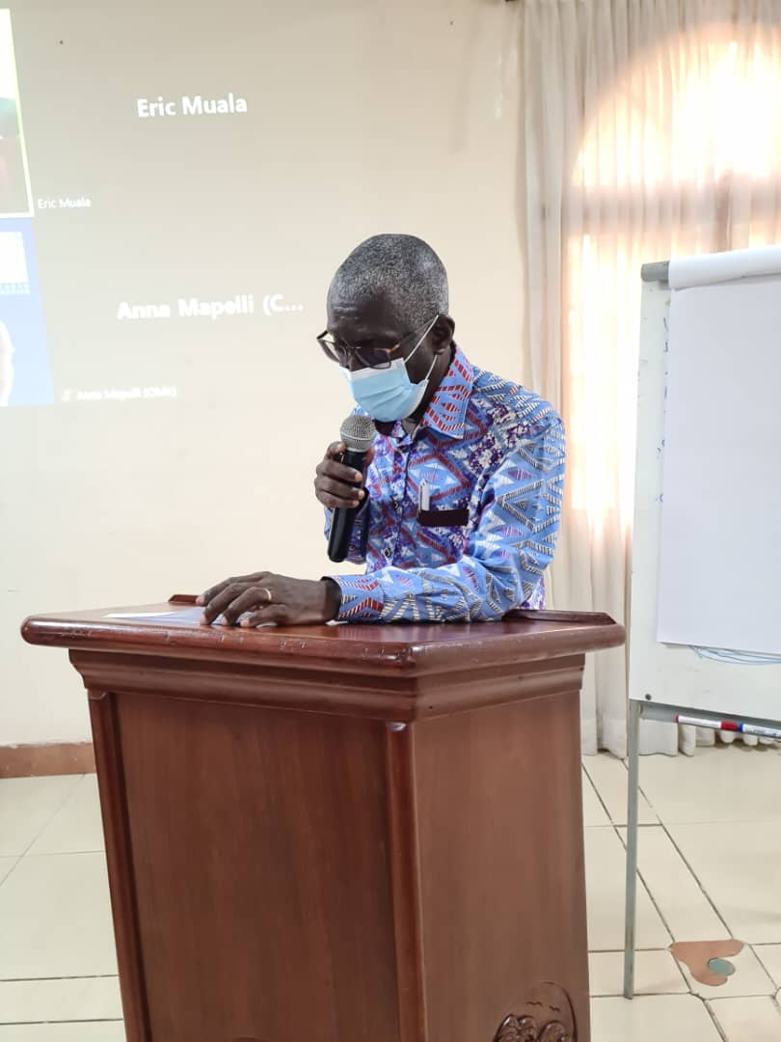Mr. Ben Ampomah as Executive Secretary of the Water Resources Commission and Focal person for Volta Basin Authority (VBA) for Ghana welcomed participants to the workshop. He noted that quite a lot of efforts had been put into the Volta Flood and Drought Management (VFDM) project and remarkable results were accomplished in relation to the set objective of building the capacities of the six Volta Basin Member States in floods and drought management and towards minimizing extreme hydro-climatic disaster risks. He also stated that the contribution of this project can be better appreciated and measured if the results are adequately disseminated and utilized for disaster prevention, response, raising awareness, disaster risk assessment and risk modelling for floods and drought in the Volta Basin. He wished all participants, especially those who have traveled from Ouagadougou and Geneva a pleasant stay in Accra.

**VFDM Project Partners statements**

On behalf of Executive Director, VBA, Dr. Rafatou Fofana emphasized the importance of capacity building and the need for effective participation in order that the products of the project will reflect the situation in the areas of the Volta Basin in the countries.

Mr. Ramesh Tripathi, representative of the World Meteorological Organization noted the need to improve the knowledge of stakeholders in risk modeling and assessment with the technical support of CIMA. He acknowledged the VBA, and Global Water Partnership - West Africa (GWP-WA) and the collaboration with WMO partners, including the CIMA Research Foundation, VU University and national institutions in charge of meteorology, hydrology, water resources management, risk and disaster management, environment and civil society for the continued support of the project.

**Keynote Address – Hon. Cecilia Abena Dapaah**

The keynote address was delivered by the Minister of Sanitation and Water Resources, Honourable Cecilia Abena Dapaah. She encouraged all participants to put together the knowledge that they will obtain from the three-day workshop with their valuable experiences and commitments to provide productive solutions and actions for water security, climate change, and disaster risk challenges in Ghana specifically the Volta Basin. The Minister shared thoughts on significant project outcomes that would assist to make informed decisions to address the impacts of climate change including the devastating effects of floods and droughts that are becoming perennial misfortunes in the Volta Basin. She elaborated on the loss of lives and property including livestock and food crops in the White Volta during floods since 2007, and in recent times, joined by Black Volta and Oti rivers. According to her, this situation is exacerbated by the spillage of the Bagre Dam in Burkina Faso for which the Forecasting and Early Warning System (FEWS) for the White Volta basin was necessary. She mentioned that in 2019, the government took a pragmatic step to implement structural measures for dredging sections of the White Volta Basin rivers. This resulted in a significant reduction of flooding of the dredged areas that were flooded in the past and reduced destruction of crops and farmlands in the area. These non-structural and structural investments have made a big difference and saved lives and underscore the value of advance planning and disaster risk management.

* 1. **National workshop objectives and agenda**

The overall objective of the national workshop is to improve the knowledge of stakeholders at the national level on the floods and droughts risk of the Volta Basin, through the risk maps developed for the climate scenarios considered as well as the participation and commitment of stakeholders in the assessment and modeling of said risks.

More specifically, the workshop aims to:

* improve participants' knowledge on disaster risk assessment and probabilistic flood and drought risk assessment;
* present to participants, the results of the flood and drought risk profile in the Volta Basin, developed through probabilistic risk analysis and risk assessment for current and future climate scenarios in the basin;
* get participants to take ownership of an approach for integrating flood and drought risks into policy and strategy development processes based on available technical and scientific knowledge; and
* formulate recommendations for the development of policies that take into account the risks and key messages for the development of an action plan for the prevention of flood and drought risks in the Volta Basin.

The main outputs and outcomes expected from the workshop are:

* the participants improve the knowledge on the methodological approach used to develop the risk profile of floods and droughts in the Volta Basin;
* the participants have knowledge of the main results of the probabilistic assessment of flood and drought risks according to current and projected climate scenarios for the basin and for each national portion of the Volta basin;
* the participants take ownership of the flood and drought risk profile for the Volta Basin;
* the participants take ownership of an approach for integrating the risks of floods and droughts into the process of developing policies and strategies on the basis of available technical and scientific knowledge;
* recommendations are made for the integration of flood and drought risks into national policy-making processes;
* key messages are defined for the development of an action plan for the prevention of flood and drought risks in the Volta basin;
* the flood and drought risk profile of the Volta Basin is finalized following the various national workshops, with the comments of the stakeholders, for its official dissemination.

Following the objectives and results of the workshop, the agenda of the workshop was presented and validated by acclamation.

* 1. **Establishment of the presidium**

A presidium was proposed by the organizers, validated and accepted by all the participants. The presidium is composed as follows:

* Mr. Joachim Ayiiwe Abungba – Principal Basin Officer, WRC Black Volta Basin Secretariat, Wa, Ghana
* Mr. Godfred Asamoah – Water Quality Officer, WRC Head Office, Accra, Ghana.

# **Progress of the work of the national workshop**

## **Session 1: Introduction to Disaster Risk Assessment, Risk Components and Probabilistic Risk Analysis**

The presentation of the first session of this workshop was made virtually by Mr. Marco MASSABO of the CIMA Foundation and focused on the clarification of certain concepts such as disaster, risk, hazard, exposure and vulnerability. In his intervention, it was noted that knowledge of disaster risk is one of the priorities (Priority 1) of the Sendai Framework for Disaster Risk Reduction. Disaster risk management is based on understanding risks in all their dimensions, taking into account the characteristics of hazards, the exposure of people and property, the vulnerability of populations and their capacities to cope with risks and the impacts of risks on the environment. This knowledge can be used for risk assessment, prevention and mitigation.

In this intervention, it is shown that along time disaster risk has been defined in different ways but always including the measure of the probability of occurrence and severity of impacts of an adverse event. In his presentation, the risk components described were Hazard, Exposure, and Vulnerability. Hazard is a phenomenon or process or human activity that may cause loss of life, injury, or other health problems. Exposure is people or properties living in hazard-prone areas. Vulnerability is the potential for loss, the degree to which life, livelihood, property, and other assets is put at risk by a discrete and identifiable event.

Following these different notions, the cards below were presented, and the participants are invited to work on the concepts of hazard, stock, exposure, vulnerability, and risk. First, it was asked to participants to identify in groups the different elements that could be exposed.

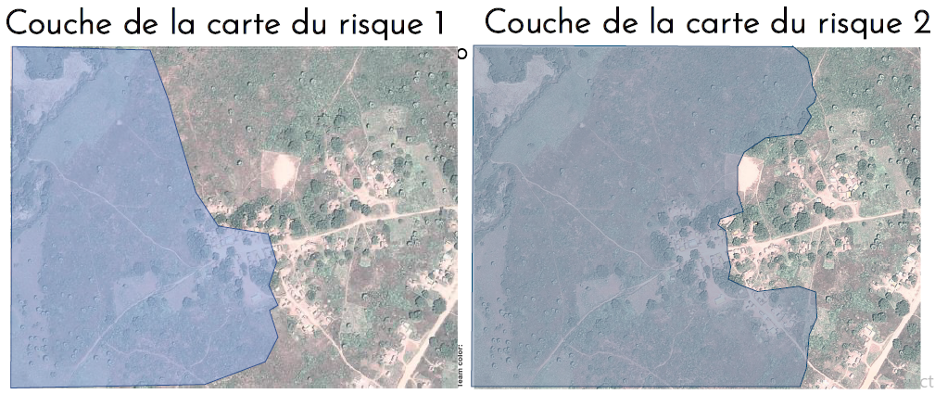

Figure 1: Extension of two different flood hazard scenarios, provided as reference maps to the groups.

After analyzing the different map layers, the participants listed the elements set out below: affected people, homes, forest resources, basic infrastructure such as Roads and Buildings, Farmlands, Population and Water sources.

Following this exercise, the communicator shared with the participants the notions of stock and exposure. Stock is the total amount/value of an asset in the study area and exposure is the part of the stock that is in a hazard-prone area.

For the following part of the session, the participants (e) were engaged in group exercises to determine the economic value of buildings’ stock and exposure on the map layer of the area at risk of flooding.

The determination of the inventory of total building stock and the value of exposed buildings consisted of: (i) identifying and listing the total assets (buildings) in the area and the exposed ones, the ones that are in the flood-prone area; (ii) determine the total value of the identified assets considering a value of $40 per unit for type A (red), a value of $400 per unit for type B (light blue) and a value of $4,000 per unit for type C (yellow) as shown in Figure 2 below.

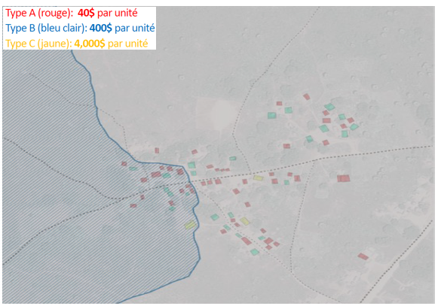

Figure 2: Determination of the economic value of buldings’ stock and exposure

The summary of the results obtained can be found in Table 1 below.

Table 1:Results of group work on the evaluation of the stock and the exposed value

|  |  |  |
| --- | --- | --- |
| **Team** | **Stock inventory ($)** | **Value exposed ($)** |
| Blue | 23,440 | 6,880 |
| Yellow | 23,440 | 14,800 |
| Green | 23,440 | 6,880 |

Following this exercise, participants were also asked to determine potential losses, considering vulnerability, and the percentage of stock lost on the same map layer. Note that the potential losses are functions of the exposed value and the vulnerability index such that:

**Potential Losses = Exposed Value × Vulnerability Index.**

The vulnerability index is a function of the water level and the category of the exposed asset based on the so-called vulnerability curves (see figure 6 below). Indeed, through vulnerability curves the flood water level can be linked to the degree of loss for the asset: for instance, for building type B 1m of water level results in damaging the building for about 40% of its value. As part of this exercise, the vulnerability indices for each type of building were estimated individually by each work team according to a given water level for the assigned flood scenario.

The table in the figure below present the results obtained in terms of stock, exposure, vulnerability index, potential losses and percentage of stock lost from one of the three teams.

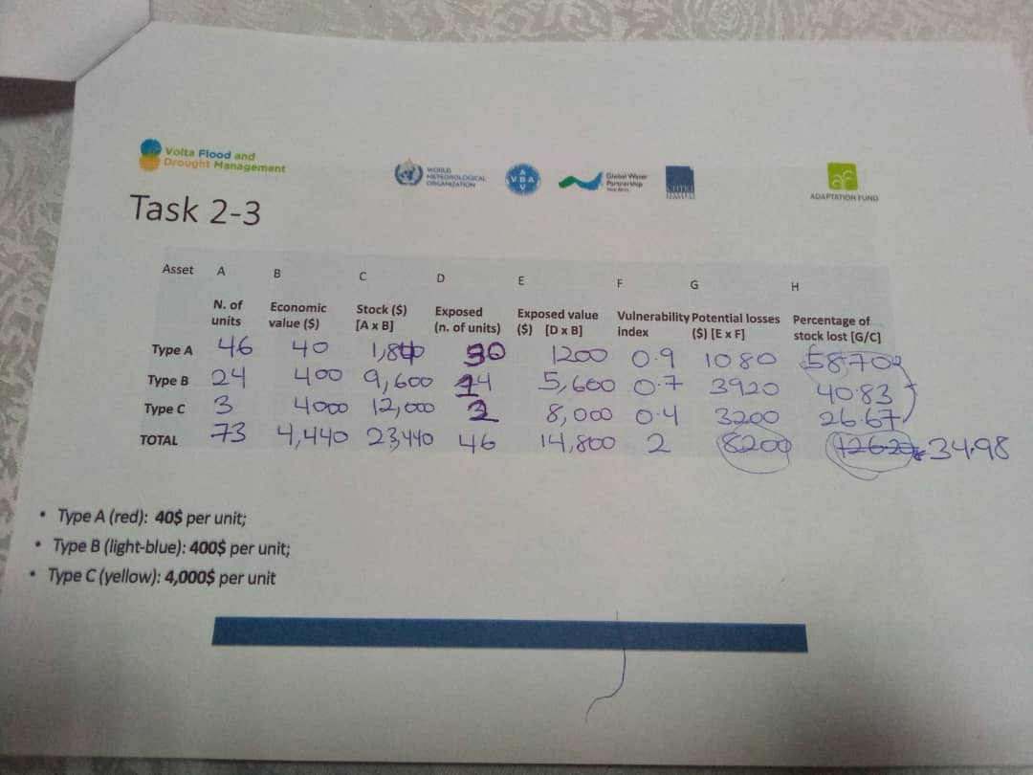

Figure 3: Results of group exercise on risk components from one of the three teams.



Figure 4: Vulnerability curves

## **Session 2: Understanding Risk Metrics: AAL and PML**

Session 2 focuses on understanding risk metrics. It emphasizes methodologies for risk assessment.

Three methodologies were listed: historical analysis, scenario analysis and probabilistic analysis. With regard to the probabilistic assessment which has also served as the basis for establishing the Disaster Risk Profile in the Volta Basin, it considers a large number of possible scenarios, their probability and the associated impacts. The probabilistic assessment consists mainly of determining two risk metrics. These are (i) the Average Annual Loss (AAL) and (ii) the Probable Maximum Loss (PML). The AAL is the expected loss per year averaged over several years while the PML describes the loss that could be expected corresponding to a given probability, expressed in terms of the annual probability of exceedance or its inverse, the return period.

Following the definition of these two concepts, participants were asked to work in groups, using two different time series of disaster losses, to complete the following tasks:

* calculate the average annual loss and identify the highly probable, moderately probable and unlikely events for the two-time series?
* derive 3 key messages and compare the results, what difference do you notice between the two time series?

|  |  |
| --- | --- |
|  |  |
|  |  |

First, the participants(e)s were asked to calculate the AAL over the entire duration of each series, as well as over each half-duration of the series considered (figure 5). Determining the AAL of a series amounts to calculating the average of the annual losses observed over several years, i.e. 40 years in the context of this exercise. The calculation of the AAL of the two half-durations of a series consists of carrying out the same process while considering only the half-durations of the identified series, i.e. 20 years for the first half-duration and another 20 years for the last half-duration in this exercise.

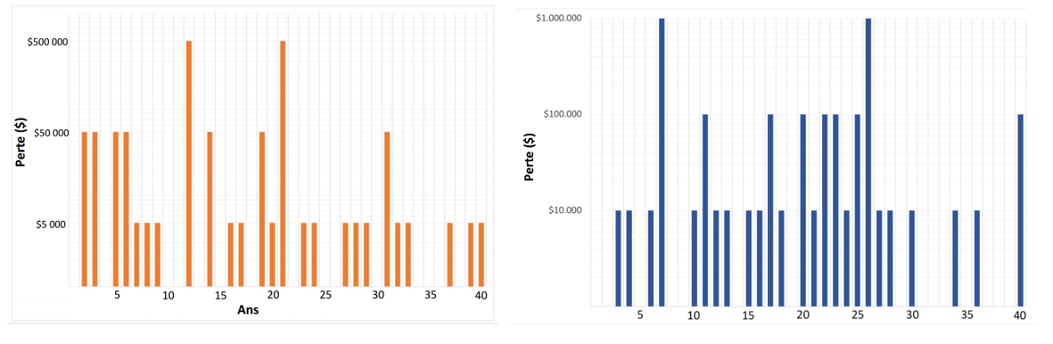

Figure 5:Time series of disaster losses 1 and 2

The results indicate that for series 1 (40 years), the resulting AAL is $35,750. For the first 20 years of Series 1, the AAL is valued at $41,500 while for the last 20 years of Series 1, the AAL is $30,000. For series 2 (40 years), the AAL obtained is $71,500. For the first 20 years of Series 2, the AAL is valued at $69,500 while for the last 20 years of Series 2, the AAL is $73,500. The summary of the results obtained is recorded in Table 2 below.

Table 2:Summary of AAL for each series and half-series

|  |  |  |  |  |  |  |
| --- | --- | --- | --- | --- | --- | --- |
|  | Series 1 | First 20 years series 1 | Last 20 years Series 1 | Series 2 | First 20 years series 1 | Last 20 years Series 2 |
| Average Annual Loss | $35,750 | $41,500 | $30,000 | $71,500 | $69,500 | $73,500 |

After the calculation of the AAL, the participants(e)s proceeded to the identification of very probable, moderately probable and improbable events for the two chronological series. For the determination of the very probable events, it was a question of identifying the value of the most frequent damages. In other words, it was a question of identifying the losses which were repeated at least once every 2-3 years. For the determination of moderately probable events, it was a question of identifying the value of frequent damages. In other words, it was a question of identifying the losses observed once every 5 to 10 years. As for the determination of improbable events, it was a question of identifying the value of less frequent damages. It was therefore necessary to identify the losses that were repeated once every 20 to 30 years.

Table 3 below presents the summary of the losses observed with different occurrence probabilities over the two time series as well as over the first 20 years of the series and the last 20 years of the series.

Table 3:Summary of loss values related to their likelihood for each series and half-series

|  |  |  |  |  |  |  |
| --- | --- | --- | --- | --- | --- | --- |
|  | **Expected loss** | | | | | |
| Series 1  (40 years) | Series 1  (first  20 years) | Series 1  (last  20 years) | Series 2  (40 years) | Series 2  (first  20 years) | Series 2  (last  20 years) |
| **Very probable** | $5,000 | $5,000 | $5,000 | $10,000 | $10,000 | $10,000 |
| **Likely** | $50,000 | $50,000 | $50,000 | $100,000 | $100,000 | $100,000 |
| **Unlikely** | $500,000 | $500,000 | $500,000 | $1,000,000 | $1,000,000 | $1,000,000 |

For the third task, participants based themselves on the probable loss observed in order to plot on a graph the Probable Maximum Loss curves (PML) corresponding to the probabilities given for the two time series of losses.This involved making projections of the various probabilities on the x-axis (see figure 6 below) and the expected losses on the y-axis.

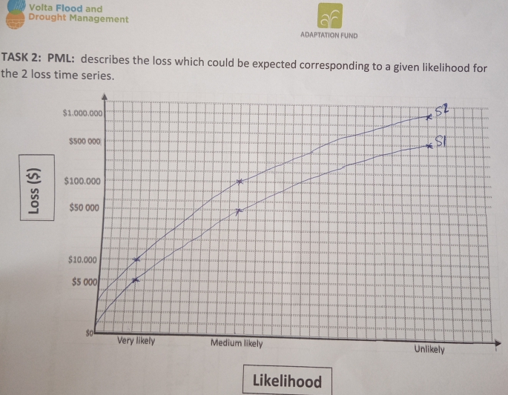

Figure 6:Methodology for determining PML curves

## **Session 3: Understanding the flood risk profile**

At the beginning of the session the chosen risk indicators for floods were presented. These indicators are seven (07) in number: (i) people potentially affected, (ii) economic loss for the built-up area, (iii) loss of agricultural production, (iv) loss of grazing land, (v) implications on critical infrastrucures, (vi) implications on water resources and hydropower generation and (vii) protected areas subject to flooding.

Then, the expert presenters went through the results obtained for each indicator of the risk of floods in the Volta Basin. Maps and graphs of the risk profile were presented and explained to the participants for better understanding. Presenters words were supported by the key figures for each indicator visible on the charts.

For example, the impacts of floods on the population under current climate conditions are distributed in almost all regions of the Volta Basin. The annual number of people affected increases from about 30,000 under current climate conditions to more than 40,000 under projected climate conditions, and up to 80,000 taking into account socio-economic projections (considering the reference model for projected climate conditions).

Only the regions of Ghana within the Volta basin are included in the risk profiles. Considering the overall impacts, the most impacted regions are the one in the north-eastern part of the Country. In terms of population, on average about 15 thousand people are affected per year in current climate conditions, and they are more than the 50% of overall affected people in the Volta basin. The impacts are important – in comparison to the overall basin – also in terms of economic losses to the built-up area; the average annual loss in current climate conditions is about USD 12.5 million for the Ghanese portion of the basin, compared to a loss of about USD 22 million for the entire Volta basin. Considering projected climate conditions, the overall impact increases, but with a high variability among the considered models.

The presentation generated many questions for clarification as to the understanding of the indicators on the charts. The response elements allowed the participants(e)s to deepen their understanding and better take ownership of the risks of flooding in the Volta Basin. Ms. Anna MAPELLI also specified that the floods concerned by this study are those known as ''fluvial'' and that the RCP 7.5 scenario was used for the climate projections.

The presentation of the first part of this session ended with group exercises, allowing participants to become familiar with reading charts and maps. The task was related to take in consideration one region of Ghana and analyzing the average number of people affected by the floods, comparing it with the figures at the level of the entire basin or of the entire national portion and analyzing the variation of people affected considering projected climate conditions and socio-economic projections. The results of this group work were directly presented in plenary and the experts of CIMA Foundation made comments on the results after the results’ presentation from each group.

As for the availability of water resources, the analysis was made on the results of hydrological modeling, comparing results in current and projected climate conditions, but there is no AAL or PML. Water availability was expressed as a percentage (%) of variation, from current to projected climate conditions, in the average annual flow at the level of the sub-basins. To this end, the greatest variations are observed in the northern and eastern parts of the Volta basin with a variation in the average annual flow greater than 250%. Annual average number of hectares of protected areas to be potentially flooded increase from more than 50,000 hectares in current climate scenarios to more than 90,000 hectares in projected climate scenarios. Figure 7 below clearly illustrates the areas of the basin most affected by flooding in terms of average annual number of people affected.

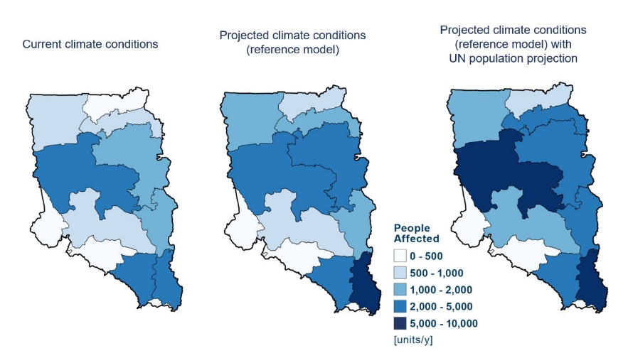

Figure 7: Annual average number of people affected by flooding in the Ghana Volta Basin

Finally, the presentation of the last part of this session ended with group exercises. The task was related to take in consideration one region of Ghana and analyzing the AAL for the various indicators in the current and projected climatic conditions, comparing it with the figures at the level of the entire Volta basin. The results of this group work were directly presented in plenary.

## **Session 4: Understanding the drought risk profile**

Session 4 of the workshop was moderated virtually by Ms. Anna MAPELLI from the CIMA Foundation. It focused on the drought risk profile in the Volta Basin. The animation of the session was interactive with exchanges around ten (10) multiple choice questions on the drought to which the participants were invited to answer.

The questions are presented below, and the answers are underlined in bold:

* **Q1: Which statement about droughts is not true?**

A: Drought can be considered a prolonged dry period.

B: Drought is a temporal deficit in water availability.

**C: Drought, water stress and water scarcity are synonymous with each other.**

D: A drought can occur in any season (at any time of the year) and anywhere.

* **Q2: What situations illustrate drought conditions?**

A: A lack of precipitation

B: Low river flow

C: Less water in the soil than usual

**D: All of these answers**

Drought can be related to the absence or prolonged lack of precipitation or also to low river flows in the absence of rain. The nuance was thus made with water stress, which corresponds to a situation in which the demand for water exceeds the available water resources. Situations that illustrate drought conditions are lack of rainfall, low flow of rivers and reduced water in the soil. In addition, the presenter emphasized the impacting droughts. Although droughts are often referred to as “drier than average hydrological and weather conditions”, these conditions do not necessarily cause an impact. This study therefore focused on "impacting droughts"

* **Q3: How did we determine impacting droughts?**

A: Looking only at below normal precipitation conditions for a given region.

B: By calculating the standardized precipitation index and selecting events where precipitation is less than one standard deviation from the mean.

**C: By identifying the years when the maize yield is lower by a certain percentage than the expected value, and by examining the hydro-meteorological conditions (through the different normalized indices) of these years.**

D: By evaluating reports (and/or media info) on the number of people affected.

Impacting droughts are determined by identifying years in which the maize yield is lower by a certain percentage than the expected value and by examining the hydrometeorological conditions (through the various normalized indices) of these years. Indeed, maize was used as a reference because it is very sensitive to drought. Based on this, the probability of occurrence of these impacting droughts is estimated, as well as the risk of drought for agricultural production, livestock and people.

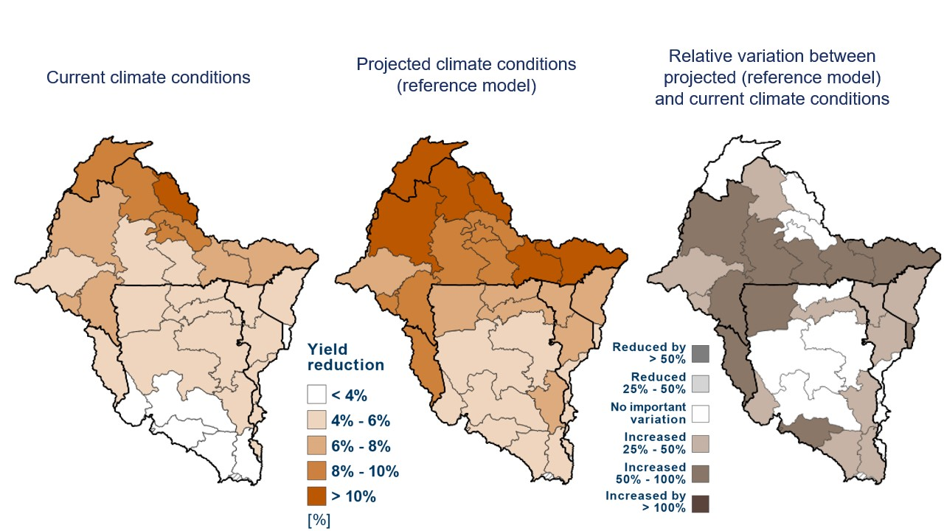Mrs. Anna MAPELLI specified that the risk indicators chosen for drought in this study are five (05) in number and they are: (i) people potentially affected; (ii) loss of agricultural yield; (iii) economic loss for agricultural production; (iv) livestock potentially affected and (v) protected areas likely to be affected. She then went through the numerical results of drought risk indicators for current and projected climate conditions in the Volta Basin through maps and graphs. The communicator clearly explained that under current and projected climate conditions, drought-induced agricultural yield losses are considered to be highest in the northern regions of the Volta Basin, particularly in Mali and Burkina Faso (see figure below). Also, under current climate conditions, the highest average annual yield loss (about 10% reduction) is observed around the Center-North of Burkina Faso as shown in the figure below.

Figure 8:Average annual agricultural yield losses

The communicator continued her presentation with question number 4 of the Quiz, namely:

* **Q4: What is the determining factor of yield reduction?**

**A: This can be any of the items below, and may differ by region.**

B: Precipitation deficit

C: Soil moisture deficit

D: High evaporation rate

The determining factor in yield reduction concerns all the elements mentioned, in particular a rainfall deficit, a soil moisture deficit and a high evaporation rate and may differ depending on the region. The other questions of the quiz were asked according to the progression of the presentation to consolidate the participants’ understanding of certain concepts, methodology and results.

* **Q5: In your opinion, what is most important to obtain a high average annual loss?**

A: A large agricultural production area

B: Variable weather conditions

C: A high average crop yield

**D: All of these factors can play a role (and their relative importance can vary by region).**

All the elements cited (a large area of agricultural production, variable weather conditions and a high average crop yield) are important in determining the amount of the average annual loss in crop production.

* **Q6: The AAL represented by the lower bar is higher than that of the brown bar at the top** (see image below), because…:

A: More people will grow corn in the future.

B: On average, farms will be more productive

C: maize prices will be higher

**D: Hydro-meteorological conditions causing yield losses (impacting drought) will occur more often.**

The AAL value represented by the lower bar is higher than that of the brown bar at the top because the hydrometeorological conditions (a precipitation deficit, a soil moisture deficit and a high evaporation rate) cause the losses. yield losses (impacting drought) will occur more often.

* **Q7: Do we consider an event that causes a loss of $4 million in the current climate conditions**(see image below), How much loss would a drought with a similar return period cause in the projected climate conditions?

A: $4 million

**B: $5.5 million**

C: $6 million

D: $7 million

* **Q8: Where are most of the severely drought affected people located (based on image below)?**

A: In cities

B: We don't know

**C: In the northern part of the Volta basin**

D: In large regions

Figure 9: Annual average number of people living in areas affected by severe drought.

* **Q9: What influences the increase in the number of people living in drought-affected areas in the future?**

A: Mainly climate change

B: Mainly population growth

**C: The interaction of the two**

D: Neither

According to the communicator, more than 4.5 million people are exposed to severe drought conditions in the current climate per year in the Volta Basin. In the projected climate conditions, there is an increase of 66% compared to the current climate conditions, i.e. more than 8 million people per year. The increase in the number of people living in drought-affected areas in the future is influenced by the interaction of climate change and population growth.

* **Q10: Which region is expected to experience a reduction in the average annual number of animals living in areas affected by severe droughts?**

**A: A region of Ghana**

B: A region of Burkina Faso

C: A region of Togo

D: No region

As illustrated in the figure below, there is only one region in Ghana expected to experience a reduction in the average annual number of animals living in areas affected by severe droughts.

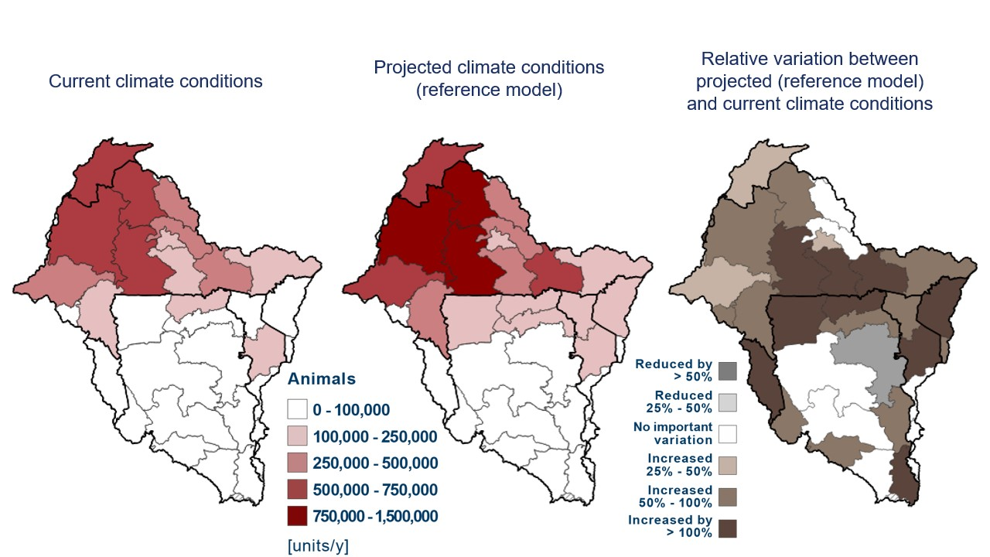

Figure 10:Livestock in drought-affected areas

Before ending her presentation, Ms. Anna MAPELLI took care to define the different types of drought, namely (i) meteorological drought which consists of a lack of precipitation; (ii) hydrological drought resulting in low river flows; and (iii) agricultural drought which involves less water in the soil than usual.

## **Session 5: Communicating the results of the Volta Basin Risk Profile**

At the beginning of this session, the participants were invited to work once again in groups with the task of preparing an "Elevator pitch" (speech in the elevator) based on the results of the flood and drought risk profile in order to convince a decision maker to take actions to reduce potential impact due to floods and drought. One participant has been chosen to play the role of the decision-maker whom the participants must convince for the organization of an emergency meeting with the Heads of State of the member countries of the Volta basin in order to increase financial resources for investments in the management and prevention of floods or drought in the said basin.

A rapporteur was chosen per group to convince the decision maker. At the end of the discussion sessions, the decision maker was very satisfied with the preparation and performance of the representatives of each group.

## **Session 6: Recommendations for policies based on knowledge of flood and drought risks**

Session 6 focused on formulating policy recommendations based on knowledge of flood and drought risks. Indeed, the process of drawing up the risk profile of floods and droughts in the Volta Basin foresees defining the recommendations, which must be integrated into the said document and which will be co-developed during the present national workshops. These recommendations focus on five important points, namely:

* integration and communication;
* preparedness and early warning;
* disaster risk reduction strategy;
* awareness and education; and
* budget allocation for risk management.

The elaboration of the recommendations was done through group exercises. The task assigned to them was broadly to develop recommendations for policies based on knowledge of the risks of floods and droughts considering that for the previous session, the representatives of each team were able to convince the decision maker to organize the meeting of the Heads of States, and assuming that the participants should also take part in it.

Specifically, the group exercise consists of:

* discuss the results of the Volta Basin risk profile and any other risk information;
* define by team at least three recommendations for policies and/or strategies taking into account basin-wide risks through a format designed for this purpose;
* present the policy recommendations formulated to the decision-maker.

The following recommendations were then formulated at the rate of three (03) recommendations per team:

* Developing Risk based Flood preparedness plan and strategy
* Developing community contingency plans for flood prone zones
* Developing risked informed spatial plans

The sheets of recommendations made by team are appended to this report (Appendix 5).

## **Session 7: Presentation of the VOLTALARM early warning system**

The presentation of the VOLTALARM early warning system based on the myDewetra platform was made by Ms. Anna MAPELLI. It is a system designed by considering the 4 pillars on which an EWS must be based, namely: (i) Knowledge of disaster risks; (ii) Detection, monitoring, analysis and forecasting of hazards and consequences; (iii) Dissemination and communication of alerts; and (iv) Preparedness and Response Capacity. VOLTALARM, being based on these pillars, therefore constitutes a support for decision-making. The system makes it possible to aggregate global and local data, to overlay information and analyze risk scenarios in real time. It also integrates IT tools for the elaboration and communication of alerts. The data integrated into the system comes from several different data providers.

The results of the Risk Profile are already integrated into the system and available for visualization. As part of the implementation of the VOLTALARM, an automatic open-hardware weather station (a pilot activity) has been set up in one locality (chosen according to the highest level of vulnerability to climate risks) per country in order to increase availability of data for monitoring hydrometeorological conditions and facilitate access to stations data throught VOLTALARM platform.

Ms. Anna MAPELLI carried out a practical phase (live demonstration) to allow participants to see how the system's data can be used from the platform (see platform homepage in figure 11). Finally, the communicator presented the system's input data (regional and global meteorological and hydrological models from various finished or ongoing projects), the user's guide and the system's integrated tools, in particular the bulletins one.

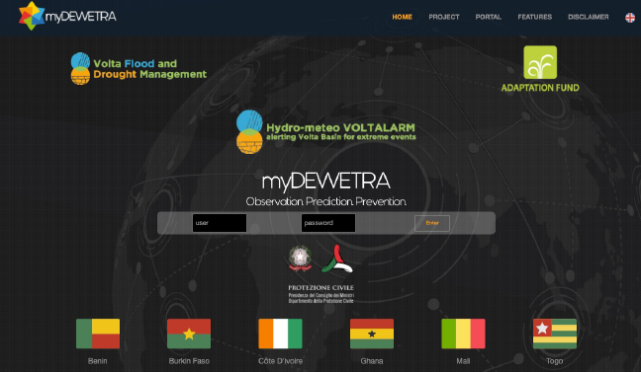

Figure 11:Overview of the myDEWETRA / VOLTALARM platform

An exchange phase closed this session and was nourished by questions and answers between the participants and the communicator.

# **Closing ceremony of the national workshop**

The closing ceremony of the workshop was chaired by Mr. Ben Ampomah. On behalf of the Minister for Sanitation and Water Resources, Mr. Ben Ampomah noted as timely the adoption of the flood and drought risk profile information of the Volta Basin and maps produced towards addressing disaster risks, preparedness and response. It is paramount to strengthen the hydrological and hydro-meteorological information systems on extreme water-related events in the Volta Basin. He called for enhanced collaboration through sharing of experiences amongst Volta Basin member states in addressing societal needs and challenges arising from climate change. He encouraged the participants that the results of this three-day national workshop could be extended beyond the Volta Basin to other disaster-prone parts of the country. Mr. Ben Ampomah expressed appreciation to partners of VFDM project notably the VBA, WMO, GWP-WA and CIMA Foundation for the continued technical and financial support. He wished all participants a safe journey back to their stations and duly closed the workshop.

# **Annex1: List of participants**

|  |  |  |  |  |
| --- | --- | --- | --- | --- |
| **N°** | **Surname & First Name** | **Email/Phone** | **Function** | **Structure/Institution** |
| 1 | OWUSU George | [georgesenyo@gmail.com](mailto:georgesenyo@gmail.com) | Technical Services Manager | CERSGIS |
| 2 | ANSAH Owusu Samuel | [ansahsamuelowusu2014@gmail.com](mailto:ansahsamuelowusu2014@gmail.com) | Principal Meteorologist | Ghana Meteorological Agency |
| 3 | ABUNGBA Ayiiwe Joachim | [joachimayiiwe@yahoo.com](mailto:joachimayiiwe@yahoo.com) | Principal Basin Officer | WRC - Black Volta |
| 4 | Dr. FOFANA Rafatou | [fofiaj2008@gmail.com](mailto:ofiaj2008@gmail.com) | Director, Volta Observatory | Volta Basin Authority |
| 5 | ASHALEY James | [ashaleyj@yahoo.com](mailto:ashaleyj@yahoo.com) | Principal Engineer | Ghana Irrigation Development Authority |
| 6 | AMPOMAH Ben | [byampomah@yahoo.com](mailto:byampomah@yahoo.com) | Executive Secretary | Water Resources Commission |
| 7 | PAINTSIL Adwoa | [adwoap@gmail.com](mailto:adwoap@gmail.com) | Director Environmental Quality | Water Resources Commission |
| 8 | DEKU Celestina | [cedkem@gmail.com](mailto:cedkem@gmail.com) | Senior Planning Officer | Landuse & Spatial Planning Authority (LUSPA) |
| 9 | ATAKORAH Georgette | [gatakorah@worldbank.org](mailto:gatakorah@worldbank.org) | Environmental Specialist | World Bank |
| 10 | BOADI Sylvester Afram | [sylvester2009gh@gmail.com](mailto:sylvester2009gh@gmail.com) | Principal Technologist | CSIR-Water Research Institute |
| 11 | QUIST Fred Ignatius | [ignatuisfredquist@gmail.com](mailto:ignatuisfredquist@gmail.com) | Contracts Manager | VRD Weija Gbawe |
| 12 | DARKO Sylvester | [slykwesi@yahoo.com](mailto:slykwesi@yahoo.com) | Head Of Hydrology | HSD |
| 13 | AYIVOR S. Jesse | [jsayivor@ug.edu.gh](mailto:jsayivor@ug.edu.gh) | Snr. Research Fellow | IESS. UG |
| 14 | ADOBOE Lee Justice | [devitor2002@yahoo.com](mailto:devitor2002@yahoo.com) | National Coordinator | GWJN |
| 15 | ASUMAN Eric | [ericuz04@yahoo.com](mailto:ericuz04@yahoo.com) | Ag. D-Gen | Gmet |
| 16 | ZIWU Lawrencia | [laurrenex@gmail.com](mailto:laurrenex@gmail.com) | P.R.O | WRC |
| 17 | LUMOR Mawuli | [tews@garid.accra.com](mailto:tews@garid.accra.com) | TEWS Accra | GARID |
| 18 | NORMAN Charlotte | [charlottenorman72@yahoo.com](mailto:charlottenorman72@yahoo.com) | Director | NADMO |
| 19 | COULIBALY Sidi | 22670234104 | Communicator | GWP-WA |
| 20 | YARO/OUEDRAOGO Aguiratou | 22665272165 | Finance & Admin Manager | GWP-WA |
| 21 | MUALA Eric | [ericmuala25@gmail.com](mailto:ericmuala25@gmail.com) | Principal Monitoring Officer | WRC |
| 22 | BOATENG-GYIMAH Maxwell | [boatgyimax2@gmail.com](mailto:boatgyimax2@gmail.com) | Executive Secretary | CWP-GH |
| 23 | ASAMOAH Godfred | godfredasamoah19@yahoo.com | Environmental Quality Officer | WRC |
| 24 | Dr. OFORI D. Benjamin | [bdofori@staff.ug.edu.gh](mailto:bdofori@staff.ug.edu.gh) | Senior Research Fellow | IESS. UG |
| 25 | AGGREY James | [jamgrey04@yahoo.com](mailto:jamgrey04@yahoo.com) | Engineer | WRC |
| 26 | LOGAH Frederick Yaw | [logahfy@yahoo.com](mailto:logahfy@yahoo.com) | Senior Research Scienntist | WRI |
| 27 | OTOO James Oppong | [oppongkyekyekuotoo@gmail.com](mailto:oppongkyekyekuotoo@gmail.com) | Senior Disease Control Officer | NADMO |
| 28 | WEMAKOR Joseph | [wemakorj@gmail.com](mailto:wemakorj@gmail.com) | Executive Com | GNDR |
| 29 | DWUMAH Nicholas | [kofidwumah72@gmail.com](mailto:kofidwumah72@gmail.com) | Principal | ANYLPSD |
| 30 | SARFO-ADU Gordon | [gsarfoadu@gmail.com](mailto:gsarfoadu@gmail.com) | Corporate Planning Manager | FORESTRY COMMISSION |
| 31 | DENKYIE K. Michael | [denkyiemichael74@gmail.com](mailto:denkyiemichael74@gmail.com) | CCA/DRR | NADMO |
| 32 | OSEI BARIMAH Edmond | baripharma@yahoo.com | Drainage &  Sewage Engineer | HSD |
| 33 | HLORBU Patricia Etornam | [etornam422@gmail.com](mailto:etornam422@gmail.com) | Public Relations | WRC |
| 34 | LAMPTEY Mary | 0243135630 | Admin Asst. | CWP-GH |
| 35 | TOAH Edward Kwame | 0277700403 | Driver | WRC |

# **Annex2: National workshop agenda**

|  |  |  |
| --- | --- | --- |
| **Day 1** | | |
| **Time (GMT)** | **Description** | **Responsible** |
| 8:30 am - 9:00 am | **Reception of participants / logistical details** | VFDM Team |
| 9:00 am - 9:30 am | **Opening session** | National Minister of the host country, VBA, WMO, CIMA, VFDM Team |
| 9:30 am - 10:30 am | **Introductory session (participants and workshop presentation)** | VFDM team |
| 10:30 am - 11:00 am | **Family photo and coffee break** |  |
| 11:00 am - 1:00 pm | **Session 1: Introduction to Disaster Risk Assessment, Risk Components and Probabilistic Risk Assessment** | CIMA trainers + VFDM team |
| 1:00 pm - 2:00 pm | **Lunch** |  |
| 2:00 pm - 3:30 pm | **Session 2: Understanding Flood Risk profile** | CIMA trainers + VFDM team |
| **Day 2** | | |
| **Time (GMT)** | **Description** | **Responsible** |
| 8:30 am - 9:00 am | **Welcoming participants and quick recap** | CIMA + VFDM Team |
| 9:00 pm - 10:30 pm | **Session 3: Understanding Flood Risk profile** | CIMA trainers + VFDM team |
| 10:30 am - 11:00 am | **Coffee break** |  |
| 11:00 am - 1:00 pm | **Session 4: Risk informed policies’ recommendations for floods** | CIMA trainers + VFDM team |
| 1:00 pm - 2:00 pm | **Lunch** |  |
| 2:00 pm – 3:30 pm | **Session 5: Understanding Drought risk profile** | IVM / CIMA trainers + VFDM team |

|  |  |  |
| --- | --- | --- |
| **Day 3** | | |
| **Time (GMT)** | **Description** | **Responsible** |
| 8:30 am - 9:00 am | **Welcoming participants and quick recap** | CIMA + VFDM Team |
| 9:00 pm - 10:30 pm | **Session 6: Risk informed policies’ recommendations for droughts** | IVM/CIMA trainers + VFDM team |
| 10:30 am - 11:00 am | **Coffee break** |  |
| 11:00 am - 1:00 pm | **Session 7: Risk informed regional strategies recommendations** | CIMA trainers + VFDM team |
| 1:00 pm - 2:00 pm | **Lunch** |  |
| 2:00 pm – 3:00 pm | **Session 8: VOLTALARM presentation** | CIMA trainers + VFDM team |
| 3:00 pm – 3:30 pm | **Workshop closing session** | VFDM team |

# **Annex3: Recommendations of the workshop formulated by team**

|  |
| --- |
| **Policy Recommendation 1** |
| Developing Risk based Flood preparedness plan and strategy |
| **Main Goal description** |
| Flood control structures  Set up Special Purpose Vehicle for raising funds  Early warning system and dissemination for floods  Strengthen the institutional capacity  **Objectives:**   1. To reduce the impacts of floods to populations in the Volta Basin 2. Build resilience of affected communities to reduce economic losses |
| **Target groups** |
| NADMO  Gmet  Gender Departments  Basin Authorities  Communities  DA/MMDAs  Researchers |
| **Risk profile indicators and/or other existing risk information** |
| Average number of populations affected  Average annual losses for the built up area |
| **Responsible institutions:** |
| NADMO, Basin Agencies/Authorities, WRC |
| **Policy Recommendation 2** |
| Developing community contingency plans for flood prone zones |
| **Main Goal description** |
| Creation of alternative livelihood interventions  Establishment of community contingency funds  Early warning systems |
| **Target groups** |
| NADMO  Basin Authorities  Communities  DA/MMDAs  CBOs |
| **Risk profile indicators and/or other existing risk information** |
| Over 16ha of crop land affected annually  Average number of populations affected |
| **Responsible institutions:** |
| MMDAs  NADMO  WRC  NGOs  CBOs |

|  |
| --- |
| **Policy Recommendation 3** |
| Developing risked informed spatial plans |
| **Main Goal description** |
| Creation of buffer zones  Creation of flood retention areas  Recommended building materials for flood prone areas |
| **Target groups** |
| Communities  GIDA  WRC |
| **Risk profile indicators and/or other existing risk information** |
| Protected areas affected |
| **Responsible institutions:** |
| MMDAs  NADMO  WRC  NGOs  CBOs |