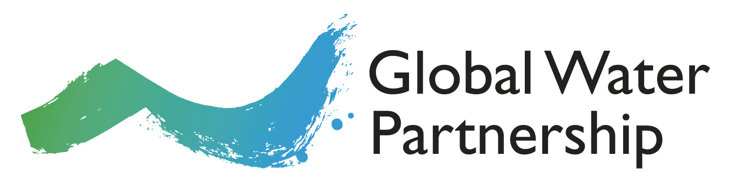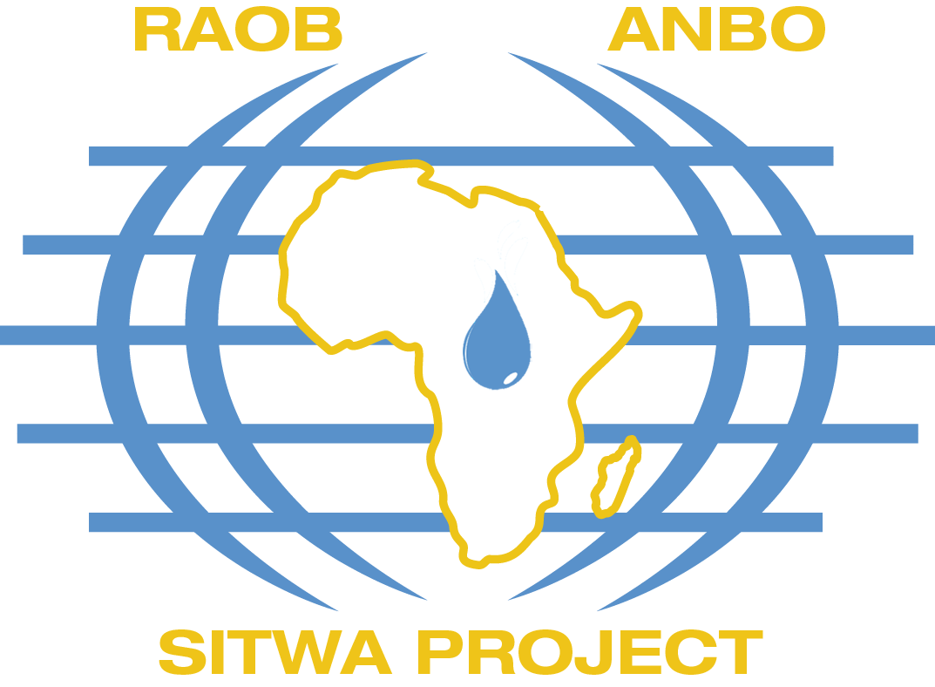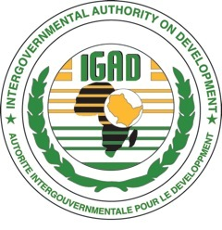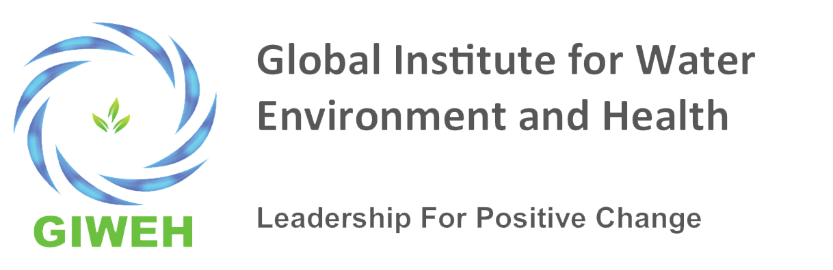

Regional Training in International Water Law (IWL)
for improved transboundary water management in Africa
(5-11 June 2017)

Application form

- PERSONAL DETAILS

Surname/family name..………………………………………………………..Sex………………………………….

First name(s)/Given name(s)………………………………………………………………………………………….

Title: Mr/Mrs/Miss/Ms/Dr…………………………………………………….Date of birth…………………..

Address………………………………………………………………………………………………………………………….

Telephone number: (incl. country and area code) …………………………………………………….

E-mail: …………………………………………………………………………………………………………………………..

Nationality………………………………… Passport number………………………………………………………

Country of issue……………………………………… Valid Until: …………………………………………………

- EDUCATION
Mention only degree education
College/University attended | From (mm/yy) | To (mm/yy) | Title of degree awarded | Result
- EXPERIENCE
Mention only 4 latest jobs
Employer | From (mm/yy) | To (mm/yy) | Position

To consider your application, it is much appreciated if you would kindly answer the following questions:
- Briefly describe the institution you currently work for (type of organization, mission, vision, objectives)
------------------------------------------------------------------------------------------------------------------------------------------------------------------------------------------------------------------------------------------------------------------------------------------------------------------------------------------------------------------------------------------------------------------------------------------------------------------------------------------------------------------------------------------------------------------------------------------------------------------------------------------------------
- Do you have any responsibilities related to management of water resources in basins/aquifers in your country and / or neighbouring countries? Give a brief description.
------------------------------------------------------------------------------------------------------------------------------------------------------------------------------------------------------------------------------------------------------------------------------------------------------------------------------------------------------------------------------------------------------------------------------------------------------------------------------------------------------------------------------------------------------------------------------------------------------------------------------------------------------
- How is the current training in IWL relevant to your present work, and why would you like to participate in the training?
---------------------------------------------------------------------------------------------------------------------------------------------------------------------------------------------------------------------------------------------------------------------------------------------------------------------------------------------------------------------------------------------------------------------------------------------------------------------------------------------------------------------------------------------------
- Have you attended any similar training programme(s) in IWL or water legislation before? If yes, please specify
Where……………………………………………………………………………………………………………………………
When…………………………………………………………………………………………………………………………….Theme of the training………………………………………………………………………………………………
- Write a summary of max 150 words of the case study you intend to share during the training (see guidance note below).
……………………………………………………………………………………………………………………………………………………………………………………………………………………………………………………………………………………………………………………………………………………………………………………………………………………………………………………………………………………………………………………………………………………………………………………………………………………………………………………………………………………………………………………………………………………………………………………………………………………………………………..
- In your position, how would you influence decision making within your institution/ministry/agency and / or contribute to better management of water on issues related to transboundary water resources?
------------------------------------------------------------------------------------------------------------------------------------------------------------------------------------------------------------------------------------------------------------------------------------------------------------------------------------------------------------------------------------------------------------------------------------------------------------------------------------------------------------------------------------------------------------------------------------------------------------------------------------------------------
- How does your workplace support your participation for the training in IWL?
-------------------------------------------------------------------------------------------------------------------------------------------------------------------------------------------------------------------------------------------------------------------------------------------------------------------------------------------------------------------------------------------------------------------------------------------------------------------------
Please check the type of participation you request:
A. Fully self-sponsored.
B. Partial sponsorship: Workshop costs and per diem during the 7-day workshop (breakfast, lunch and coffee) covered by the organisers
C. Partial sponsorship: Accommodation, workshop costs and per diem during the 7-day workshop (breakfast, lunch and coffee) covered by the organisers.
D. Full sponsorship: Flight ticket, accommodation, workshop costs and per diem during the 7-day workshop (breakfast, lunch and coffee) covered by the organisers

Please indicate which institution is recommending you for the training
------------------------------------------------------------------------------------------------------------------------------------------------------------------------------------------------------------------------------------------------------------------------------------------------------------------------------------------------------------------
I hereby certify that the information contained herein is truthful and authorize the selection committee to verify its accuracy.

Signature: _________________________

Place and date: _______________________
Guidance note for the development of Case Studies
The case studies provide an opportunity for peer-to-peer learning amongst the participant. Each case study should illustrate an example of how international law relating to transboundary waters (rivers, lakes and aquifers) has been, or might be, applied within a given context. These case studies may show a successful example of how international law has been put into practice, or they may show some of the difficulties in applying the rules and principles of international law within a particular context.
The case studies might deal with one or more of the following:
- Experiences in transboundary water conflict and cooperation in Africa
- Evolution of international water law in Africa
- Regional approaches to transboundary water resources in Africa, e.g. SADC, EAC, ECOWAS, IGAD.
- Definitions and scope in treaty arrangements, e.g. is there ambiguity or disagreements over terminology such as the drainage basin, water security, river vs aquifers, IWRM, ecosystem approach, etc.?
- Substantive norms, e.g. how have/might key principles such as equitable and reasonable utilization, no significant harm, protection of ecosystems and prevention of pollution be applied in practice?
- Procedural rules, e.g. how have/might rules relating to notification and consultation on planned measures, data and information exchange, joint monitoring, stakeholder engagement be applied in practice?
- Institutional arrangements, e.g. what is/might be the role of river basin organizations, how efficient and effective have such institutions been in a particular context, what role and functions have they performed?
- Dispute settlement mechanisms, e.g. how have past disputes been resolved, or how might potential disputes be resolved? Have different dispute settlement mechanisms been used and to what effect, e.g. negotiation, conciliation, mediation, 3rd party fact-finding/expert panels, arbitration and adjudication?
- Implementing international water law through domestic legislation, e.g. to what extent have national laws been harmonized with transboundary commitments? Are there inconsistencies between international water law and national legal and institutional arrangements/ capacity?

The case study proposal will be 150 words max. Successful applicants will then be asked to develop case studies of 3-5 pages, which will be submitted for comment prior to the start of the training. The revised case studies will then be presented during the training, and refined based on comments received from the facilitators and fellow participants. Each of the participants must be willing to share the case studies online via, e.g., the GWP Toolbox website.

