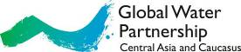

Global Water Partnership Central Asia and Caucasus (GWP CACENA)

Asia
Report
September 2013
Contents
Section 1: GWP CACENA Regional Secretariat 2
Section 2: CWP-Armenia 4
Section 3: CWP-Kyrgyzstan 5
Section 4: CWP-Turkmenistan 7
Section 5: CWP-Uzbekistan 9
Section 6: CWP-Georgia 10
Section 7: CWP-Kazakhstan 13

Section 1: GWP CACENA Regional Secretariat
Chuncheon Global Water Forum
Mr. Vadim Sokolov, GWP CACENA Regional Coordinator, participated in the Chuncheon Global Water Forum held on 11-14 September 2013 in the South Korea. This Forum is being organized annually since 2005 with the support of the Korean government in the city of Chuncheon, South Korea. It was a working visit within cooperation between the GWP CACENA, SIC ICWC and the Global Green Growth Institute (GGGI).
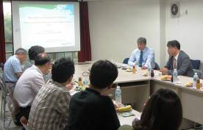
On September 11, there was held a working meeting with a group of experts and researchers of the Korean Institute of Construction Technologies - KICT (www.kict.re.kr). At the request of the KICT, Vadim Sokolov did a presentation for the staff of the Institute on three issues:
- overview of the water problems in Uzbekistan;
- ideology and content of the information system for the water sector in Uzbekistan;
- monitoring of water resources, and information support by UzHYDROMET.
Following the presentations, consultations with the leaders of KICT (Mr. Kim Hyeonjun, Director of the Research Department of Water Resources and the Environment, and Mr. Kim Kyung-Tak, Leading Researcher of the Research Department of Water Resources) were held. KICT showed interest in developing cooperation with GWP CACENA and the Ministry of Agriculture and Water Resources of Uzbekistan (MAWR) within a joint project on information system for MAWR of Uzbekistan. There were agreed the following practical steps for the implementation of the joint project:
1. Preparation of the detailed proposal ( in the form of feasibility studies ) on development of information system for the Ministry of Agriculture and Water Resources of Uzbekistan by GWP CACENA, SIC ICWC and KICT jointly ( October 2013 - January 2014 ).
2. Visit of a group of KICT experts to Uzbekistan (February 2014) to coordinate the development of the information system feasibility study with the leaders of MAWR Uzbekistan and signing of a memorandum of cooperation in the framework of the joint project.
3. Transfer of feasibility study through the Embassy of Uzbekistan in Korea to the Korea International Cooperation Agency (KOICA) for funding.
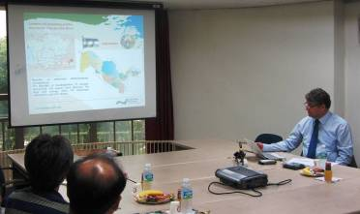
On September 12-13, Vadim Sokolov took part in the Chuncheon Global Water Forum. At the session "Transboundary Water Management and Cooperation", Dr. Sokolov made a presentation "Framework for Water Security in the Aral Sea Basin - the results of survey carried out by SIC ICWC and GWP CACENA with GGGI", and then he also took part in a panel discussion at the "Water for Global Community."
Special attention should be paid to presentation "Opportunities for harmonized cooperation in transboundary rivers" by Le Ti Huu, Director of the Water Security Center in University of Hanoi, Vietnam. He convincingly showed that cooperation in transboundary basins may be based on the principles of the UN Convention, 1997, as it was done in the Mekong River Basin. Especial spirit of cooperation based on mutual respect for all parties was created in the Mekong Basin. The strategic elements of the "Mekong spirit" are as follows:
- Sharing the vision of co-operation
- Mutual understanding
- Mutual trust
- The primary objective of cooperation is a River of prosperity
The main idea of presentation is that if you want to achieve harmonious cooperation then no need to focus on the problems of water it-self. It should be focused on the coordination aspects of economic and social welfare within the shared river basin. Water problems are linked to socio-economic areas of cooperation through coordination mechanisms for more effective management and water governance based on the principles of the 1997 UN Convention. Dr. Ti showed the evolution of the aspects of cooperation in the Mekong Basin: in the 1950s and ‘70s, the emphasis was on the control of floods, and the development of agriculture; in the period 1980-2000 the main problem was to link the interests of agriculture, hydropower, fisheries and navigation; and after 2000 - a basis of cooperation was the strategic planning for economic growth, as well as the IWRM implementation and conflict resolution tools. Under present conditions it is easier to attract investments for water sector not directly, but by "dressing" them into economic and green growth ideas.
On September 14, Dr. Vadim Sokolov held consultations with Dr. Hong Il Pyo, Project Coordinator of the GGGI. They discussed the issues of cooperation between GGGI and SIC ICWC and GWP CACENA, particularly in two areas that were identified during the visit of Mr. Hong to Tashkent in July 2013: further definition of regional strategy for the Aral Sea Basin - "Water and Green Growth" - and the possibility to support the Russian-speaking network of INBO-EECCA.

Dr. Hong informed that in the leadership of GGGI there were major changes occurred, and the priorities of the work program of the Institute were changed accordingly. The new leaders didn't approve the idea to support the Russian-speaking network of INBO-EECCA. On the other hand, the leaders of GGGI intend to continue work on the development of a regional strategy for the Aral Sea Basin - "Water and Green Growth" - and to mobilize some financial resources for this in 2014. Concerning this the GGGI leaders have considered the fact that this project has been marked as a priority by the new Chair of the Executive Committee of IFAS, Mr. Khamrayev Sh.R., during his meeting with Mr. Hong in July, in Tashkent.
It was agreed that up to the end of October 2013, GGGI (Dr. Hong) will introduce a new template for submitting a proposal for funding of the project. During November, GWP CACENA and SIC ICWC will provide according this form the rationale for the project to develop a regional strategy for the Aral Sea Basin - "Water and Green Growth" - to be considered for allocation of adequate funding in 2014.
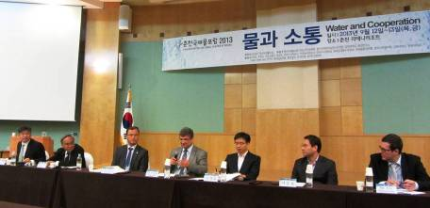
Vadim at the discussion panel on transboundary cooperation at the Chuncheon Global Water Forum in Korea

Section 2: CWP-Armenia
Preparing and conducting the training on water for schools
The five-day training for the senior schools was prepared aimed to raise awareness of senior high school students, to inform them about water challenges and involve into water resources management process.
The following themes were considered:
- Need and importance of water resources protection for existing and future generations.
- Water quality indicators: physicochemical and biological monitoring. The world day of water monitoring.
- Integrated impact on watershed.
- Human right to pure water and sanitation.

The training was conducted in the school named Hamo Sahyan in Erevan.
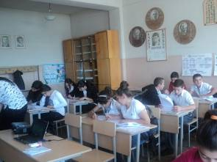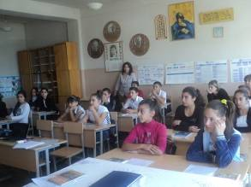
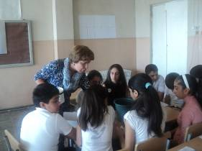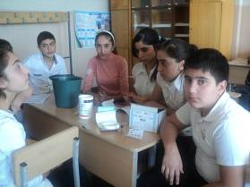
All the training students received training materials and certificates. CWP-Armenia actively participates in the development of strategy on sustainable sanitation for Armenia within OSCD project "Towards development of national strategy on sustainable sanitation in Armenia".

Sub-regional youth forum
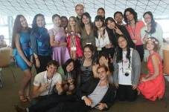
On 19-21 August 2013, in Vladivostok, CWP-Armenia took part in the Sub-regional youth forum on implementation of RIO+20 decisions. This forum was organized by the Far East Federal University together with ESCATO for Northern and Central Asia and for Eastern and North-Eastern Asia under support of the Federal Agency on Youth Affairs, the Ministry Education and the Ministry of Foreign Affairs of Russian Federation.

Section 3: CWP-Kyrgyzstan

The National Workshop on International Water Law in Kyrgyzstan
The National Workshop on International Water Law was organized under the UNECE support in the health resort "Aurora" near the Issyk-Kul Lake on 12-13 September 2013 in Kyrgyzstan. Mr. Djailoobaev, Representative of CWP-Kyrgyzstan, took part at the workshop, where he made a presentation "Transboundary Water Cooperation in Kyrgyzstan".
The seminar was attended by representatives of state authorities on water resources use (water managers, environmentalists, MFA, the Hydrometeorological service, UNECE, as well as the international experts on water law, etc.). Four colleagues from the Ministry of Water Resources of Tajikistan were also invited.
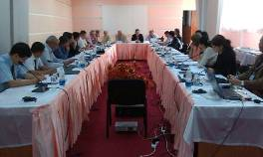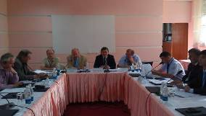

UNDP Roundtable on development of GEF water projects in Kyrgyzstan
The CWP-Kyrgyzstan representatives took part in the UNDP Roundtable on developing the GEF water projects on 17 September 2013 in Bishkek, Kyrgyzstan.
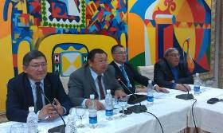
This roundtable was aimed to bring experts together for consulting on two projects that are financed by GEF and will be implemented by the UNDP national offices:
- Capacity building of the countries in the transboundary Syrdarya river basin to sustainable use of groundwater and mineral resources, taking into consideration of climate variability and change.
- Facilitating transboundary cooperation and integrated water resources management in the Chu-Talas river basins.

First Workshop “River Basin Commissions and Other Joint Bodies for Transboundary Water Cooperation: Legal and Institutional Aspects” & Eighth meeting of the Working Group on Integrated Water Resources Management
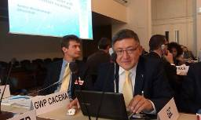
Recognizing the importance of exchange of experience on the establishment and functioning of joint bodies, the Parties to the Water Convention have included in the Work Programme for 2013-2015 two workshops to promote the exchange of experience and good practices between joint bodies worldwide and to draw lessons learned and recommendations.
The First Workshop was organized on 23 and 24 September 2013, back-to-back with the eighth meeting of the Water Convention's Working Group on Integrated Water Resources Management (25 and 26 September 2013) in Geneva, Switzerland.
Mr. Djailoobaev, Representative of CWP-Kyrgyzstan, took part at these two events.
The First Workshop convened in the International Year of Water Cooperation aims to highlight opportunities and inspire effective practices/solutions in advancing the legal and institutional frameworks and tools for transboundary water cooperation through the exchange of experience and cross-fertilization within existing joint bodies, as well as to support the emergence of new joint bodies for transboundary water cooperation.
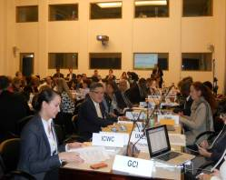
It is also intended to contribute to the establishment of cooperation and to provide a forum for networking between different joint bodies from across the world, and to build capacity for their effective functioning.
The main objective of the meeting of the Working Group on Integrated Water Resources Management is to review the implementation of the Work Programme for 2013–2015.

Section 4: CWP-Turkmenistan

CWP-Turkmenistan collaborates with the Programme "Transboundary water management in Central Asia"

Mrs. Guljamal Nurmukhamedova, Chair of CWP-Turkmenistan, took part in the series of national workshops on Basin Planning organized for the representatives of various national organizations and their branches within the following programme themes:
1. Legislation for basin planning. Available legislative mechanisms.
2. Institutional framework for basin planning: the basin organizations as a base for IWRM principles implementation.

3. Participation of stakeholders. Definition and mechanisms for stakeholder involvement.
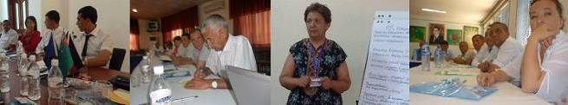
National workshops on IWRM in Dashoguz, Mary and Turkmenabad. August, 2013
В ходе семинаров слушатели из числа государственных служащих были ознакомлены с перспективами и юридической основой для партнерства государственных ведомств и общественных организаций.

Collaboration with the Regional Environmental Centre for Central Asia (CAREC)
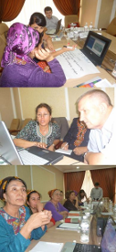
CWP-Turkmenistan took part in the 1st consultative meeting "Green Pack” for Central Asia as a tool for promotion of water issues in the secondary education in Turkmenistan" held on 29 August 2013 in Ashgabat. The "Green Pack" is a multimedia resource for environmental education for teachers of secondary schools and their schoolchildren. At the same time this tool can be used at various educational levels. It is oriented to study various aspects of environment protection and sustainable development.

The workshop was attended by representatives of the following organizations:
- Ministry of Environment Protection of Turkmenistan;
- Institute for teachers advanced training;
- National institute of deserts, flora and fauna of the
Ministry of nature protection of Turkmenistan;
- some secondary schools of Turkmenistan;
- international agencies and projects;
- national and international NGOs;
- environmental business.
The main aim of this meeting was to present the "Green Pack" multimedia educational resource for Central Asia that was developed by the Regional Environmental Centre for Central Asia and by the Regional Environmental Centre for Central and Eastern Europe, and to demonstrate advantages of interactive education for school children aged 11-15.

Specific tasks of this meeting were as follows:
- to acquaint participants with the multimedia educational resource;
- to discuss its use in the educational sphere in Turkmenistan;
- to discuss prospective progress and promotion of this educational resource in Turkmenistan.
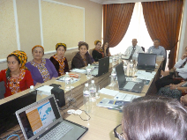
Special session dedicated to water issues and potential role of "Green Pack" in Turkmenistan was held by Mrs. Guljamal Nurmukhamedova.
The "Green Pack" educational resources is planned to be tested in October-November 2013. The series of information workshops on water themes for school teachers are planned to be held too. Because this resource is oriented to study priority issues of the Caspian Region, Kazakhstan and Central Asia as a whole (water resources, desertification, biodiversity, mountains and glaciers, energy efficiency, climate change, seas and oceans, soil, etc.) and could contribute to Green Growth, Mrs. G. Nurmukhamedova believes that such a work can be financed by GWP CACENA (because up today there are no another available financial resources).

Study tour to Tbilisi

Following the regional forum on energy efficiency in the framework of the project "The Mayors-East Agreement", the representatives of Central Asia and Caucasus who signed the Mayor Agreement visited Tbilisi (Georgia).

Начало формы

Section 5: CWP-Uzbekistan
Two roundtables on IWRM implementation and GWP role
On 8 September 2013 in Samarkand, CWP-Uzbekistan has organized a roundtable dedicated to raising awareness on GWP and CWP-Uzbekistan activities related to IWRM implementation. The roundtable was attended by partners of CWP-Uzbekistan and by authorities of water management, municipal and water supply service of Zerafshan River Basin. The students (future Masters of water management) from the Samarkand Agricultural Institute and the Samarkand State Institute on Architecture and Construction were also invited.
The roundtable's aims were:
- to ensure progress in the Work Program implementation and the Plan of Activity by the national groups - partners of CWP-Uzbekistan;
- to increase number of the GWP CACENA partners;
- to involve partners into the CWP-Uzbekistan activity;
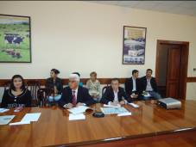
- to promote IWRM principles and principles of GWP, as well increase awareness on activity of GWP, GWP CACENA, CWP-Uzbekistan.
Participants proposed to raise awareness about GWP Strategy and ways for its implementation. The water supply managers suggested ways for cooperation on climate change adaptation and on supply with pure drinking water for urban population. Conditions for water resources management should be improved. This opens possibilities to broaden IWRM implementation. Total: 31 participants.
The 2nd roundtable was organized to bring together the water users of the Agricultural Sector, who participate in the Rural Enterprise Support Project, for exchange of practice and information on IWRM implementation. It was concluded that cooperation with water users is needed to use their experience for improving IWRM implementation. And that the partners of CWP-Uzbekistan should cooperate with local municipal body on creating the regulations for control of water resources allocation.

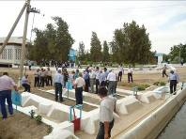
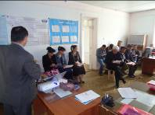

Section 6: CWP-Georgia

Strategic Action Plan (SAP) and National Integrated Water Resources Management Plan (IWRM) Presentation

Discussion of Strategic Action Plan/Proframme prepared within UNDP/GEF project "Reducing transboundary degradation in the Kura Ara(k)s River Basin" was held on 16 September 2013, at the UNDP Georgia Country Office in Tbilisi.

The Strategic Action Plan/Proframme (SAP) for the Kura River Basin is a Guideline developed to support regional countries in sustainable management of water resources and improvement of integrated water resources management (IWRM). SAP contains outcomes and measures at the regional level that reflect national and transboundary priorities. These measures correspond to the Basin Vision and Ecosystem Quality Goals (EQG).

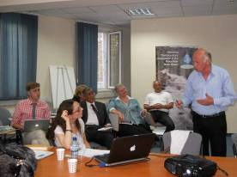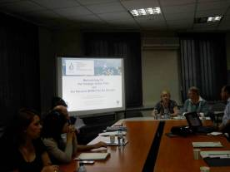

SAP includes 4 EQGs and 10 outcomes to implement these goals including "Coordinated adaptation to climate change". CWP-Georgia informed participants about the GWP CACENA project. CWP-Georgia intends to collaborate very closely with the UNDP/GEF EQG-10 project. Total: 25 people.

International Conference on Energy for Sustainable Development
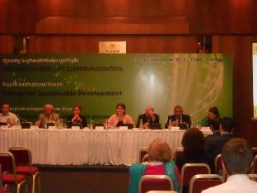
The International Conference on Energy for Sustainable Development was held in the Conference Hall at the Sheraton Metekhi Hotel on 17-19 September 2013 in Tbilisi. CWP-Georgia was invited to participate. This Conference was organized by UNECE and the Ministry of Economy and Sustainable Development of Georgia.
This conference was useful for CWP-Georgia because its activity relates to development of the Sustainable Development Plan for Georgia. CWP-Georgia is going to participate in the event on land use issues in October in Geneva.

Environment Action Programme Task Force: 2013 annual meeting
CWP-Georgia participated in the meeting of the Environment Action Programme (EAP) Task Force that took place on 17-18 September 2013 in Tbilisi, Georgia. This meeting marked the 20th anniversary of the EAP Task Force and of OECD’s support for its work. The nature of work has evolved considerably over the years and is now focused on environment-related co-operation with countries of Eastern Europe, Caucasus and Central Asia. The discussion was built around two main components of the EAP Task Force’s programme of work: green growth policies, with a focus on fossil fuel subsidies, and water policy reform, particularly the linkage to green growth.
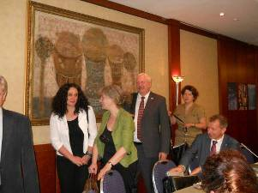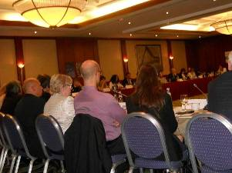

2nd Regional Meeting of Organizing Committee of International Project "Environment Protection in the International River Basins"

The 2nd Regional Meeting of Organizing Committee of International Project "Environment Protection in the International River Basins" was held on 18-19 September 2013 in the Sheraton Metekhi Palace. CWP-Georgia participated in this meeting.

The International Project "Environment Protection in the International River Basins" is being implemented in the following countries: Armenia, Azerbaijan, Belarus, Georgia, Moldova and Ukraine.

Participants were informed about project goals and results achieved during the reporting period from February to July 2013.

CWP-Georgia closely collaborates with this project within the Policy Dialogues on IWRM. CWP-Georgia participated in the development of new water law that is being discussed nowadays.

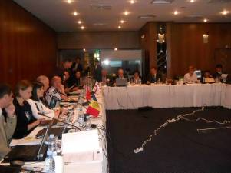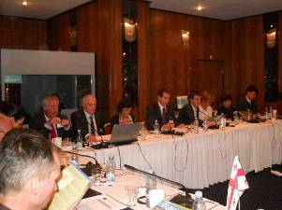

First Workshop “River Basin Commissions and Other Joint Bodies for Transboundary Water Cooperation: Legal and Institutional Aspects” & Eighth meeting of the Working Group on Integrated Water Resources Management
(See Section 3) CWP-Georgia participated in these two events
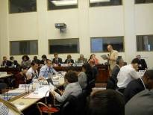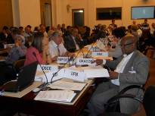

Institutionalizing of Adaptation to Climate Change and Impact Mitigation in Georgia regions
The Working Meeting within the project "Institutionalizing of Adaptation to Climate Change and Impact Mitigation in Georgia regions" took place on 24-25 September 2013 in the Conference Hall at the Holiday Inn. Hotel in Tbilisi. The project is being implemented in Russia and Eastern Europe within the EU Eastern Partnerships. The Climate Policy was discussed during the meeting. CWP-Georgia took part in this meeting as a partner of the above mentioned project.

Training for officials
On 29-30 September 2013, the National Association of self-government organizations of Georgia organized a training for officials within the project "Institutionalizing of Adaptation to Climate Change and Impact Mitigation in Georgia regions" in the "Ambasadori" Hotel in Kachreti settlement.
The representative of CWP-Georgia (Mrs. Nino Chkhobadze) was invited as a trainer. Participants were informed about legislative aspects of climate changes and 2nd report on climate changes as well as about the GWP Water and Climate Programme.
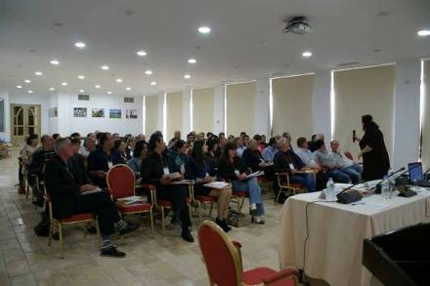

Section 7: CWP-Kazakhstan
The Working Meeting with local partners
CWP-Kazakhstan organized the working meeting on the project "Drought Risk Management: IWRM as a decision on regulation of water demand in irrigated agriculture". Mrs. Yakhiyaeva had a business trip to the Kzylordinskaya oblast. The working meeting of project executors was held on 6 September 2013.
2nd meeting of the EU-CA working group on Climate Change and Strategic Planning of Nature Management
CWP-Kazakhstan took part in the 2nd meeting of the EU-CA working group on Climate Change and Strategic Planning of Nature Management that was held on 13-14 September 2013 in Almaty.
Interview to the Kazakhstan TV channel "Khabar"
Mr. Nariman Kipshakbaev, Chair of CWP-Kazakhstan, gave an interview about drought for the future documentary - "Drought".

Member Countries of GWP CACENA:
Azerbaijan, Armenia, Georgia, Kazakhstan, Kyrgyzstan, Tajikistan, Turkmenistan, Uzbekistan

