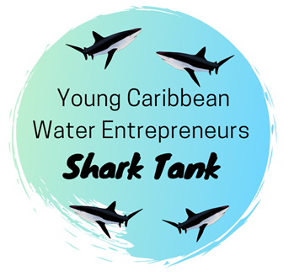

Water Project Proposal Template

The following project proposal template must be completed by all applicants in the Global Water Partnership-Caribbean (GWP-C) Young Caribbean Water Entrepreneurs Shark Tank Competition. The finished proposal template must be submitted along with a 2 – 3 minute video pitch (Refer to pitch guidelines) to gwp.caribbean@gmail.com by Saturday, August 31st, 2019 at midnight (Atlantic Standard Time). All applications (proposal and video) must be in English.

Section 1: Applicant Information
Please provide the requested information below. Note: If two (2) persons are part of a submission, each person must include their applicant information.

Applicant 1

Name of Applicant:
Nationality:
Country of Residence:
E-mail Address:
Phone Number:
Current Age:
Current Place of Employment & Position:

Applicant 2 (If Applicable)

Name of Applicant:
Nationality:
Country of Residence:
E-mail Address:
Phone Number:
Current Age:
Current Place of Employment & Position:

Section 2: Project Proposal
Please complete all required information in the project template below.

- Project Title:

- Complete the following details on the project:

Project Type: (Select one that applies below)

New Project

Ongoing Project

Main Location of Project Implementation: (State the community and country/Whether the project is or will be regional)

If you selected “Ongoing Project” please state, the start date of the project:

- Describe the project: (do not exceed 800 words)

Please ensure that the project description includes:

- The goals and objectives of the project.
- The foreseeable beneficiaries of the project and why it will be important to them.
- Potential for replication and scaling of the project.

- Select the competition theme under which your project falls: (more than 1 theme can be selected if applicable)

Water and Climate

Water and Agriculture

Water and Health

Water and Energy

Water and Tourism

- What challenge is your project addressing? Why is this important to you? (do not exceed 1000 words)

- How is your project going to solve the challenge? – (do not exceed 500 words)

- How is your project different from existing or trending solutions? (do not exceed 400 words)

- Project Team Information: (provide brief responses to the questions below)

Give a short description of the member/s of the project team including their age and experience?

Are there any foreseeable partners for implementing the project? (If applicable please identify them)

- Implementation Framework: (do not exceed 600 words)
- List key activities to be carried out.
- Include timelines for implementation of the key activities or phases of the project.
- Include roles and responsibilities of the team and partners in project implementation.

- How will key activities to be implemented, lead to intended outcomes? (Answer this question using the logframe below)

LOGFRAME
ACTIVITIES | OUTPUTS | OUTCOMES | MEANS OF VERIFICATION

- Budget: (Provide an overall budget of the project not exceeding 400 words)

- If applicable, provide links to existing information and material related to the project?
(Example: website, video, crowdsourcing link, articles, blog posts etc.)

If you have completed this project template, we thank you for being inspired to be a part of the first-ever GWP-C Young Caribbean Water Entrepreneurs Shark Tank Competition.

