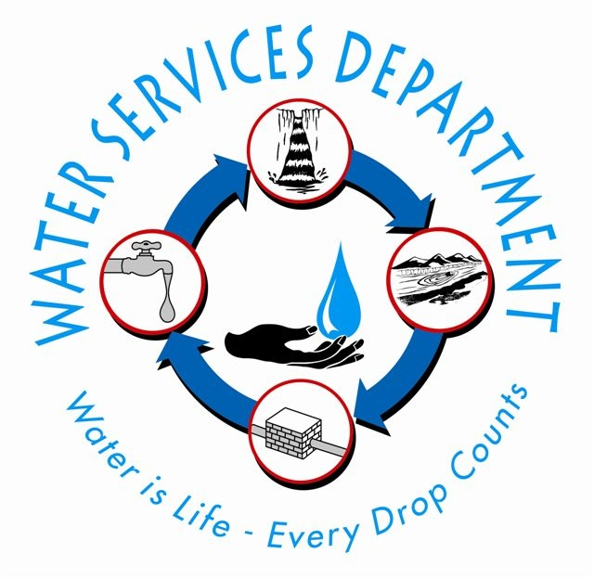


ST. KITTS WATER SERVICES DEPARTMENT
Ministry of Energy, Public Works, Housing and Public Utilities

“Water Is Life-Every Drop Counts”

FOR IMMEDIATE RELEASE March 13, 2013

World Water Day 2013 – Water Cooperation

The Water Services Department is hosting a week of activities to celebrate World Water Day, which is held annually on March 22nd as a means of focusing attention on the importance of freshwater and advocating for the sustainable management of freshwater resources. The staff of the department will be engaging the community by visiting schools, both primary and secondary, appearing on radio and TV, hosting a meet and greet event at the Circus on Friday, March 22 from 11 AM to 5PM as well as facilitating a guided hike to the Wingfield water source on Saturday, March 23 from 7 AM to 11 AM. Please find attached an agenda with the full week of activities.

The Water Services Department will also be launching its website on March 22. The website address is www.water.gov.kn. This will be the one-stop shop for all things related to water in our Federation. Consumers will be able to access a wide array of information ranging from various services offered by the department, notices, FAQs to conservation tips and educational materials for children of all ages. Up to date information related to your water supply will be posted often. The website will be an important platform for the public to play a positive role in protecting the water resources of St. Kitts.

The theme adopted this year is Water Cooperation. This is a cross cutting principle that highlights how important water is to all segments of our society and our lives. Water cooperation is key to poverty eradication, social equity and gender equality. Water cooperation creates economic benefits since virtually all economic activities depend on water. Water cooperation is crucial to preserving water resources and protecting the environment. Sharing knowledge and best practices for Integrated Water Resources Management is one of the main goals of the Water Services Department. Water cooperation builds peace by creating and fostering trust between groups and communities. Finally, there is no doubt that water unites rather than divides people and societies and that it is truly the foundation for sustainable development.

This is a call for action; for all of us to work together to manage and utilize our water resources in a sustainable manner. Come and join us during our week of activities to know more about how water connects us all and the ways we can work together to ensure water for all for generations to come.
XXX
For more information contact:

Halla Sahely
St. Kitts Water Services Department
Needsmust
Basseterre, St. Kitts
Tel.: (869) – 466 – 3070
E-mail: halla@sahely.com

World Water Week of Activities 2013
FINAL Agenda
Date: March 17-23, 2013

Date/Time | ACTIVITY
March 11-15 | Radio / TV to promote week of activities
Sun, March 17 | DAY 1
9.30 AM  PM | Church service – Antioch Baptist, The Village  Ministerial speech/statement on the commemoration of World Water Day 2013 in St. Kitts-Nevis to be aired on TV/radio
Mon., March 18 | DAY 2
School visits - High schools
Radio/TV appearances

Tue., March 19 | DAY 3
School talks -High school and primary schools
Radio/TV appearances

Wed., March 20 | DAY 4
School talks - Primary schools
Radio/TV appearances

Thu., March 21 | DAY 5
School talks - Primary schools
Radio/TV appearances

Fri., March 22 | DAY 6
11.00 AM – 5.00 PM | WEBSITE (water.gov.kn) Launch / Meet and Greet  - Location: The Circus (11 AM to 5 PM)  - Launch of WSD website  - Informational booth with posters and brochures  - Interact with key WSD staff  - Learn about your rights and responsibility  - Make enquiries about your water account
Sat., March 23 | DAY 7
7:00 AM –11:00 AM | Guided Hike to WINGFIELD Water Source  - Meeting point: Wingfield Estate Grounds  - Open to the public, free of charge  - Please wear appropriate footwear and clothing  - Please bring along water/snack, walking sticks as needed

