Stakeholder Consultation Report -Armenia
EXECUTIVE SUMMARY

Series of discussions with the main stockholders have been planned and implemented.
The main stakeholders have been involved in the working group established for SDG 6 monitoring in 2017 and it was re-established in 2020.
On behalf of CWP Armenia official letters have been developed and sent to all Ministries and agencies, responsible for water management in different aspects. Nominated new experts together with approved candidacies of already existing intergovernmental working group/ IWG members have been working on the 2023 monitoring report. List of Agencies and participants from each agency is attached in Annex 1- SDG 6 Monitoring Group.
Taking into account the changes in the government and involvement of the new specialists in various ministries and departments (climate change), it was necessary to hold detailed discussions and to additionally clarify the methodology and discuss the definitions for each Chapter. So after re-establishment of IWG thematic discussions in the Ministry of Environment, Water Committee and Statistical Committee were organized. During thematic discussions, which were done in August- September 2023 in detail were discussed the approach of the report, cross cutting interministerial issues, problems, which exist in the sector and possible solutions of these problems. All these aspects were involved in respective chapters. List of participants, agendas and photos of two tematical meetings are in the Annex 2, 3, 4 respectivly.
Final workshop has been organized on September 15 with participation of all experts involve in IWG and participated in seperetly tematical meetings. 16 participants from 7 institutions have been ivated. Two expirianced expert facilitators Alisa Savadyan and Arevik Hovsepyan, as well as two young facilitators Lilit Baghdasaryan and Margarita Melkonyan have facilitated final public consultation’s four sessions. Draft report has been discussied with all participants very detailed and opinion of all institutions have been included in the draft report. Problems existed in the sector also has been discussed with IWG members. Some problems are described by facilitators in the cahpters below.

- CONCLUSIONS FROM FACILITATED DISCUSSIONS ON SECTION 1: ’ENABLING ENVIRONMENT’

According to all the participants, Armenia is making progress in the direction of recording the principles of the IWRM in its policies, strategies and legal acts. It should be noted that this progress is also being recorded while making changes in the water legislation.

There is a need to continue the process of developing sectoral policies, to review the National Water Program and, very importantly, to review and adopt the draft implementation strategy for the SDG 6 targets.

One of the main strategic directions is water basin planning and the development of the RBMP, which Armenia is implementing step by step with great success.

The process of approximating the legal framework within the framework of the CEPA agreement is also being successfully implemented.

A climate change adaptation plan has been adopted for two large sectors, water and agriculture, and the process of developing this document and action plan for other sectors is ongoing.

There is still a lot to be done in transboundary cooperation, in particular, the implementation of ongoing processes / implementation of joint monitoring, restoration of the measurement process after COVID-19 / is being improved.
Another very important point is the signing of agreements with Georgia.

According to the opinion of facilitators to this target and as a result of the discussion with the beneficiaries, it can be concluded that the country will reach a rather high indicator by the end of 2030: the score can clearly be 80.

- CONCLUSIONS FROM FACILITATED DISCUSSIONS ON SECTION 2. "INSTITUTIONS AND PARTICIPATION"

At the institutional level, it should be noted that there is still a lot to be done.
It should be noted that the existing institutional potential and capacity in the country is not sufficient for the implementation of the principles aimed at improving the legal framework, in particular, the existing water basin management organizations at the local levels have not been established for years and do not comply with the implementation of their resposnibilities defined by the legislation. There is a great need for capacity building of the existing staff for the implementation of the IWRM principles.

There is a need both for improving intersectoral cooperation and for clarifying and coordinating actions within the various projects implemented by donors.

There is a need to improve the various existing cooperation platforms, as well as shared databases, in particular the water cadastre.

According to the opinion of facilitators to this target and as a result of the discussion with the beneficiaries, it can be concluded that Armenia will reach this target with a score not exceeding 60, taking into account the large turnover of specialists in the governmental system and the quite frequent personnel and system changes.

- CONCLUSIONS FROM FACILITATED DISCUSSIONS ON SECTION 3: ’MANAGEMENT INSTRUMENTS’
Clear steps are being taken to improve management tools. Both the laboratory capacity and the methodology for carrying out follow-up studies have been improved, but there is still much to be done, in particular the extension of the monitoring network, the development of laboratory capacity, including the changes made within the framework of the CEPA agreement.

Modernization of the water use permit issuing system is very important and a priority.
Development of a integrated drought management plan, implementation of an early warning system for floods and mudslides, creation of risk management plans and systems need to be implemented with active involvement of opportunities for support from donor organizations.
Harmonization and approximation of databases created and used by different management bodies should be considered as an important tool.

According to the opinion of facilitators to this target and as a result of the discussion with the beneficiaries, it can be concluded that in 2030, Armenia can record the success of reaching a score of 60, taking into account that in order to reach this target, there is a need to take steps.

- CONCLUSIONS FROM FACILITATED DISCUSSIONS ON SECTION 4: ’FINANCING’

It should be noted that Armenia is recording certain success in the direction of introducing and implementation of various components of the IWRM. The state finances investments in the water sector at the local level, mainly in the form of subvention programs, as well as co-financing the implemented loan projects with a certain percentage.

It also finances the agricultural sector, which is a major water user. In this area, the state encourages investment in horticulture, mainly by returning 50% of the money to private investors in the direction of creating a drip irrigation system, building small reservoirs and establishing a garden.

However, it should be noted that along with the state's investments, there are still many grant supports, which unfortunately are not aimed at making large investments. Thanks to the grant projects, modern documents, policies, strategies are developed in the system, development of capabilities, various types of evaluations and studies are carried out.

According to the opinion of facilitators to this target and as a result of the discussion with the beneficiaries, it can be concluded that in 2030, Armenia can record the success of reaching a score of 60, taking into account that large loan projects implemented by donors are underway, in which the state has co-financing components.

- NEXT STEPS
The possible scoring of each target has been presented in the previous chapters.
According to the facilitators, the last consultation meeting was much more comprehensive than the previous two ones, and the results of the discussion much more expressed the opinion of all the participants.
Cross-cutting problems in the system should be solved jointly by the forces of all responsible structures. The participants definitely agreed with this opinion and indicated their readiness to continue steps towards the improvement of the sector.

- ANNEXES

Annex 1: SDG 6 Monitoring group
Annex 2: List of Participants
Annex 3: Agenda
Annex 4: Photos
Annex 5: Facilitator’s Comments
Annex 6: Stakeholder’s consultation survey results
Annex 7 : Facilitators certificates

ANNEX 1: SDG 6 MONITORING GROUP
ԿԶՆ 6.5.1 ցուցանիշի մոնիթրինգի երրորդ հաշվետվության պատրաստման նպատակով տարբեր գերատեսչություններից աշխատանքային խմբում պաշտոնապես ընդգրկված աշխատակիցների ցանկը/ List of Specialists from Various Institutions Officially Included in the Working Group with the Goal to Develop the Third Monitoring Report on the SDG 6.5.1 Indicator

ՀՀ/N | Անուն Ազգանուն/ Name and surname | Գերատեսչություն/ Institution  Պաշտոն/ Position
1 | Լիլիթ Աբրհամյան/ Lilit Abrahamyan | ՇՄՆ, Ջրային քաղաքականության վարչության պետ/ Water Policy Department of MoE of RA, Head of Department (հեռ.՝ Tel:/tel: 011 818 527, էլ. հասցե` / email: lilit.abrahamyan@env.am ),
2 | Նազիկ Ջզմաչյան/ Nazik Jzmachyan | ՇՄՆ, Ջրային ռեսուրսների կառավարման վարչության ջրավազանային պլանավորման կառավարման բաժնի գլխավոր մասնագետ/ Water Resources Management Department of MoE of RA, Lead Specialist of Basin Planning Management Division (հեռ.՝ Tel: /tel: 011818545, էլ. հասցե` / email: n.jzmachyan@env.am)
3 | Լիանա Ալիխանյան/ Liana Alikhanyan | ՇՄՆ, Ջրային քաղաքականության վարչության գլխավոր մասնագետ/ Water Policy Department of MoE of RA, Lead Specialist (հեռ.՝ Tel: 011 818 527, էլ. հասցե` / email: liana.alikhanyan@env.am),
4 | Աննա Մազլումյան/ Anna Mazlumyan | ՇՄՆ, Կլիմայական քաղաքականության վարչության գլխավոր մասնագետ / Climate Policy Department of MoE of RA, Lead Specialist (հեռ.՝ Tel: 011 818 552, էլ. հասցե` / email: a.mazlumyan@env.am)
5 | Էդգար Միսակյան/ Edgar Misakyan | ՇՄՆ, «Հիդրոօդերևութաբանության և մոնիթորինգի կենտրոն» ՊՈԱԿ, տնօրենի տեղակալ/ “Hydrometeorology and Monitoring Center” SNCO of MoE of RA, Deputy Director (հեռ.՝ Tel:010576280, էլ. հասցե` / email: e.misakyan@env.am)
6 | Հարություն Երեմյան / Harutyun Yeremyan | ՇՄՆ, «Հիդրոօդերևութաբանության և մոնիթորինգի կենտրոն» ՊՈԱԿ, ստորերկրյա ջրերի մոնիթորինգի ծառայության պետ / “Hydrometeorology and Monitoring Center” SNCO of MoE of RA, Head of Groundwater Monitoring Services Department (հեռ.՝ Tel: 010554732, էլ. հասցե` / email: h.eremyan@env.am )
7 | Աննա Զատիկյան / Anna Zatikyan | ՇՄՆ, «Հիդրոօդերևութաբանության և մոնիթորինգի կենտրոն» ՊՈԱԿ, տեղեկատվական-վերլուծական ծառայության պետ-գլխավոր վերլուծաբան / “Hydrometeorology and Monitoring Center” SNCO of MoE of RA, Head of Information and Analysis Service Department, Lead Analyst (հեռ.՝ Tel: 011810084, էլ. հասցե` / email: iac@env.am )
8 | Տիգրանուհի Բաղդասարյան/ Tigranuhi Baghdasaryan | ՏԿԵՆ, Ջրային կոմիտե, Արտաքին կապերի բաժնի պետ/ Water Committee of RA MTAI, External Relations Department, Head of Department (հեռ.՝ Tel: 093267880, էլ. հասցե` / email: tigranuhi.baghdasaryan@scws.am)
9 | Աննա Մարգարյան / Anna Margaryan | ՏԿԵՆ, Ջրային կոմիտե, Գույքի կառավարման և ներդրումների իրականացման վարչության պետ / Water Committee of RA MTAI, Asset Management and Investments Implementation Department, Head of Department (հեռ.՝ Tel: 010-52-96-86; 091325633, էլ. հասցե` / email: tigranuhi.baghdasaryan@scws.am)
10 | Արմինե Առուշանյան / Armine Arushanyan | ՏԿԵՆ, Ջրային կոմիտե, Ջրամատակարարման և ջրահեռացման համակարգերի վարչության գլխավոր մասնագետ/ Water Committee of RA MTAI, Department of Water Supply and Sanitation, Lead Specialist (հեռ.՝ Tel:, էլ. հասցե` / email: )
11 | Նելլի Բաղդասարյան / Nelli Baghdasaryan | ՀՀ ՎԿ Վիճակագրական պետական խորհրդի անդամ / State Council on Statistics of RA, Member of Council (հեռ.՝ Tel: 091494405, էլ. հասցե` / email: nelli@armstat.am)
12 | Նաիրա Մանդալյան / Naira Mandalyan | ՎԿ Բնապահպանության վիճակագրության բաժնի ավագ մասնագետ/ Nature Protection Statistics Division of SC of RA, Lead specialist (հեռ.՝ Tel: 055003293, էլ. հասցե` / email: nairam67@gmail.com
13 | Աննա Հակոբյան/ Anna Hakobyan | ՎԿ Բնապահպանության վիճակագրության բաժնի պետ/ Head of Nature Protection Statistics Division of SC of RA  (հեռ.՝ Tel: 52-46-20, էլ. հասցե՝ eco@armstat.am)
14 | Արամ Արարատյան / Aram Araratyan | ԱԳՆ բազմակողմ համագործակցության վարչության ՄԱԿ-ի բաժնի դիվանագետ պետ / Department of Multilateral Policy and Development Cooperation of MoFA, Diplomat of Division of the UN and sustainable development cooperation (հեռ.՝ Tel: 060-62-05-36, էլ. հասցե` / email: a.araratyan@mfa.am)
15 | Նունե Բակունց / Nune Bakunts | ԱՆ ՀՎԿ ԱԿ Գլխավոր տնօրենի տեղակալ / National Center for Disease Control and Prevention of MoH, Armenia, Deputy General Director (հեռ.՝ Tel: 010-55 06 01; 094423185, էլ. հասցե` / email: info@ncdc.am; n.bakunts@gmail.com)
16 | Ռուբեն Գրիգորյան/ Ruben Grigoryan | ԱՆ ՀՎԿ ԱԿ Շրջակա միջավայրի հիգիենայի բաժնի պետ / National Center for Disease Control and Prevention of MoH, Armenia, Head of Environmental Hygiene Department (հեռ.՝ Tel: 010-55 06 01; 099696261, էլ. հասցե` / email: info@ncdc.am; ruben1984.1984@mail.ru)
17 | Արևիկ Մարգարյան / Arevik Margaryan | ԷՆ Ռազմավարական ոլորտի աշխատանքները համակարգող վարչության պետ/ Department of strategic sectors of MoE, Armenia, Head of Strategic sectors coordination Department (հեռ․՝ 099050737, էլ. հասցե` / email: amargaryan@mineconomy.am)
18 | Արևիկ Հովսեփյան/ Arevik Hovsepyan | «Ազգային ջրային համագործակցություն» ԳԷ ՀԿ / «Country Water Partnership» SE NGO (հեռ․՝ 091539202, էլ. հասցե` / email: cwp.armenia@gmail.com)
19 | Ալիսա Սավադյան  Alisa Savadyan | «Ազգային ջրային համագործակցություն» ԳԷ ՀԿ / «Country Water Partnership» SE NGO (հեռ․՝ 091204215, էլ. հասցե` / email: asavadyan@gmail.com)
20 | Լիլիթ Բաղդասարյան  Lilit Baghdasaryan | «Ազգային ջրային համագործակցություն» ԳԷ ՀԿ / «Country Water Partnership» SE NGO (հեռ․՝ 099200903, էլ. հասցե` / email: cwp.armenia@gmail.com)
21 | Մարգարիտա Մելքոնյան/Margarita Melkonyan | «Ազգային ջրային համագործակցություն» ԳԷ ՀԿ/  «Country Water Partnership» SE NGO (հեռ․՝ /Phone: +374 77(96) 53 06 51, էլ. հասցե` / email:/email: melkonyanmargarita96@gmail.com )

ANNEX 2. LIST OF PARTICIPANTS
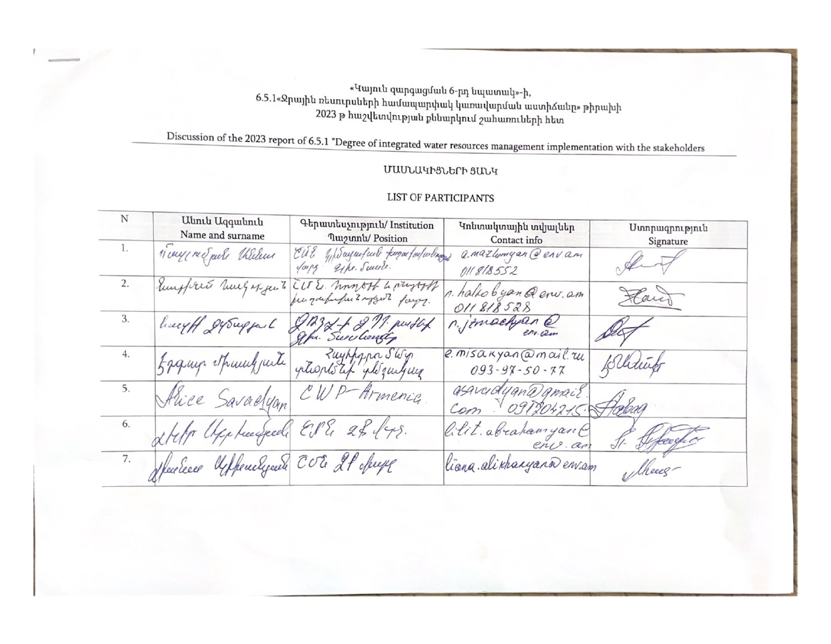
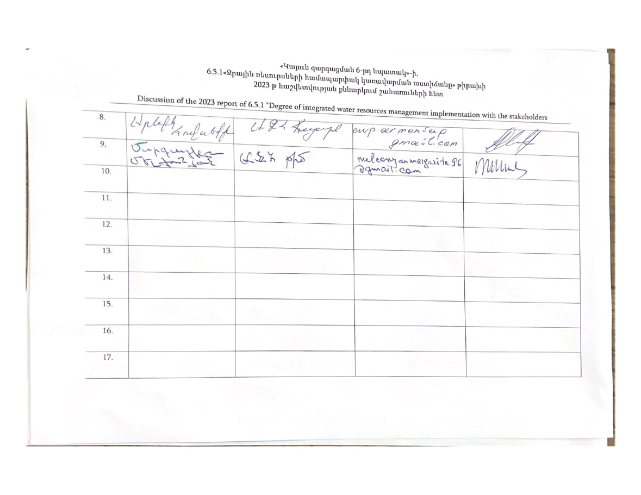
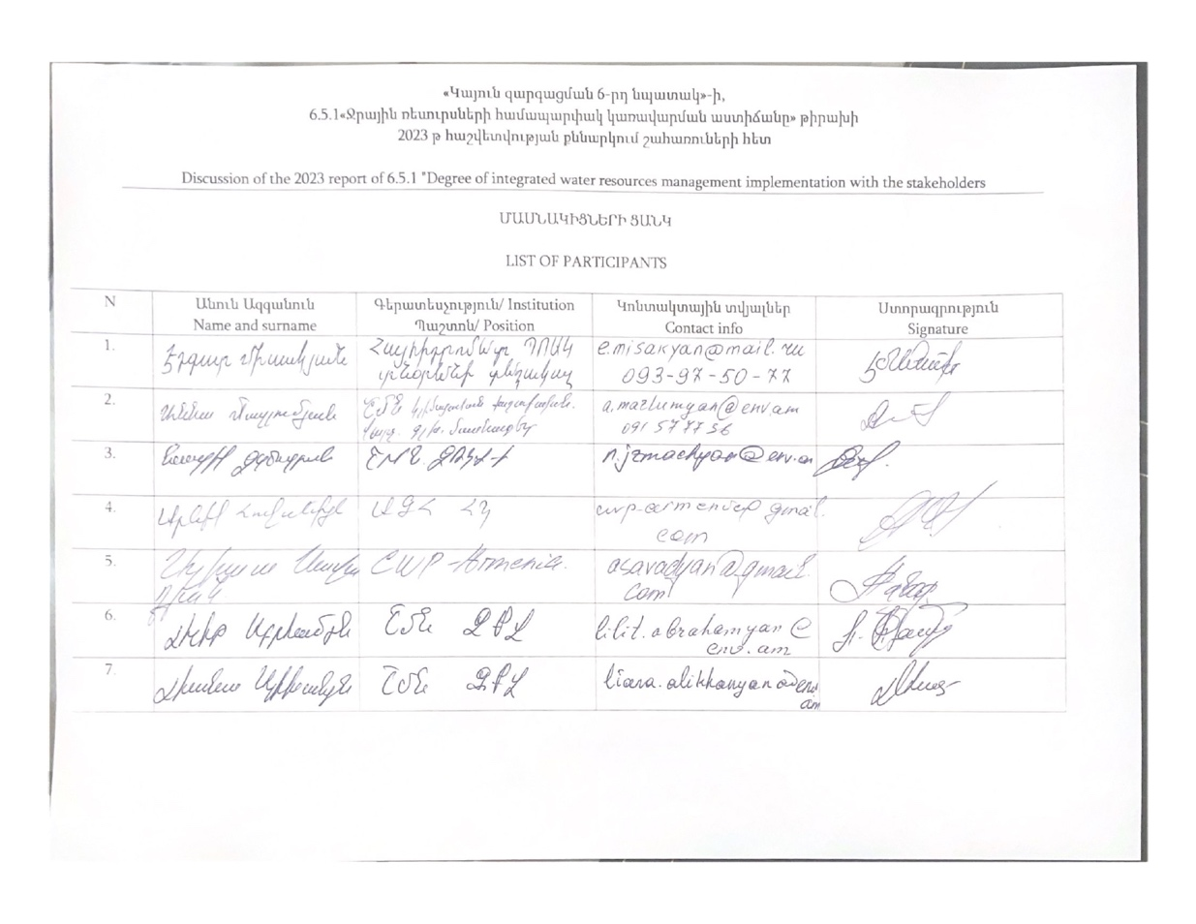
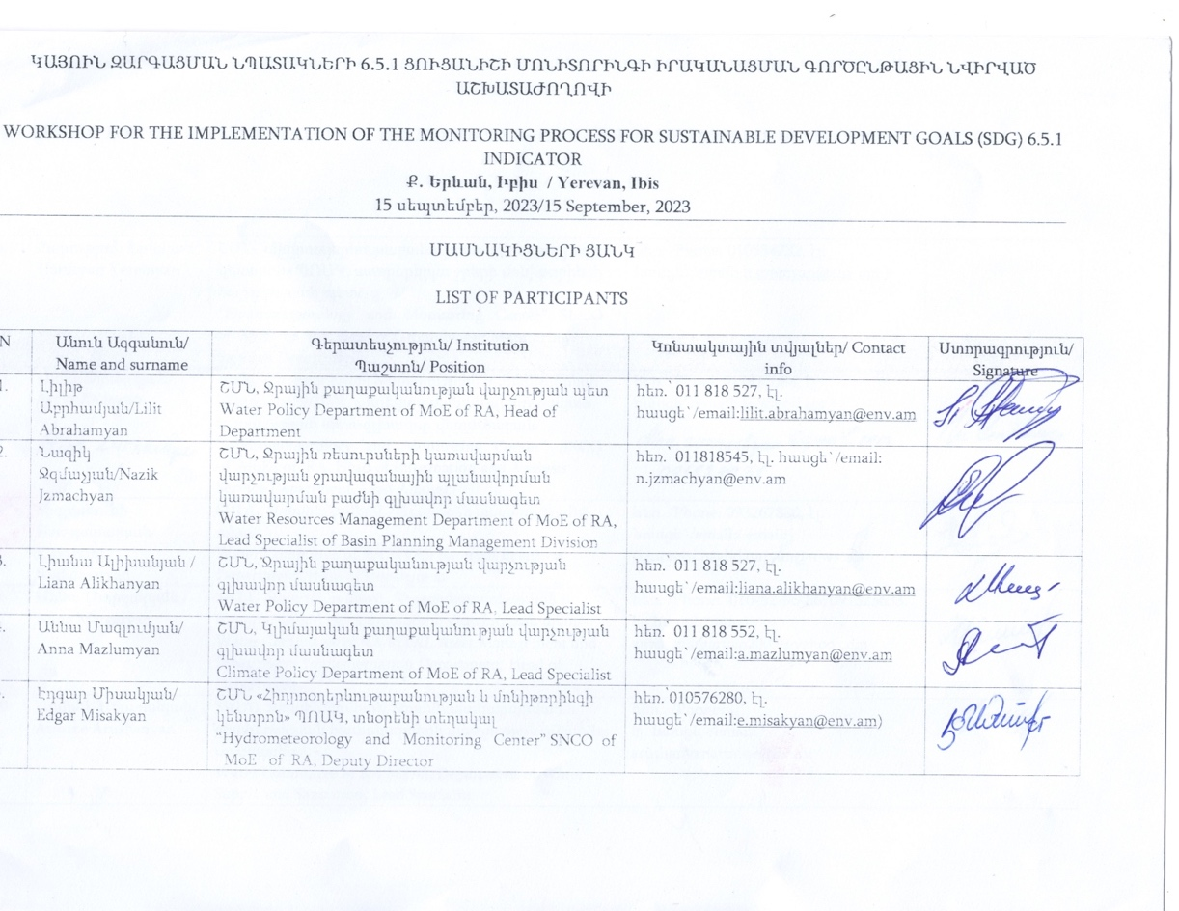
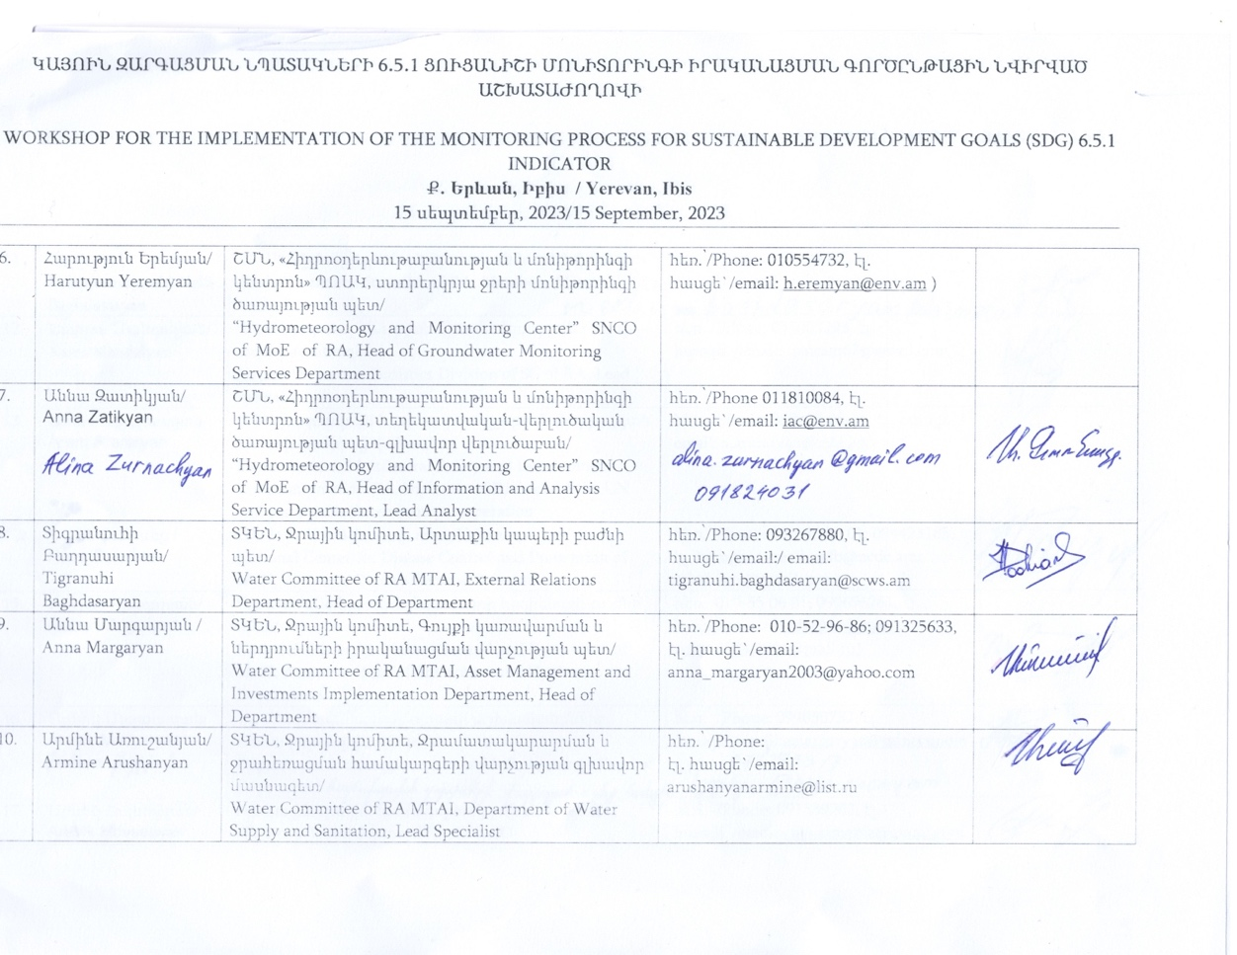
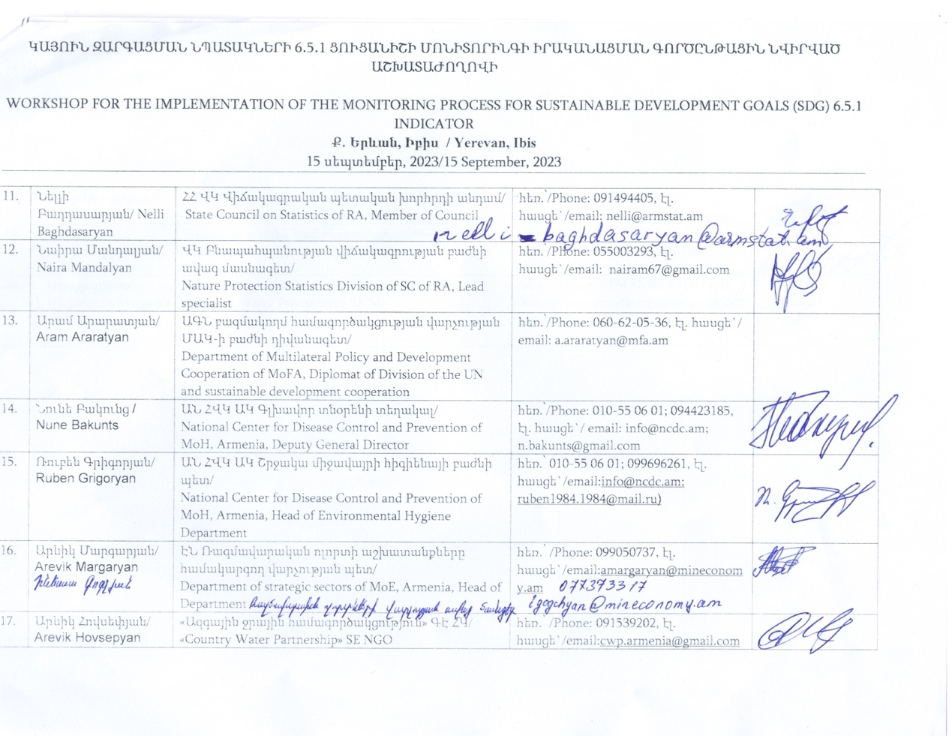
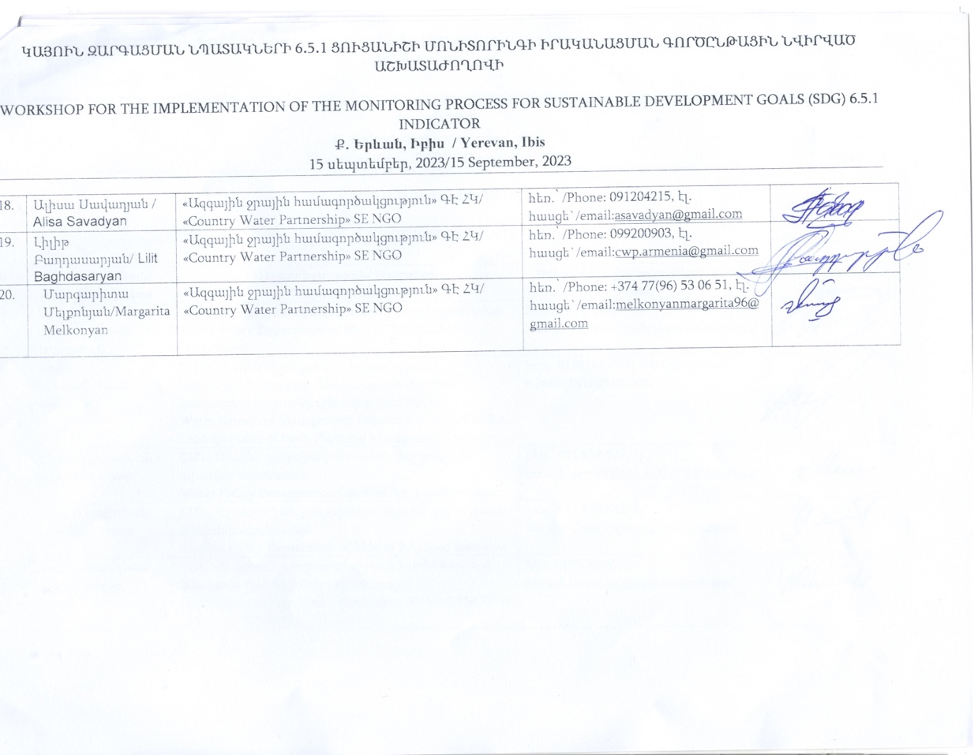

ANNEX 3. AGENDAS OF STAKEHOLDERS CONSULTATIONS HELD ON AUGUST 31, SEPTEMBER 7, SEPTEMBER 15.
ՕՐԱԿԱՐԳ
AGENDA

ՀՀ Շրջակա միջավայրի նախարարություն
Ministry of Environment of RA

Ժամ  Time | Գործողություն  Activity | Պատասխանատու  Person in charge
11:00 -  11:15 | Մասնակիցների գրանցում,  ԱՋՀ-ի կողմից բացման խոսք  Registration of participants,  Welcoming speech – CWP Armenia NGO | Ալիսա Սավադյան  ԱՋՀ-ի խորհրդի անդամ  Alisa Savadyan  CWP board member
11:15 -  11:30 | ՇՄն-ի 6.5.1 թիրախի մոնիթորինգի վերաբերյալ ընթացիք աշխատանք  On going activities on monitoring of 6.5.1 target of the Ministry of Environment of RA | Լիլիթ Աբրահամյան  6.5.1 թիրախի համակարգող  Lilit Abrahamyan  Focal Point of 6.5.1 target
11:30 -  13:00 | Հաշվետվության բաժինների քննարկում  - Բարենպաստ միջավայր – 7 հարց  - Ինստիտուցիոնալ համակարգ և մասնակցային գործընթաց 12 հարց  - Կառավարման գործիքներ 9 հարց  - Ֆինանսական ասպեկտներ 5 հարց  Discussion of the sections of the monitoring  - Enabling environment - 7 questions  - Institution and Participation 12 questions  - Management instruments 9 questions  - Finanancing 5 questions | Վարող Ալիսա Սավադյան  ՀՄԿ-Էդգար Միսակյան  ՇՄն- Լիաննա Ալիխանյան Նազիկ Ջզմաչյան,  Facilitator Alisa Savadyan  HMMC-Edgar Misakyan  Ministry of Environment of RA Lianna Alikhanyan  Nazik Jzmachyan
13:00 | Հանդիպման ամփոփում  Հետագա քայլեր  Wrap up  Further actions | Լիլիթ Աբրահամյան  Ալիսա Սավադյան  Lilit Abrahamyan  Alisa Savadyan

Կայոին զարգացման նպատակների 6․5․1 ցուցանիշի ՄՈՆԻՏՈՐԻՆԳի ԻՐԱԿԱՆԱՑՄԱՆ ԳՈՐԾԸՆԹԱՑԻՆ նվիրված
ԱՇԽԱՏԱԺՈՂՈՎԻ
ՕՐԱԿԱՐԳ
aGENDA FOR
WORKSHOP FOR THE IMPLEMENTATION OF THE MONITORING PROCESS FOR SUSTAINABLE DEVELOPMENT GOAL 6.5.1 INDICATOR

15 սեպտեմբերի 2023/ September 15, 2023
Իբիս Երևան կենտրոն հյուրանոցի «ՍԻՍ» սրահ/ “SIS” hall, Ibis Yerevan Center
Ժամ/Time | Գործողություն/Activity
09:00 – 09։30 | Մասնակիցների ժամանում, գրանցում/Participants Arrival and Registration
09:30- 09:40 | Ողջույնի խոսք / Opening Speech  Միջացառման նպատակի ներկայացում/ Introduction of the Goal of the Workshop  Արևիկ Հովսեփյան՝ ԱՋՀ ՀԿ/ Arevik Hovsepyan – CWP NGO
09։40-09։50 | ԿԶՆ-6 մոնիթորինգի իրականացման գործընթացի վերաբերյալ հաշվետվության ներկայացում / Introduction of Report on the Implementation of the Monitoring Process for SDG- 6  Ալիսա Սավադյան՝ ԱՋՀ ՀԿ/ Alisa Savadyan CWP NGO
09։50-11։20 | Բաժին 1 ՝ 6․5․1 ցուցանիշի վերաբերյալ հարցաշարի «Խթանիչ միջավայրի ստեղծում» բաղադրիչի ներկայացում և քննարկում/ Introduction and Discussion of Section 1: SDG Indicator 6.5.1: Survey - "Creating an Enabling Environment" Component  Խոսնակ՝ Լիանա Ալիխանյան ՇՄՆ, Ջրային քաղաքականության վարչության գլխավոր մասնագետ / Speaker: Liana Alikhanyan, Water Policy Department of MoE of RA, Lead Specialist  Ֆասիլիտատոր՝ Արևիկ Հովսեփյան ԱՋՀ / Facilitator: Arevik Hovsepyan CWP
11:20 – 12:00 | Սուրճի ընդմիջում/ Coffee Break
12։00-13։30 | Բաժին 2 ՝ 6․5․1 ցուցանիշի վերաբերյալ հարցաշարի «Շահագրգիռ կառույցները և մասնակցությունը» բաղադրիչի ներկայացում և քննարկում/ Introduction and Discussion of Section 2: SDG Indicator 6.5.1: Survey - ""Institutions and Participation " Component  Խոսնակ՝ Նազիկ Ջզմաչյան, ՇՄՆ, Ջրային ռեսուրսների կառավարման վարչության ջրավազանային պլանավորման կառավարման բաժնի գլխավոր մասնագետ/ Speaker: Nazik Jzmachyan, Water Resources Management Department of MoE of RA, Lead Specialist of Basin Planning Management Division  Ֆասիլիտատոր՝ Ալիսա Սավադյան ԱՋՀ/ Facilitator : Alisa Savadyan CWP
13։30-14։30 | Ճաշի ընդմիջում/ Lunch Break
14։30-16։00 | Բաժին 3 ՝ 6․5․1 ցուցանիշի վերաբերյալ հարցաշարի «Կառավարման գործիքներ» բաղադրիչի ներկայացում և քննարկում/ Introduction and Discussion of Section 3: SDG Indicator 6.5.1: Survey - “Management instruments " Component  Խոսնակ՝ Էդգար Միսակյան, ՇՄՆ «Հիդրոօդերևութաբանության և մոնիթորինգի կենտրոն» ՊՈԱԿ, տնօրենի տեղակալ/ Speaker: Edgar Misakyan, “Hydrometeorology and Monitoring Center” SNCO of MoE of RA, Deputy Director  Ֆասիլիտատոր՝ Մարգարիտա Մելքոնյան ԱՋՀ/ Facilitator: Margarita Melkonyan CWP
16:00-16։30 | - Սուրճի ընդմիջում/ Coffee Break
16։30-17։30 | Բաժին 4՝ 6․5․1 ցուցանիշի վերաբերյալ հարցաշարի «Ֆինանսավորում» բաղադրիչի ներկայացում և քննարկում/ Introduction and Discussion of Section 4: SDG Indicator 6.5.1: Survey - “ Financing" Component  Խոսնակ՝ Աննա Մարգարյան, ՏԿԵՆ, Ջրային կոմիտե, Գույքի կառավարման և ներդրումների իրականացման վարչության պետ/ Speaker: Anna Margaryan, Water Committee of RA MTAI, Asset Management and Investments Implementation Department, Head of Department  Ֆասիլիտատոր՝ Լիլիթ Բաղդասարյան ԱՋՀ/ Facilitator: Lilit Baghdasaryan CWP
17։30-18։00 | Հարցաշարի ամփոփում, աշխատաժողովի փակում/ Summary of the Survey Results, Closure of the Workshop  Խոսնակ՝ Լիլիթ Աբրահամյան՝ ՇՄՆ, Ջրային քաղաքականության վարչության պետ, ԿԶՆ 6․5․1, 6․5․2 ցուցանիշների մոնիտորինգի ազգային համակարգող/ Speaker:Lilit Abrahamyan, Water Policy Department of MoE of RA, Head of Department, Focal Point for SDG 6.5.1 and 6.5.2 Indicators  Աշխատաժողովի փակում՝ Ալիսա Սավադյան՝ ԱՋՀ/ Closure of the Workshop: Alisa Savadyan CWP

ANNEX 4. PHOTOS OF STAKEHOLDERS CONSULTATIONS
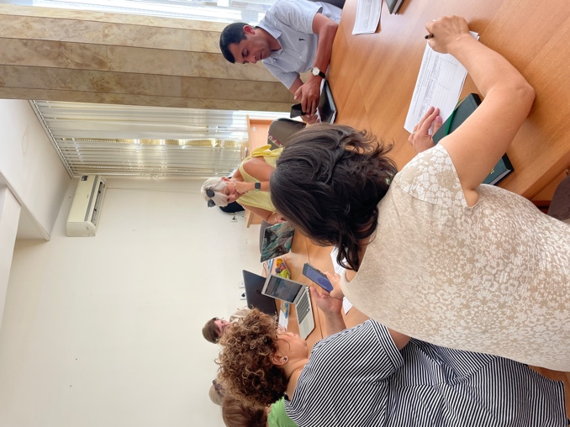 | 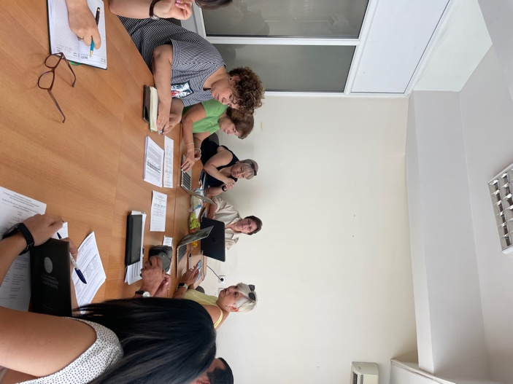
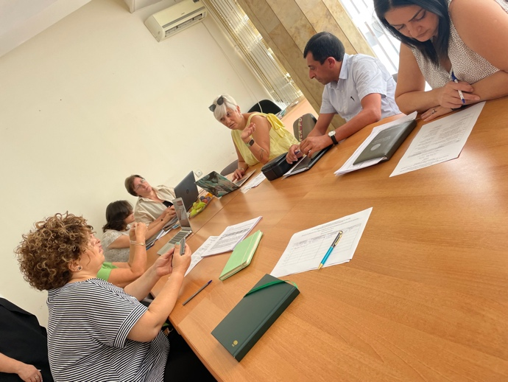 | 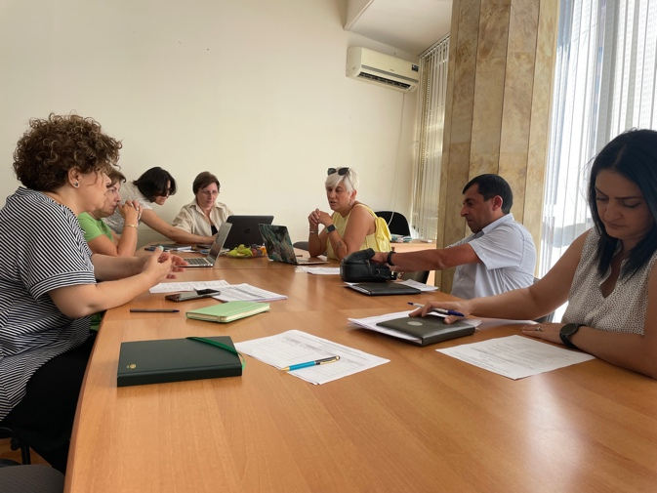
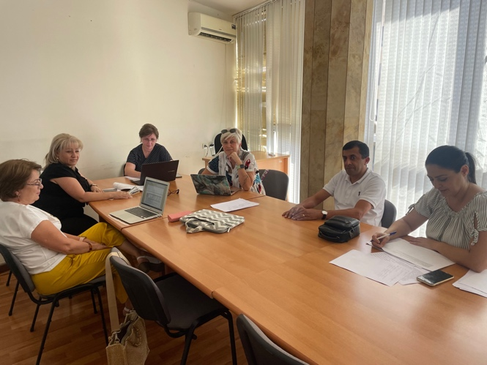 | 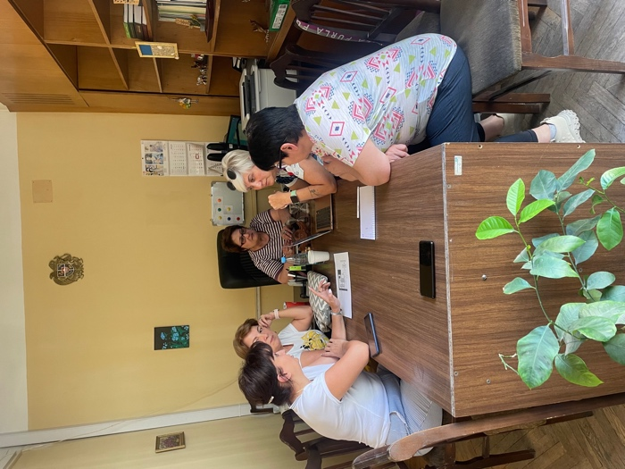
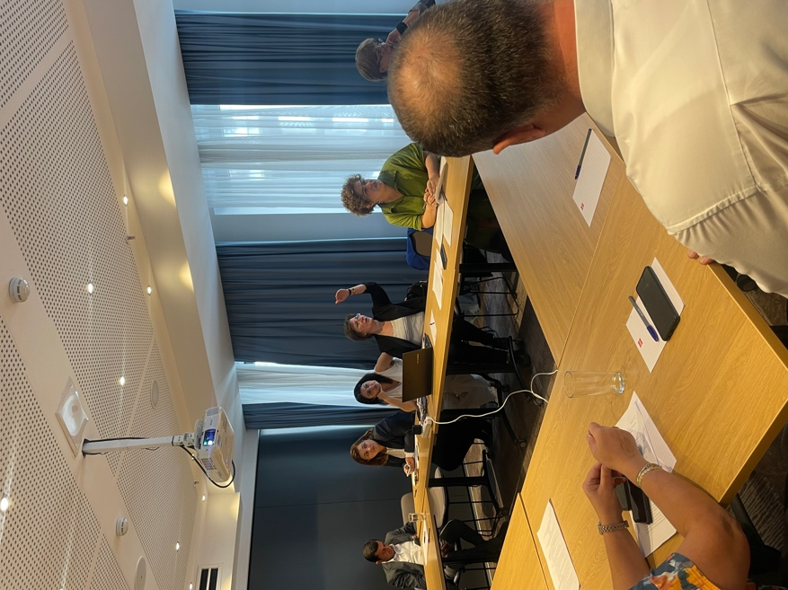 | 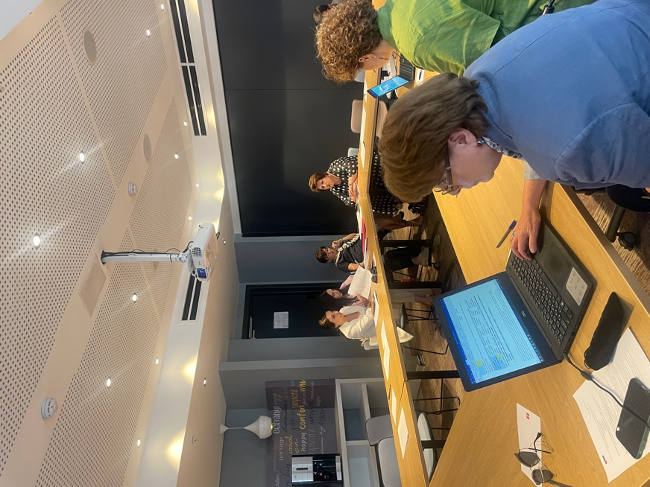
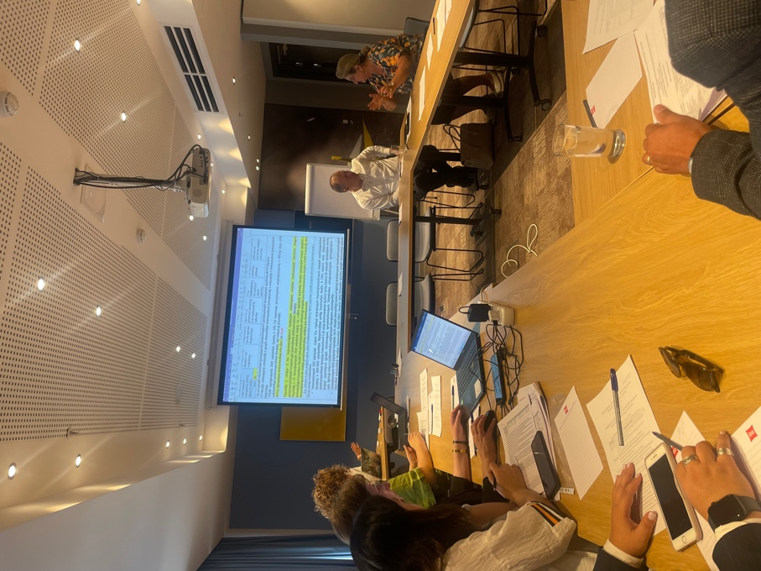 | 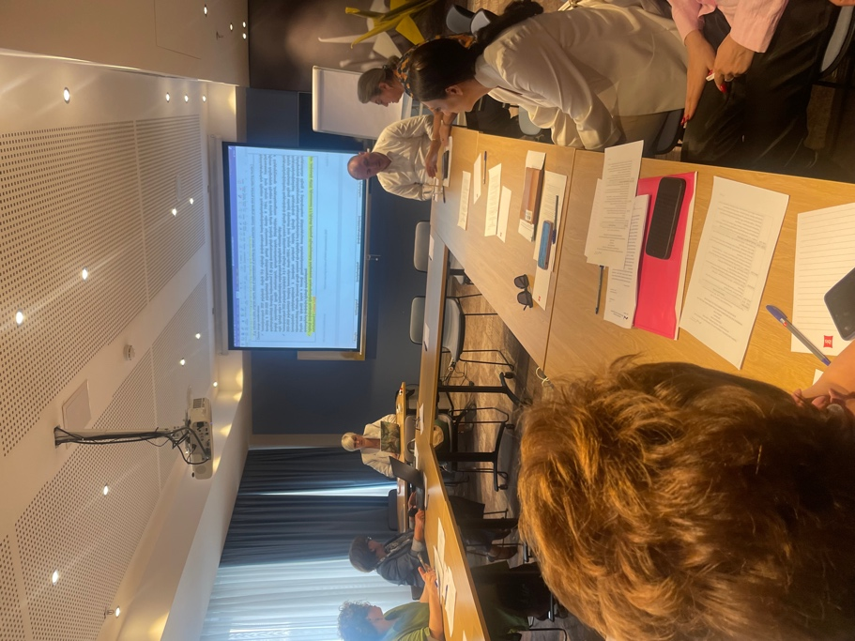

ANNEX 5: FACILITATOR’S COMMENTS

Conducting public consultations in the chosen format is very effective and acceptable to all participants. It has been used for the implementation of the SDG 6 monitoring process by CWP Armenia since 2017.

Before the main workshop, the facilitators organized separate thematic discussions taking into account the daily tight schedule of the stakeholders and the interests of different institutions. During these thematic meetings, the role of facilitators is very important, so that the beneficiaries understand the importance of providing useful and targeted information and clearly provide the information that will record the progress.

During the main stakeholders consultation meeting, everyone clearly understands their role and the importance of working together to achieve a common goal.

All participants had the opportunity to express their opinions and raise their problems.

Some problems arose in obtaining information on financial investments in the agricultural sector and this information gap was noted in the questionnaire. In the future, in order to solve this problem, it is necessary to involve a participant from the department, which is responsible for the implementation of projects.

ANNEX 6: THE RESULTS OF “FINAL SURVEY FOR SDG 6.5.1 STAKEHOLDERS’ CONSULTATION”

Series of discussions with the main stockholders have been planned and implemented.
Final workshop has been organized on September 15 with participation of all experts involved in IWG and participated in separate thematical meetings. 16 participants from 7 institutions have been invited. Four facilitators have facilitated the final public consultation’s four sessions.

To wrap up the discussions, as well as aiming to identify the stakeholders and the latter’s needs a survey questionnaire named “Final survey for SDG 6.5.1 stakeholders’ consultation” was sent to all the participants of the webinars.
The questionnaire consisted of 13 questions in total.
Part of the questions aimed to stakeholder identification and the rest was designed to reveal the stakeholders’ needs as well as their opinion on the consultations held.

The questions are listed afterwards:
- Name of country where you participated in stakeholder consultations for SDG 6.5.1 reporting.
- Age
- Type of organization you represent.
- Name of the organization you represent.
- Is your organization a GWP partner organization?
- Gender
- How well did the consultation process meet its objectives?
- Was the consultation process well organized?
- To what extent could you express your opinion during the consultation process?
- To what extent are your opinions reflected in the final country response of the SDG 6.5.1 survey?
- To what extent has the final country response of the SDG 6.5.1 survey identified relevant challenges to IWRM implementation in your country?
- How could the SDG 6.5.1 consultation process in your country be improved in the future?
- Please share any other comments about the SDG 6.5.1 consultation process here

The questionnaire was originally organized in Armenian, thus the answers reflected in this wrap up report are translated from Armenian to English.
Within the period of 17/09/2023 – 25/09/2023 the questionnaire has been filled by 10 stakeholders.
The rest of the participants have not participated in survey filling.

QUESTION 1
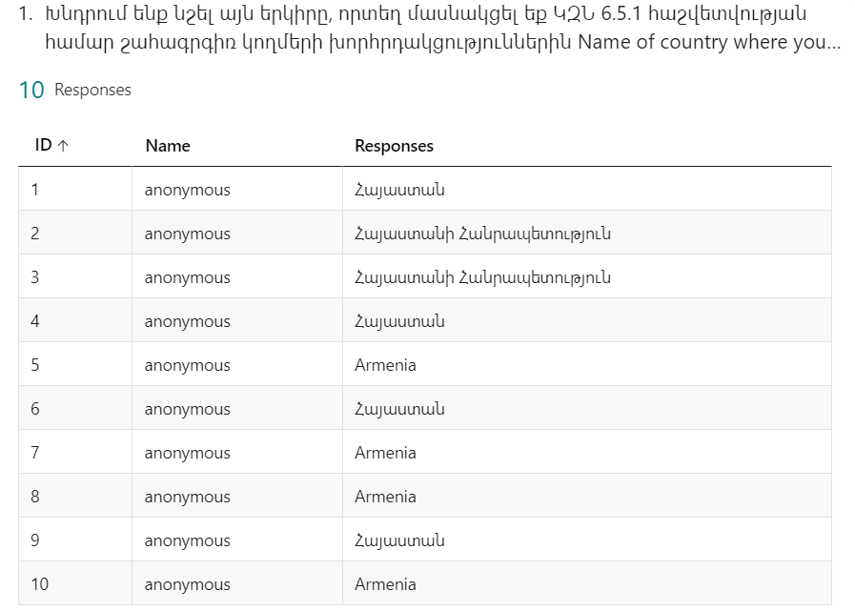
As we may clearly see from the Table 1 all the surveyors have participated in stakeholder consultations for SDG 6.5.1 reporting in the Republic of Armenia.
Table 1
QUESTION 2
As we may clearly see from the Chart 1, all the surveyors were aged 36-65.

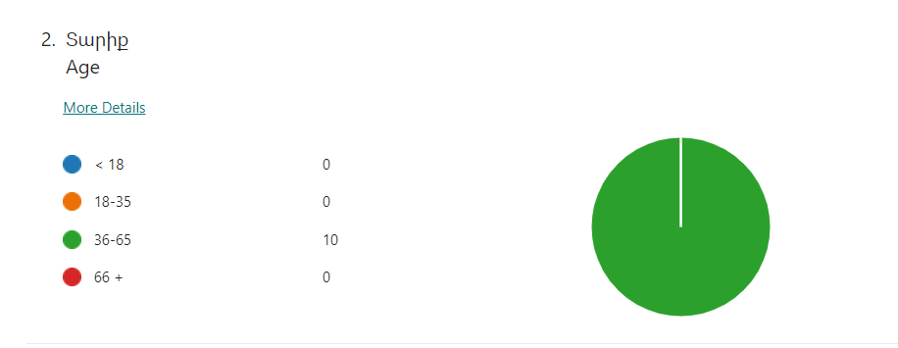
Chart 1

QUESTION 3
As we may clearly see from the Chart 2, the prevailing majority of the surveyors represent the Government. There was one surveyor who was an independent professional and another surveyor representing a non-governmental organization or civil society.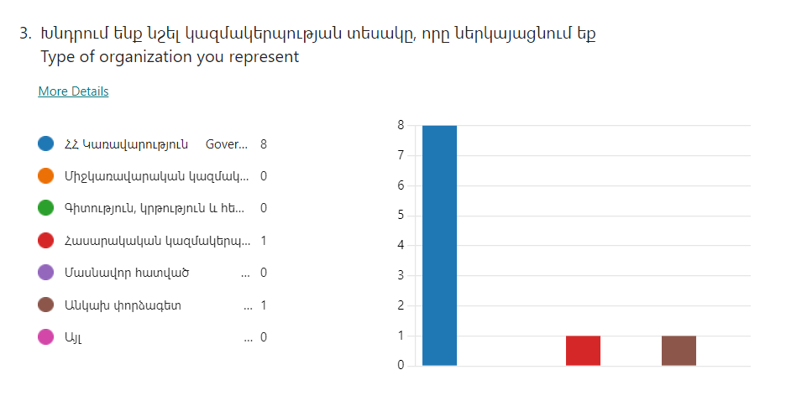
Chart 2
QUESTION 4
As we may see from the Table 2, the stakeholders represented the following structures.
- Ministry of Health of RA – 2 surveyors
- Ministry of Environment of RA - 1 surveyor
- Statistical Committee of the Republic of Armenia – 2 surveyors
- “Hydrometeorology and Monitoring Center” SNCO of RA – 2 surveyors
- Water committee of RA MTAI – 1 surveyor
- CWP Armenia – 2 surveyors

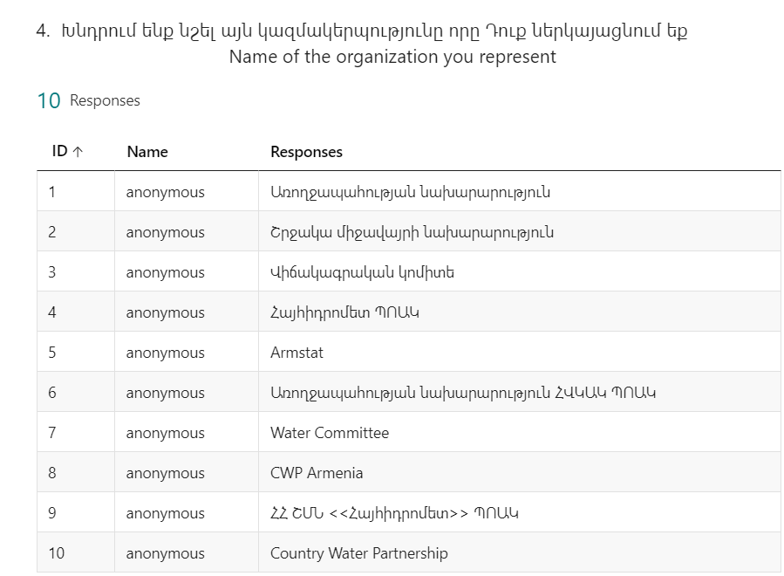
Table 2

QUESTION 5
As we may clearly see from the Chart 3, the prevailing majority of the surveyors represent GWP partner organizations. One of the surveyors was non-GWP partner organization representative. One of the surveyors wasn’t aware.
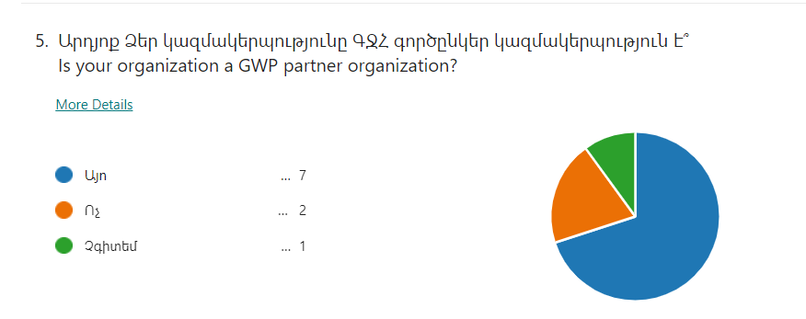

Chart 3
QUESTION 6
As we may see from the Chart 4, 8 surveyors out of 10 were females and only 2 were males.
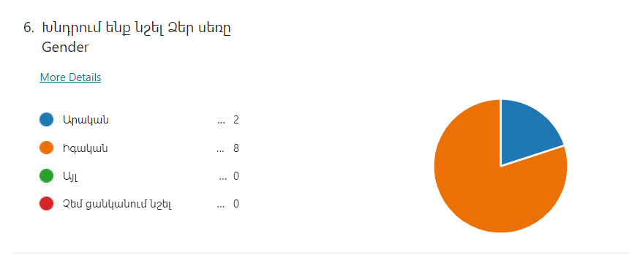
Chart 4
QUESTION 7
As we may see from the Chart 5, for the 6 surveyors the consultation process met its objectives upon “Excellent” and for the 4 surveyors upon “Satisfactory”.
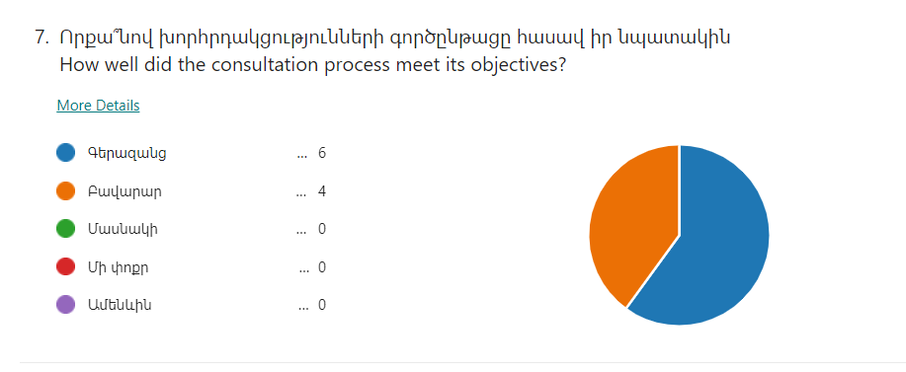
Chart 5

QUESTION 8
As we may see from the Chart 6, for the 9 surveyors the consultation process was well-organized upon “Excellent” and for the 1 surveyor upon “Satisfactory”.
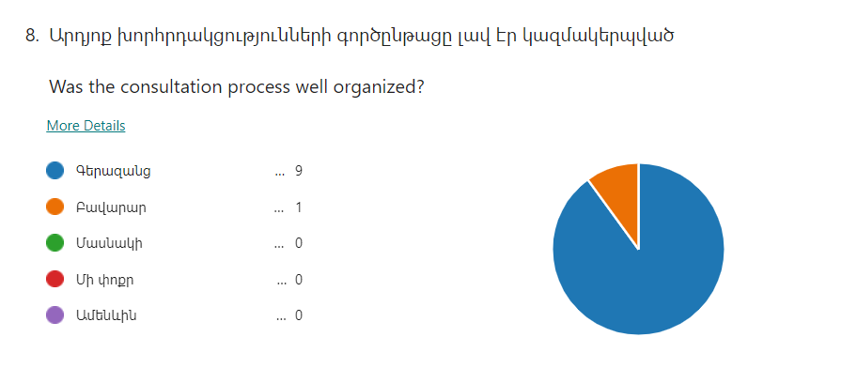

Chart 6

QUESTION 9
As we may see from the Chart 7, the 6 surveyors expressed their opinion during the consultation process upon “Excellent” and the 4 surveyors upon “Satisfactory”.
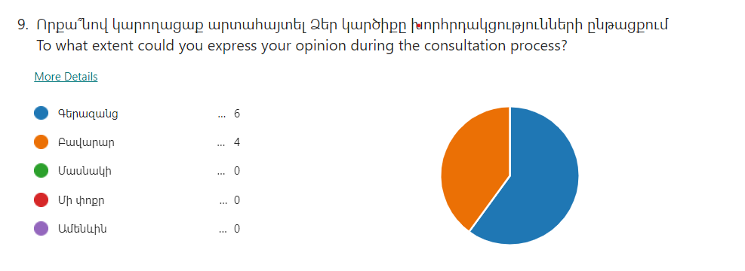
Chart 7
QUESTION 10
As we may see from the Chart 8, for the 4 surveyors their opinion has been reflected in the final country response of the SDG 6.5.1 survey upon “Excellent”, for the 5 surveyors their opinion has been reflected upon “Satisfactory” and only one surveyor hasn’t been provided with the final country response yet.
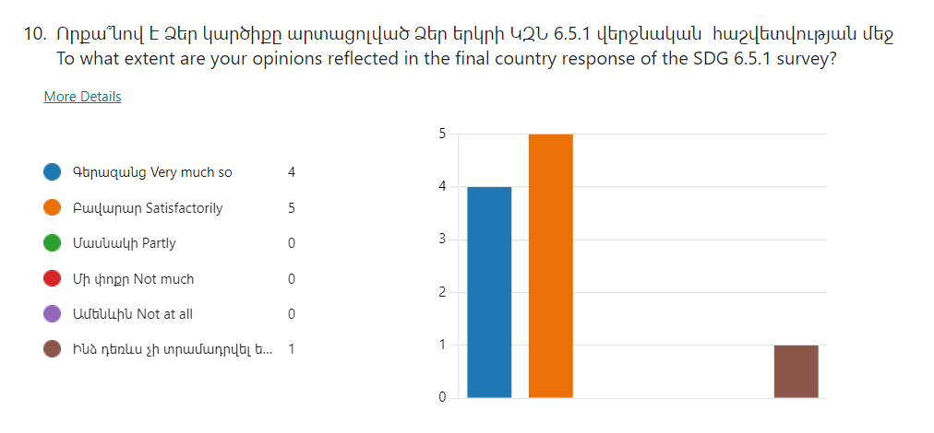
Chart 8

QUESTION 11 - To what extent has the final country response of the SDG 6.5.1 survey identified relevant challenges to IWRM implementation in your country?
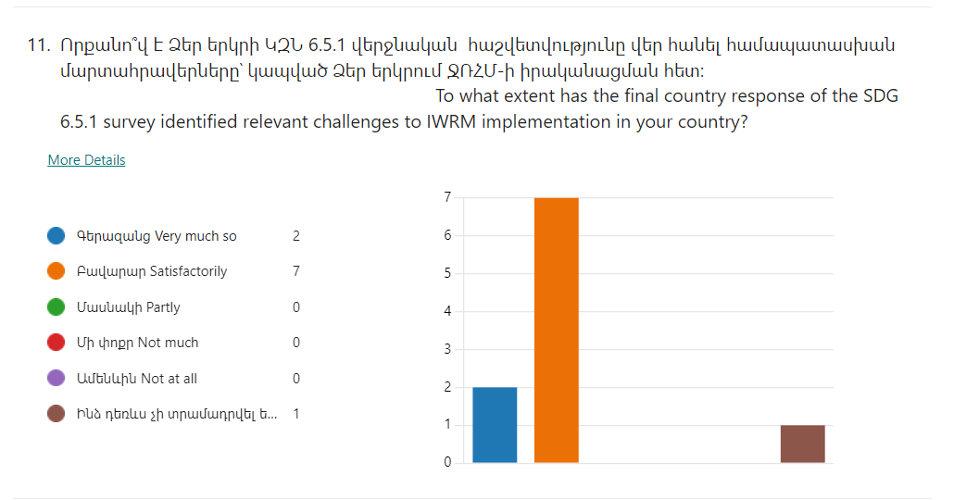
In regard this question, 7 surveyors expressed as “Excellent”, 2 surveyors as “Satisfactory” and only one surveyor hasn’t been provided with the final country response yet.
Chart 9

QUESTION 12 – How could the SDG 6.5.1 consultation process in your country be improved in the future?
The expressed opinions are wrapped up afterwards.
- Include a wider range of stakeholders (private sector, RB local stakeholders). To increase the sense of responsibility for reporting in the state structures of the water sector, to improve the level of cooperation between different structures.
- Include more competent professionals.
- By reviewing the legal framework and improving appropriate communication channels.
The participation of all stakeholder agencies should be more intensive and continuous.
- Organizing consultations more often will make it possible to make them more participatory, which will increase their efficiency.

QUESTION 13 - Please share any other comments about the SDG 6.5.1 consultation process here.
The expressed opinions are wrapped up afterwards.
- The consultations were well-organized, the discussions were informative, meaningful, and interesting.
- Target issues were clearly presented.
- Active involvement of stakeholders helped to receive more comprehensive discussions and provide better results.
- The consultations were quite well organized, there were exchanges of opinions, discussions, which contributed to achieving the issues faced by the RA.
- The representatives of all interested parties participated in the consultations and the results of the monitoring express the opinion of all.

ANNEX 7: FACILITATOR’S CERTIFICATES

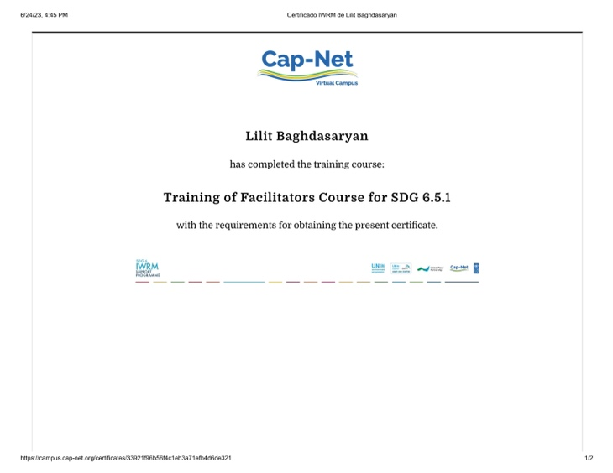 |  | 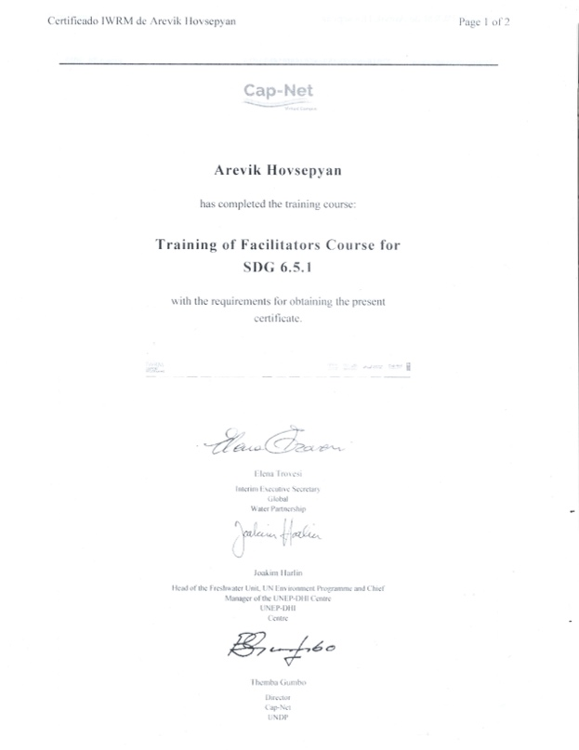
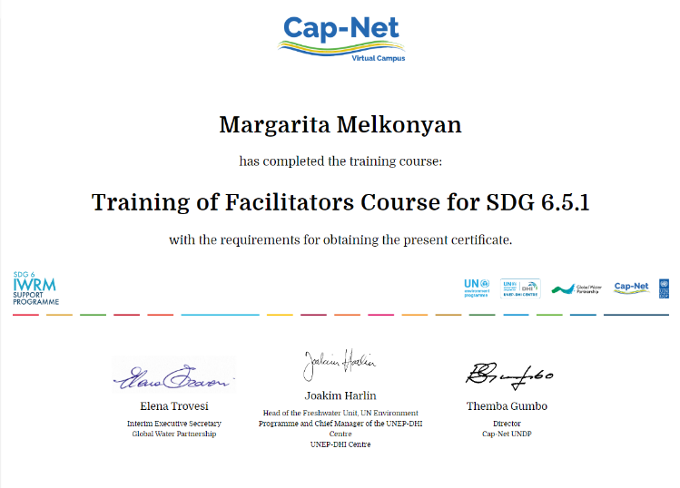 | 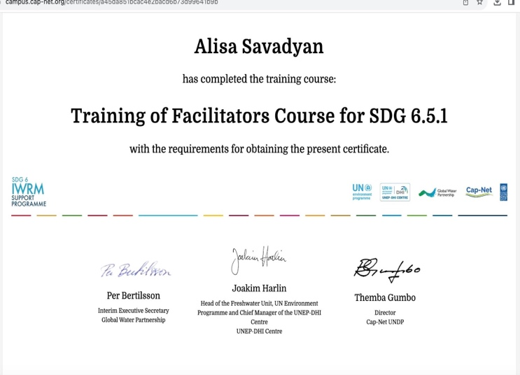

The members of IWG are: Ministry of Environment Hydrometeorology and Monitoring Centre, Water Committee, Ministry of Health, Ministry f Economy, Ministry of Finance State Statistical Committee.

