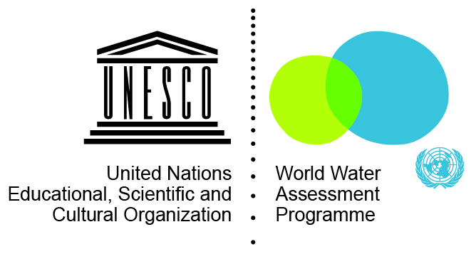
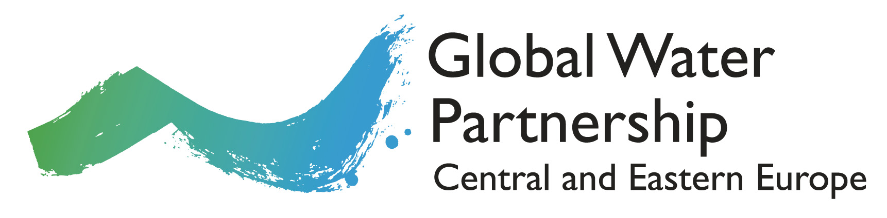

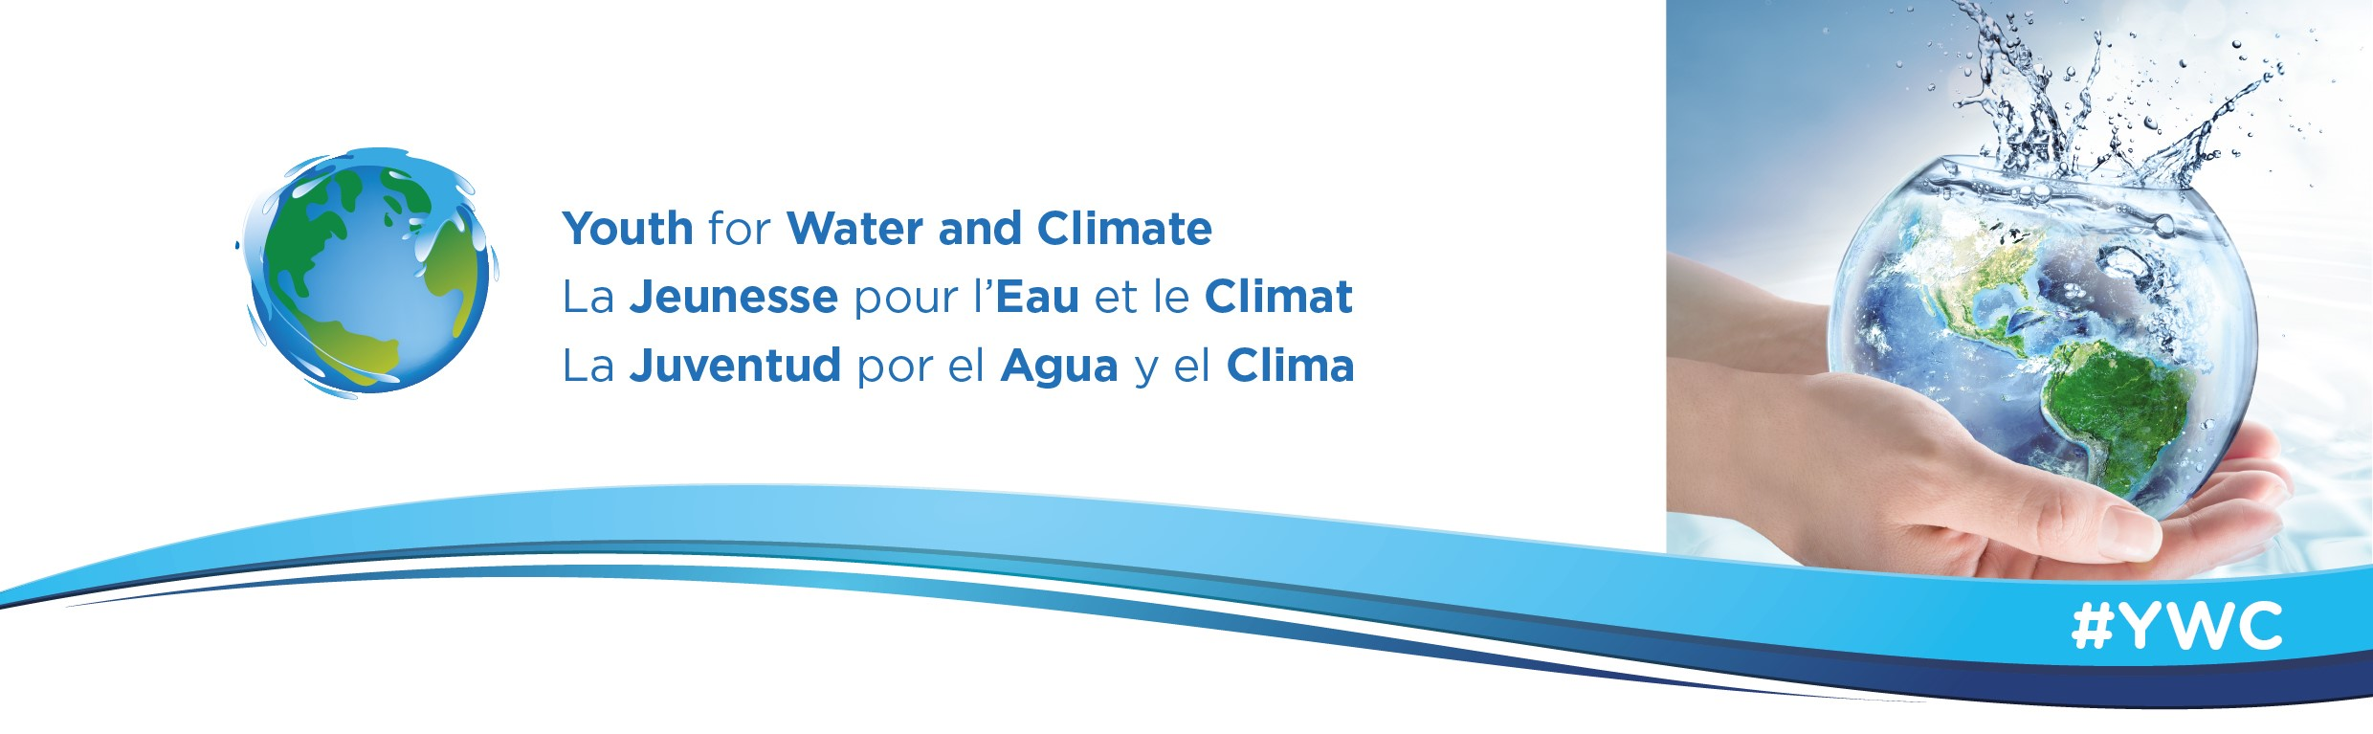
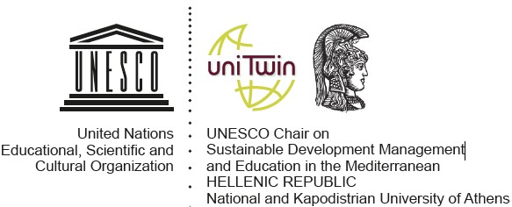

WATER IN THE SUSTAINABLE DEVELOPMENT – CHALLENGES AND OPPORTUNITIES
Summer School 2017 Application Form

1. PERSONAL DETAILS & CONTACT INFORMATION

Last Name: |  | First Name(s):

Gender: ☐ Female ☐ Male Date of Birth: Please choose date

Nationality: |  | Passport No.:

Address:

Postcode and City: |  | Country:

Home Phone No. |  | Mobile No.:

E-mail address:

Facebook |  | Twitter

2. EMERGENCY CONTACT INFORMATION

Last Name: |  | First Name(s):

Relationship:

Phone No. |  | E-mail address:

3. OTHER INFORMATION

Any allergies?
Any specific requirements?

4. ENGLISH LANGUAGE PROFICIENCY

All lectures and sessions will be taught in English. Please specify your English level:

☐ A0 - No proficiency at all ☐ B1 - Threshold

☐ A1 - Breakthrough ☐ B2 - Vantage

☐ A2 - Waystage ☐ C1/C2 – Proficient user

5. PERSONAL STATEMENT

Please use this space to write a short motivation letter giving a brief explanation why you are interested in the Summer School:

6. DATES AND TRAVEL

Water in the sustainable development – challenges and opportunities Summer School will start on 10 July and finish on 15 July. Arrivals are on 9 July and departures on 16 July.
Participants are expected to make their own travel arrangements.

7. ACCOMMODATION INFORMATION

The students will be accommodated in double rooms in a university residence located on the University of Life Sciences’ campus.

8. INSURANCE INFORMATION

Please arrange health insurance before your trip to Poland since organizers take no responsibility in this respect.

9. COURSE FEE PAYMENT INFORMATION

The fee for students coming from universities that are not registered Global Water Partnership Partners is 380 EUR and it includes registration fee, tuition, accommodation on campus (in double rooms) and lunches for the duration of the summer school.

For students from GWP CEE and GWP MED Universities which are officially registered as GWP Partners there is no fee.

All participants are expected to arrange and pay for their travel to Warsaw, Poland.

10. AUTHORIZATION FOR USE OF IMAGE

I, the undersigned,
Full name
Address
hereby authorize Global Water Partnership Central and Eastern Europe to photograph and to film me during the Summer School 2017.

11. DECLARATION

Please read the following declaration and sign it in the appropriate place below.

- I confirm that the information given in this form is correct and accurate.
- I have read and understood the above information.
- In support of my application I enclose my Curriculum Vitae

Signature: |  | Date:

Please, submit your application by 31 May 2017 via e-mail to gwpcee@gwpcee.org

