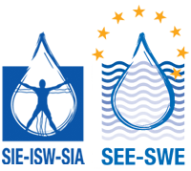
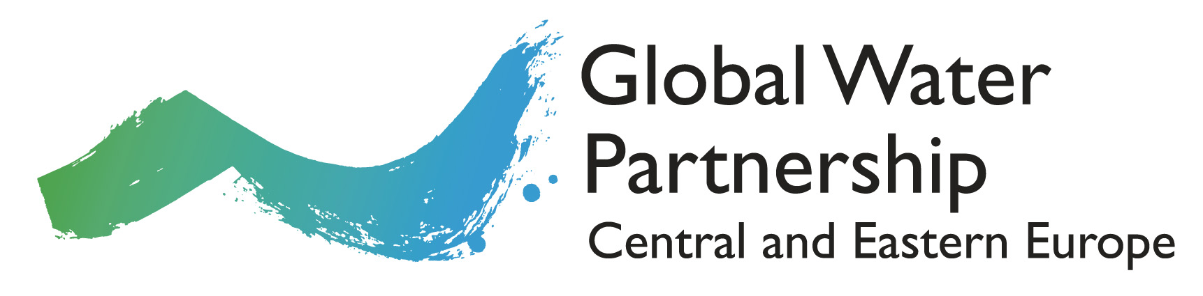
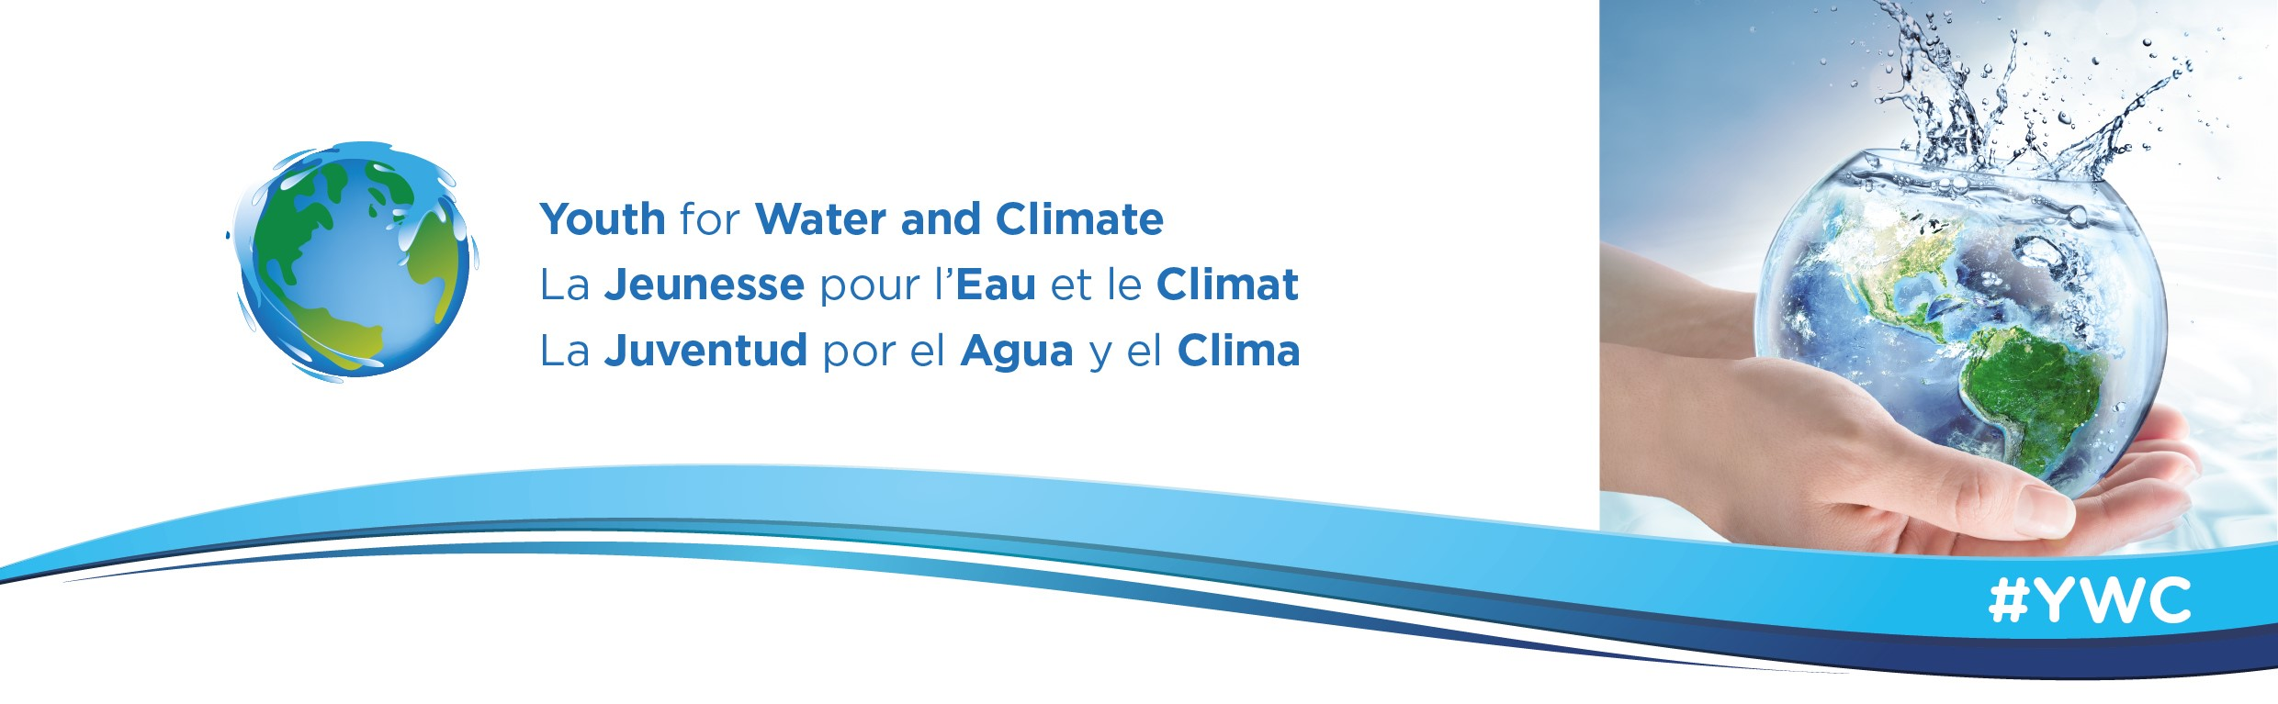
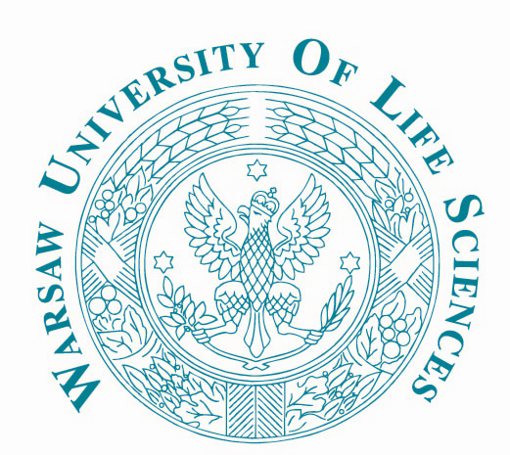
Towards 2030 Agenda: A summer school for climate change, innovation and youth advocacy in water management

Summer School 2018 Application Form

1. PERSONAL DETAILS & CONTACT INFORMATION

Last Name: |  | First Name(s):

Gender: ☐ Female ☐ Male Date of Birth: Please choose date

Nationality: |  | Passport No.:

Address:

Postcode and City: |  | Country:

Home Phone No. |  | Mobile No.:

E-mail address:

Facebook |  | Twitter

2. EMERGENCY CONTACT INFORMATION

Last Name: |  | First Name(s):

Relationship:

Phone No. |  | E-mail address:

3. OTHER INFORMATION

Any allergies?
Any specific requirements?

4. ENGLISH LANGUAGE PROFICIENCY

All lectures and sessions will be taught in English. Please specify your English level:

☐ A0 - No proficiency at all ☐ B1 - Threshold

☐ A1 - Breakthrough ☐ B2 - Vantage

☐ A2 - Waystage ☐ C1/C2 – Proficient user

5. PERSONAL STATEMENT

Please use this space to write a short motivation letter giving a brief explanation why you are interested in the Summer School:

6. DATES AND TRAVEL

The Summer School will start on 1 July and will finish on 6 July 2018. Arrivals are on 30 June and departures on 7 July.
Please, contact us BEFORE you make your travel arrangements.

7. ACCOMMODATION INFORMATION

The students will be accommodated in double or triple rooms in a university residence located on the campus of the University of Life Sciences.

8. INSURANCE INFORMATION

Please arrange health insurance before your trip to Poland since organizers take no responsibility in this respect.

9. COURSE FEE PAYMENT INFORMATION

Applicants from universities which are registered partners to GWP CEE, GWP MED and GWP CACENA are especially encouraged to apply. If selected, they will be granted financial support, covering the price of the course and accommodation. The participants will have to cover their travel costs to Warsaw. Exceptions in that regard are for participants from the following countries, whose travel cost will be covered as well: Armenia, Bulgaria, France, Hungary, Latvia, Moldova, Poland, Slovakia, and Ukraine.

The summer school is open also to MSc and PhD students from any other university in Europe that show an interest in enhancing water resource management knowledge and broader aspects of water security.
Fees:
- 0 EUR registration fee for students from GWP CEE, GWP MED and GWP CACENA Universities which are officially registered as GWP Partners
- 380 EUR registration fee, tuition, accommodation on campus (in double or triple rooms) and lunches for duration of the summer school for student from Universities which are not officially registered as GWP Partners.

10. AUTHORIZATION FOR USE OF IMAGE

I, the undersigned,
Full name
Address
hereby authorize Global Water Partnership Central and Eastern Europe to photograph and to film me during the Summer School 2017.

11. DECLARATION

Please read the following declaration and sign it in the appropriate place below.

- I confirm that the information given in this form is correct and accurate.
- I have read and understood the above information.
- In support of my application I enclose my Curriculum Vitae

Signature: |  | Date:

Please, submit your application by 31 May 2018 via e-mail to gwpcee@gwpcee.org

