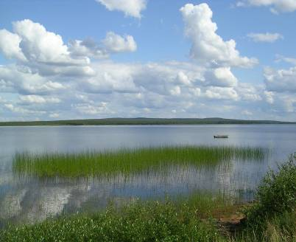


Service contract for the support to the follow-up of the Communication on Water scarcity and Droughts

WATER SCARCITY&DROUGHT INDICATORS’
FACT SHEETS
■ December, 17, 2013



- INDEX

1. FAPAR (FRACTION OF ABSORBED PHOTOSYNTHETICALLY ACTIVE RADIATION) 2
2. H (GROUNDWATER LEVEL) 9
3. SSPI (STANDARDIZED SNOWPACK INDEX) 18
4. SOIL MOISTURE 26
5. SPI (STANDARDIZED PRECIPITATION INDEX) 34
6. SRI (STANDARDIZED RUNOFF INDEX) 42
7. WEI+ (WATER EXPLOITATION INDEX PLUS) 54

FAPAR (FRACTION OF ABSORBED PHOTOSYNTHETICALLY ACTIVE RADIATION)

Indicator Fact Sheet

FAPAR: Fraction of Absorbed Photosynthetically Active Radiation

Indicator definition
Droughts affect the vegetation canopy and specifically its capacity to intercept solar radiation. The Fraction of Absorbed Photosynthetic Solar Radiation (fAPAR) is known to be strongly related to water stress. fAPAR and fAPAR anomalies (the deviation from the long-term mean for a certain period of time) are considered good indicators to detect and assess drought impacts on vegetation canopies.

Relevance of the indicator to drought
The Fraction of Absorbed Photosynthetically Active Radiation (fAPAR) represents the fraction of the solar energy which is absorbed by the vegetation canopy. fAPAR is a biophysical variable directly correlated with the primary productivity of the vegetation, since the intercepted PAR is the energy (carried by photons) underlying the biochemical productivity processes of plants. fAPAR is one of the Essential Climate Variables recognized by the UN Global Climate Observing System (GCOS) and by the FAO Global Terrestrial Observing System (GTOS) as of great potential to characterize the climate of the Earth.
Due to its sensitivity to vegetation stress, fAPAR has been proposed as a drought indicator (Gobron et al. 2005 and 2007). Indeed droughts can cause a reduction in the vegetation growth rate, which is affected by changes either in the solar interception of the plant or in the light use efficiency.

Policy relevance
Water Framework Directive WFD (Directive 2000/60/EC of the European Parliament and of the Council of 23 October 2000 establishing a framework for Community action in the field of water policy)
- Environmental objectives: Exemption for temporary deterioration in the status (Art. 4 (6))
- Programme of measures: Additional measures are not practicable (Art. 11 (5))

Communication of the EC to the Council and European Parliament: “Addressing the challenge of water scarcity and droughts in the European Union” (published on July 2007)
- Developing drought risk management plans (Paragraph 2.3.1.)
- Developing an observatory and an early warning system on droughts (Paragraph 2.3.2).
- Improve knowledge and data collection: Water scarcity and drought information system (Paragraph 2.7.1.)

Technical Information

1. Indicator
fAPAR is presented as the MERIS Global Vegetation Index (MGVI). MGVI is a remote sensing derived indicator estimating fAPAR at canopy level. MERIS stands for Medium Resolution Imaging Spectrometer, a satellite sensor operating onboard the European ENVISAT satellite platform.

2. Spatial scale
MGVI data cover all of Europe with a spatial resolution of 1.2 x 1.2 km².

3. Temporal scale
Every 10 days aligned on the first day of each month, which corresponds to 3 images per month (day 1-10, day 11-20, day 21-last day of month).

4. Methodology
- Detailed methodology for the calculation of the indicator
fAPAR is difficult to measure directly but can be inferred from models describing the transfer of solar radiation in plant canopies, using Earth Observation (EO) information as input data. fAPAR estimates are retrieved using EO information by numerically inverting physically-based models.
The fAPAR estimates used within EDO are operationally produced by the European Space Agency (ESA). They are derived from the multispectral images acquired by the Medium Resolution Imaging Spectrometer (MERIS) onboard ENVISAT by means of the MERIS Global Vegetation Index (MGVI) algorithm, developed at the JRC (Gobron et al. 2004).
MGVI is a physically-based index which transforms the calibrated multi-spectral directional reflectance into a single numerical value while minimizing possible disturbing factors. It is constrained by means of an optimization procedure to provide an estimate of the fAPAR of a vegetation canopy. The objective of the algorithm is to reach the maximum sensitivity to the presence and changes in healthy live green vegetation while at the same time minimizing the sensitivity to atmospheric scattering and absorption effects, to soil color and brightness effects, and to temporal and spatial variations in the geometry of illumination and observation.
The MGVI level-3 aggregation processor is routinely operated on the ESA Grid Processing on Demand (G-POD) system. The algorithms have been developed and are maintained by the European Commission Joint Research Centre (JRC). More information on the algorithms can be found in Pinty B. et al. (2002) and Gobron N. et al. (2004).

- Data acquisition: The 10-day fAPAR estimates are regularly produced by the European Space Agency (ESA) as MERIS fAPAR Level-3 Aggregated Products following the approach by Aussedat et al. (2007).

- Anomaly estimation: fAPAR anomalies are produced at JRC as follows:
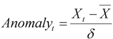
where X_{t} is the fAPAR of the 10-day period t of the current year and , is the mean fAPAR and δ is the standard deviation calculated for the same 10-day period t using the available time series (archive).

- Reference period for calculating the Statistics
For the production of fAPAR anomalies, JRC extended the MERIS fAPAR time series (ranging from end 2002 to the current day) with fAPAR estimations obtained from the Sea-viewing Wide Field-of-view Sensor (SeaWiFS) from mid 1997 to end 2002 with an algorithm completely compatible with the MGVI (Gobron et al. 2002). This allowed for the creation of a reference period starting mid 1997.

5. Data source and frequency of data collection
MGVI data are delivered as a subscription service within the Service Support Environment (SSE) of the European Space Agency. This service is called "MGVI Catalogue Search and Download" and can be accessed via this link: http://services.eoportal.org/portal/service/ ShowServiceInfo.do?serviceId=7180CB90&categoryId=89802980
Frequency of data collection: every 10 days

6. Quality Information
a. Strength & weaknesses at data level
[+] Every ten days, the MGVI gives a spatially continuous picture of the vegetation status/health at a high spatial resolution (~1km) for the entire European continent.
[-] Drought and water stress are not the only factors that can cause a decrease of MGVI values/anomalies. Changes in land cover or pests and diseases can also be responsible for such variation of the signal. Therefore this indicator must be used jointly with other indicators giving information on rainfall and soil moisture deficits in order to determine if the variation in the vegetation response (signal) is linked with a drought event or not.
[-] Anomalies are dependent of the time series (reference period) available to calculate the long-term average and the standard deviations. This period should be long enough to characterize the area where the index is calculated. As the reference period is still short (1997 to today), the anomalies are to be interpreted with care.
b. Performance of the indicator
MGVI has been used successfully to assess the impact of the 2003 drought on plant productivity in Europe (Gobron et al. 2005). Moreover Rossi et al. (2008) highlighted the potential of this indicator for drought detection and monitoring by comparing it to other drought indicators such as the Standardized Precipitation Index (SPI). Recently, fAPAR has been capable to reflect the impact of the 2011 spring drought in western Europe (mainly France, Germany, Benelux, UK) and central Europe (http://desert.jrc.ec.europa.eu/action/php/index.php?action=view&id=118).

Products

fAPAR and fAPAR anomalies can be presented in the form of maps and graphs, providing information both on the spatial distribution of the vegetation activity and the temporal evolution over longer time periods. Gridded data can easily be aggregated over administrative or natural entities such as river basins. This allows for the qualitative and quantitative comparison of the intensity and duration of the fAPAR anomalies with recorded impacts such as yield reductions, low flows, or the lowering of groundwater levels, for example.
The Map Server of the European Drought Observatory (EDO) displays the latest available fAPAR 10-day composite image and the fAPAR anomaly image calculated by comparing this image to the historical series in the same 10-day period (Figure 1). In the future historical images will be retrievable.
The fAPAR product is dimensionless. It is ranging from 0 to 1 in terms of real values, with 1 corresponding to a maximum of vegetation activity. On the map these values are represented by yellow to green colours.
The fAPAR anomaly product is given in units of standard deviation. Anomalies are commonly ranging from -4 to +4, represented by colours ranging from red to green, red showing negative anomalies.
Both products are easy to read. The interpretation must take into account the fact that this indicator is showing a variation in the vegetation health and/or cover. This variation can be a consequence of a rainfall / soil moisture deficit but can also be due to other factors.

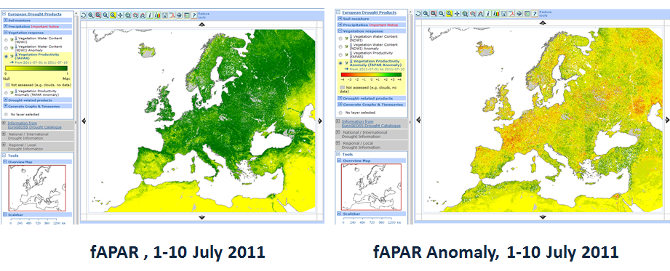

Figure 1: fAPAR (left) and fAPAR anomaly (right) images for the ten-day period of 1-10 July 2011, as shown on the EDO Map Server

Assessment of capacity for drought monitoring
Gobron et al. (2000, 2006a, 2006b) present an evaluation for different canopy radiation transfer regimes using the current fAPAR products derived from SeaWiFS against ground-based estimations.
The MGVI/fAPAR algorithm seems to perform better than NDVI as a drought indicator, as NDVI shows a much larger temporal variability than fAPAR, and does not always allow for the detection of droughts (Gobron et al. 2007).

References

Aussedat O., Taberner M., Gobron N., and Pinty B. (2007). MERIS Level 3 Land Surface Aggregated Products Description. Institute for Environment and Sustainability, EUR Report No. 22643 EN, 16pp.
Gobron, N., Pinty, B., Verstraete, M.M., and Widlowski, J.-L. (2000). Advanced Vegetation Indices Optimized for Up-Coming Sensors: Design, Performance and Applications. IEEE Transactions on Geoscience and Remote Sensing, 38: 2489-2505.
Gobron N., Pinty B., Mélin F., Taberner M., and Verstraete M. M. (2002). Sea Wide Field-of-View Sensor (SeaWiFS) - Level 2 Land Surface Products - Algorithm Theoretical Basis Document. Institute for Environment and Sustainability, EUR Report No. 20144 EN, 23 p.
Gobron N., Aussedat O., Pinty B., Taberner M., and Verstraete M. M. (2004). Medium Resolution Imaging Spectrometer (MERIS) - An optimized FAPAR Algorithm - Theoretical Basis Document. Revision 3.0. Institute for Environment and Sustainability, EUR Report No. 21386 EN, 20 p.
http://fapar.jrc.ec.europa.eu/WWW/Data/Pages/FAPAR_Home/FAPAR_Home_Publications/atbd_meris_v4_gen.pdf
Gobron N., Pinty B., Mélin F., Taberner M., Verstraete M.M., Belward A., Lavergne T., and Widlowski J.-L. (2005). The state vegetation in Europe following the 2003 drought. International Journal Remote Sensing Letters, 26 (9): 2013-2020.
Gobron, N., Aussedat, O., Pinty, B., Robustelli, M., Taberner, M., Lavergne, T. (2006a). Technical Assistance for the Validation the ENVISAT MGVI Geophysical Product. Final Report. EUR Report 22246 EN, European Commission - DG Joint Research Centre, Institute for Environment and Sustainability, 103pp.
Gobron, N., Pinty, B., Aussedat, O., Chen, J. M., Cohen, W. B., Fensholt, R., Gond, V., Lavergne, T., Mélin, F., Privette, J. L., Sandholt, I., Taberner, M., Turner, D. P., Verstraete, M. M., Widlowski, J.-L. (2006b). Evaluation of Fraction of Absorbed Photosynthetically Active Radiation Products for Different Canopy Radiation Transfer Regimes: Methodology and Results Using Joint Research Center Products Derived from SeaWiFS Against Ground-Based Estimations. Journal of Geophysical Research – Atmospheres, 111(13), D13110.
Gobron, N., Pinty, B., Mélin, F., Taberner, M., Verstraete, M.M., Robustelli, M., Widlowski, J.-L. (2007). Evaluation of the MERIS/ENVISAT fAPAR Product. Advances in Space Research 39: 105-115.
Pinty B., Gobron N., Mélin F., and Verstraete M.M. (2002). Time Composite Algorithm Theoretical Basis Document. Institute for Environment and Sustainability, EUR Report No. 20150 EN, 8 pp.
http://fapar.jrc.ec.europa.eu/WWW/Data/Pages/FAPAR_Home/FAPAR_Home_Publications/pinty_etal_ies_2002.pdf
Rossi, S., Weissteiner, C., Laguardia, G., Kurnik, B., Robustelli, M., Niemeyer, S., and Gobron, N. 2008. “Potential of MERIS fAPAR for drought detection”, in Lacoste, H., and Ouwehand, L. (eds.), “Proceedings of the 2nd MERIS/(A)ATSR User Workshop”, 22–26 September 2008, Frascati Italy (ESA SP-666), ESA Communication Production Office, November 2008. http://envisat.esa.int/pub/ESA_DOC/meris_workshop_2008/papers%20/p63_rossi.pdf

H (GROUNDWATER LEVEL)

Indicator Fact Sheet

Groundwater level (H)

Key message

The supply of cities and irrigation for a large part of Europe depend on groundwater. A very significant proportion of Europe's wetlands and rivers are also dependent on groundwater. Good Status of groundwater is critical to achieving environmental and socio-economics objectives of the EU. On the other hand, over-abstraction leads to groundwater depletion, with consequences like deterioration of water quality (e.g. saline water intrusion,less dilution of pollutants, adverse impacts on river ecology), loss of habitats (e.g. wetlands), modification of river/aquifer interactions, and ground subsidence.

Changes in groundwater levels can heavily relate to groundwater abstractions. Nevertheless, reduced groundwater levels can be also a result of climatic changes (reduced precipitation, increased temperature, increased runoff).

Relevance of the indicator to drought and/or water scarcity

Groundwater (GW) level in aquifers changes in response to natural and socioeconomic pressures (precipitation and/or temperature anomaly, soil properties, withdrawals for water supply, land use, etc.). Reduced volume of recharge can indicate hydrological drought, which will induce a decrease of renewable groundwater resources and potential impact on surface water and related ecosystems. To use groundwater level as an indicator of hydrological drought the impact of abstraction must be decoupled in order to assess the natural reduction in groundwater level (not the one caused by over abstraction).

Policy relevance

- Water Framework Directive WFD (Directive 2000/60/EC of the European Parliament and of the Council of 23 October 2000 establishing a framework for Community action in the field of water policy)

- Communication of the EC to the Council and European Parliament: “Addressing the challenge of water scarcity and droughts in the European Union” (published on July 2007)

Technical Information

1. Indicator
The groundwater level indicator is the period of return of the average monthly level observed for a measuring station, divided into five quantiles, the driest (represented in red) to the wettest (in dark blue):
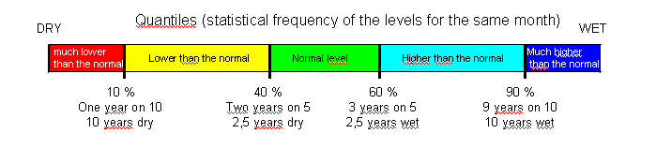
The reference period for monthly groundwater level of at least 12 consecutive years.

The comparison of the current monthly level with the above statistics provides a measure of the groundwater level in the aquifer compared to the reference level, indicating possible drought and water scarcity conditions, due to natural or anthropogenic factors (depending on whether the data reflect the natural GW level which is decoupled from abstraction fluctuations)

2. Spatial scale
Point data, measured at stations representative of a given aquifer. The aquifer must representative of groundwater that can be used for this purpose within the watershed or country.
3. Temporal scale
Month (average of daily values)
4. Methodology
a. Detailed methodology for the calculation of the indicator
To obtain the value of a groundwater level which corresponds to à given return period (5 years, 10 years, …) we use the following method :
1) On a monthly basis the flow duration curve (FDC, or empirical monthly cumulative frequency distribution) is computed ;
2) The FDC is split into five classes based on 4 quantile thresholds, namely Q90, Q60, Q40 and Q10 ;
3) The monthly observed value is compared with the FDC and assigned to the according class
b. Detailed methodology for the data manipulation
For a one month period, if the whole daily values are missing, we do not calculate the average monthly level. If there is at least one daily value, we calculate the average monthly level with the existing daily values. We do not rebuild time series when data are missing.
The station should theoretically record groundwater levels that are not influenced by abstraction, but in practice there is often an influence, even slight. A groudwater levels station must not be placed into an active well. When the levels are influenced by abstraction, we could recalculate “natural” levels from abstraction information but nowadays this information is not enough precise.
6. Quality Information
a. Strength & weaknesses at data level
Most of the groundwater level data are recorded with electronic equipment (sensors). During field inspections (every three months for stations equipped with data acquisition centres and every six months for stations equipped with long distance transmission data acquisition units), there is a probe measurement and sensor test and calibration of the sensor if necessary. If any drift in the sensor has been observed, the data are corrected. Each data has two codes of validity, in accordance with the specifications defined by SANDRE(French Data Reference Centre for Water, http://sandre.eaufrance.fr/ ).

b. Performance of the indicator
Despite the critical importance of groundwater resources in Europe there have been very few direct studies of the effect(s) of climate change on groundwater recharge. But it is obvious that the combined effect of changes in precipitation and temperature will in most cases increase or reduce groundwater recharge.
The indicator is relatively simple but significant ; it is comparable to others indicators like rainfall, efficient rainfall or streamflow indicators. It can be related to efficient rainfall that conditions the recharge.
The quality of the indicator mainly depends on data availability and accuracy which itself depends on the quality of equipment and maintaining. The objective is to produce more than 95% daily data (validated and correct) per year for each station with data acquisition units.

Indicator Assessment

Groundwater level (H)

Policy and Management context

☑ Awareness rising at EU and local level
☑ Monitoring and Management at local level
☑ Policy making at EU and local level
GW level indicator can be used for water policy, especially for restricting water use.
The proposed indicator, can be used to assess hydrological drought as well as water stress. When combined with other relevant WS&D indicators, it can be used for awareness raising purposes.

Environmental and Socio-economic context
The low groundwater level of an aquifer controls a wide range of water resource issues (quantity, quality, ecology, socio-economy). As the different water bodies (rivers, lakes, aquifers, wetlands) are hydraulically connected, groundwater level reduction will result in resources reduction, depressing of rivers flows and lake levels, shallowing or retreat of wetlands, in general reduction of water resources, imbalance in the natural water cycle and can lead to serious water stress and scarcity conditions.
Low groundwater level may be caused by periods of low rainfall during the period of recharge (generally in autumn and winter), but the effects can be prolonged or made worse by abstraction at critical periods. The aquifers are more or less sensitive to meteorological drought, depending on their inertia.
On the socio-economic side, during a drought, groundwater will be placed under even greater pressure with competition for water between different users. This will often result in abstractions for industry, agriculture or public being restricted or curtailed with attendant social and economic consequences.

Specific Assessment
a. Based on the indicator
The indicator can be presented on a graph on the local level and on a map on the national level
Example 1 : station 01086X0011/LS4 (GW body : Craie de Champagne nord - 3207 - FRHG207)
The indicator is presented on a graph.
GW level in 2010 is about 2.5 year dry from january to may, between 2.5 and 10 years dry from june to august, and between 2.5 and 10 years wet from september to december. In 2010 the recharge started in august when it starts only in october generally.

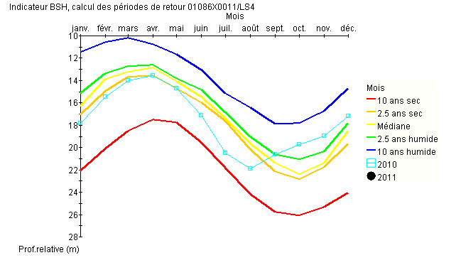
Source http://www.ades.eaufrance.fr/

Example 2 : National map of the groundwater level indicator of the hydrological situation bulletin (BSH)
The indicator is presented on a map. The following map shows the situation of groundwater level for the month of October 2008. The map shows that most of the aquifers in France have a normal or higher than normal level. But there is also in the south of France a few aquifers that have a very lower than normal level.
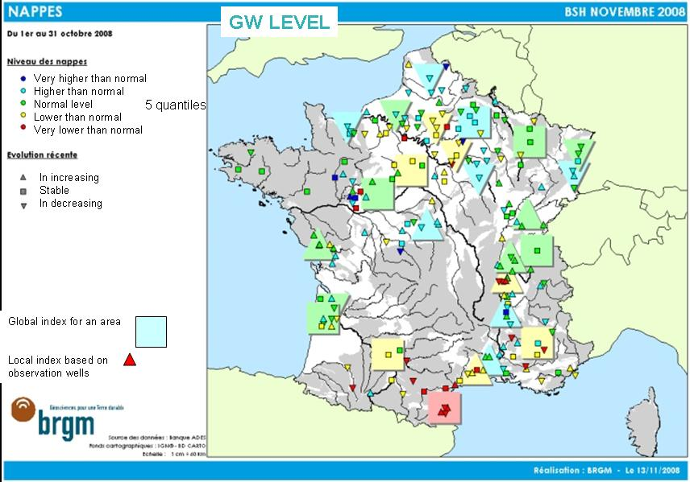
Source http://www.eaufrance.fr/spip.php?rubrique214&id_article=1

On a EU level, the same type of map could be presented.

UK does a similar analysis but on a month by month basis using 7 bands :

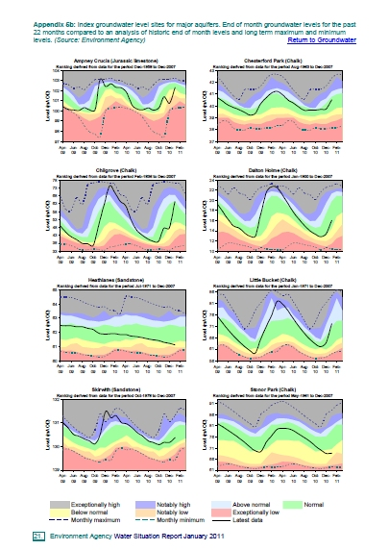
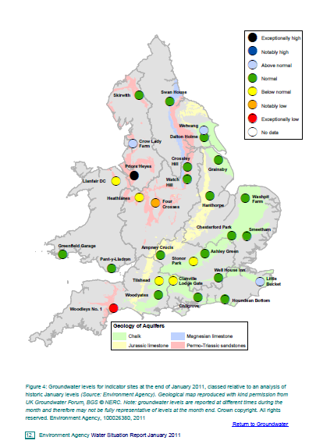

b. Other related assessment (based e.g. on performance indicators, literature)

References

SSPI (STANDARDIZED SNOWPACK INDEX)

Indicator Fact Sheet

SSPI: Standardized SnowPack Index

Indicator definition
The availability of water in rivers, lakes and ground is mainly related to precipitation. However, in the cold climate when precipitation falls in the form of snow, water is stored in the snowpack and this will decrease runoff and ground water recharge during the winter months and, on the other hand, contribute to the increased runoff during the spring and early summer. Changes in this pattern may cause serious shortfalls in the availability of water. The warming climate is predicted to decrease snowpack, cause snowmelt during winter and decrease the springtime snowmelt. Also the expected increased variation in the climate pattern will cause grater variations in the snowpack. Lack on snowmelt can increase possibilities for drought during the spring and early summer, which is an important growing period for plants and crops.
The SSPI is computed the same way as the SPI (Standardized Precipitation Index), except for being based on the daily snowpack water equivalent (=kg/m² of snow) time series. The SSPI provides information of the relative volume of the snowpack in the catchment on a ten-daily and monthly basis compared to the period of reference.
The indicator can be used for awareness raising, evaluation of occurred droughts, forecasting future drought risks and management purposes.

Relevance of the indicator to Drought
Snowpack in river basins changes in response to air temperature and precipitation. Snowpack is a natural water reservoir which human cannot control. In the northern parts of Europe and in the mountains snowpack is an essential part of water cycle.
Snowpack indicator only applies in those regions where snowpack accumulation is regular annually. These regions in the EU are mainly the Nordic countries, the Alps, the Pyrenees and the Carpathian Mountains. Nevertheless, the impact of snowpack to the hydrology is not limited only to these regions. Several large Central Europe rivers’ flow, e.g. the Rhein, partly depends on the melting snowpack of the Alps. The snowmelt increases streamflow and improves water balances in reservoirs and aquifers. This has great significance for all water uses during spring and summer when precipitation in often scarce and the need of water is high, particularly for agriculture.
Snowpack interacts with droughts in several ways. In the case of meteorological drought, melting of the snowpack can postpone the occurrence of low river flows and thus hydrological drought. Positive SSPI values during late winter and spring indicates low risk of hydrological drought in early summer. On the contrast, negative values of SSPI during late winter and spring indicate high risk of hydrological drought in early summer. The SSPI indicator needs to be used hand in hand with SPI and SRI indicators: e.g. SSPI values might be negative during winter, but still the risk of drought during spring and early summer is not high if the SPI and SRI indicators are at the same time showing high positive values.
It is also possible that early snowpack prolongs hydrological drought; e.g. if winter comes early during ongoing drought, rainfall won't increase runoff, streamflow and groundwater recharge since the rain is stored into the snowpack. Thus positive values of SSPI during autumn and winter may indicate hydrological drought if the summer has been dry.
The relevance of the SSPI indicator to drought varies around Europe and it is not only related to the regularity of snowpack accumulation but also to the hydrological differences between river basins (e.g. size, number of lakes and reservoirs, etc.).
In addition the indicator is extremely relevant to flood risk management in forecasting the spring floods at least in Northern parts of Europe.

Policy relevance
Water Framework Directive WFD (Directive 2000/60/EC of the European Parliament and of the Council of 23 October 2000 establishing a framework for Community action in the field of water policy)
- Environmental objectives: Exemption for temporary deterioration in the status (Art. 4 (6))
- Programme of measures: Additional measures are not practicable (Art. 11 (5))

Communication of the EC to the Council and European Parliament: “Addressing the challenge of water scarcity and droughts in the European Union” (published on July 2007)
- Improving drought risk management
- Developing drought risk management plans (Paragraph 2.3.1.)
- Developing an observatory and an early warning system on droughts (Paragraph 2.3.2.)
- Use of the EU Solidarity Fund (Paragraph 2.3.3.)
- Improve knowledge and data collection: Water scarcity and drought information system (Paragraph 2.7.1.)

Technical Information

1. Indicator
The SSPI is similar to the SPI, SRI and fAPAR indicators. The SSPI is computed the same way as the SPI, except for being based on the daily snowpack water equivalent (SWE) time series. The Standardized Snowpack Index (SSPI) gives snowpack values as standardised values between -3 to 3 calculated from snowpack values water equivalent in mm in water (=kg/m² of snow). The intensity of snowpack is classified into the following seven categories:
SSPI Values | Category | Cumulative Probability | Probability of Event [%]
SSPI ≥ 2.00 | Highly more than normal | 0.977 – 1.000 | 2.3%
1.50 < SSPI ≤ 2.00 | Much more than normal | 0.933 – 0.977 | 4.4%
1.00 < SSPI ≤ 1.50 | More than normal | 0.841 – 0.933 | 9.2%
-1.00 < SSPI ≤ 1.00 | Near normal | 0.159 – 0.841 | 68.2%
-1.50 < SSPI ≤ -1.00 | Less than normal | 0.067 – 0.159 | 9.2%
-2.00 < SSPI ≤ -1.50 | Much less than normal | 0.023 – 0.067 | 4.4%
SSPI < -2.00 | Highly less than normal | 0.000 – 0.023 | 2.3%

2. Spatial scale
Regional data; modelled for 25 km x 25 km grids in the catchment (soon 10 km X 10 km). The model uses remote sensing from the satellites.
The SSPI can be calculated for any given area in Europe, e.g. river basin district, river basin or sub-basin.
3. Temporal scale
Daily values. Remote sensing gives real time observations once a day.
4. Methodology
a. Detailed methodology for the calculation of the indicator
Detailed guidelines on the methodologies to model snowpack water equivalent (SWE) values in the catchment can be obtained from the Finnish Meteorological Institute FMI (see par. 5.).
The SSPI is calculated using the same methodology as in the SPI to define the SSPI as the unit standard normal deviate associated with the percentile of snowpack accumulated over a specific duration. Computation of the SSPI involves fitting a probability density function (PDF, e.g. gamma PDF) to a given frequency distribution of daily snowpack. As in the same case of SPI, the PDF parameters are then used to find the cumulative probability of an observed snowpack. This probability is then transformed to the standardized normal distribution with mean zero and variance one, which results in the value of the SSPI.
The mathematical formula to calculate the SSPI is:
SSPI_{y,d,k} is the average k-day (k = 10 or 30) Standardized Snow Pack Indicator for day d year y:

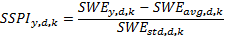

where SWE_{y,d,k} is the k-day SWE for year y and day d, and SWE_{avg,d,k} is the k-day average SWE for day d based on years 1979-2010:

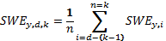

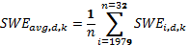

and SWE_{std,d,k} is the standard deviation of k-day SWE for day d from years 1979-2010

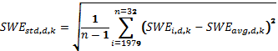

The SWE data is provided and the SSPI is calculated by the FMI for whole EU.

b. Reference period for calculating the Statistics

The SWE data is available as daily values since 1979. Reference period 1979-2010 is used.

5. Data source and frequency of data collection
European Space Agency's (ESA) GlobSnow project led by the Finnish Meteorological Institute (FMI) has developed and provides snowpack water equivalent (SWE) values for the whole Northern Hemisphere. The SWE data is based on passive microwave radiometer data combined with ground-based synoptic snow observations. The SSPI is calculated based on SWE values by the FMI for the whole EU.
For more information, contact the FMI:
Principal Investigator Jouni Pulliainen, firstname.lastname@fmi.fi
Project Manager Kari Luojus, firstname.lastname@fmi.fi
www.globsnow.info

6. Quality Information
a. Strengths & weaknesses at data level
Strength of the data is that it presents only natural variation since there is now human abstraction from the snowpack. It is also strength that the data is congruent throughout the Europe since the data is collected through same methodology.
The weakness of the data is that there are still some difficulties to estimate the snowpack in the mountains. Improvements regarding this issue are being made to the product (e.g. going from 25 km grids to 5 km grids). Testing of the data together with the Swiss snowpack data (done together with the WSL Institute for Snow and Avalanche Research SLF) shows that the GlobSnow data underestimates the actual snowpack in the mountains during high snowpack occurrence. Otherwise the data has consistent behaviour and it is suitable for detection of anomalies. The data is suitable for the calculation of the SSPI indicator since the indicator is calculated as anomalies from the time series (probabilities) and not as specific values of snowpack (cp. SPI).

Testing exercise of the GlobSnow data (AMSR-E) compared to the Swiss data (OSHD) of monthly mean snowpack values (mm of water) over Switzerland.
b. Performance of the indicator
This indicator is already available and calculated automatically daily for the whole Europe by the FMI.
The use of the indicator is straightforward, but the indicator is not comprehensive to assess or to forecast droughts by itself, since runoff from the snowpack is only part of the whole runoff of the catchment area. The SSPI needs to be used hand in hand with SPI and SRI.
Products
SSPI can be presented in the form of maps and graphs, providing information both on the spatial distribution of the snowpack and the temporal evolution over longer time periods. Gridded data can easily be aggregated over administrative or natural entities such as hydrological watersheds, RBD’s, etc. This allows for the qualitative and quantitative comparison of the intensity and duration of this pressure on water resources with recorded impacts such as yield reductions, low flows, or lowering of groundwater levels, for example.

Example of a monthly Standardized Snowpack Index SSPI for the EU as grid data, Winter 2005 – 2006

The SSPI is under the process to be put into the European Drought Observatory (EDO) so that it can be viewed through same map server as the already existing EDO indicators SPI, fAPAR and Soil moisture.
First example of the SSPI displayed in EDO (note that this is just a test display produced in order to develop the online data transfer between FMI and EDO, e.g. the legend is not correct, etc.):
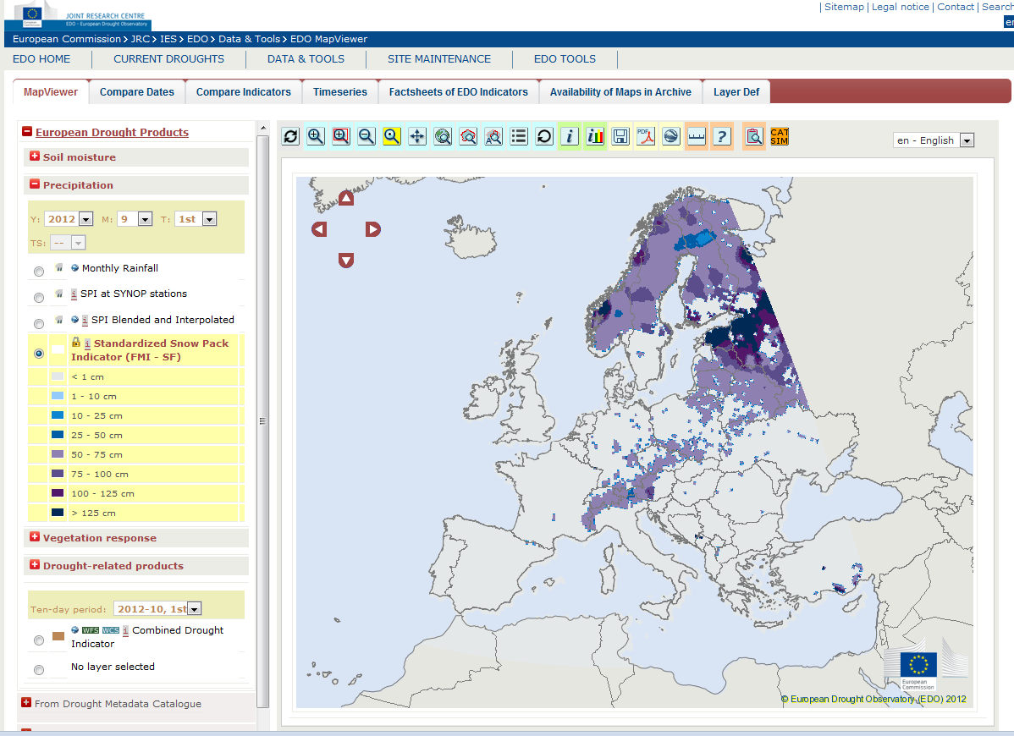
TEST EXAMPLE

References
Pulliainen, J, 2006. Mapping of snow water equivalent and snow depth in boreal and sub-arctic zones by assimilating space-borne microwave radiometer data and ground-based observations. Remote Sensing of Environment, vol. 101, pp. 257-269.
Takala, M., Pulliainen, J.,Metsämäki, S. and Koskinen, J., 2009. Detection of Snowmelt Using Spaceborne Microwave Radiometer Data in Eurasia from 1979 to 2007. IEEE Transactions on Geoscience and Remote Sensing, vol. 47, no. 9, pp. 2996-3007.
Takala, M., Luojus, K., Pulliainen, J., Derksen, C., Lemmetyinen, J., Kärnä, J.-P., Koskinen, J. and Bojkov, B., 2011. Estimating northern hemisphere snow water equivalent for climate research through assimilation of space-borne radiometer data and ground-based measurements. Remote Sensing of Environment, doi:10.1016/j.rse.2011.08.014.

SOIL MOISTURE
Document | Author / Edited by | Date | Distribution
Soil Moisture  Indicator fact sheet_v.3 |  | 06.20.2011
Abbreviations:
HFE: Henriette Faergemann (DG ENV) | Henriette.Faergemann@ec.europa.eu
ANA: Andrea Nam | Andrea.NAM@ec.europa.eu
MKO: Maggie Kossida (ETC/W) | mkossida@chi.civil.ntua.gr
BWE : Beate Werber (EEA) | Beate.Werner@eea.europa.eu
RCO : Robert Peter Collins (EEA) | Robert.PeterCollins@eea.europa.eu
JVO: Jurgen Vogt (JRC) | juergen.vogt@jrc.ec.europa.eu
GSM: Guido Schmidt (Tecnoma) | gschmidt@tecnoma.es
MGA: Maria Conception Garcia Gomez (ES) | MCGGomez@marm.es
SCR: Stephanie Croguennec (FR) | Stephanie.CROGUENNEC@developpement-durable.gouv.fr
TDA: Tierry Davy (FR) | thierry.davy@scarlet.be
GBO: Guiseppina Monacelli (IT) | giuseppina.monacelli@isprambiente.it
LDI: Luit-Ja Dijkhuis (NL) | Luit-Jan.Dijkhuis@minvenw.nl
MAK: Marta Konkoly (HU) | marta.konkoly@vm.gov.hu
PKO: Peter Kozak (HU) | Kozakp@atikovizig.hu
OPU: Osmo Purhonen (FI) | osmo.purhonen@ely-keskus.fi

Indicator Fact Sheet

Soil moisture

Key message
Droughts cause the reduction of soil moisture, affecting the potential agriculture productivity of the affected area and increasing the water stress. Soil Moisture and Soil moisture anomalies (the deviation form the long term mean for a certain period of time) are considered good indicators to detect and assess drought impacts on agriculture.

Relevance of the indicator to drought and/or water scarcity
Information on soil moisture is presented in form of soil suction (pF) values of the top soil layer. The pF value describes the forces necessary for plants to apply in order to extract water from the soil for their use. It incorporates variations in the water holding capacity of different soil types and thus allows for comparison of the soil water status at different locations throughout Europe.
Information on soil moisture is also presented in form of Soil Moisture Anomaly. Anomalies are obtained using the Gamma distribution.
The WMO (world Meteorological Organization) considers the soil moisture as a relevant indicator for monitoring and assessing agricultural droughts owing to its importance for agriculture productivity and the associated impacts on society.

Policy relevance
- Water Framework Directive WFD (Directive 2000/60/EC of the European Parliament and of the Council of 23 October 2000 establishing a framework for Community action in the field of water policy)

- Communication of the EC to the Council and European Parliament: “Addressing the challenge of water scarcity and droughts in the European Union” (published on July 2007)

Technical Information

1. Indicator
Information on soil moisture is presented in form of soil suction (pF) values of the top soil layer that commonly range between 1.5 for very wet conditions up to 5.0 for very dry soils.
Information on Soil Moisture Anomaly is presented in number of Standard Deviations from the average.
2. Spatial scale
The spatial resolution is 5Km.
3. Temporal scale
Every 10 days aligned on the first day of each month, which corresponds to 3 images per month (day 1-10, day 11-20, day 21-last day of month).
Monthly and annual averages have been assessed.
4. Methodology

- Detailed methodology for the calculation of the indicator
Values show an instantaneous image of the top soil water content as modelled by LISFLOOD. Meteorological input information is derived from measured and spatially interpolated meteorological point data provided by the MARS (now Agri4Cast) activity of IPSC. Data are received via the Global Telecommunication System of WMO and further processed, which results in a one to two days delay before data are shown online.
The monthly soil moisture data as can be compared to the long-term monthly average of soil moisture at each location, resulting in a normalized soil moisture anomaly indicator that allows for the evaluation of the current situation as compared to a climatological average. Two long-term meteorological datasets have been applied to simulate a pseudo-climatology of soil moisture for Europe:
- Measured meteorological data from JRC-MARS. The original daily meteorological point data are spatially interpolated and comprise the period 1990 to 2009, i.e. a period of 19 years.
- Re-Analysis data of the European Centre for Medium-Range Weather Forecasts (ERA-40) that comprise the period 1958-2001 (i.e. 44 years) and provide a consistent set of forecasted meteorological parameters.
Soil Moisture Anomaly assessment is based on the statistical procedure used for precipitation to obtain SPI. A Standardized Soil Moisture Index (SSmI) is obtained.

5. Data source and frequency of data collection
Data are received via the Global Telecommunication System of WMO and further processed, which results in a one to two days delay before data are shown on-line on the EDO website.
Frequency of data collection: every 10 days. Monthly averages are calculated.
6. Quality Information
a. Strength & weaknesses at data level
[+] Every ten days, at a high spatial resolution (~5km) for the entire Europe.
[-] This indicator might be affected by non natural factors when assessed in irrigated areas, where soil moisture can be increased artificially by means of the associated hydraulic infrastructure, using alternative water sources. Therefore, the area where this indicator will be assessed must be carefully selected.
[-] Anomalies depend on the length of the time series used to calculate the long-term average.
b. Performance of the indicator
The estimation and interpretation of the indicator, is easy and simple.

Indicator Assessment

Soil Moisture

Policy and Management context

☑ Awareness rising at EU and local level
☑ Monitoring and Management at local level
☑ Policy making at EU and local level

Environmental and Socio-economic context
The proposed indicator can be used to assess drought impacts on agriculture, providing stakeholders with information potentially useable for water and agricultural management.

Specific Assessment
a. Based on the indicator
Soil moisture and soil moisture anomalies can be presented in the form of maps and graphs, providing information both on the spatial distribution of the soil moisture and the temporal evolution over longer time periods. Gridded data can easily be aggregated over administrative or natural entities such as hydrological watersheds.
The EDO Mapserver displays the latest available Soil moisture 10-day composite image and the Soli moisture anomaly image calculated comparing this image to the historical series in the same 10-day period.
The Soil Moisture product is ranging from 5 (drier) to 1.5 (wetter) in terms of real values, and from red to green on the map, with 1.5 corresponding to a maximum Soil moisture value.
The Soil moisture anomaly Indicator is ranging from -2.5 to +2.5, and from red to green, red showing negative anomalies.
Both products are easy to read.
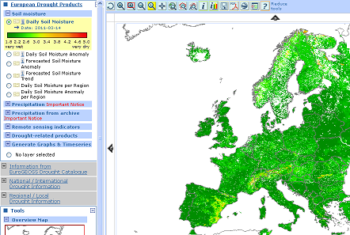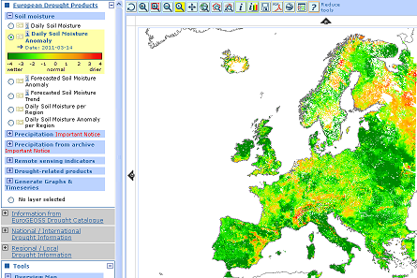
Figure 1: Soil moisture (left) and Soil moisture anomaly (right) images produced by the processing chain within EDO for the 14th of March, 2011

Length of time series: a 21 years length time series is used, with data from 1990 to 2011 kindly provided by JRC.
As for Soil Moisture, monthly averages are calculated. Also an average for the whole Segura River Basin has been obtained.
As for Soil Moisture Anomaly, the normalization process has been based on the use of a Gamma Distribution, treating each month of the year individually (twelve series of 21 data each have been processed) in order to obtain the deviation from the average value of soil moisture for each month of the year.
b. Segura River Basin
Soil moisture does not seem to provide relevant information of the drought periods observed in the Segura river Basin during the last 20 years. It shows a cyclical pattern on a yearly basis, but there are only slight differences from one year to another.

Figure 2: Soil moisture in the Segura River Basin from 1990 to 2010

Soil moisture anomaly

Figure 3: Soil moisture Anomaly-1 in the Segura River Basin from 1990 to 2010
Soil moisture anomaly provides valuable information from the point of view of drought monitoring since it is showing deviations from normal trends. Monthly values of the Soil Moisture Anomaly obtained (equivalent to a Standardized Soil moisture Index-1, SSmI-1) are a bit erratic but drought trends are properly represented.
Annual averages of the Soil Moisture Anomaly obtained (equivalent to a Standardized Soil moisture Index-12, SSmI-12) provide a smoother graph but drought trends are properly represented as well.
Figure 4: Soil moisture Anomaly-12 in the Segura River Basin from 1990 to 2010
Regarding the Soil Moisture Anomaly performance in the Segura River Basin, it represents fairly well the drought period suffered in the Basin during the mid 90’s, although the last drought period of the Basin, which took place from 2005 to 2009, does not seem to be properly described by the indicator. Moreover, severity thresholds do not seem to represent properly well the real severity of former droughts.
In addition, the assessment of the indicator on irrigated areas may provide information of non-natural conditions. Therefore, assessment area will have to be carefully selected.

References
Segura River Basin Drought Management Plan (2007)

SPI (STANDARDIZED PRECIPITATION INDEX)

Indicator Fact Sheet

SPI: Standardized Precipitation Index

Indicator definition
The Standardized Precipitation Index (SPI-n) is a statistical indicator comparing the total precipitation received during a period of n months with the long-term rainfall distribution for the same period of time. SPI is calculated on a monthly basis for a moving window of n months, where n indicates the rainfall accumulation period, which is typically of 1, 3, 6, 9, 12, 24 and 48 months. The corresponding SPIs are denoted as SPI-1, SPI-3, SPI-6, etc.
In order to allow for the statistical comparison of wetter and drier climates, SPI is based on a transformation of the accumulated precipitation into a standard normal variable with zero mean and variance equal to one. SPI results are given in units of standard deviation from the long-term mean of the standardized distribution.
In 2010 WMO selected the SPI as a key meteorological drought indicator to be produced operationally by meteorological services.

Relevance of the Indicator to Drought
A reduction in precipitation with respect to the normal precipitation amount is the primary driver of drought, resulting in a successive shortage of water for different natural and human needs. Since SPI values are given in units of standard deviation from the standardised mean, negative values correspond to drier periods than normal and positive values correspond to wetter periods than normal. The magnitude of the departure from the mean is a probabilistic measure of the severity of a wet or dry event.
Since the SPI can be calculated over different rainfall accumulation periods, different SPIs allow for estimating different potential impacts of a meteorological drought:
- SPIs for short accumulation periods (e.g., SPI-1 to SPI-3) are indicators for immediate impacts such as reduced soil moisture, snowpack, and flow in smaller creeks;
- SPIs for medium accumulation periods (e.g., SPI-3 to SPI-12) are indicators for reduced stream flow and reservoir storage; and
- SPIs for long accumulation periods (SPI-12 to SPI-48) are indicators for reduced reservoir and groundwater recharge, for example.

The exact relationship between accumulation period and impact depends on the natural environment (e.g., geology, soils) and the human interference (e.g., existence of irrigation schemes). In order to get a full picture of the potential impacts of a drought, SPIs of different accumulation periods should be calculated and compared. A comparison with other drought indicators is needed to evaluate actual impacts on the vegetation cover and different economic sectors.

Policy Relevance

Water Framework Directive WFD (Directive 2000/60/EC of the European Parliament and of the Council of 23 October 2000 establishing a framework for Community action in the field of water policy)
- Environmental objectives: Exemption for temporary deterioration in the status (Art. 4 (6))
- Programme of measures: Additional measures are not practicable (Art. 11 (5))

Communication of the EC to the Council and European Parliament: “Addressing the challenge of water scarcity and droughts in the European Union” (published on July 2007)

- Improving drought risk management
- Developing drought risk management plans (Paragraph 2.3.1.)
- Developing an observatory and an early warning system on droughts (Paragraph 2.3.2.)
- Use of the EU Solidarity Fund (Paragraph 2.3.3.)
- Improve knowledge and data collection: Water scarcity and drought information system (Paragraph 2.7.1.)

Technical Information

1. Indicator
SPI gives the number of standard deviations from standardised mean rainfall for a particular location and period of time and as such reflects the statistically expected frequency (and probability) of a given event. The intensity of a dry or wet period is usually classified into the following seven categories:

SPI Values Category Cumulative Probability Probability of Event [%]
SPI ≥ 2.00 Extreme wet 0.977 – 1.000 2.3%
1.50 < SPI ≤ 2.00 Severely wet 0.933 – 0.977 4.4%
1.00 < SPI ≤ 1.50 Moderately wet 0.841 – 0.933 9.2%
-1.00 < SPI ≤ 1.00 Near normal 0.159 – 0.841 68.2%
-1.50 < SPI ≤ -1.00 Moderately dry 0.067 – 0.159 9.2%
-2.00 < SPI ≤ -1.50 Severely dry 0.023 – 0.067 4.4%
SPI < -2.00 Extremely dry 0.000 – 0.023 2.3%
The SPI can be computed for any timescale of interest to the user, reflecting potential impacts from the agricultural, hydrological and water supply management perspectives (see above).
2. Spatial Scale
Point data, derived from observations at rain gauge stations, which may be interpolated to a regular grid at a spatial scale appropriate to the station density.
Gridded data at 0.5º, 1.0º, 2.5º derived from readily available climatological datasets such as the Global Precipitation Climatology Centre (GPCC) and the Global Precipitation Climatology Project (GPCP).
3. Temporal Scale
Typically of 1-, 3-, 6-, 12-, 24-, 48-months, or even longer time-periods depending on the potential impact and regional characteristics. For statistical reasons a minimum rainfall accumulation period of one month is recommended. SPI is then calculated for every month with a moving window of the selected time-length.
4. Methodology
a. Detailed Methodology for the calculation of the indicator
Computation of the SPI involves fitting a probability density function to a given frequency distribution of precipitation totals for a station or grid point and for an accumulation period. Typically the gamma probability density function is used, but others, such as the Pearson-III probability density function may also be used (see below). The statistics for the frequency distribution are calculated on the basis of a reference period of at least 30 years (see point 4.b).
The parameters of the probability density function are then used to find the cumulative probability of an observed precipitation event for the required month and temporal scale. This cumulative probability is then transformed to the standardised normal distribution with mean zero and variance one, which results in the value of the SPI. The procedure of transforming the observed rainfall via the cumulative distribution functions (CDFs) of the Gamma distribution and the standardised normal variable to the SPI is illustrated in Figure 1:

Figure 1: Transformation of the observed rainfall via the Gamma cumulative distribution function (CDF) and the CDF of the standardized normal variable to the SPI.
Two statistical distributions have been shown to perform equally well in estimating the SPI: the Gamma and the Pearson-III distributions. The Gamma distribution has been adopted by most centres around the world as a model from which to compute SPI. It is described by only two parameters, but offers considerable flexibility in describing the shape of the distribution, from an exponential to a Gaussian form. It has the advantage that it is bounded on the left at zero and therefore excludes the possibility of negative precipitation. Additionally, it is positively skewed with an extended tail to the right, which is especially important for dry areas with low mean and a high variability in precipitation.
However, for some stations and SPI timescales, distributions such as the beta, Pearson-III or normal distributions may fit the observations better. Ultimately the requirement is to obtain the best estimate of the probability of the observed precipitation to be transformed to the standard normal distribution for SPI. It therefore follows that the best estimate of SPI will come from the distribution that best fits the station data.
As a general rule, it is recommended to use the Gamma distribution as the standard model. If, however, a satisfactory fit cannot be achieved, alternative distributions should be tested.
A more detailed description of the procedure for calculating the SPI, including the mathematical formulations, can be found at http://climate.colostate.edu/pub/spi.pdf (Colorado State University).

Further references are provided at the end of this fact sheet. A detailed example of how to compute the SPI using the R statistics package is provided in Annex A.
b. Reference period for calculating the Statistics
The World Meteorological Organization (WMO) recommends that precipitation totals for the at least 30 years are used as reference time-line for calculating rainfall statistics. Several investigators recommend calculating the statistics for the SPI from even longer time periods (e.g., 50 or more years) in order to ensure an accurate representation of extreme events. The current WMO standard reference period is 1961-1990. However several Member States use more recent periods (e.g., 1971-2000, 1981-2010) in order to accommodate changes in the precipitation regime due to climate change and to compare actual rainfall figures to a more recent situation. In order to ensure comparability of the results across Europe and across scales it is highly recommended to use a common reference period for the calculation of the SPI. Considering the results of an inventory of the reference periods used in various Member States, the specific needs for accurately representing extreme events, and possible changes in the rainfall regimes due to climate change, the Water Scarcity and Drought Expert Group strongly recommends using the period January 1971 to December 2010 as Reference Period for the calculation of the SPI.
In the case that a lack of data would significantly restrict the number of rainfall stations to be used, a shorter reference period may be used (e.g., 1981-2010). However, in all cases, the Reference Period used should be clearly indicated with all data presented.
5. Data source and frequency of data collection
Station precipitation data can be taken from high resolution national rain gauge networks or from lower resolution WMO SYNOP stations. Data should be available with at least a monthly time step. Historical time series should be homogeneous and as complete as possible. WMO recommends a maximum of 5 years of missing data (maximum 3 years in a row) over a 30 years period.
As a further check on the data, it is recommended that a threshold of 90% completeness be applied for all SPI timescales and months. For example, for the SPI-1 for May, there must be at least 0.9*31=28 days with observations; and for the SPI-3 for May, there must be at least 0.9*(31+30+31)=83 days with data. Furthermore, in order to have enough data to fit a distribution for the reference period, 90% of the years must have valid data for the month and SPI timescale. For example, for the SPI-3 for May and a 30-year reference period, 0.9*30=27 years must have 3-month accumulations for May with at least 83 days of observations.
For data visualization, it is necessary to interpolate the SPI to a grid. The resolution of the grid should be chosen based on the density of the stations. No advantage is gained from interpolating sparse station data to a high resolution grid, and such an approach may result in misleading information. Since the SPI is a measure of the deviation from normal at a particular time and location, the localised effects of factors such as topographic barriers, sea breezes, land surface type etc. on rainfall are already included in the measure. Therefore the simplest interpolation methods are preferred. Recommended methods are the basic inverse distance method or the Cressman/Barnes method, which uses a successive correction technique to take advantage of higher station densities where they exist (see Xia et al. 1999, Barnes 1973, Cressman 1959). For details of the implementation of the Cressman/Barnes method see, for example, http://www.atmos.millersville.edu/~lead/Obs_Data_Assimilation.html).
Gridded data interpolated from rain gauges at 1º resolution are available from GPCC¹. GPCC “First Guess” data are available monthly on the 5th of each month, and final analyses are available through the GPCC monthly monitoring product 2 months after the end of the month.
Gridded data at 2.5° spatial resolution, interpolated from rain gauges and satellite remote sensing observations are available from GPCP² monthly, typically 2 months after the end of each month.
6. Quality Information
a. Strength & Weaknesses at data Level
Quality of the index depends on the quality of the precipitation time-series used for the computation, namely on the density of rain-gauges used and on the time length, availability and quality of the precipitation data. It is often desirable to interpolate the SPI in order to represent the index at locations other than the station. It is preferable to compute SPI at the stations first and then interpolate rather than interpolate the precipitation first and then compute the SPI. This is because, in order to obtain a distribution fit that best describes the precipitation data, it is important that the observations come from the same population. It is also possible to increase the number of observations used to compute the distribution parameters by clustering stations that have similar statistical properties. One such approach, amongst many that are available for achieving this, is to use to L-moments of the data to regionalize the stations as described in Hosking and Wallis 1997,
b. Performance of the Indicator
The indicator is relatively easy to calculate and straightforward to interpret. Care needs to be taken in arid areas with generally low precipitation, where the distribution of rainfall data is significantly deviating from a normal distribution. Here specific care has to be taken in estimating the parameters of the distribution in order to adequately parameterize the tails.
Since the gamma distribution is bounded on the left at zero, it is not defined for zero precipitation. If the data includes observations of zero precipitation a mixed distribution is used that takes account of the probability of zero precipitation and the cumulative probability H(x) becomes
H(x) = q + (1-q)G(x),
where q is the probability of zero, calculated from the frequency of zero precipitation observations in the time series, and G(x) is the cumulative probability calculated from the gamma distribution for non-zero observations.
This approach introduces two problems for regions with many observations of zero precipitation. Firstly, the minimum value SPI can take is determined by the probability of zero – for example if the probability of zero is 0.5, the minimum possible value of SPI is 0 (see Figure 1). Secondly, with fewer observations to compute the parameters of the gamma distribution the fit becomes less well defined. Therefore, for regions with a high probability of zero rainfall, the SPI should be interpreted with care and, where possible, alternative drought indicators should be used in addition. A high probability for zero rainfall is characteristic of an arid climate and in such cases the concept of a drought needs to be adapted. In such cases it may be useful to restrict the calculation and analysis to the normal rainy season(s). In Europe this applies to very limited areas.
Monthly precipitation data are readily available. Depending on the station density, the spatial representativity of interpolated SPIs will vary.
The indicator is suitable for probabilistic forecasting, using ensemble forecasts of precipitation fields.
The indicator can readily be integrated with other indicators.

Products
SPI can be presented in the form of maps and graphs, providing information both on the spatial distribution of the precipitation deficit and the temporal evolution over longer time periods. Gridded data can easily be aggregated over administrative or natural entities such as hydrological watersheds. This allows for the qualitative and quantitative comparison of the intensity and duration of the precipitation deficit with recorded impacts such as yield reductions, low flows, or lowering of groundwater levels, for example.
The European Drought Observatory (EDO) displays the latest available SPI maps (see Fig. 2).

Figure 2: Example of a 3-months SPI (SPI-3) over Europe as displayed on the Map Server of the European Drought Observatory (http://edo.jrc.ec.europa.eu) and of a time series of SPI-1 and SPI-3 for the region of Emsland (DE) from January 2005 to April 2011.

The color scale is ranging from extremely dry (red) to extreme wet (dark green). Data are shown as grids or aggregated to administrative regions. Tools for displaying historical maps of SPI (gridded or aggregated) will be added in order to ease the analysis of historical events. More detailed information can be shown based on the analysis of data from national and regional networks of higher spatial density. Possibilities to aggregate the information to relevant natural units such as river basins and sub-basins will be implemented.
Graphs showing the SPI time series for a particular region or point can be displayed clicking on the region or grid point. The length of the historical time-series to be displayed can be selected.

References
Barnes S.L., Mesoscale Objective Map Analysis Using Weighting Time-Series Observations. NOAA Tech. Memo. ERL NSSL-62. US Dept. of Commerce, 60pp, 1973.
Cressman G.P., An Operational Objective Analysis System. Monthly Weather Review, 87: 367-374, 1959.
Guttman N.B., Accepting the Standardized Precipitation Index: A Calculation Algorithm. Journal Of The American Water Resources Association, 311-322, Vol 35, 2, 1999.
Giddings L., Soto M., Rutherford, B.M., and Maarouf A., Standardized Precipitation Index Zones for México. Atmósfera, 33-56, 2005
Hosking J.R.M., Wallis J.R., Regional Frequency Analysis: An Approach Based on L-Moments. Cambridge University Press. 1997.
Lloyd-Hughes B., Saunders M.A., A Drought Climatology for Europe. Int. J. Clim., 22: 1571-1592, 2002.
McKee T.B., Doesken N.J., Kleist J., The Relationship of Drought Frequency and Duration to Time Scales. Proc. 8th Conf. on Appl. Clim., 17-22 Jan. 1993, Anaheim, CA, 179-184, 1993.
McKee T.B., Doesken N.J., Kleist J., Drought Monitoring with Multiple Time Scales. Proc. 9th Conf. on Appl. Clim., Dallas, TX, 233-236, 1995.
WMO, Guide to Climatological Practices. 3rd Edition, 2010.
Wu H., Hayes M., Wilhite D. and Svoboda M., The Effect of the Length of Record on the SPI Calculation. Int. J. Clim., 25: 505-520, 2005.
Xia Y., Winterhalter M., Fabian P., A Model to Interpolate Monthly Mean Climatological Data to Bavarian Forest Climate Stations. Theoretical and Applied Climatology, 64: 27-38, 1999.

SRI (STANDARDIZED RUNOFF INDEX)

Indicator Fact Sheet

Standardized Runoff Index (SRI)

Key message
Even though the availability of water in watersheds mainly depends on rainfall, information on other components of the hydrological cycle, such as runoff, improves insight into the situation of the basin in relation to drought. Increasing the knowledge about the dynamics of flows in European basins, will improve the knowledge of plausible trends of hydrological drought events in order to take appropriate measures both to conserve aquatic ecosystems and minimize impacts on water uses. The streamflow, as a component of the hydrological cycle, is related to infiltration, ground water dynamics, superficial runoff, soil moisture, etc., therefore time-response of runoff against precipitation will depend on the characteristics of the basin: size, complexity, artificial regulation, etc.
So far SPI has been used in many places as the sole indicator of drought, but as described above, other elements of the hydrologic cycle, as runoff, must be considered to obtain a more complete understanding of the basin in terms of drought. After the analysis of some streamflow indicators, SRI has been chosen as a suitable indicator for hydrological drought since the methodology is sufficiently contrasted (since is based on SPI), it is easy to apply, the results are suitable and easy to be interpreted and it can be applied in a wide rage of basins. SRI takes into account, in addition to precipitation, other elements of the hydrologic cycle that are relevant in many basins and are difficult to be modeled, thus it is convenient to consider SRI as a complement of SPI.

Relevance of the indicator for drought and/or water scarcity
This factsheet is focused on runoff, a primary concern for water managers as it is closer to being a verified product from models than soil moisture (Shukla and Wood, 2008). The standardized runoff index (SRI), which is assessed similarly to the SPI, is used to classify hydrological drought.

Policy relevance
- Water Framework Directive WFD (Directive 2000/60/EC of the European Parliament and of the Council of 23 October 2000 establishing a framework for Community action in the field of water policy)
- Communication of the EC to the Council and European Parliament: “Addressing the challenge of water scarcity and droughts in the European Union” (published on July 2007)

Technical Information

1. Indicator
McKee et al. (1993) select the Gamma distribution for fitting monthly precipitation data series, and suggest that the procedure can be applied to other variables relevant to drought, e.g., streamflow or reservoir contents. Although it is perfectly possible to use other statistical distributions when they fit better to the observations. The SRI can be computed the same way as the SPI (Standardized Precipitation Index), except for being based on the monthly-mean runoff time series.
Severity Thresholds have been defined based on the probability of exceeding an observed runoff value, which will have an associated SRI value.

Categories | Probability of Event [%] | Cumulative Probability | SRI Values
Extremely wet | 5% | 0 - 5 | SRI > 1.65
Very wet | 10% | 5 - 10 | 1.65 ≥ SRI ≥ 1.28
Moderately wet | 20% | 10 - 20 | 1.28 ≥ SRI ≥ 0.84
Near Normal | 50% | 20 - 80 | 0.84 ≥ SRI ≥ -0.84
Moderate drought | 20% | 80 – 90 | - 0.84 ≥ SRI ≥ -1.28
Severe drought | 10% | 90 – 95 | - 1.28 ≥ SRI ≥ -1.65
Extreme drought | 5% | 95 - 100 | SRI < -1.65

Length of the series depends on the aims of the assessment and the quality of the data. When the SRI is calculated in combination with other indices, the reference period used should be the same.
2. Spatial scale
Point data, based on stream gauge. However, the variable represents the average behavior of a territory (basin or sub-basin). Maps showing the spatial distribution could be built by interpolation.
3. Temporal scale
Several scales are possible depending of the basin characteristics and the aims of the study: Monthly (SR1), Quarterly (SRI3), Annual (SRI12), Seasonal or Interannual (SRI18, SRI24, SRI36).
In general, short scales, like monthly and quarterly scales, are useful in small and non-artificially regulated basins, while longer scale, annual and interannual, are more suitable for larger basins with a complex hydrological cycle, or watersheds with artificial storage. Anyhow, temporal scale must be selected depending on the characteristics of the basin and the purpose for which to use the indicator.
4. Methodology
a. Detailed methodology for the calculation of the indicator
The methodology developed by Mckee et al. (1993) for the SPI, is applied in defining the SRI as the unit standard normal deviate associated with the percentile of hydrologic runoff accumulated over a specific duration (Shukla and Wood, 2008).
Computation of the SRI involves fitting a probability density function (PDF) to a given frequency distribution of monthly runoff for a gauge station (or cell). Typically the gamma probability density function is used, but others, such as the Pearson Type III PDF has been more appropriate for some parts of the Iberian Peninsula (Vicente Serrano, 2006).
As in the same case of SPI, the PDF parameters are then used to find the cumulative probability of an observed runoff event for the required month and temporal scale. This cumulative probability is then transformed to the standardized normal distribution with mean zero and variance one, which results in the value of the SRI.
SRI is calculated using the same procedure as SPI, as follows:
$\text{SRI}\text{=+}(t−\frac{c_{0}+c_{1}t+c_{2}t^{2}}{1+d_{1}t+d_{2}t^{2}+d_{3}t^{3}})$$t=\sqrt{\text{ln}\left(\frac{1}{{\left(H(x)\right)}^{2}}\right)}$

for 0 < H(x) ≤ 0.5
$\text{SRI}=−(t−\frac{c_{0}+c_{1}t+c_{2}t^{2}}{1+d_{1}t+d_{2}t^{2}+d_{3}t^{3}})$$t=\sqrt{\text{ln}\left(\frac{1}{{\left(1−H(x)\right)}^{2}}\right)}$

for 0.5 < H(x) ≤ 1.0
Being H(x) the cumulative probability function Gamma, corrected to include 0 values of the series, for which Gamma is not defined.

c₀ = 2.515517 | d₀ = 1.432788
c₁ = 0.802853 | d₁ = 0.189269
c₂ = 0.010328 | d₂ = 0.001308
A more detailed description of the SPI calculation procedure (same as SRI), can be found at the Colorado State University website: http://climate.colostate.edu/pub/spi.pdf. This document includes the mathematical formulations.

5. Data source and frequency of data collection
The data are provided by Water Agencies, considering relevant and selected stream gauges. At regional level, an aggregation for the data could be considered, according to water resources management concerns.
The indicator can be used with any series of flows, but it is more advisable to use data in pristine conditions in order to avoid the affection caused by human activity.
The frequency of data collection is monthly.
6. Quality Information
a. Strength & weaknesses at data level
Similar to SPI, the quality of the index depends on the quality of the runoff time series. The runoff time series shows a regular checking process (validation of relation level-runoff by contrast with direct runoff-gauges, contrast with data from other sources such as hydrological automatic systems).
Several works (Pruhdomme and, 2007; Lloyd Hughes et al., 2009) assessed hydrological drought from observed streamflow gauges in different European regions. The criteria applied in assessing the representativeness of the stations for large-scale evaluation of hydrological droughts could be considered.
Additionally, run-off data might be affected by human activity, which would distort the natural trends of a drought. Therefore, when pristine conditions data are not available, it is advisable to use data from hydrological models or restitution to natural conditions (using ‘affected’ data and existing demands). Natural runoff can also be difficult to quantify in basins with a high percentage of groundwater. These circumstances must be taken into account when applying the indicator.
This indicator is targeted to be used complimentarily with other indicators, thus errors could be possibly detected during this process as some trends may be illogical to explain.
Although the SRI and SPI are similar when based on long accumulation periods, the SRI incorporates hydrologic processes that determine seasonal lags in the influence of climate on streamflow (Shukla and Wood, 2008). This fact must be taken into account when comparing both indices in which the results don't necessarily go in parallel. Therefore both indicators should be used together.
SRI may also be related to water deficit, but in this case the indicator would measure water scarcity instead of drought. And, since water deficit is a parameter that depends on the watershed characteristics, the relation between SRI and water deficit in a particular basin wouldn’t be transposable to other European basins, thus it would make the application of the indicator across Europe difficult.
Special attention to choosing the probability density function (PDF) considered, a poorly adapted distribution may lead to large discrepancies in estimating extreme percentiles (Vidal et al., 2010). Lloyd Hughes and Saunders (2002) found gamma distributions suitable for the larger part of Europe, but users should choose the distribution function that better fits their data series.
As a result, on monthly to seasonal time scales, the SRI is a useful counterpart to the SPI or others indicators for depicting hydrologic aspects of drought.
b. Performance of the indicator
Scoring based on criteria (data availability, clarity, validity, accuracy, sensitivity, capacity of integration with other indicators etc.)
The estimation and interpretation of the indicator, is easy and simple.

Indicator Assessment

Standardized Runoff Index (SRI)
Policy and Management context
☑ Awareness rising at EU and local level
☑ Monitoring and Management at local level
☑ Policy making at EU and local level
The indicator SRI is applied to assess hydrological drought, and it can be combined with other indicators to analyze the impacts on reservoirs storage. The results are expected to contribute to the management of conditions of drought at basin scale, as support to decision-making process by stakeholders.

Environmental and Socio-economic context
According with the opinions of several authors, decreases in runoff and rainfall imply decreases in soil moisture with negative socio-economic impacts in agriculture, and may affect surface water supplies, riparian habitats and may also alter fluvial geomorphic processes (Gardner, 2009).
The detection of hydroclimatic variability and change in runoff is a major concern in several basins of the world (Kumar and Duffy, 2009). The spatial-temporal variability in rainfall affects runoff response, but beyond climatic effects, physiographic and anthropogenic factors (irrigation, dams, etc.) explains the intrabasin variability in streamflow response.
It could be remarked, that there are clear environmental links between “drought flows” (derived from this indicator) and those hydrological conditions “consistent with the achievement of the values specified for the biological quality elements (WFD definition for GES in Annex 5 (1.2.1.)).

Specific Assessment
a. Based on the indicator

Example 1: Segura River Basin (SRB, ES):
Stream gauges considered are shown in Figure 1. The catchment associated to the gauge station selected will define the area where the indicator is applied. In the example case, all gauge station upstream the main dams of the basin have been selected in order to obtain an indicator which can be applied to the whole basin.
When ever is possible the data provided by gauge stations must be referred to a natural conditions, although the methodology is also suitable for gauge stations affected by human activity.
From these gauge stations a monthly time series of accumulated water volume is obtained, assessing the annual accumulated water volume afterwards. The annual volume is updated monthly obtaining a monthly time series of annual accumulated water volume. Finally, this last time series is treated statistically to obtain the SRI-12.

Time series length: reference period for SRI must be coherent with SPI reference period. A 31 years length time period has been used, from January 1980 to December 2010.
Severity levels: Severity thresholds are defined based on the probability of exceeding an observed runoff value, which will have an associated SRI value. This values are:

Categories | Probability of Event [%] | Cumulative Probability | SRI Values
Extremely wet | 5% | 0 - 5 | SRI > 1.65
Very wet | 10% | 5 - 10 | 1.65 ≥ SRI ≥ 1.28
Moderately wet | 20% | 10 - 20 | 1.28 ≥ SRI ≥ 0.84
Near Normal | 50% | 20 - 80 | 0.84 ≥ SRI ≥ -0.84
Moderate drought | 20% | 80 – 90 | - 0.84 ≥ SRI ≥ -1.28
Severe drought | 10% | 90 – 95 | - 1.28 ≥ SRI ≥ -1.65
Extreme drought | 5% | 95 - 100 | SRI < -1.65

Fig. 1. Stream gauges considered for the estimation (SRB).

Fig. 2. SRI-12 performance in the Segura River Basin (SRB).
SRI-12 Performance: SRI-12 represents very well the two main drought periods suffered in the Segura River Basin during the last 30 years.
Suitability for non-pristine gauge stations
Some gauge stations might not be measuring the pristine natural conditions. Natural conditions may be affected by abstractions or water management.
- Abstractions: as long as main abstractions do not change their trend significantly, SRI will be just showing changes in natural condition trends. Consequently this methodology is also suitable for gauge station affected by stationary abstractions.
- Water management: some water management infrastructures, like dams, will affect the natural conditions of a certain flow. Figure 3 shows how SRI-12 of the Segura River Basin changes when Run-off is measured downstream the main dams. Depending on water storage capacity in dams of the basin, and how feasible is to select when to release water from dams, SRI-12 will get softer than the SRI-12 of pristine conditions. However, main droughts are still well represented by the ‘non-natural SRI-12’.

Fig. 3. SRI-12 for pristine vs non-pristine gauge stations.
On an EU level is possible to estimate the SRI at basin scale. Then on an EU scale, a map with spatial pattern could be estimated. The assessment of hydrological drought at large-scale from observed streamflows, has been made from several European initiatives as an example the works of Lloyd Hughes et al. (2009).
Example 2: Indicator Testing:
In order to check whether the indicator could be applied in Europe with the current available data without new investment, to verify if the indicator works properly and identifies the existence of drought in the different basins and to evaluate how well the indicator fits other indexes and historical data, an assessment of the indicator was carried out in nine countries and 11 river basins: Morava RB (CZ), Odra RB (PL), Paimionjoki and Kokemanienjodi RB (FI), Slovenia, Thames RB (UK), Po and Arno RB (IT), Leitha/Raab/Rabnitz RB (AT), Meuse RB (NL) and Segura RB (ES).
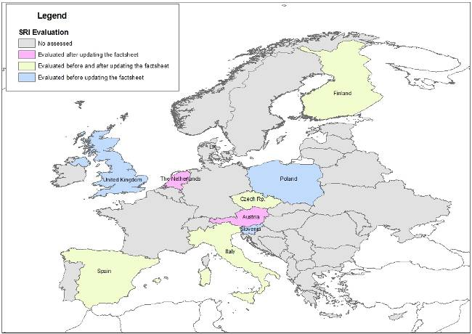
Fig. 4. European countries that have participated on the SRI assessment.
The results were compared with historical data and with other indicators, such as SPI or other local drought indices. The conclusions of this evaluation are:
On Data Availability
- Most of the MS could apply the indicator on their basins with the existing data. The data series used have good quality and are long enough.
- In most cases, MS used data from gauging stations. Data from hydrological models could be used by most MS without a great investment of money and time.
- An important issue is the representativeness of the gauge stations in the basins.
On the Applicability:
- The calculation procedure is good and easy to carry out. Also it is sufficiently contrasted since it is the SPI methodology. The SRI methodology in general delivers feasible results and can be easily used with the available data.
- The Gamma distribution is a probability distribution function that can be used in most of the European basins, but users can choose other PDF that better fits to their data series.
On the Performance
- The indicator has a good representativeness of the results. SRI can identify past droughts, and therefore future droughts.
- An adequate temporal scale is SRI_12, since it reflects the regulation capacity of the basin (artificial reservoirs, snow, aquifers, etc). However temporal scale would depend on the type of basin and the objectives of the assessment.
Some weaknesses of the indicator were pointed out in this assessment:
- Type of basin: how the indicator is affected by the water source: rain-fed or snow-fed river basins.
- Pristine conditions: most of the European basins are affected by human activities thus it can be difficult to obtain runoff data in pristine condition. In these cases, hydrological models can be used or restitution to natural conditions can be made (adding basin abstractions to observed data).
Other outputs of these assessments have been incorporated into this factsheet.
b. Other related assessment (based e.g. on performance indicators, literature)
Other assessment based on SRI and SPI, are presented by Shukla and Wood (2008) at basin scale, and by Kingtse (2008) across the United States. The SRI, similar to the SPI, is used to classify hydrological drought.
In addition the SDVI indicator, developed by M. Mrkvickova and R. Vlnas, also tries to define the severity of drought based on runoff. But this index is less widely used and has a less development than SRI.
References
Clausen, B., Pearson, C. P. (1995) Regional frequency analysis of annual maximum streamflow drought. J. Hydrol. 173, 111–130.
Gardner, L.R., 2009. Assessing the effect of climate change on mean annual runoff. Journal of Hydrology, 379: 351-359.
Khedum, C.P., Choudary, H., Mishra, A.K. Giardino, J.R., Singh, V.P., 2011. Analysis of Drought Severity and Duration Based on Runoff Derived from the Noah Land Surface Model. Symposium on Data-Drivenn Approaches to Droughts, Purdue University.
Kumar, M. and Duffy, C. J., 2009. Detecting hydroclimatic change using spatio-temporal analysis of time series in Colorado River Basin. Journal of Hydrology, 374: 1-15.
Lloyd Hughes, B. and Saunders, M.A., 2002. A drought climatology for Europe. Int. J. Climatol., 22: 1571-1592 doi: 10.1002/joc.846.
Lloyd Hughes, B., Hannaford, J., Parry, S., Keef, C., Prudhomme, C., and Rees, H.G., 2009. Drought catalogues for UK and Europe, Science Report SC070079/SR, Environment Agency.
McKee, T. B., Doesken, N. J., and Kleist, J., 1993. The relationship of drought frequency and duration to timescales, paper presented at 8th Conference on Applied Climatology, Anaheim, Calif., 17– 22 Jan.
Mo, K.C., 2008: Model-Based Drought Indices over the United States. J. Hydrometeor, 9, 1212–1230.
Pruhdomme, C. and Sauquet, E., 2007. Modelling a Regional Drought Index in France. Centre for Ecology and Hydrology, NERC. http://nora.nerc.ac.uk/1366/1/EuraquaDroughtForecastingFinalReport.pdf
Shukla, S., and Wood, A.W. 2008. Use of a standardized runoff index for characterizing hydrologic drought. Geophysical Research Letters 35, L02405, doi: 10.1029/2007GL032487.
Stahl, K, 2001, Hydrological drought, A study accros Europe, dissertation, University of Freiburg, available online at http://www.freidok.uni-freiburg.de/volltexte/202/pdf/stahl-diss.pdf
Tallaksen, L. M. and van Lanen, H. A.J., 2004, Hydrological Drought: Processes and Estimation Methods for Streamflow and Groundwater, Developments in Water Science, 48, Elsevier.
Vidal, J.P., Martin, E., Baillon, M., Franchistéguy, L., and Soubey-rouxm J.M., 2010. A 50-year high-resolution atmospheric reanalysis over France with the Safran System. Int. J. Climatol.. doi: 10.1002/joc.2003.

WEI+ (WATER EXPLOITATION INDEX PLUS)

Indicator Fact Sheet

WEI+: Water Exploitation Index Plus

Indicator definition
The Water Exploitation Index (WEI) is an indicator of the level of pressure that human activity exerts on the natural water resources of a particular territory, helping to identify those prone to suffer problems of water stress. Traditionally the WEI has been defined as the annual total water abstraction as a percentage of available long-term freshwater resources. It has been calculated so far mainly on a national basis.
A review and upgrade of the index (WEI+) has been developed by the Expert Group on Water Scarcity & Droughts with the purpose of better capturing the balance between renewable water resources and water consumption, in order to assess the prevailing water stress conditions in a river basin. The proposed WEI+ aims mainly at redefining the actual water exploitation, since it incorporates returns from water uses and effective management, tackling as well issues of temporal and spatial scaling.

Relevance of the Indicator to Water Scarcity
Water scarcity is a man-made phenomenon. It is a recurrent imbalance that arises from an overuse of water resources, caused by consumption being significantly higher than the natural renewable availability. Water scarcity can be aggravated by water pollution (reducing the suitability for different water uses), and during drought episodes.
Water abstraction to satisfy human needs is the most important quantitative pressure on freshwater resources. Excessive growth of demands in a territory in relation to the availability of water resources can result in the medium-long term in a chronic shortages situation characteristic of an unsustainable use of resources. This indicator can identify whether the rates of abstraction are sustainable, helping to analyse how changes in human consumption impact on the freshwater resources either by adding pressure to them or by making them more sustainable.

Policy Relevance
Water Framework Directive WFD (Directive 2000/60/EC of the European Parliament and of the Council of 23 October 2000 establishing a framework for Community action in the field of water policy):
- Environmental objectives
- Quantitative status for groundwater
- Programme of measures

Communication of the EC to the Council and European Parliament: “Addressing the challenge of water scarcity and droughts in the European Union” (published on July 2007)
- Allocating water and water-related funding more efficiently: improving land-use planning
- Considering additional water supply infrastructures
- Fostering the emergence of a water-saving culture in Europe
- Improve knowledge and data collection, a water scarcity and drought information system throughout Europe (paragraph 2.7.1.)

The WEI+ indicator can also support defining impacts of climate change scenarios, and ensuring adaptation, such as included in the 2009 White Paper on “Adapting to climate change: Towards a European framework for action”, in particular chapter 3.2.3.
.

Technical Information

1. Indicator
The EG has agreed that WEI+ would be formulated in these terms:
WEI+ = (Abstractions – Returns) / Renewable Water Resources
In order to better reflect real exploitation and its effects on water scarcity this formula includes in the denominator the water resources provided by artificial reservoirs.
2. Spatial Scale
To correctly represent the problem of water scarcity and to meet awareness purposes, River Basin Districts or - following the diction of Art. 5(1) of the WFD - the portion of an international RBD falling within a Member states territory. Other relevant scales may be the smaller River Basins that constitute RBDs, respectively their national parts or significant Sub-basins respectively their national parts when relevant for water management.
3. Temporal Scale
In some basins, water scarcity is reflected only when calculating the indicator at the monthly WEI+ but not necessarily by the annual WEI+. It is recognized that the monthly index level best represents seasonal shortages that may not be revealed in the annual scale, while the annual WEI+ may be enough where the absence of water scarcity problems is evident.
Given that the application of the index on a monthly basis in some cases requires considerable effort in data acquisition, the TWG recommends a two-step approach. In a first step the WEI+ at annual scale would be applied. Where appropriate and if data are available, WEI+ at monthly scale should be calculated either for every month or in the worst month where water scarcity situations could be expected.
In any case, if the problem of data acquisition is adequately solved by the outputs of water balance models (under development at EU level); the monthly basis would be adopted as the general approach.
4. Methodology
a. Water Resources and related parameters
In basins free of human interventions, the hydrological balance equation is:
ExIn + P – Eta – ΔS = Qnat
Both sides of this equation may be identified with Renewable Water Resources (RWR):
Option 1. RWR = ExIn + P – Eta – ΔS
Option 2. RWR = Qnat

In this case ΔS is the natural change in storage and Qnat equivalent to observed outflow. Definition of the terms of the equation follows:
Actual External Inflow (Ext.In) Total volume of actual flow of rivers and groundwater, coming from neighbouring territories (e.g. RBDs) within or outside the country. Units in mio m³.
Precipitation (P) Total volume of atmospheric wet precipitation (rain, snow, hail). Precipitation is usually measured by meteorological or hydrological institutes. Units in mio m³.
Actual Evapotranspiration (ETa) Total volume of evaporation from the ground, wetlands and natural water bodies and transpiration of plants. According the definition of this concept in Hydrology, the evapotranspiration generated by all human interventions is excluded, except rain-feded agriculture and forestry. The 'actual evapotranspiration' is calculated using different types of mathematical models, ranging from very simple algorithms (Budyko, Turc-Pyke, etc) to schemes that represent the hydrological cycle in detail. Please do not report potential evapotranspiration which is "the maximum quantity of water capable of being evaporated in a given climate from a continuous stretch of vegetation covering the whole ground and well supplied with water". Units in mio m3.
Change in storage (∆S) Changes in the stored amount of water (>0, if storage is increasing!) during the given time period, including river bed, lakes, underground water (soil moisture and groundwater) as natural part of the storage (ΔSnat) and in regulated lakes or artificial reservoirs (ΔSart). ΔS can be ignored for long-term averages, to be evaluated in annual calculations and to be considered in monthly calculations. ΔSres is different from zero if the amount of filling in and the release are different in the given time period. Units in mio m³.
Natural Runoff (Qnat) Actual outflow of rivers and groundwater into the sea plus actual outflow into neighbouring territories (within or outside the country). Units in mio m³.
To be applied in basins with human altarations, since observed outflow does not equal RWR, for option 2, flow re-naturalization is necessary. It can be made by restoring consumption (abstractions – returns) and flow alteration linked with management, which may be approached by adding the variation in artificial storage:
Option 1. RWR = ExIn + P – Eta – ΔSnat
Option 2. RWR = Outflow + (Abstraction – Return) – ΔSart
Results of the 2nd Testing Exercise show practical difficulties of considering variation of natural storage in Option 1. Some unacceptable mistakes in the results have been observed if there are no appropriate tools to assess ΔSnat (e.g. from an integrated hydrological model). Option 2 has been the preferred choice of most of the TWG members who have participated in this test. However, have come to light some issues that are mentioned below:
- Difficulties to re-naturalize flows in complex system of reservoirs on a monthly basis.
- If over-exploitation of aquifers, these fraction must be removed from the RWR.
- Significant delays in the transmission of groundwater withdrawals to flows observed on the surface.
- In case part of the water stored in the artificial reservoirs comes from a transfer (as opposed to generated within the RBD) or from a desalination plant, then the ΔSart needs to be carefully considered and corrected for the effect of these alternative water resources (i.e. water transfers, desalination)
However, when estimating RWR, the TWG recommends “using the best option based on available information and certainty”.
As suggested by some TWG members, a complementary sub-indicator could be developed, reflecting the water scarcity in relation to the overall available water resources, including all storage, natural and artificial. This sub-indicator could illustrate the water availability to solve e.g. emergency situations. A way of representing this indicator might be the evolution of stored water resources over time, and comparing data with previous years or reference periods.

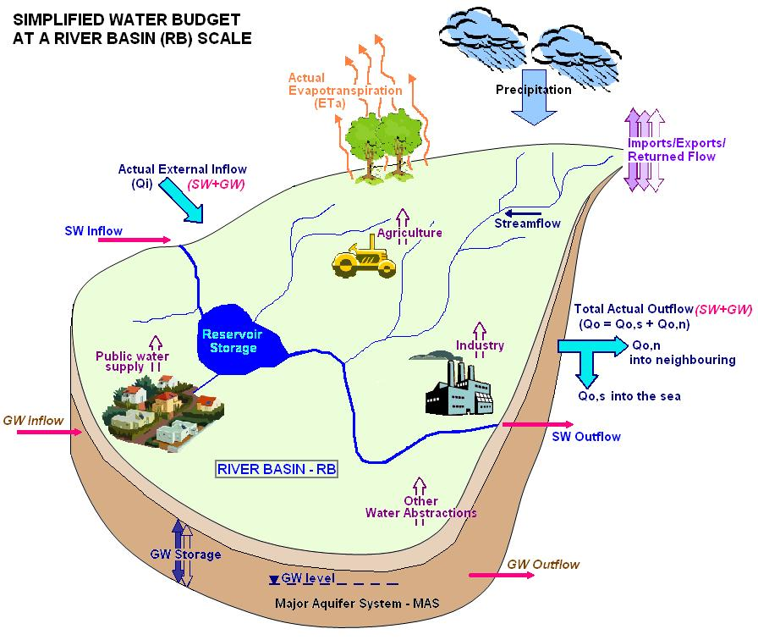
Figure 1: Schematic illustration of the simplified water budget. SOURCE: EEA, 2011.
b. Demand related parameters
Three similar terms are used apparently with similar meaning:
Freshwater abstraction (or freshwater withdrawal) Water removed from surface or groundwater resources, either permanently or temporarily, regardless of any input from water return or artificial recharge. Mine water and drainage water are included. Water abstracted for hydropower generation should be excluded from the formulation of the Water Exploitation Index (WEI+), while water abstracted for cooling should be included. Water abstractions from groundwater resources in any given time period are defined as total amount withdrawn from the aquifer. Units in mio m³.
Water Demand Water requirements of specific quality for different purposes, such as drinking, irrigation, etc., assuming that water availability is not a limiting factor. Water demand is theoretical (calculated or estimated) and can correspond to current situation or to future socio-economical scenarios. Units in mio m³.
Water Use In contrast to water supply (i.e. delivery of water to final users including abstraction for own final use), water use refers to water that is used (consumed) by the end users for a specific purpose, such as for domestic use, irrigation or industrial processing. (Usually the basis for paying fees.) Returned water (at the same place and in the same time period) and recycling is excluded. Units in mio m³.
All three of them imply a different indicator and convey a different message. “Freshwater Abstraction”, evaluates the level of pressure exerted on the natural system. “Water use” reflects the amount of water that is removed from the terrestrial water cycle and returns to the atmosphere. “Water demand” may include requirements unsatisfied (actual or future) by lack of available resources and it is comparable to different availability scenarios, being more useful from a management perspective.
The TWG recommends using preferably the water abstraction parameter since it directly measures how much pressure is exerted on the natural system.
If water demand is significantly higher than water abstractions, the TWG recommends the use of a parallel index, depicting the imbalance .The proposed indicator to use in parallel with the WEI+ is: Water Demand Index (WDI) = water demand / water abstraction.
c. Water returns
Returned water Volume of abstracted water that is discharged to the fresh water resources of the hydrological unit (e.g. RBD, RB) either before use (as losses) or after use (as treated or non-treated effluent). It includes water that was directly discharged from a user (e.g. domestic, industrial etc. including cooling water, mining), and water lost from the waste water collection system (as overflow or leakage). Artificial groundwater recharge is also considered as returned water for the current purposes of calculation of WEI+. Discharges to the sea are excluded. Units in mio m³.
The TWG believes that water return is a relevant parameter to characterize actual pressures on natural systems. In this regard recommends this factor be included in the formula to better represent the real problems of water scarcity in the basins. Given the observed effects on the indicator values, the TWG recommends considering the returns in the nominator, as a decrease of the water abstraction, and not in the denominator. It is essential that that this volume is returned to the same unit where abstracted and where the indicator is being calculated (RBD or subunits or RB).
d. Artificial storage as a modification of monthly RWR
The particular issue of whether considering or not volumes stored in artificial reservoirs has also been dealt with. Results of the 2nd Testing Exercise reflect that in those basins where artificial reservoirs manage a significant percentage of the water resources, abstractions can be higher than the natural water resources in some months, leading to WEI+ values well above 100%. This would lead to problems of interpretation.
Since artificial reservoirs provide water resources used specifically to minimize water scarcity situations these volumes should be included in the formula, reflecting a seasonal redistribution, not altering the amount of Renewable Water Resources.
However, some members of the TWG noted that the use of this variable would mean additional work and added difficulty to find information.

e. The role of environmental flows
Environmental flows Water quantity dedicated to maintaining or partially restoring important characteristics of the natural flow regime (i.e. the quantity, frequency, timing and duration of flow events, rates of change and predictability/variability) in such a way that values specified for the biological quality elements should not avoid to be classified as Good Ecological Status. Units in mio m³.
Environmental Flows should be conceptually considered in the WEI+. At the moment, due to the absence of a harmonized and comparable method of calculation, eflows should be left out of the WEI+ formula itself, and be considered instead in the definition of the relevant thresholds.
In order to better reflect hydrological pressures on the natural systems, the TWG recommends using in parallel a complementary sub-indicator as a relation of observed streamflow with respect to the natural streamflows. Ratio of Observed-Natural Streamflows (RoONS) = observed streamflows / natural streamflows.
f. Water requirements
Water requirements Volume of water which must be retained in the catchment (thus not actually available for abstraction) in order to meet different legal obligations (e.g. downstream navigation, environmental thresholds, as defined in transboundary treaties). Units in mio m³.
The TWG recommends exploring the reasons for this water reserve in treaties. When it is exclusively due to environmental reasons, recommendation 8 would be applicable. When this reserve was intended for limiting water abstractions, then it should be subtracted from available resources in the WEI+ formula.
g. Groundwater and surface water separation
Surface water Inland waters, except groundwater; transitional waters and coastal waters. Units in mio m³.
Groundwater (available for annual abstraction) Recharge less the long-term annual average rate of flow required to achieve ecological quality objectives for associated surface water. It takes account of the ecological restrictions imposed to groundwater exploitability, nevertheless other restrictions based on economic and technical criteria could also be taken into account in terms of accessibility, productivity and maximum production cost deemed acceptable by developers. The theoretical maximum of groundwater available is the recharge. Units in mio m³.
The separation between surface water and groundwater is very relevant and should be explored at a later stage.
g. Calculation
Calculations should be based on the water balance equation of the given period, taking into account the methodological and technical recommendations stated so far and assuring the consistent estimation of the abstraction and resources side:
WEI+= (Abstractions - Returns) / (NWR - ΔSart)
h. Reference period for calculating the Statistics
Not applicable.

5. Thresholds
According to the literature, the warning threshold for WEI can be 20 %, which distinguishes a non-stressed region from a stressed region (Raskin et al., 1997, Lane et al., 2000). Severe water stress can occur where the WEI exceeds 40 %, indicating strong competition for water but which does not necessarily trigger frequent water crises. Some experts argue that 40 % is too low a threshold, and that water resources can be used much more intensely, up to a 60 % threshold. Others argue that freshwater ecosystems cannot remain healthy if the waters in a river basin are abstracted as intensely as indicated by a WEI in excess of 40 % (Alcamo et al., 2000).
In the framework of a “Discussion Paper on Environmental Flows in the EU” (Sánchez & Schmidt, 2012) a preliminary assessment of the relationship between environmental flows and ecological classes was carried out. According to these results, environmental flows lie roughly between 25% and 50% of the Mean Annual Runoff for the Good Ecological Status class.
Some members of the TWG have worked on the issue and advanced proposals based on the comparison with environmental flows already assessed (IT, CZ) or on statistical approaches (HU). Defining thresholds for the WEI+ is challenging and it requires in-depth investigations. However, preliminary thresholds should be used considering the environment and socio-economical relevance (e.g. the expected water deficit for existing uses in the basin). In this sense the values of WEI+ could also be correlated with the expected annual deficit.
Concerning the definition and especially the complexity of the thresholds it should be kept in mind that the indicator itself is robust and valuable although the calculations are relatively simple. This pragmatic approach should also be reflected by the thresholds.

6. Data source and frequency of data collection
The required data depends mainly on the methodological option selected for calculating RWR:

- In option 1, required data are: Precipitation, Actual Evapotranspiration, External Inflow and Variation of natural storage. These elements are considered very difficult to be consistently assessed without counting with an integrated hydrological model.

- In option 2 required data are the observed outflow, the abstractions, the estimated returns and the variation of artificial storage.
This data may be provided either by Member States or by tools already under development at the European level in the framework of the Blueprint, water accounts for the abstractions side and LISFLOOD model for hydrological cycle parameters. In the future a convergence of both estimates should be expected.
All the necessary data must be generated in a monthly basis.
7. Quality Information
a. Strength & Weaknesses at data level
Quality of the index depends on the quality of the data series used for the estimates. The elements needed in option 1 to calculate the RWR are considered very difficult to be consistently assessed without counting on an integrated hydrological model.
Where available, gauging stations provide robust series of observed outflow, but re-naturalization implies the other datasets that may not be so reliable.
Total abstraction is not always well known, particularly if non-authorised uses are important. There may also be substantial changes from one year to another depending on the availability, and when it is not possible to supply actual demand.
Finally, returned water includes a variety of components which are not easy to measure and also require estimates, particularly for irrigation, where losses in distribution systems and application to plot are estimated by applying efficiency coefficients.
b. Open conceptual issues
The issue of multiple counting of the same amount of water in large river basins (internal flow of the most upstream area creates the external inflow of the next downstream area and is in both areas considered as water resource) is still not solved. Therefore a foot-note should be added to the respective WEI+ values.
The separation between surface water and groundwater should be analysed in a future development.
c. Performance of the Indicator
The indicator is relatively easy to calculate and straightforward to use.
Depending on the specific situations of the member states, it can also be readily integrated with other indicators at the same scale and used for awareness raising purposes.

Products
The WEI+ can be presented in the form of maps and graphs, providing information both on the spatial distribution of the level of pressure that human activity exerts on the natural water resources and the temporal evolution over longer time periods. This allows for the qualitative and quantitative comparison of the intensity and duration of this pressure on water resources with recorded impacts such as yield reductions, low flows, or lowering of groundwater levels, for example.

References
Alcamo, J., Henrich, T. & Rosch, T., 2000. World Water in 2025 - Global modelling and scenario analysis for the World Commission on Water for the 21st Century. Report A0002, Centre for Environmental System Research, University of Kassel, Germany
European Environment Agency, 2011. WISE-SoE WQ Data Request, Data Input Tool for the WISE-SoE#3 "State and Quantity of Water Resources" User Manual, v.1.2., July 2011.
European Environment Agency, 2012. Towards efficient use of water resources in Europe. EEA Report No 1/2012.
Poórová, J., Danáčová, Z. & Majerčáková, O., (2008): The Opportunities of the Present Methods of Water Resource Assessment in Slovakia. XXIV. Conference of Danube Countries: On the Hydrological Forecasting and Hydrological bases of Water Management. ISBN 978-961-91090-3-8
Poórová, J.(2002): Measure of Influence of water usage on discharge series. International Conference: Participation of women in the fields of meteorology, operational hydrology and related sciences. Bratislava, 2002, SHMI, p. 179-189, fig. 5, lit.7 ang
Sánchez, R. & G. Schmidt. 2012. Environmental flows in the EU. Discussion paper. Draft 1.0, for discussion at the EG WS&D.

Mean Annual Runoff is defined in this context as the long term average of the natural runoff.
Global Precipitation Climatology Centre: http://gpcc.dwd.de
Global Precipitation Climatology Project: http://www.gewex.org/gpcp.html

