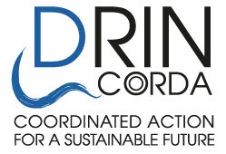
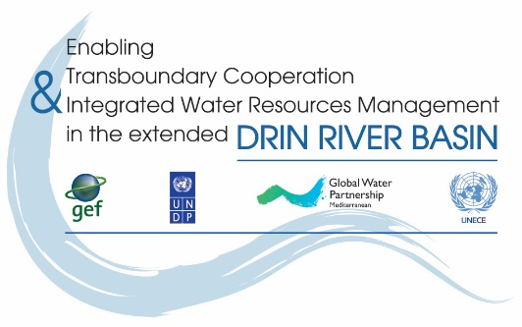

THE DRIN ACTION DAY 2016

Expression of interest

- Name of NGO:__________________________________________________________________

- Country: _______________________________________________________________________

- Drin Sub-basin the NGO is active/work at: _____________________________________________

- Our NGO would like to participate in the proposed activity

Name of person in charge: ___________________________________________________________
Address: _______________________________________________
Tel.: ___________________________________________________
Fax: ___________________________________________________
e-mail: _________________________________________________
web-site: _______________________________________________

- Title of proposed activity:

_________________________________________________________________________________

- Description of proposed activity(ies) (use max 2 pages):
_________________________________________________________________________________
_________________________________________________________________________________
_________________________________________________________________________________
_________________________________________________________________________________
_________________________________________________________________________________
_________________________________________________________________________________
_________________________________________________________________________________
_________________________________________________________________________________
_________________________________________________________________________________

Date foreseen for the event to be held (5th of May 2016):
_________________________________________________________________________________

Having read and understood the attached Guidelines, I undertake the responsibility of organising the event.

Signature: __________________________ Date: _______________________

Function in your NGO: ___________________________

This form must be sent by e-mail (georgia@gwpmed.org and dimitris@gwpmed.org) to GWP-Med

