Annex 1: APPLICATION FORM

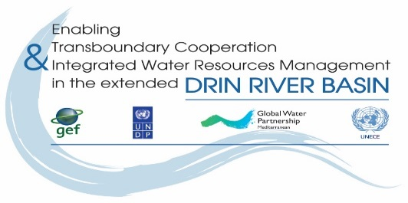


THE DRIN DAY CELEBRATION 2017

Expression of interest

- Name of NGO/CSO:__________________________

- Country: _______________________________________________________________________

- Drin Sub-basin the NGO is active/work at: _____________________________________________

- Our NGO would like to participate in the proposed activity

Name of person in charge: _____________________________________________
Address: _______________________________________________
Tel.: ___________________________________________________
Fax: ___________________________________________________
e-mail: _________________________________________________
web-site: _______________________________________________

- Title of proposed activity:

_______________________________________________________________________

- Description of proposed activity(s) (use max 2 pages):
_______________________________________________________________________________
________________________________________________________________________________
________________________________________________________________________________
________________________________________________________________________________
________________________________________________________________________________
________________________________________________________________________________
________________________________________________________________________________
________________________________________________________________________________
________________________________________________________________________________

Date foreseen for the event to be held (5 May 2017, possibly 6-7 May 2017):
________________________________________________________________________________

Having read and understood the attached Guidelines, I undertake the responsibility of organizing the event.

Signature: __________________________ Date: _______________________

Function in your NGO: ___________________________

This form must be sent by e-mail (dejan.panovski@gwpmed.org; anna-maria@gwpmed.org; dimitris@gwpmed.org ) to GWP-Med

