APPLICATION FORM

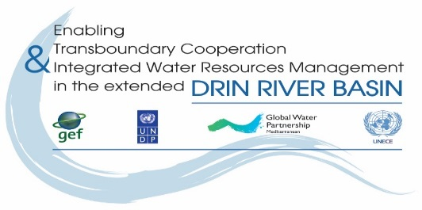
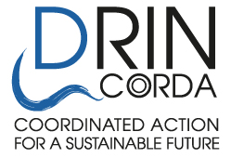

THE DRIN DAY CELEBRATION 2021

- Name of NGO/CSO :________________________________________

- Country: _________________________________________________

- Drin Sub-basin the NGO is active/work at: ______________________

- Our NGO would like to participate in the proposed activity

Name of person in charge: ____________________________________________
Address: ________________________________
Tel.: ____________________________________
Fax: ____________________________________
E-mail: __________________________________
Website: ________________________________

Having read and understood the attached Guidelines, I undertake the responsibility of organizing the event.

Signature: __________________________ Date: _______________________

Function in the NGO: ___________________________

- Introduction:
Provide here a brief description about the NGO that prepares the application and the Partner NGO(s). You may include in an Annex more extensive descriptions of the applying NGOs.
_______________________________________________________________________

- Title of proposed activity:
_______________________________________________________________________
- Outcomes:
Describe here the outcomes to be achieved through the proposed activity(ies)
_______________________________________________________________________
- Description of proposed activity(ies)
Describe the activities to be implemented, the methodology to be followed and actions to be undertaken for their implementation (use max 2 pages):
______________________________________________________________________
- Outputs:
Describe the outputs/products to be developed/prepared through the activities proposed.
______________________________________________________________________

- As an Annex to the Application provide the following (please note that failure to provide the below listed items will lead to the rejection of the proposal):
6.1 Detailed financial budget.
6.2 Evidence on Establishment of the NGO (Certificate of registration) in English, translated by a certified translator.
6.3 A list of similar implemented projects (in the field of environment, water, or nature resources awareness) implemented in the last 5 years
6.4 Submission Letter
7. In case that the activities are implemented with a partner, fill in the information requested below including the signature of the person in charge.

Partner/Cooperating NGO/CSO:
- Name of NGO/CSO:__________________________

- Country: _______________________________________________________________________

- Drin Sub-basin the NGO is active/work at: _____________________________________________

- Our NGO would like to participate in the proposed activity, as described above.

Name of person in charge: _____________________________________________
Address: _______________________________________________
Tel.: ___________________________________________________
Fax: ___________________________________________________
E-mail: _________________________________________________
Website: _______________________________________________

Signature: _______________________________________________________

Date foreseen for the event to be held 15.May 2021

This form must be sent by e-mail to GWP Med
dejan.panovski@gwpmed.org

