APPLICATION FORM

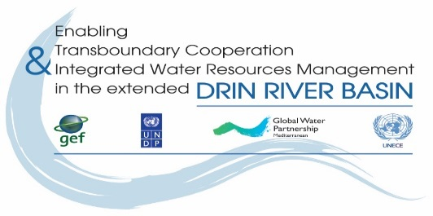
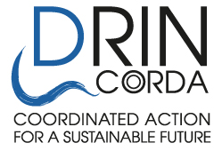

THE DRIN DAY CELEBRATION 2020

Expression of interest

- Name of NGO/CSO :________________________________________

- Country: _________________________________________________

- Drin Sub-basin the NGO is active/work at: ______________________

- Our NGO would like to participate in the proposed activity

Name of person in charge: ____________________________________________
Address: ________________________________
Tel.: ____________________________________
Fax: ____________________________________
e-mail: __________________________________
web-site: ________________________________

- Title of proposed activity:
_______________________________________________________________________

- Description of proposed activity(s) (use max 2 pages):
_____________________________________________________________

Description of the activities should include:

- Introduction: Provide a brief description about the NGO that prepares the application and the
Partner NGO(s).
- Outcomes: Describe the outcomes to be achieved through the proposed activities.
- Activities: Describe the activities to be implemented, the methodology to be followed and
actions undertaken for their implementation.
- Outputs: Describe the outputs/products to be developed/prepared through the activities
proposed.
- Detailed financial budget should be sent as an Annex to the Application Form
________________________________________________________________________________

The proposed activities as described above will be implemented with the following
partner/ cooperating organization:

Partner/cooperating NGO/CSO:
- Name of NGO/CSO:__________________________

- Country: _______________________________________________________________________

- Drin Sub-basin the NGO is active/work at: _____________________________________________

- Our NGO would like to participate in the proposed activity, as described above.

Signature: _______________________________________________________
Name of person in charge: _____________________________________________
Address: _______________________________________________
Tel.: ___________________________________________________
Fax: ___________________________________________________
e-mail: _________________________________________________
web-site: _______________________________________________

Having read and understood the attached Guidelines, I undertake the responsibility of organizing the event.

Signature: __________________________ Date: _______________________

Function in your NGO: ___________________________

Date foreseen for the event to be held (possibly 5-6 June 2020):

This form must be sent by e-mail to GWP Med
dejan.panovski@gwpmed.org

