Regional Conference on
Water-Energy-Food-Ecosystems Nexus
in the Mediterranean Source to Sea Continuum:
From Strategy to Action

24-26 February 2026
Cyprus Institute, Nicosia, Cyprus

Nicosia Accord
Draft for discussion

Conference Organised by
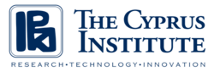
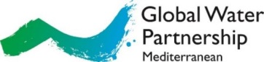

In synergy with
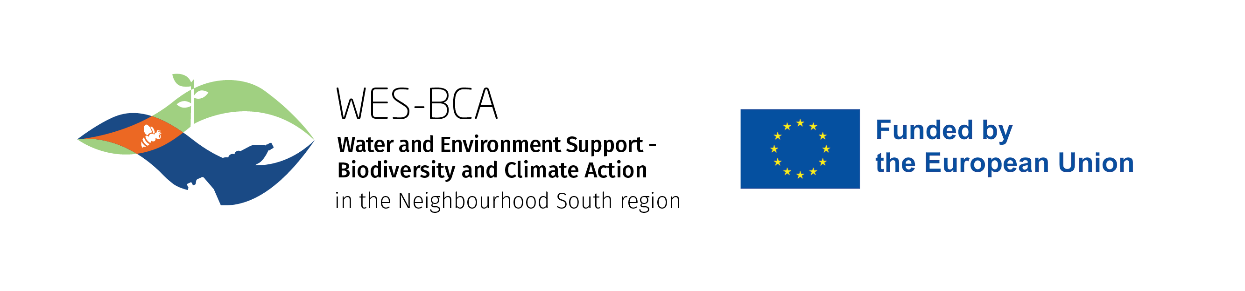

In the framework of:
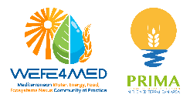
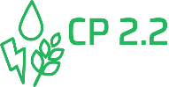  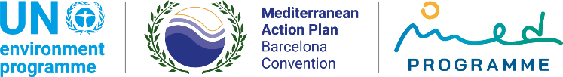   | GEF / UNEP-MAP Mediterranean Coastal Zones: Managing the Water-Energy-Food and Ecosystems Nexus Child 2.2. Project, managed by GWP-Med
 | PRIMA WEFE4MED Project, managed by CyI
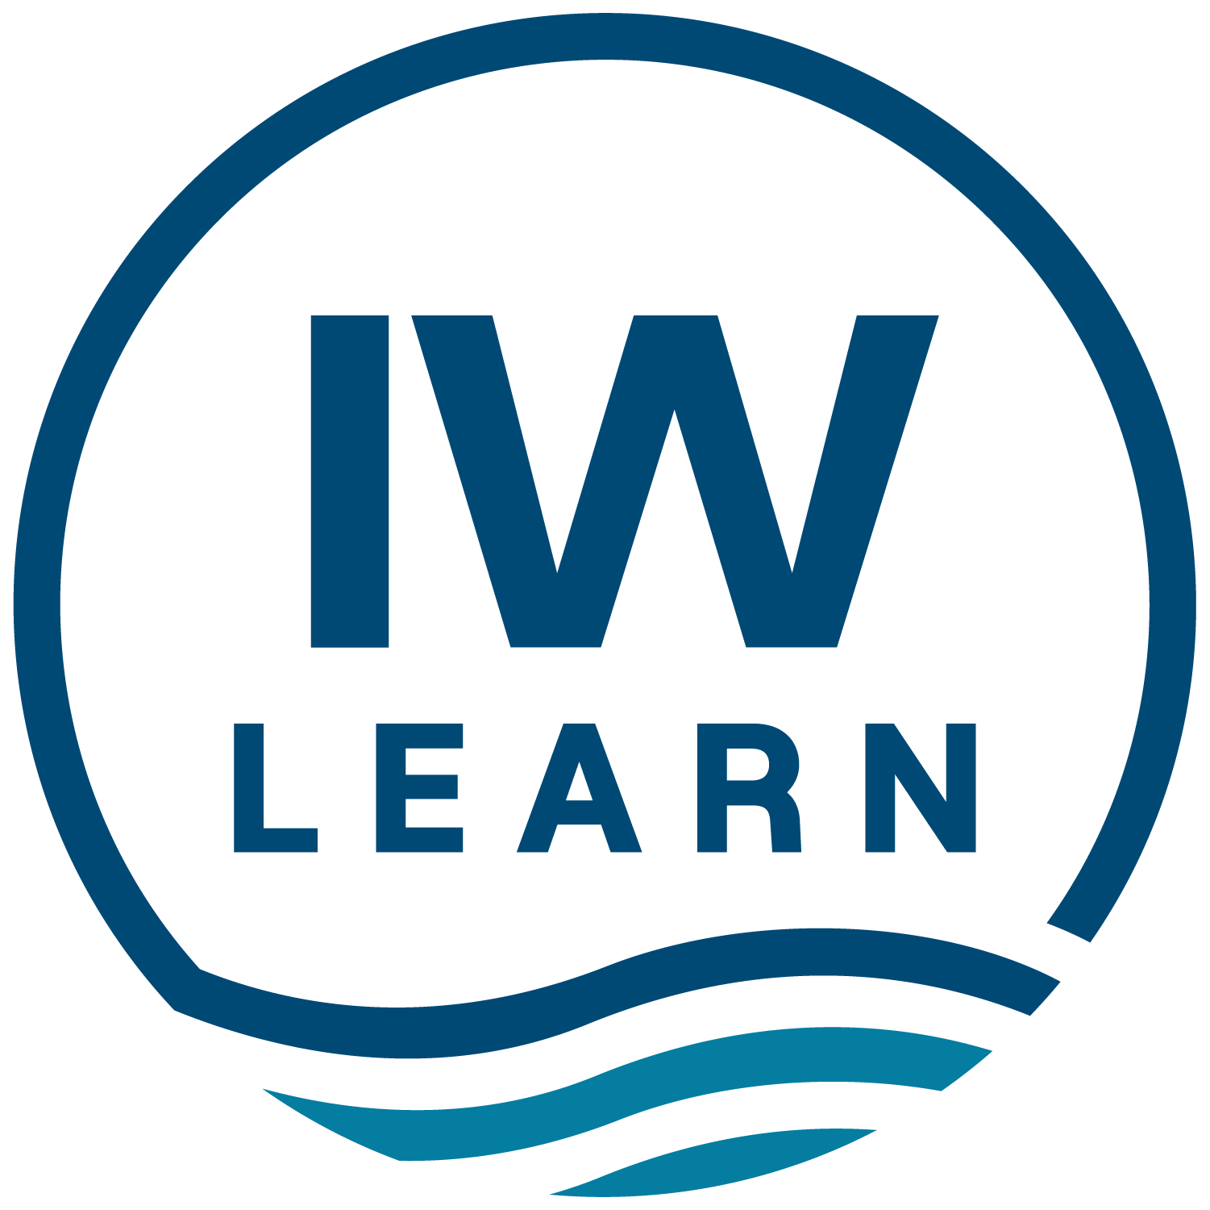  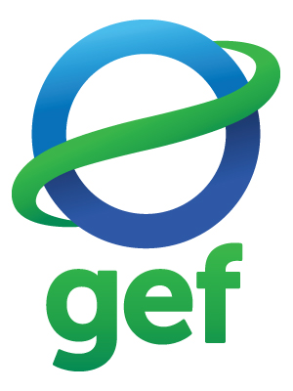 | GEF IW:LEARN

NICOSIA ACCORD

Note to reader: The Nicosia Accord does not present the key results of the Regional Conference. It recognizes the added value of WEFE Nexus of the Mediterranean S2S Continuum and the progress achieved with the elaboration and adoption of the related Strategy, and provides main suggestions for the elaboration of its Action Framework, expressing commitment to support its development.

Preamble

Our Mediterranean and the ancient sea around which we all live, is an exquisite mosaic of people, cultures and a global hotspot of significant bio-, geo- and cultural diversity. The region is challenged by multiple pressures that are expected to become more severe by the triple planetary crisis (climate change, pollution and biodiversity degradation). This situation directly affects efforts towards water, energy and food security as well as environmental sustainability in the Mediterranean countries.

Integrated approaches, including Integrated Coastal Zone Management (ICZM), Integrated Water Resources Management (IWRM), Ecosystems-Based Approach (EBA) and their Integrative Methodological Framework (IMF), Integrated Energy Planning (IEP), etc. are applied in the region making impact towards sustainable development.

Identifying inter-dependencies and recognising possible trade-offs, the system-thinking applied through a Water-Energy-Food-Ecosystems (WEFE) Nexus in a Source to Sea Continuum approach adds value by enabling sectoral and spatial integration in policy development and management of natural resources, aiming to facilitate -often missing- operational channels towards commonly defined objectives and to mobilise funding and investments for multi-disciplinary benefits, delivering beyond the ‘no harm principle’. Moving from strategy to action requires structured preparation, realistic risk allocation, institutional discipline, and coordinated partnership among governments, stakeholders and financiers.

The Strategy for WEFE Nexus in the Mediterranean Source to Sea continuum

The ‘Strategy for WEFE Nexus in the Mediterranean Source to Sea continuum’ presents a comprehensive strategic framework to assist countries in enhancing policy and action integration across WEFE sectors and to promote leveraging of necessary funding towards sustainability and climate-resilience objectives.

The Strategy was built on a dual and inter-connected (formal amongst governments and informal amongst stakeholders) regional participatory consultation process. The Union for the Mediterranean (UfM), the Barcelona Convention/UNEP MAP and the European Union provided the institutional framework, with the technical support of the Global Water Partnership-Mediterranean (GWP-Med) within the GEF UNEP/MAP MedProgramme, the EU Water & Environment Support (WES) and Water, Environment Support Biodiversity Climate Action (WES BCA) Projects, the Partnership for Research and Innovation in the Mediterranean Area (PRIMA). Technical contributions were provided by a range of partners, including through the WEFE Nexus Community of Practice facilitated by the PRIMA WEFE4Med project.

The Strategy received formal endorsement by the 15th Meeting of the UfM Regional Platform on Water (5-6 Nov 2025, Barcelona) in view of the 2nd UfM Ministerial Conference on Water and was adopted in the framework of the MSSD (2026-2035) flagship initiative by the 24th Conference of the Parties (COP24) of the Barcelona Convention (2-5 Dec 2025, Cairo).

Towards an Action Framework for the Strategy implementation

Aiming to catalyze the shift from ‘Nexus thinking’ to ‘Nexus doing’ in the Mediterranean, and in full alignment with the Strategy’s 3 Goals, 8 Objectives and 40 Directions for Action, a regional framework for actions (aka Action Framework) would assist the Strategy’s implementation, including by promoting synergies and identifying ways of leveraging necessary funding.

Reflecting countries’ priorities for integrated natural resources management, the Action Framework should be aligned with and support the implementation of the relevant Barcelona Convention Protocols, and their legally binding Regional Plans as well as the MSSD Strategy 2026-2035; the UfM strategic documents, including the UfM Vision Statement 2025, and initiatives; the Pact for the Mediterranean; the EU Water Resilience Strategy; etc. Securing further engagement of the Energy and Agriculture communities and agendas, including by utilising appropriate regional fora, is recommended.

The Action Framework is expected to be informed by WEFE Nexus technical regional processes led by regional institutions, stakeholder organisations and projects, like on Governance, Financing, Desalination and Digital Transformation, and Climate Resilience while more fields may be considered accordingly. Priority to be given to knowledge exchange, awareness raising and education, capacity building. Focus on diversity and gender+, with priority on youth and women needs to be ensured.

Among means of elaborating and implementing an Action Framework for the Strategy, the WEFE Nexus Community of Practice should assist with providing a collaborative platform to connect stakeholders and support dissemination of WEFE solutions in the Mediterranean. The Action Framework should assist in addressing climate crisis challenges, linking to regional efforts like the Eastern Mediterranean and Middle East Climate Change Initiative (EMME-CCI). Furthermore, it should link to and benefit from regional processes, like the 6th Euro-Mediterranean Water Forum (29 Sept-2 Oct 2026, Rome) and other upcoming regional and international fora, like the UN Water Conference (2-4 Dec 2026, United Arab Emirates) showcasing the Mediterranean as the cradle of WEFE Nexus in the Source to Sea Continuum approach.

In advancing from strategic direction to effective implementation, particular attention should be given to the quality of project preparation and structuring. Ensuring that WEFE-related initiatives are technically sound, financially viable, and institutionally ready will be essential to mobilise public and private investment at scale. The Action Framework should therefore promote disciplined project pipeline development, transparent risk allocation principles, and affordability considerations that safeguard public interest while enabling private sector participation where appropriate. Strengthening implementation capacity and contract management will be equally important to translate financing commitments into tangible impact on the ground.

Fully reflecting the Strategy contents, and based on a Why-What-How-Who approach, the Action Framework is suggested to elaborate on fields like: context, including anchor with regional processes; purpose; description of contents; key partners and roles; timeframe; means of implementation; indicators; monitoring; learning.

Following technical drafting by the six partner institutions that have worked for the Strategy delivery, the Action Framework is expected to be considered within the UfM Regional Platform on Water as well as the UNEP/MAP Mediterranean Commission for Sustainable Development, leading to hopeful adoption towards the end of 2026.

Upcoming technical contributions include regional consultations on AI/Digital Transformation (11 March 2026, online and 23-24 March 2026, Rome), on WEFE Nexus for climate resilience and the private sector engagement (23-25 June 2026, Tunis, in the framework of the UNEP/MAP GEF MedProgramme 4th Annual Stocktaking Meeting and the Cairo Water Week, October 2026, Cairo), etc.

Rooted on these considerations, and building on the foundations of previous regional multi-stakeholder events (Rabat, June 2023 / Tunis, February 2024), the Regional Conference on ‘WEFE Nexus in the Med Source to Sea Continuum: From Strategy to Action’, 24-26 February 2026, Nicosia, Cyprus, hosted by the Cyprus Institute and organised under the auspices of the Cyprus Presidency of the EU Council 2026, attended (in presence and online) by XXX stakeholders from ZZZ countries, launched the regional multi-stakeholder consultation process for shaping the Strategy’s Action Framework, expressing their commitment to contribute with their knowledge and capacity for its preparation.

