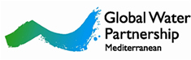
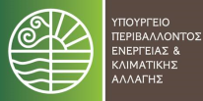
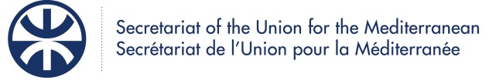
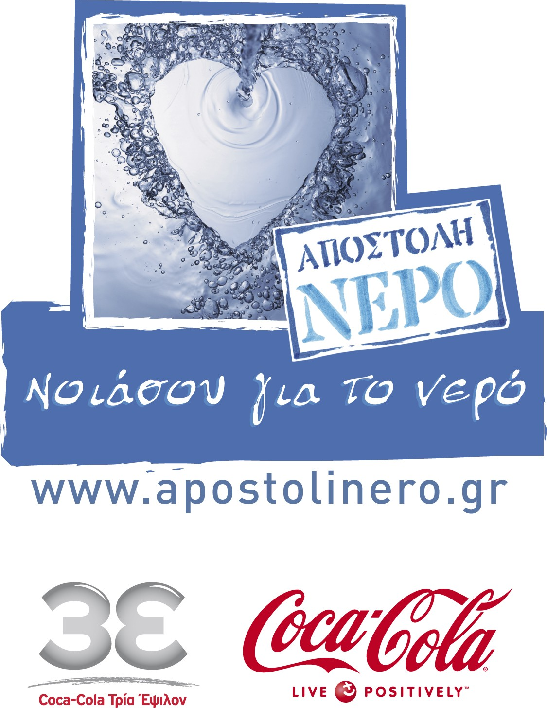

Regional Conference on
Advancing Non-Conventional Water Resources Management
in the Mediterranean

14-15 September 2011
Hilton Hotel, Athens, Greece

Announcement

Background

Access to adequate quality water, in sufficient quantity, is fundamental for sustainable livelihoods and for economic development. Water resources are heavily exploited in most countries of the Mediterranean region. With rapid population growth, environmental degradation and climate change impacts, it is no longer possible to satisfy water demand by simply attempting to increase water supply.

Therefore, an integrated approach for water resources management, based on good governance, inter-sectorial coordination, water demand management, and the sustainable use of non-conventional water resources, is absolutely vital if countries are to ensure that enough water is available to all Mediterranean citizens, economic activities and the environment. In the framework of the Barcelona Convention, the regional objective for water saving of 25% by 2025 was adopted in 2009 by the participating countries, taking 2005 as reference year.

Mobilising non-conventional water resources can provide adequate solutions where projected levels of water savings (following a realistic and integrated planning based on sustainable management) prove hard to achieve and can substantially assist in bridging the gap between supply and demand. The use of non-conventional waters is already applied in many countries of the region, primarily through reuse of treated and untreated waste water including recycling of agricultural run-off, rainwater harvesting and desalination. Other techniques contemplated by Mediterranean countries include inter-basin transfers, exploitation of undersea freshwater springs, cloud seeding, etc. These techniques present various degrees of efficiency, sustainability and potential for further development.

Particularly in the Mediterranean south, Egypt, Syria, Israel, Jordan and Tunisia figure among the 20 countries in the world with the largest volumes of wastewater, treated and untreated, used for irrigation (source: World Bank, 2010). However, most countries of the region are far from reaching the potential of non-conventional water resources.

Nevertheless, there is a set of policy, institutional, legal, technical, social, environmental and economic constraints that pose impediments for fully developing non-conventional water resources in a sustainable manner. Among others, an unofficial and uncontrolled use of insufficiently treated or even totally untreated wastewater is taking place in some Mediterranean countries, resulting in risks to users and the environment. Policy, legal and institutional frameworks are often missing to stimulate concrete action. Similar are obstacles that could encourage related investment by the private sector assisting to catch up with rapidly growing demand and emerging needs.

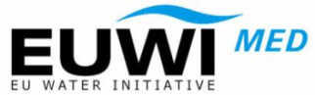

Among other key political documents, the draft Strategy for Water in the Mediterranean (SWM) that was elaborated in 2010 in the framework of the Union for the Mediterranean (UfM) set as Objective to “Develop additional water resources volumes once demand side policies and planning options for water saving have proven to be insufficient, using a sound mix of conventional and alternative resources (e.g. water storage systems, reused water, and desalination). The choice and the priority between these provided possibilities should prove to be health-safe and environment-friendly, depending mainly on financial cost, energy consumption, social acceptance and political aspects.”

Furthermore, draft SWM’s Recommendations for Action include to
- “Develop and implement prioritized programmes for introducing adequate wastewater treatment. Establish minimum quality requirements for wastewater treatment plant effluents and secure adequate treatment of wastewaters to avoid downstream pollution.”
- “Assess the opportunities and the risks for using non-conventional water resources. Propose legal frameworks and define adequate thresholds and quality standards for each kind of treated wastewater reuse. Promote research for the use of low-cost and low maintenance non-conventional wastewater treatment techniques that meet established quality standards, especially useful for rural and peri-urban areas, with easy operability and low qualified-personnel requirements.”
- “Promote the most efficient and adequate non-conventional technology according to the corresponding use, energy and demand assessment (e.g. desalination, wastewater production, rainwater harvesting, aquifer recharge, etc) preceded by Strategic Environmental Assessment, Environmental Impact Assessment or other internationally recognized sustainability assessments.“
- “Identify the appropriate scale for the domains where technology and knowledge are needed and available, and avoid duplicating efforts when building water demand strategies. Exchange knowledge and practices and ensure qualified transfer of pilot experiences on emerging issues.”
- “Where not already applied, secure gradual convergence between the objectives of water quality improvement and water scarcity mitigation targets set and initiatives being undertaken in the context of regional fora such as those under the Barcelona Convention, the EU Water Framework Directive and other EU water-related Directives as well as the EU Marine Strategy Framework Directive, the Euro-Mediterranean Process and the Arab League initiatives.”

The importance of a wide and meaningful participation of water stakeholders (including governments, local authorities, water users associations, civil society, academia, private sector, media, etc) in advancing the non-conventional water resources management agenda is evident. Among them, the participation of the private sector, as user and thus bound to achieve considerable water savings and producer of water that can be reused as well as investor and corporate social responsibility partner, is also important and needs to be explored and sustainably developed.

Objectives of the Conference

The Regional Conference on Advancing Non-Conventional Water Resources Management in the Mediterranean, 14-15 September 2011, Athens, Greece, aims:

- To provide a platform for multi-stakeholder dialogue on priorities and needed synergies for advancing non-conventional water resources management in the Mediterranean, including within the political frameworks of the European Neighborhood Policy, the Union for the Mediterranean, the Barcelona Convention, the League of Arab States, etc.
- To elaborate in particular on the role of the private sector in advancing the agenda of non-conventional water resources.
- To share best practices and lessons learned from local applications in the Mediterranean region.
- To brainstorm on ideas for regional, sub-regional or trans-national projects in NCWR in the Mediterranean.
- To discuss ways to enhance awareness raising, stakeholders’ involvement and pilot application, including through corporate social responsibility programmes.

The Conference would contribute as:
- replication event of the GEF Strategic Partnership for the Mediterranean Large Marine Ecosystems (GEF MedPartnership).
- regional consultation event within the preparations of the 6th World Water Forum, Marseilles, March 2012.
- outreach event of the ‘Mission Water’ Corporate Social Responsibility Programme of Coca Cola HBC Greece and Coca Cola Hellas.

Organisation

The Conference is organized by the Hellenic Ministry for Environment, Energy and Climate Change, the Secretariat of the Union for the Mediterranean, the Global Water Partnership – Mediterranean and the System of Coca-Cola in Greece (Coca-Cola HBC Greece and Coca-Cola Hellas) with the environmental program ‘Mission Water’.

The Conference contributes to the activities of the Mediterranean Component of the EU Water Initiative (MED EUWI) and the GEF MedPartnership.

Targeted number of participants

Up to 120 targeted participants

Draft Agenda - Outline

The Conference will include the following Sessions

Session 1. Welcome and Introductory Speeches
[statements by organizers and officials]
Session 2. Setting the scene-existing experience: Non-Conventional Water Resources Management (NCWRM) in the Mediterranean
[presentations with Q/A]
Session 3. How to build appropriate Institutional Settings and Legal Instruments for NCWRM?
[facilitated panel discussion and interventions from participants]
Session 4. How to effectively Engage the Stakeholders and their Build Capacity for NCWRM ?
[facilitated panel discussion and interventions from participants]
Session 5. What is the role of Corporate Social Responsibility for advancing NCWRM ?
[facilitated panel discussion and interventions from participants]
Session 6. Learning from Experiences: Best Practices and Case Studies
[presentations with Q/A]
Session 7. Financing NCWRM in the Mediterranean
[facilitated panel discussion and interventions from participants]
Session 8. Priorities for Action on NCWRM in the Mediterranean: Brainstorming on regional, sub-regional or trans-national project ideas
[facilitated open discussion]
Session 9. Conclusions and Closure of the Conference
[statements by organizers and officials]

