

Enabling Delta Life – a discussion paper
‘What makes managing land and water in deltas different?’

Draft version 3.0

August 2012

Marcel Marchand
Tom Bucx
Cees van de Guchte
Bart Makaske
Wim van Driel

Deltares and Alterra

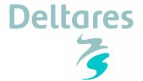
Contents
1. Introduction 3
2. What makes deltas different? 4
3. Framework for Delta Assessment 5
3.1. Drivers of change 5
3.2. Trends in society 6
3.3. Spatial layer model for deltas 6
3.4. Management responses for each layer 8
3.5. Governance characteristics for each layer 8
4. Analysis of case studies 11
4.1. Main issues 11
4.2. Measures 12
4.3. Governance 15
4.4. Suggestions for other deltas 16
5. Conclusions 17

Introduction

The Global Water Partnership - GWP - and the Netherlands International Development Programme – DGIS – have the intention to jointly explore how to further the sustainable management of deltas. Many of the deltas worldwide host dense human populations and are important centres of economic activity, such as agricultural and industrial production, shipping and mining. Although comprising only some 5% of the land area, deltas have up to ten times higher population densities. And this number is expected to increase rapidly, especially in the heavily populated mega-deltas in Asia.

Deltas are relatively young landforms shaped by the interplay of coastal and riverine processes. They are characterized by a mosaic of gradients between land and sea, fresh and saline waters, as well as exposed and sheltered environments. These patterns and dynamic processes are at the basis of the ecosystem services provided by deltas, such as land formation, coastal protection and food from fisheries.

Being ‘hotspots’ of human activity, deltas are also vulnerable to changes induced by a range of driving forces, both natural and anthropogenic. Under the uncertainty of the possible impacts of climate change, low lying deltas around the world face challenges to cope with subsidence, flood risk, storms and salinization. Due to on-going urbanization, demographic growth and economic activities, which have to be combined with food production and ecosystem integrity, the demand for sustainable water allocation and sound infrastructure is omnipresent. Competing demands from a variety of sectors and stakeholders require a transparent dialogue and an enabling governance environment for sound decision-making.

Assessments for investments are at the core of any delta management framework, whereas cost-benefit analyses addressing both short and long term perspectives are key to develop affordable and no-regret options to intervene as to sustain the well-being of people, their economic activities as well as their safe living environment. Although the above can be said of many water related areas, low lying deltas are most vulnerable to the threats mentioned above, which makes striving for comprehensive and integrated solutions even more urgent.

The complex and interrelated issues in deltas may need to be specifically addressed towards developing more resilient and sustainable deltas in the future. This discussion paper describes an integrated framework for delta assessment, the need for specific strategies for deltas, especially as it relates to integrated water resources management, and taking into account the increasing interest for the institutional, socio-economic, financial and awareness-raising aspects.

This is version 3.0 for discussion, which has been updated based on comments and suggestions received up till 28 August.

What makes deltas different?

Ten reasons why deltas require special attention from integrated water management:

- Most deltas are moderately to extremely vulnerable to sediment starvation. Upstream river developments (such as storage dams) often lead to a reduction of sediment inflow, whereas dikes and embankments often impede lateral sediment dispersion. Together with an on-going sea level rise 24 out of the 33 largest deltas are at serious risk (Syvitski et al., 2009)
- The geological characteristics of delta soils make them prone to subsidence, exaggerated by anthropogenic extraction of ground water, which can lead to extreme subsidence on the short term.
- Deltas are relatively young landscapes, featuring highly dynamic geomorphological processes, such as coastal erosion and accretion and river meandering and avulsion.
- Delta soft soils pose specific challenges to civil infrastructure (such as roads, railways, bridges and tunnels).
- Their position at the most downstream part of rivers make deltas particularly receptive to water pollution.
- Flood hazards come from three different sources: fluvial, coastal and pluvial. A combination of high river discharges with heavy rainfall and extreme tide or storm surge may easily result in disastrous consequences.
- Droughts in deltas do not only lead to a shortage of water, but also to an increase in seawater intrusion. Fresh groundwater reserves are being threatened with seepage of saline water.
- Invariably, deltas are the most densely populated places on earth. Most of the world’s megacities are situated in delta areas, and urbanisation rapidly increases. This fact leads to constraints of space and resources, resulting in a multitude of complex and interrelated development and management issues, ranging from spatial urban and land use planning and traffic control to flood protection, land reclamation, water supply and sanitation problems and preservation of nature reserves and ecosystem services.
- Most deltas contain deposits of fossil fuels (oil, gas), of which their exploitation leads to soil subsidence and environmental challenges, such as risk of leakages and pollution.
- Delta rivers and estuaries have the highest economic value of all ecosystems. Nutrient recycling and food production are the major functions that contribute to this high value. Typical delta wetlands (mangroves, salt marshes, estuaries) are among the most valuable as well as among the most threatened ecosystems.

Many of the issues above are somehow, and often strongly, interrelated. This calls for inclusive, integrated approaches towards delta development, management and governance under the uncertainty of climate change.

Framework for Delta Assessment

A framework has been developed (figure 1) for describing deltas in a uniform format which enables a comparison of deltas with regard to sustainability and resilience (Bucx et al., 2010). This framework links the DPSIR approach (OECD, 1993) with a layer model for spatial development (McHarg, 1969, Meyer & Nijhuis, 2010, Marchand & Ruijgh, 2009). The framework also provides a linkage with governance issues and with the different actors and agencies involved in delta development and management.

Figure 1. Framework for Delta Assessment

Drivers of change
Population growth, economic development, climate change and subsidence are the main drivers of change in deltas. These developments pose extensive demands on the available natural resources. But also technological development can be seen as a driver of change: it may provide opportunities for more cost-efficient and innovative infrastructure or exploitation of previously untapped natural resources. Box 1 provides a general description of the main drivers of change.

Box 1: Drivers of change
Population growth: the global population still grows with some 2% per year, although there are distinct regional differences. The migration of people towards coastal urban areas often yields in a greater than average growth of the population in delta areas. The number of people to be served and to be protected against natural hazards will increase.

Economic development: despite the current financial crisis, economic growth may be expected over longer periods of time, resulting in larger demands to be met, higher values to protect, more energy to be generated and more goods to be transported. This may also lead to upstream developments (dams etc.), which are also recognized as important drivers of change for deltas.
Climate change: there is general consensus that the rise of global temperature is inevitable, with its associated (local) impacts on sea-level rise and the hydrological cycle (larger and more frequent droughts and floods).

Subsidence: most deltas are subjected to the natural geological process of long-term subsidence. Additionally, extraction of groundwater and fossil fuels, may cause significant lowering of the delta surface on the short term. Other short-term processes leading to delta surface lowering at a more local scale are shallow compaction and oxidation of organic sediments, which may also result from human activities.

Technological development: innovations may open opportunities to enhance the functionality of infrastructure solutions, to extent the lifetime of infrastructure and/or to develop more cost efficient designs.

Trends in society
There is a number of societal trends that affect the organization and outcome of delta planning and development (Box 2). Of these trends decentralization and privatization may be viewed as autonomous developments. The challenge is to utilize the advantages of both trends, while minimizing their undeniable drawbacks. This calls for a selective enhancement of governance structures, reflecting the regional scale, an integrated and long-term perspective of more resilience and sustainable delta development.

Box 2: Trends in society
Decentralization: brings delta issues closer to the stakeholders involved. Due to lack of national coordination, there is, however, a sincere risk of uncontrolled and/or chaotic developments.

Privatization: Public-private partnerships are becoming the modus operandi for many infrastructural projects and services. Increased efficiency of tax payer’s money is a key motive. The risk of privatization, however, is a focus on the short term as well as a neglect of the public interest.

Participation: Involvement of stakeholders and citizens is important to promote societal support of development projects as well as maintenance of infrastructure. Planning may benefit from the tacit knowledge of stakeholders.

Environmental concern: Worldwide concern about a changing climate and environmental degradation has raised the environmental awareness. Sustainability of development has become accepted as a basic policy concept for many deltas.

Risk aversion: Acceptance of risk is decreasing in our modern societies. Hence considerable efforts are made to further reduce or control the risks of natural hazards.

Spatial layer model for deltas
In order to understand how the drivers lead to changes in the pressures and state of the delta, a multitude of relations between human activities, and physical and ecological delta conditions needs to be accounted for. To provide insight into this complex system, a simplified structure is applied in the form of a Layer model. This Layer model recognizes three physical planning layers (figure 2): the Base layer (water and soil), the Network layer (infrastructure) and the Occupation layer (zoning of land use functions), each with different but interrelated temporal dynamics and public-private involvement. The model indicates a physical hierarchy in the sense that the Base layer influences the other layers through both enabling and constraining factors. For instance, the soil type determines to a large extent the type of agriculture that can be performed in the Occupation layer.

Unfavourable conditions (constraints) posed by the Base layer can to a certain extent be mitigated through adaptations in the Network layer or Occupation layer. For example, farmers can use agrochemicals to improve soil conditions. And dykes can be constructed to protect low-lying land from flooding. But these adaptations to the original physical geography of an area require investments and need to be managed.

The essence of the Layer model is the difference in dynamics and vulnerability between the layers, which results in a logical order in planning for the various layers. The layers enable and/or constrain activities in another layer. Besides for analysing the physical interactions between the layers, the model is also useful in positioning the roles of different actors, such as government agencies, private entrepreneurs and stakeholders. The development and maintenance of infrastructure in the Network layer is traditionally the responsibility of the government. The government also has a main role in the protection and management of the Base layer. Moving towards the Occupation layer the role and influence of the government becomes more restricted and the influences of private parties and citizen’s interests become more dominant.

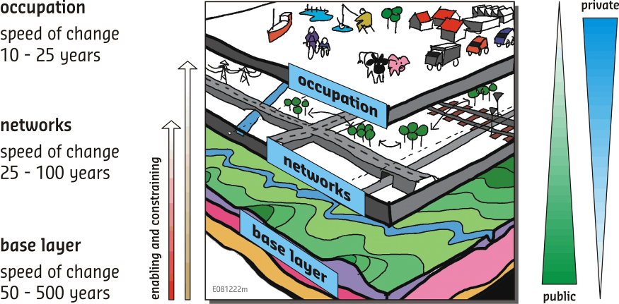

Figure 2. The spatial layer model

The Layer model is largely compatible with other well-known approaches, such as the ecosystem functions approach (De Groot, 1992; De Groot, 1994; De Groot et al., 2002). The Base layer provides the enabling conditions for humans, which can be split into function categories, such as regulation, habitat, production, information and carrier functions. An important advantage of the Layer model is that it explicitly takes into account human alterations to the natural ecosystem. Indeed, many deltas are no longer in a pristine state and should be described as modified or highly modified ecosystems. The Layer model describes these modified ecosystems in terms of the Base layer and the Network layer.

Management responses for each layer
Using the Layer model, it becomes clear that there are three main response themes on which delta management could focus, i.e. the development and adaptation of land and water use (Occupation layer), the extension and revitalization of infrastructure (Network layer) and the management and restoration of natural systems (Base layer). Regarding the Base layer it should be noted that in deltas especially the sediment dynamics (balance) between sea, river and hinterland is important. Many deltas suffer from a sediment deficit, because sediments from the catchment are trapped in reservoirs upstream. Embankments along the delta distributaries prevent flooding and vertical accretion of the delta plain. The disturbance of natural delta sediment dynamics (i.e. lack of sediment) leads to land loss and increased flood vulnerability.

Governance characteristics for each layer
The governance required for sustainable delta development extends over all three layers and is characterized by a mix of government responsibility and private or non-governmental actor roles. The strong private role in the Occupation layer is most clearly symbolized in the land ownership, which is legitimised through property rights legislation and often embedded in deep values of ownership and values associated with entrepreneurship. Land ownership induces private investments (e.g. farms, houses) and can be traded on the free market. The government can enact its influence through zoning regulations and building codes and, under very stringent conditions, can expropriate land for a public cause of national or local importance (such road networks). Informal and formal arrangements exist for (participatory) planning processes and their legitimacy.

The role of private and public involvement in the Network layer often is the result of a transition in the fundamental viewpoint that it is the government’s task to manage these networks. In the Netherlands, for instance, road and water networks are public but ownership of the utility sectors, such as railways, electricity and drinking water is being changed to public-private cooperation or private ownership. But that does not mean that there is no role left for the central government. Indeed, in order to safeguard public values in the liberalized utility sectors, authorities are installed as formal arrangements that oversee quality and guaranteed delivery of goods and services.

Although in the Base layer the role of the government is strongest, its management is often done in a rather fragmented way. Management responsibilities originate from a deep belief of stewardship to maintain the qualities of water, soils and subsoil natural resources. But the actual management instruments are mostly partially effective or inadequate to stop degradation and quality loss. These instruments are legitimized through national or international laws and obligations and enacted in the form of licences, concessions and covenants. We often encounter a multi-actor setting with government, non-government organisations and other stakeholders trying to agree on a sustainable development of the natural functions and resources.

As the governance is almost one of the most important driving forces in sustainable delta development it is not enough to only discuss roles of government and private sector in each of the layers. The three layer model can be combined with the institutional layer model of Williamson which thus gives a clear picture to link human-environment systems with different modes of decision-making (Marchand & Ruijgh-Van der Ploeg 2009). This helps to classify the different ‘agencies’ and ‘domains’ (Agarwal et al. 2002) and improve the multi-level and multi-sectoral cooperation and efficiency

Figure 3 summarizes main delta issues as a sequence of drivers, pressures, impacts, governance and responses, for each of the three layers.

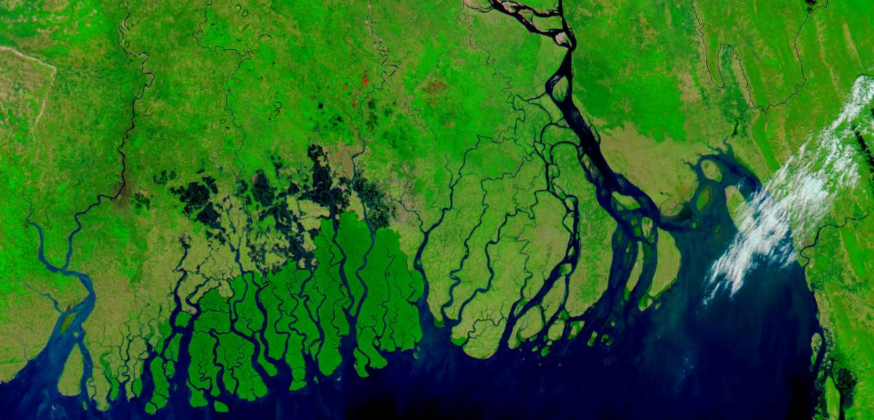
Ganges-Brahmaputra Delta, India and Bangladesh

Figure 3: Sequence of drivers, pressures, impacts, governance and responses in deltas (nb: this is a simplified representation as the vertical interactions between the layers are not included).

Analysis of case studies
As a part of the collaborative initiative ‘Enabling Delta Life’ (Global Water Partnership, 2012) key people involved in delta management were asked to develop a brief case-description on their delta. Five questions related to delta governance were posed:
1. What are the 3 main issues in your delta?
2. What are the main measures to deal with these issues?
3. How did you organize/are you organizing the process in your delta for developing this?
4. What was the most difficult part in your process so far?
5. What suggestions do you have for a country that is just starting to think about their delta?

Based on the reactions from these resource persons a very preliminary analysis was carried out, using the Framework for Delta Assessment as a guidance. Of course, this analysis should be used cautiously because limited background information and time was available. We propose that in a next version of the document a more balanced evaluation be made that takes into account the interrelations of issues as well as their relative importance.

Main issues
Table 1 below gives a summary of main water-related problems that have been identified. Note that here only the three most important issues are presented. Of course many more issues are relevant in each delta than given in the table. We have not used a more subtle discrimination into the scale of importance, because the information in the case descriptions did not allow for this. The following observations can be made:

The majority of the issues essentially deals with problems originating in the Base layer: apparently there is a substantial mismatch between the environmental conditions and resources and the demands from society. Not surprisingly, flooding, water shortages and water pollution are most often mentioned here. Perhaps more surprising is that flooding is not mentioned explicitly for the Cambodian floodplain: living with the seasonal floods is practiced here. Other well-known delta problems are also identified, such as salt water intrusion, river and coastal erosion and groundwater depletion.

Remarkably little attention is given to issues in the Network layer and Occupation layer. Benin mentions ‘inappropriate space management’ for occupation and Cambodia sees socioeconomic development as a major delta issue (a direct link between livelihood, income and well-being is given).

Furthermore, it is remarkable that climate change is only mentioned once. Current and short-term problems seem to dominate in many deltas.

Table 1: Main issues mentioned in case descriptions*
* NB: the crosses only indicate the most important issues mentioned in the case descriptions. Absence of a cross does not necessarily imply that an issue is not relevant.

Measures
Mentioned measures are more equally distributed over the three layers than the issues (table 2). Clearly a balanced approach is visible for the Mekong Delta in Vietnam, consisting of a mixture of adaptation measures (in the Occupation layer), protection measures (in the Network layer) and measures for enhancing ecosystem services (in the Base layer) for flooding. The basic strategy is ‘living with floods’, but where needed residential areas are protected by dykes and cropping patterns are changed when salinity increases. Furthermore, coastal forests are protected to enhance their ecosystem services.

Also a large number of measures are mentioned, which, due to their general nature, cannot be easily classified: ‘flood management’, ‘practicing IWRM’, ‘design and implementing sustainable management’, etc.

Table 2: Measures mentioned in case descriptions*
* NB: the crosses only indicate the most important measures mentioned in the case descriptions. Absence of a cross does not necessarily imply that a measure is not relevant.
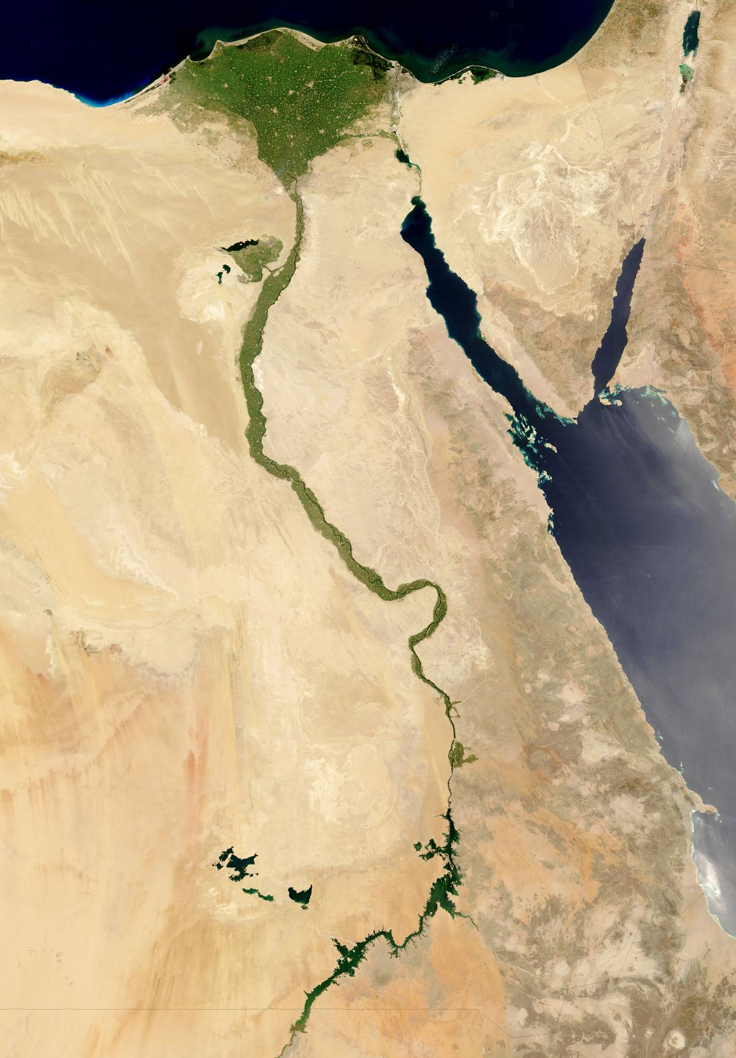
Nile Delta and river

Governance
Questions 3 and 4 relate to the organization of the process and problems encountered. This can be captured under the heading of governance. In the Framework for Delta Assessment indicators for governance are grouped under three headings: Multi-level and multi-sectoral cooperation, Involvement of stakeholders and citizens and Approaches for dealing with risks and uncertainties. When we look at the answers for the different deltas (table 3), we see that three countries explicitly mention some kind of delta planning (Vietnam: Revising Delta Master Plan; China: Pearl River Delta Comprehensive Regulation Planning; Bangladesh: Delta Development Plan).

Transboundary and river basin cooperation is explicitly mentioned by two countries (Benin and Cambodia). Involvement of stakeholders is mentioned by Egypt and Vietnam. A closer look reveals that for the Nile delta the level of participation is mainly limited to informing and consulting. Vietnam mentions ‘improving capacity for local organizations and communities’, suggesting a deeper participatory involvement. Bangladesh mentions that broad stakeholder involvement is a difficult part in the implementation process.

There is some mentioning of research towards a better understanding of delta processes and problems. Benin mentions ‘lack of knowledge about the delta systems’ as a main issue in the delta, and suggests ‘to build up capacity towards monitoring the delta system dynamics and climate change’. Vietnam mentions ‘Conducting deep research/studies to find appropriate solutions for specific areas’, ‘Studying and assessing impacts on delta of upstream development’ and ‘Establish scenarios for responding’. China mentions as a suggestion for other countries: ‘From a holistic viewpoint, scientific research should be conducted to understand the natural evolution process of the whole delta […]’.

Table 3: Governance issues mentioned in case descriptions*
* NB: the crosses only indicate the most important issues mentioned in the case descriptions. Absence of a cross does not necessarily imply that an issue is not relevant..

Suggestions for other deltas

On the question ‘what suggestions do you have for a country that is just starting to think about their delta?’ all respondents came with very clear and often similar answers. These can be roughly grouped into four categories: i) Know how your delta works, ii) Raise awareness, iii) Ensure stakeholder participation; iv) Build human capacity and learn from each other, and v) Develop a delta plan.

1. Know how your delta works.
Each delta has its own characteristics and it is important to understand how natural processes work, such as natural evolution, water and sediment movements, channel morphodynamics, etc. both in relation to history and under the present and future conditions. Monitoring (e.g. of water quality, coastal erosion and urban encroachment) will lead to on-time identification of (future) challenges, problems and potential solutions.

2. Raise awareness.
Establishing an enabling environment, mentioned by the Benin contribution, is crucial for good management. This requires both the enhancement of political will among decision makers and of cooperation with all kinds of stakeholders (see next point).

3. Ensure stakeholder participation.
There is almost unanimity with regard to the importance of ensuring meaningful and effective community and stakeholder participation in the process of the preparation of a delta plan. This is also relevant at the international level: river basin cooperation needs to be strengthened as well.

4. Build human capacity and knowledge sharing
Capacity building and human resources development was mentioned several times. Learning from other delta experiences was also mentioned: e.g. Cambodia would like to learn from Vietnam about salinity control, water management, rice cultivation, tourism, and livelihood improvement in the Mekong Delta.

5. Develop a delta plan
Each answer included reference to some sort of delta planning. Keywords that were used include: comprehensive planning, ‘Delta Vision’, no-regret measures, adaptive, economically feasible, restoring natural systems, resilience.

Conclusions

Deltas are the motor of economic development. Thanks to their location and physical properties they are often the most densely populated and economically most active parts of a country. Many of the world’s megacities are located in deltas. Deltas provide food, fibres and fuel, enable transport and trade and harbour the most productive ecosystems worldwide. Current developments may jeopardise the historical symbiosis between man and deltas. Fast growth combined with climate change and sea level rise make deltas vulnerable. But the economic dynamics will provide also for a strong impetus to vulnerability reduction measures and policies.

The information provided by the delta representatives provides a ‘snapshot’ of the problems and approaches of their deltas. Since it was not intended as a comprehensive description, a full assessment of vulnerabilities and delta resilience is not possible. The assessment of ten deltas by the Delta Alliance (Bucx et al., 2010) showed a remarkable variation in delta conditions, although also some general trends and mechanisms were found:
- an imbalance between demand and supply with regard to land and water use;
- an inadequate or ageing infrastructure in the delta;
- disruption of the natural delta processes;
- inadequate governance to address problems and implement solutions.

The case studies presented in this discussion paper show issues, problems, measures and suggestions that are in line with these mechanisms.

Delta management faces an important dilemma: accommodating more people and more activities than the Base layer of a delta can support requires new or upgraded infrastructure, which on its turn could lead to a further reduction of the natural carrying capacity of the Base layer. Solutions for this dilemma include innovative technological breakthroughs, multifunctional land use and building with nature. More importantly, however, solutions should be looked into that take account of all three layers and their interactions. It is highly unlikely that unregulated autonomous development in the Occupation layer can be accommodated solely through more and bigger infrastructure. In other words: delta governance should be focused on optimizing land occupation and activities of the population, on better managing the infrastructure and on the restoration of natural systems and processes.

Main conclusions:
- Using the Framework for Delta Assessments can effectively contribute to an increased insight in the strengths and weaknesses of existing delta management. It requires additional work however, to include institutional structures and governance issues.
- Sustainable solutions to delta problems can only be found when landuse, infrastructure and the natural environment and resources are taken into account in an integrated manner.
- Governance for deltas should start with identifying stakeholders in each of the three layers and with acknowledging that ownership and management responsibilities for each of them is fundamentally different.
- Climate change is an important driver of change, but on the short term is in most deltas subordinate to more urgent issues, such as population growth, rapid urban development and subsidence.

Our vision is that interdelta exchange of knowledge and expertise is essential for finding sustainable and innovative solutions for the delta problems worldwide. Because many deltas share the same problems, solutions developed in one delta may be applicable in other deltas, although we recognize that adaptations may be needed to account for delta-specific aspects. Globalization causes deltas to be more connected than ever before in history and urges a common search for integrated delta management strategies.

The aim is to work jointly towards a delta agenda ‘Enabling delta life’, providing guidance for implementation and joint pilots to enhance the knowledge base on issues of common interest.

References

Bucx, T., M. Marchand, A. Makaske & C. van de Guchte, 2010, Comparative assessment of the vulnerability and resilience of 10 deltas – synthesis report. Delta Alliance report number 1. Delta Alliance International, Delft-Wageningen, The Netherlands
De Groot, R.S., 1992, Functions of Nature. Wolters-Noordhoff, Groningen.
De Groot, R.S., 1994, Evaluation of environmental functions as a tool in planning, management and decision making. PhD Thesis. Wageningen.
De Groot, R.S., M.A. Wilson & R.M.J. Bouwmans, 2002, A typology for the classification, description and valuation of ecosystem functions, goods and services. Ecological Economics 41, pp. 393-408.
Global Water Partnership, 2012, Enabling Delta Life – Case studies (working document for Stockholm Water Week 2012)
Marchand, M. & Ruijgh, T. 2009, Reframing integrated water management for urbanized deltas: a combined approach of spatial planning and governance to analysis and design. Paper presented at the Conference People and the Sea, (V): living with uncertainty and adapting to change July 9th- 11th 2009, Amsterdam.
McHarg, I., 1969, Design with Nature, The Natural History Press. New York.
Meyer, H. & Nijhuis, S. 2010, Towards a Typology of Urbanizing Deltas, in Kabat, P., Vellinga, P. (eds), Deltas in Times of Climate Change, Rotterdam.
OECD, 1993, OECD core set of indicators for environmental performance reviews: a synthesis report by the Group on the State of the Environment. Organisation for Economic Co-operation and Development OECD, Paris, France.
Syvitski, J. P.M., A. J. Kettner, I. Overeem, E W.H. Hutton, M. T.H. Hannon, G. R. Brakenridge, J. Day, C. Vörösmarty, Y. Saito, L. Giosan & R. J. Nicholls, 2009. Sinking deltas due to human activities. Nature Geoscience 2, pp. 681-686.

