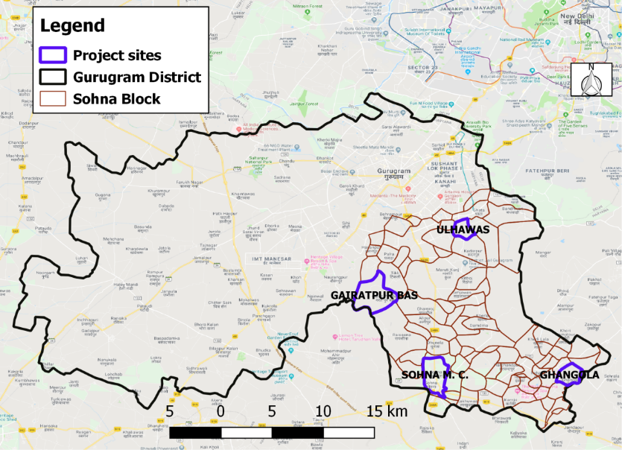
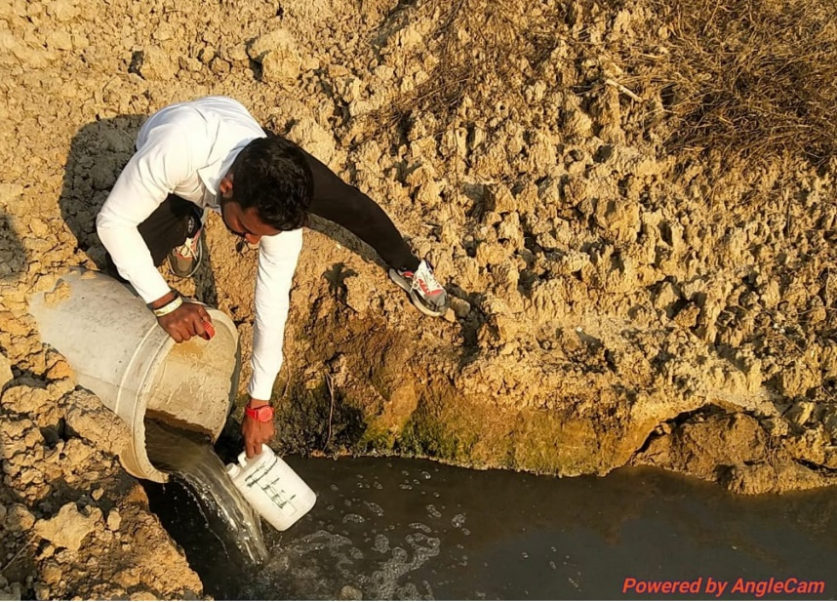
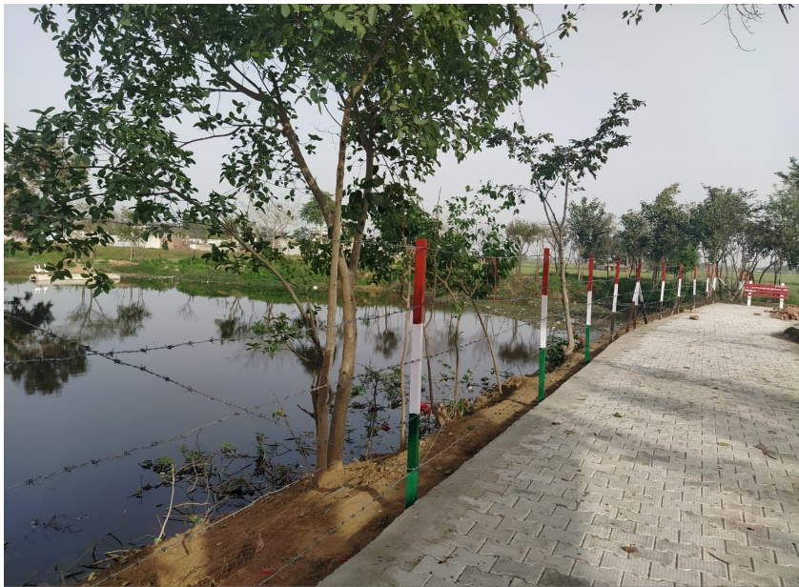
(a) (b)
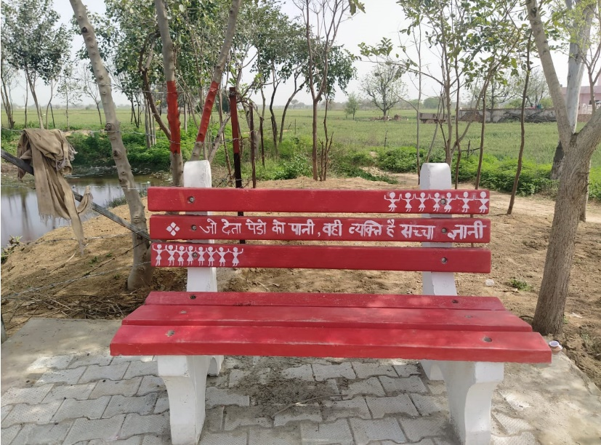
(c) (d)
Figure 1 The above pictures shows the on-ground work that GuruJal is able to accomplish and enforce through the departmental coordination between 20+ government bodies, (a) Water Sampling for testing (b) Sohna Block Water Management Research (c)&(d) Landscaping done at Bohra Kalan with footpath and benches being set around the pond.
Source of pictures: GuruJal Society, Mini Secretariat Gurugram.

Name of the Case: Enforcement and Compliance of Water Conservation Laws and Authorities in Gurugram, Haryana
Place of Implementation: Gurugram District, Haryana
Implementing Agency: GuruJal Society
Phone No.: +91-124 - 2331003 Email ID: gurujal.gurugram@gmail.com

The aims of GuruJal Society is with respect to water-related issues in Gurugram district founded on the four pillars of creating awareness, better enforcement, supporting compliance and through innovative design solutions. These aims are put into action points in a time bound manner through extensive research and analysis, accurate data points, community participation and holistic collaborative approach. GuruJal’s vision is to encourage social responsibility; sustainable development, lifestyle, and consumerism; protection of environment; inspiring and implementing solutions to the environmental crisis that Gurugram is facing. And our values distinguish us and guide our actions.

Under GuruJal, coordination between 18+ different government bodies have been incorporated as an intervention for the better enforcement with research backed data that enables number based implementation and decisions as shown in Figure 2. In the whole process, the role of GuruJal is to catalyse coordination between various departments/stakeholders and ensure the long-term sustainability of the projects through capacity building of the institutions and empowering them by providing skills, knowledge, human resources and funds to ensure the sustainability of the projects.

All the various and concerned departments are consulted and engaged with at various levels according to their internal capacities and help GuruJal in achieving their goals of enforcement of the various mandates for water conservation techniques. The convergence of all of these departments is very important and an essential feature in GuruJal’s operation and quest for conserving water in the district.
Various department are consulted for a number of tasks that takes the holistic approach to water body restoration, which includes, flora fauna profiling, which which involves making a list of native tree species, shrubs, animals, birds, reptiles, and butterflies for the region in order to increase the biodiversity of the region, which is used for the beautification of outdoor terrain which is mainly engaged in exterior works and gardening in both residential and non-residential buildings and parks through the process of landscaping. Moreover, soil and water tests are carried out to acertain the plant and animal productivity, maintain or enhance water and air quality, and support human health and habitation. Analysis of water quality is done to understand the required treatment to
Official documents from the Panchayat, called the Panchayat Resolution, is given to the government stating that they are letting government use the land for biodiversity parks etc. Regular community meetings are conducted in order to keep the locals aware and updated about the work that is taking place.

Figure 2 The above garland shows the 20+ government bodies that GuruJal coordinates between for the best practices of water management and conservation in the District of Gurugram.

Intervention: Empowering Pond and Wastewater Management Authority
Under the Section-6 of Act No. 33 (The Haryana Pond and Wastewater Management Authority Act) of 2018 as notified on 23.10.2018, we are also working on the activation of District Consulation and Monitoring Committee (District Pond and Waste Management Authority). The main functions of District Consulation and Monitoring Committee would be the following notified:

- Maintenance of its boundaries and protected area through regulation, control, protection, cleaning, beautification, conservation, reclamation, regeneration, restoration and construction of the pond..
- Development of water utilisation plans and development of proper landscaping to avoid encroachment of areas and understand water use.
- Promoting community participation and awareness in cleaning, conservation, tourism, beautification of the pond by organizing awareness programs, workshops and seminars. Activation of Village Pond and Wastewater Management Committee is also proposed under this authority.
- Developing infrastructure such as pumping machinery, channels and pipe systems for utilization of pond water and effluent of sewage effluent treatment plans for the purpose of irrigation.

Intervention: Empowering Biodiversity Management Committee
Under ‘Support A Pond’ & ‘Biodiversity Management’ interventions, GuruJal intends to rejuvenate and restore traditional water bodies, in particular, the ponds locally called as Johars. Under Biodiversity Management, development of biodiversity parks is an attempt to promote biodiversity conservation, encourage urban gardens by growing plants of all types and varieties in an urban environment, promote herbal gardens wherein a separate space in the garden is devoted to growing a specific group of plants known as herbs, and create butterfly parks/gardens/aviaries, where most of the butterflies are used for educational purposes like studying butterflies’ life cycle and behaviour.

However, the major challenge for any government project is “Operation & Maintenance”. This is the phase where the projects fail. Therefore, for the sustainability of our projects, the Biodiversity Management Committee as per section 41 and Rule 22 of the Biodiversity Act (2002) and Rules (2004), is being strengthened at all District, Parishad, Block, and Panchayat levels. For the process to be functional, operation & management of the project must be overseen by the elected Biodiversity Management Committee is being strengthened through engaging them with workshops and informing them of their roles and responsibilities, and creating a sense of accountability to the local government and individuals are being deputed from the village on payroll of the Government. Their role is to ensure the highest level of efficiency possible.

Individuals are being deputed from each of the local jurisdictions to ensure the highest level of efficiency possible. The committee would have the following functions as per the guidelines mentioned under the Act:

- Conservation and sustainable utilization of biological resources, through regulation of access to biological resources and/ or associated Traditional Knowledge, for commercial and research purposes
- Conservation of traditional varieties/breeds of economically important plants/animals through biodiversity education and awareness building
- Management of Heritage Sites including Heritage Trees, Animals/Microorganisms, etc., and Sacred Groves and Sacred Waterbodies.
- Documentation, enable procedure to develop bio-cultural protocols.
- Sustainable Use and Benefit Sharing.
- Protection of Traditional Knowledge recorded in PBR.

Intervention: Research Based Decision Making, Research Project for Sohna Block.
The overall objective of the research project was to perform an assessment report for integrated water resources management for Sohna block, while the specific objectives are given below:
- To review the current status of the water projects (existing and work in progress) within Sohna block and categorise them according to their usefulness in present context.
- To conduct a comprehensive mapping and qualitative and quantitative analysis of drinking water, surface water, groundwater and wastewater.
- To conduct geospatial analysis of cropping pattern and soil health along with recommendations on efficient water use for improved crop production.
- To assess the feasibility of various sustainable watershed management practices and recommendations for a conjunctive use of surface and groundwater.
Achievements
- Currently there are 320 identified sites that require active intervention from various departments for water conservation and restoration of traditional water bodies across the district of Gurugram. Out of which there are 13 active sites with technological interventions and 17 more which are in the pipeline.
- 520 government schools have been identified across the district, where functionality checks of Rain Water Harvesting Structures have been identified and through department coordination, the non-functional/semi functional RWH structures are being repaired
- Coordination with Municipal Corporation Gurugram, Municipal Council Pautadi, Sohna and Municipal Committee Hailey Mandi and Farukh Nagar, Public Health Engineering Department (PHED), Department of Town and Country Planning (DTCP) and Ground Water Cell along with GuruJal Team to seal illegal Borewells/Ttube wells to stop the illegal extraction of groundwater.
- Through coordination, mandates of various departments are being aligned and forces are being used to empower the local community with formation of committees such as the Biodiversity Management Committee that allows for steady implementation of mandates to take place.
Takeaways
- Replicable model for government coordination and setting a standard operating procedures for developing best water management practices in the district, that can easily translate to block level implementation and even on a national scale.
- Development of Sustainable Plans for Pond Rejuvenation and structured alignment of varying mandates between different departments for a common cause of water conservation.

Source: GuruJal Society, Mini Secretariat Gurugram.

