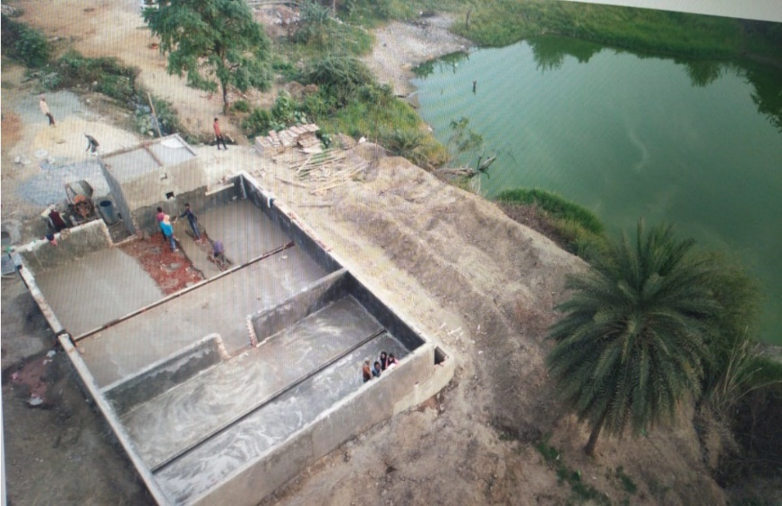

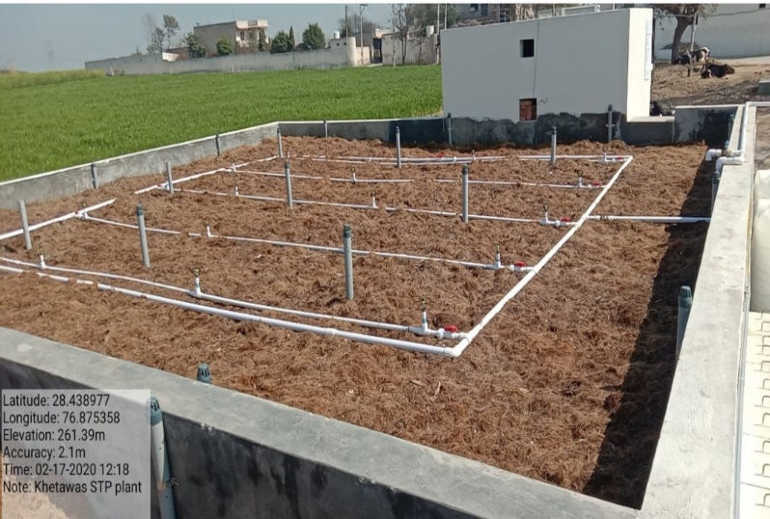
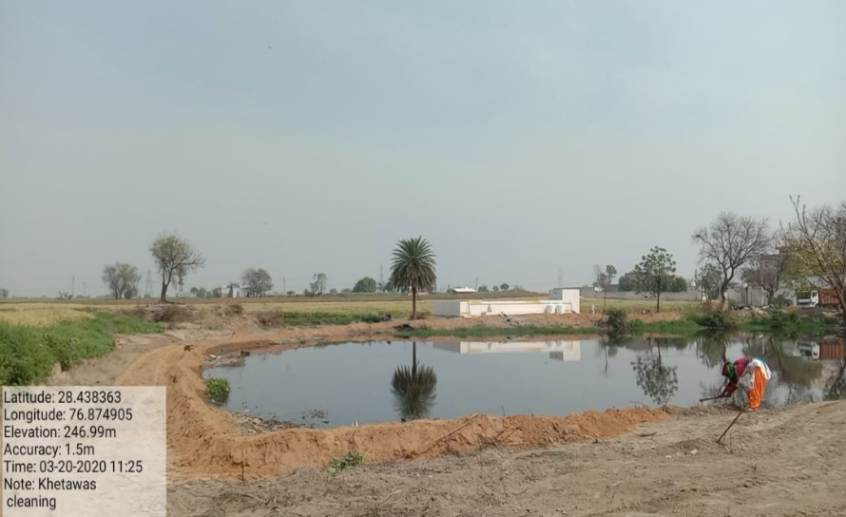
- (b)

(c) (d)
Figure 1(a) Khentawas (Farukh Nagar, Gurugram) Village pond, prior to restoration. (b) Khentawas WWTP during construction phase, with cleaning of pond periphery and levelling for landscaping purposes (c) Natural Filter Media laid down in the constructed STP. (d) Cleaning and levelling processes taking place around the periphery of the pond.
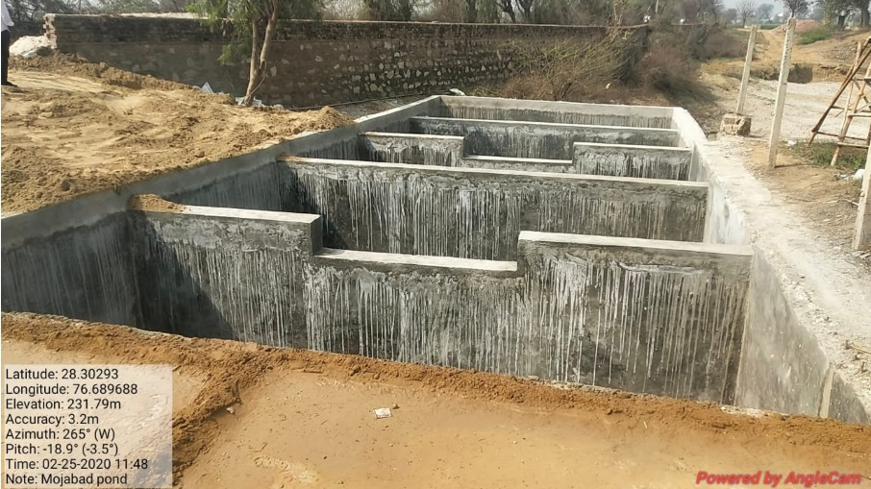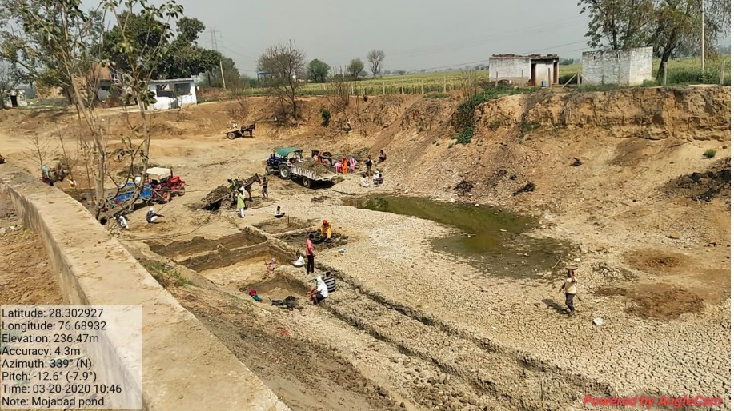
Figure 2 Mojamabad WWTP during construction phase that will be filled with aggregates after completion. The pond being dewatered and recharge capacity being increased.
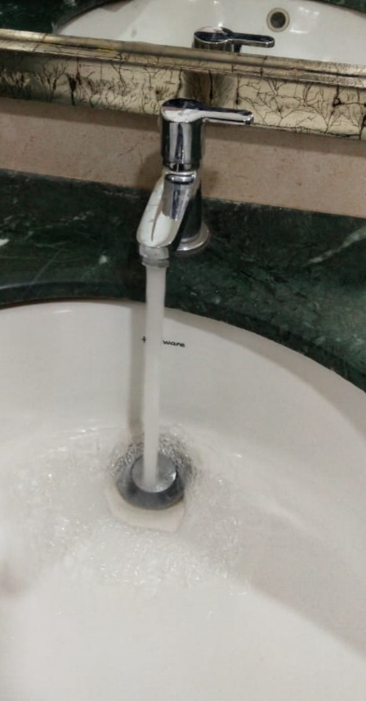
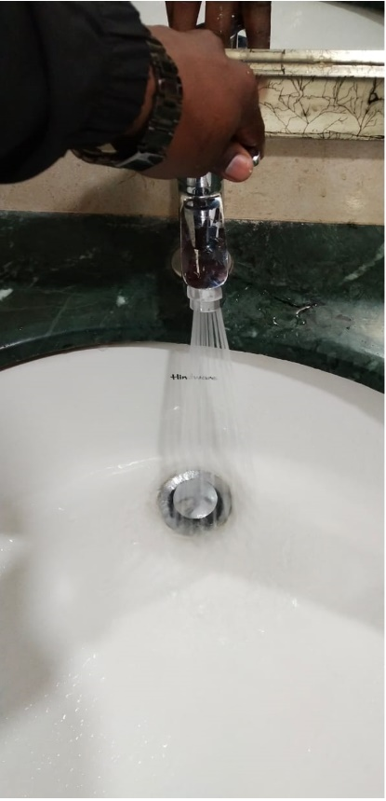

Figure 3 Installation of Aerators in sinks and washroom taps has shown to reduce water consumption by 40%

Source of pictures: GuruJal Society, Mini Secretariat, Gurugram.
Name of the Case: Design Solutions for Water Conservation
Place of Implementation: Khentawas and Mojamabad, Residential Welfare Associations in Gurugram, Haryana
Implementing Agency: GuruJal Society
Phone No.: +91-124 - 2331003 Email ID: gurujal.gurugram@gmail.com
GuruJal was conceived with the initiative and objective of addressing the issues of water scarcity, ground-water depletion and waterlogging in Gurugram. GuruJal enables and enforces actions on improving the compliances of schemes and policies supporting water conservation, following up on better enforcement of rules and regulations, to mitigate water exploitation, extensive campaigning to sensitize people, come up with better design solutions for the current standing issues and work towards making a better policy framework for water management.
Two most prominent design solutions that have been implemented for water conservation in the district of Gurugram has been restoration of traditional water bodies (johar/ponds) through decentralized systems and installation of aerators in urban housing societies across the city of Gurugram. The interventions are discussed in brief below
Intervention : Pond Restoration and Rejuvenation
The objective of decentralized system in restoration and rejuvenation of pond is to prevent the wastewater generated from particular village/area which is released into the ponds in order to stop the diminishing ecology of pond (percolation of dirty water), thereby recharging ground water tables with clean water and improve the biodiversity of the area. It is also noted that these traditional water bodies that were used to collect rainwater from the catchment area, but now due to the increase in population, and poor infrastructure for stormwater drainage in rural settings, these traditional water bodies now collect wastewater along with rainwater that also passes through open drains. Therefore, treatment of the cumulative wastewater generated is necessary. The treated waste water after it reaches the pond can further be used for irrigation, horticultural, construction purposes and other purposes, which was previously being relied on extraction of precious ground water. Apart from treatment of wastewater biodiversity zones at project sites has been created, the purpose of developing the biodiversity zone is to prevent the water body from future encroachment; provide an area to walk, making it an aesthetically pleasing. It may also be noted that the treated water that is released into the pond can directly be used for watering the plantations of the said biodiversity zone. Restoration of ponds not only the practical, but cultural and traditional values that these water bodies once held. It is also one of the objectives of the decentralized systems are so designed that they meet the regulations and standards of wastewater discharge as per the Honorable National Green Tribunal(NGT) and Central Pollution Control Board (CPCB).
There are various technologies that have been implemented in 13 active project sites across the district that began their construction in June 2019, and 17 more which are in the pipeline. These decentralized restoration technologies can be in the form of setting up of Wastewater Treatment Plants (WWTP’s) as seen in Khentawas and Mojamabad in Farukh Nagar Block of Gurugram, Haryana. Through extensive water testing it was determined that the following parameters was required to be reduced in order to meet the required standards
- Total Suspended Solid
- BOD (Biological Oxygen Demand)
- COD (Chemical Oxygen Demand)
Intervention : Installation of Aerators in Residential Welfare Associations (RWA’s).
The objective of this intervention was to sensitize the residents about Gurugram’s water crisis, daily water demand and supply, virtual water consumption, circular economy, rain water harvesting, sewage treatment plants, and plantation.
The main impact of this intervention was to create and spread awareness of the role of residential societies in water conservation with regards to reducing daily consumption of water per flat (example: 1000 liters/flat/day on an average), fixing leakages & infrastructure related issues, and discouraging the use of ornamental plants & the amount of water they utilize and instead encouraging natives trees & plants amongst the residential welfare societies of Gurugram.
Aerators were chosen as a particular intervention as it is one of the few water conservation measures that could be retrofitted into existing infrastructure which has shown to reduce the water consumption at any tap by 40%, without any change in consumption patterns of the user. Till date GuruJal has helped installing aerators in 15 RWA’s of Gurugram saving approximately 230 Kiloliters/Day (KLD), with 8500 aerators that have been installed in total.
GuruJal’s vision is to encourage social responsibility; sustainable development, and consumerism; protection of environment; inspiring and implementing solutions to the environmental crisis that Gurugram is facing.
Takeaways
- The model that was adopted for implementation of restoration of ponds in Khentawas, and Mojamabad has been adopted at various other active sites across the district, that has been flexible enough to accommodate individual site requirements across the nation.
- Active adoption of the restoration model has allowed for a sustainable solution to be developed for pond rejuvenation, that ensures the longevity and sustainability of the intervention.
- The technologies used to treat wastewater that have been adopted for Khentawas and Mojamabad can be implemented in other sites with similar conditions where domestic wastewater is the main source of wastewater in the ponds with the appropriate adjustments made for flowrates and area conditions.
- Collaboration with 18 + government departments to ensure water conservation and efficient water management in Gurugram, work committedly and make citizens water conscious and mobilize them towards sustainability.
- Education of RWA members regarding the importance of installing aerators which reduce water consumption by 3-4 L/min in kitchen or in washbasins that will in turn reduce the stress on water resources. Examples like Chennai’s water crisis, day-zero in Cape Town, Africa, and Dubai’s policy for water usage and wastage was quoted to make the residents understand the gravity of the situation.

Source: GuruJal Society, Mini Secretariat Gurugram.

