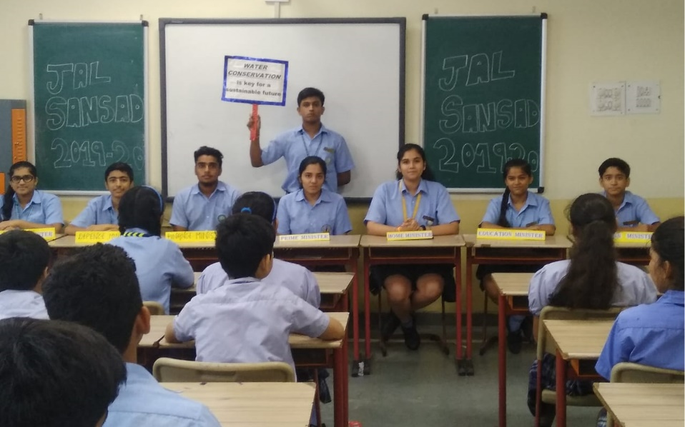
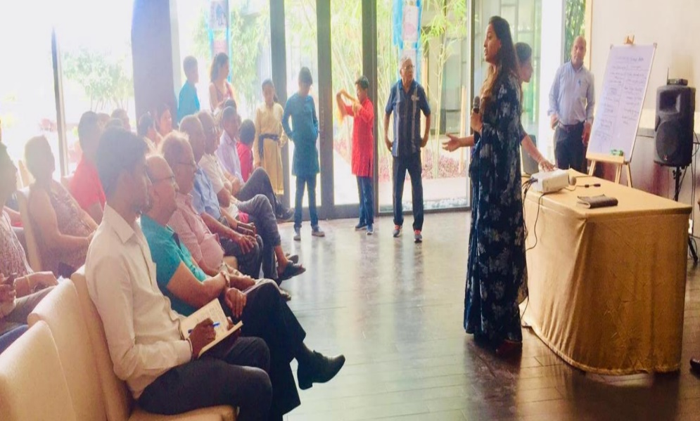
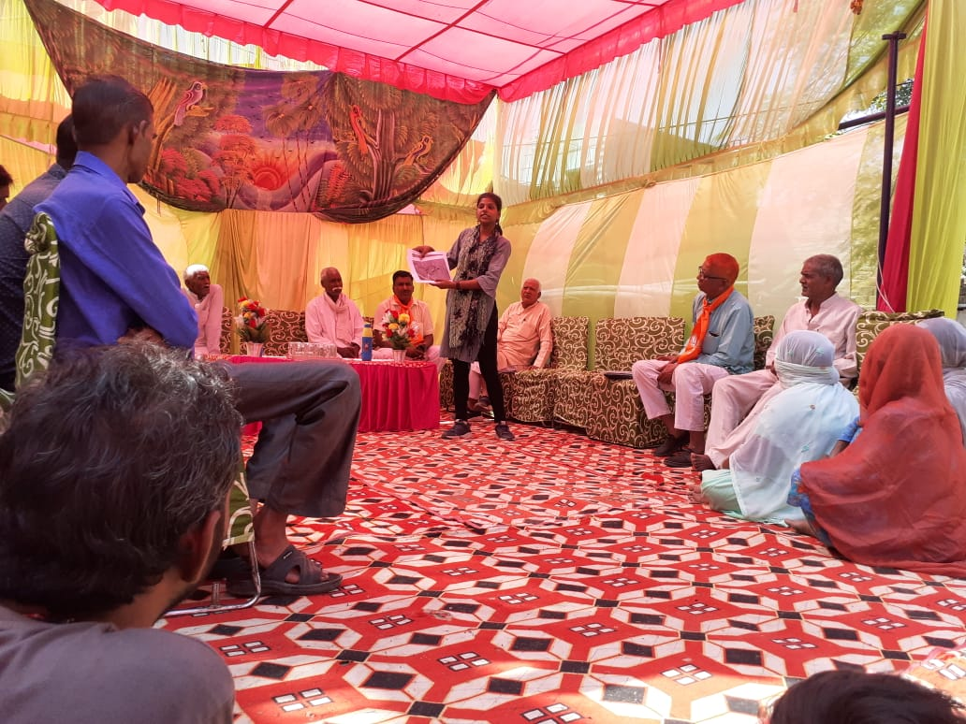
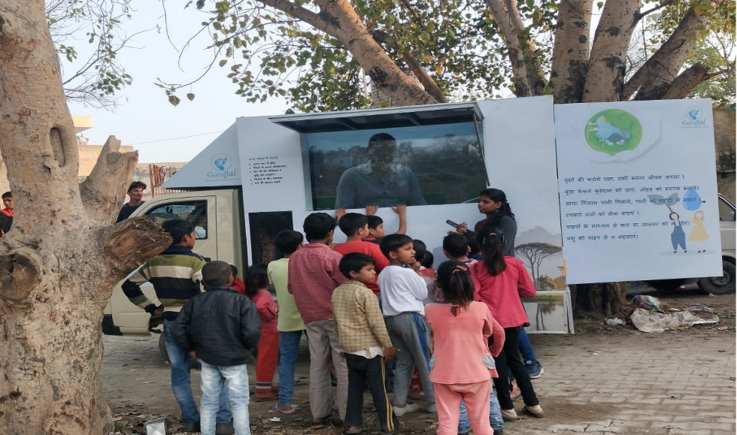 (a) (b)
(c) (d)
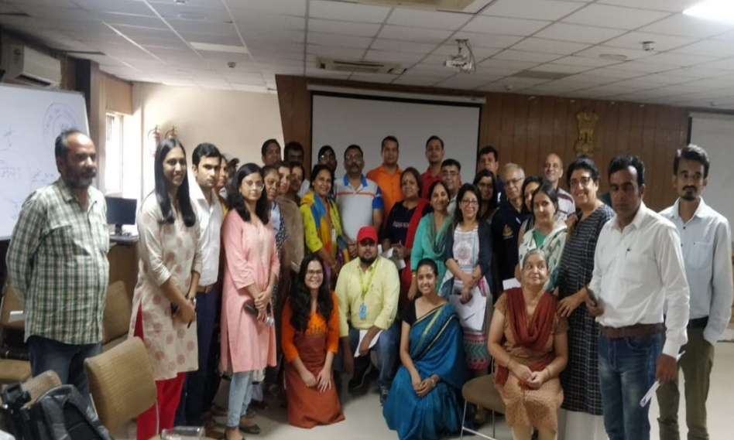
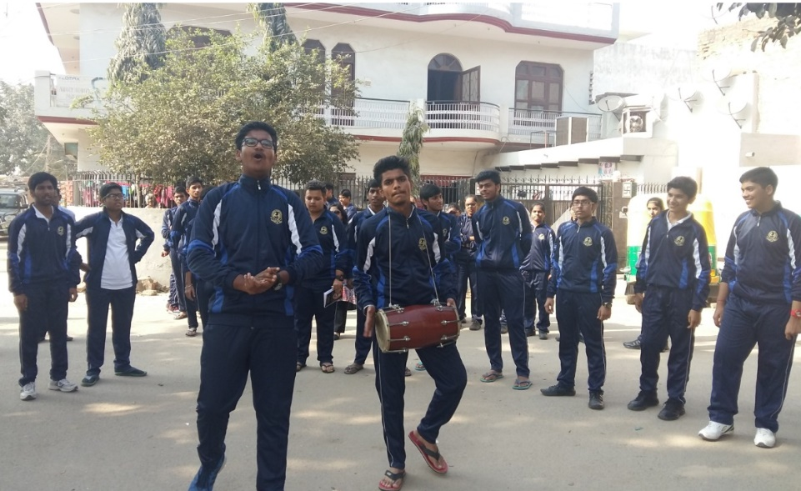
(f) (e)
Figure 1 (a) Community Meetings being held at a Gram Panchayat Level (b) Community Mobilization Van to tell visual stories on water conservation (c) RWA and Builders Conference that informed local RWA’s that educated about water conservation (d)&(e)Jal Sansad committee in a school that also carried out Nukad Natak (f) Jal Pe Charcha Participants that were trained to facilitate workshops in local communities
Source of pictures: GuruJal Society, Mini Secretariat Gurugram.
Name of the Case: Community Mobilization
Place of Implementation: Gram Panchayat, Government Schools, Corporates and RWA’s,
Gurugram, Haryana.
Implementing Agency: GuruJal Society, Mini Secretariat.
Phone No.: +91-124 - 2331003
Email ID: gurujal.gurugram@gmail.com

The aims of GuruJal Society is with respect to water-related issues in Gurugram district founded on the four pillars of creating awareness, better enforcement, supporting compliance and through innovative design solutions. These aims are put into action points in a time bound manner through extensive research and analysis, accurate data points, community participation and holistic collaborative approach. GuruJal’s vision is to encourage social responsibility; sustainable development, lifestyle, and consumerism; protection of environment; inspiring and implementing solutions to the environmental crisis that Gurugram is facing. And our values distinguish us and guide our actions.
The objective of community mobilization is to make them local community understand that the water management interventions are for them, rather than just another infrastructural development.
Intervention: Connect The Drops
Connect the Drop is a planned module to sensitize various stakeholders in order to make Gurugram a water conscious district. Workshops has been designed with detailed and focused content, specific to the targeted groups like local community members, school teachers, students, corporates and RWA’s. Under Connect the drops initiative, GuruJal as an organization endeavors to reach out and engage several sections of the society, and does so through various means, which are elaborated below –
- Community Meetings
The GuruJal team has a strong role to play in community mobilization in villages where technical intervention are taking place with the active engagement of all the locals including the Gram Panchayat members. This was done with informative handouts, posters, and through visual aids that are played on the GuruJal community van as shown in Figure 1. As they say, a picture is worth a thousand words, so visual aids are primarily used to explain the before an after effects of the technical interventions. These community meetings are integral to understand the concerns of the locals as well and forms a basis for knowledge sharing. This can be shown by the example where the cause of concern was the dumping of solid waste in the periphery of pond in Medawas. Once this concern was raised, arrangements were made by the competent authority for proper collection of solid waste in the village so that there will be no dumping in and around the pond. Community Meetings are an essential tool to reduce possible resistance amongst the locals and educate them about proper measures for water conservation.

- Jal Sansad
The objective of Jal Sansad, which started on the 19th of July, 2019 is to build a holistic and synergistic network of water conservation withing and outside of school premises and to spread awareness in relation to the same and working in conjunction with Eco-clubs along with students, staff, peripheral staff, as well as parents and guardians of the students. This is done through creating a mock parliamentary structure comprising of students representing and holding the posts of the Prime Minister, Home Minister, Finance Minister, Education Minister, Information and Broadcast Minister and Defense Minister. Each post is designed in such a manner water issues are addressed in their school, such as Water Budgeting for the Finance Minister, preparation of in-house policies of water management by the Home Minister etc. Active involvement of the students is ensured through several activities that are planned by the elected members holding the posts which are in the form of Nukad Natak, Workshops, Poster/Banner Designs, Plantantations and Maintaience of existing ones, Cultural Programs, Quiz/ Competitions, Viewing of Films/Documentaries on water.
GuruJal is able to keep a track and check compliances of all schools that are involved in this program through monthly updates that the schools submit. This is an ongoing process, currently with 42 different schools are involved, creating an impact on approximately 1050 students.
- Jal Pe Charcha
Jal Pe Charcha was an awareness campaign that was conducted in collaboration with Youth Alliance to create mass awareness concerning water scarcity in the District of Gurugram, to train over a 100+ volunteers through a 4-hour session to enable them to facilitate sessions for spreading awareness in their respective localities on June 1st -2nd, 2019. This initiative from GuruJal enabled to build trust and a positive partnership between Government and Civil Society in order to tackle the water crisis in the District. The participants of this campaign were then enabled to facilitate a workshop in their local community on the 5th of June, 2019 (World Environment Day) for creating awareness on Water conservation, by equipping them with information kits. Participants also designed posters and invites to keep the event fun and engaging.

- Jal Sabha
This water conservation campaign ran successfully in 133 Gram Panchayats with a participation of 3165 people which included entire villages of women, men and students of schools. The main agenda of this campaign was to make people aware of the different methods that one can conserve water, and focus on the actions that the Gram Panchayat as a whole could do. Discussions that took place in the form of meetings were to make people aware of the illegal trading of water in their locality, measures for maintain drinking water pipelines, biodiversity management committees were setup that identified locations withing villages for sapling plantations, that prevents soil erosion, a key part in water conservation. Information was also given about pond restoration activities within the villages. Information was also gathered during these sessions about specific needs and requirements of covered villages during this phase, that was useful to build a database for GuruJal.
- Social Media and Website
GuruJal is an organization determined to keep all of its proceedings transparent. One of the key tools that enables this transparency is dedicated platforms on all major social media, i.e. LinkedIn, Facebook, Twitter and Youtube. Daily updates on these platforms that enable GuruJal to communicate with the general public, and the general public too is constantly able to raise their concerns with regards to water through these platforms. In fact, regular complaints are registered through Facebook and Twitter through concerned and aware citizens that raise issues, and the GuruJal team coordinates to get the issues addressed within a 24-hour frame. The website is automated to reflect any changes and updates from the internal dashboard that keeps a track of all the work that is taking place in the areas of intervention. Web analytics shows over 300 new users that visit the websites, with over 350+ regular users for the GuruJal website. Future strategies are being compiled at the moment to increase the reach of GuruJal on all social platforms that will enable to increase transparency and accountability for all the intervention fronts that GuruJal is involved in.
Intervention: Community mobilization in partnership with Navjyoti India Foundation
The community mobilization is the process to raise awareness about the demand for water, and providing education about applying the rich heritage of water conservation in the local communities in both rural and urban setting. With the help of community mobilisation, the process is designed to enhance the understanding of the local community about the importance of water and how it affects their life on a daily basis. This is done by engaging the locals at various levels within the community, with a brief description of how they were engaged -

- Gram Panchayat Members/ Bio-Diversity Management Committee –
The Gram Panchayat Members/ BMC Members were engaged in workshops where active discussions about the status of their local ponds, along with brief discussion and information exchange about traditional values that the water body holds in the local community. Technology for treatment of wastewater that comes into the ponds with natural methods such as the “three pond system” was also discussed in these workshops. Trainings was also given especially in regard to tracking and map the native species in the area and addressing the challenges that come with it.
- School Teachers
The main objective of involving school teachers and other higher personnel’s such as principals was the inculcate a responsibility that they have towards training the future generation for water conservation efforts. The workshops that was conducted for them was based on the concept of creating a “Jal Gurukul” based on replication of the best practices, that discusses about identifying potential responsible leaders amongst the student body. The workshop also addresses the challenges that are faced for implementation of water conservation efforts in the local school body. Moreover, internal monitoring methodology programs were also discussed at length for proper implementation and longevity of the solutions proposed.

- Children in Schools
While more interactive design approach is taken for engaging school children, water conservation still remains a grave issue to be discussed with children. While the task of entertaining and capturing their attention becomes difficult, the impact becomes equally rewarding, as children serve as the gatekeepers for families to adapt new and the best practices for water conservation at a household level. The main objectives of engaging with children were to not only educate them of the best practices at home, but also to implement them at their school and on a daily basis. While developing them for better accountability, interpersonal and creative skills all targeted through water conservation, this was done through interactive workshop sessions, games, story-telling sessions, sharing success stories. Older students were also taught about the concept of water audits and water budgeting in their homes, schools and local communities.

- Open Sessions for corporates/RWA’s/Government Officers.

Retaining and implementation of knowledge are two different aspects altogether. While many of us as general citizens are aware that there are water scarcity issues in the country and around the globe, however developing a sensitivity towards it and inculcating personal behavioural changes for water conservation is a difficult task. The primary objective of having these open sessions amongst corporate sectors and RWA’s is to make them aware of the high consumption of freshwater resources within these local communities. Methods to conserve water and reduce overall water consumption are some of the main topics of discussions within these workshops. Laws and Acts for Water Treatment are also discussed as a method of awareness, as it is required by both corporates and RWA’s that if their consumption of water exceeds 50, 000 Litres/day, then they would have to treat the wastewater generated within the premises. These open sessions and activities are meant to engage with all sections of societies that asks one to consider the water footprint of each product that one uses, and empowering one with the tools to reduce the water footprint.

Achievements
- After community mobilisation efforts and activities in villages, people stopped throwing the solid waste in the water bodies and a regular vehicle started to come to the village and collect the solid waste.
- Communities in certain villages are very active as they volunteer their services and are active participants to make their water body restore and make it a beautiful place. With the help of the village and Gram Panchayat body, the technical interventions for the treatment of wastewater has begun in full swing and is nearing completion.
- Currently, workshops for mobilising the community have occurred in 319 different locations, with 12,892 participants that have been a part of awareness campaigns. Moreover, 156 schools have individually conducted workshops in, with participants as teachers, principals and students, with 5,554 participants.
Takeaways
- Active education and awareness program run by GuruJal, with the community mobilization program has encouraged the community members to make the local community aware of water conservation practices, and educate through workshops with various stakeholders such as teachers, farmers, students, Gram Panchayat members to inform them about interventions for the requirement of rejuvenation of water body.
- Initiatives organized under Connect the Drops Intervention allowed to build a common platform where all the stakeholders (Administration, Scientists, Water Experts and the citizen volunteer) spoke about the water crisis and what each one of them can offer to conserve water.
- Active community engagement and stakeholder alignments for the longevity and sustainability of technical interventions proposed. Knowledge exchange between different parts of the community ensures that the challenges on ground are heard and expressed.

Source: GuruJal Society, Mini Secretariat, Gurugram.

