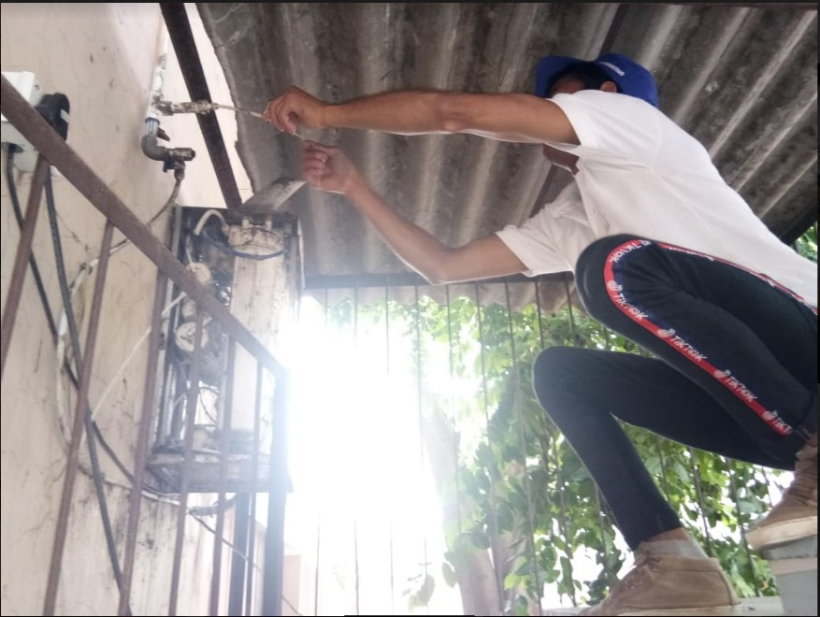
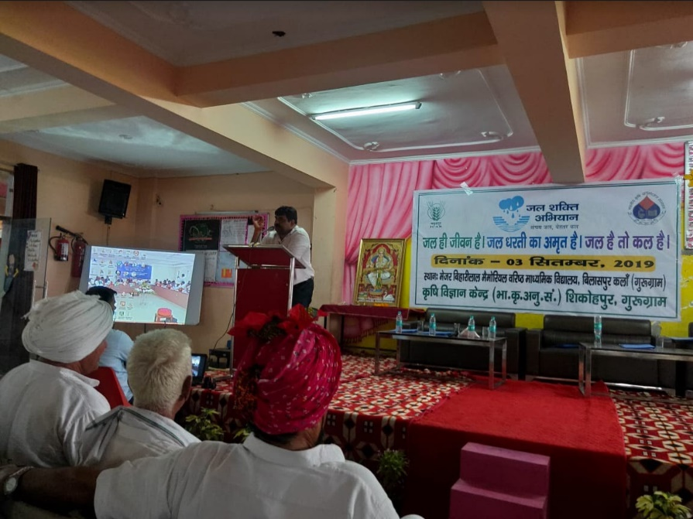

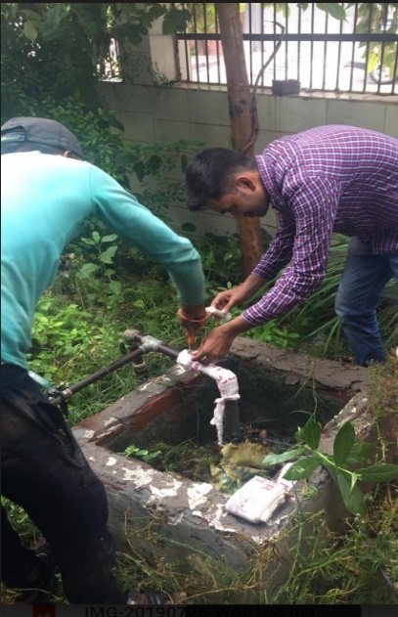
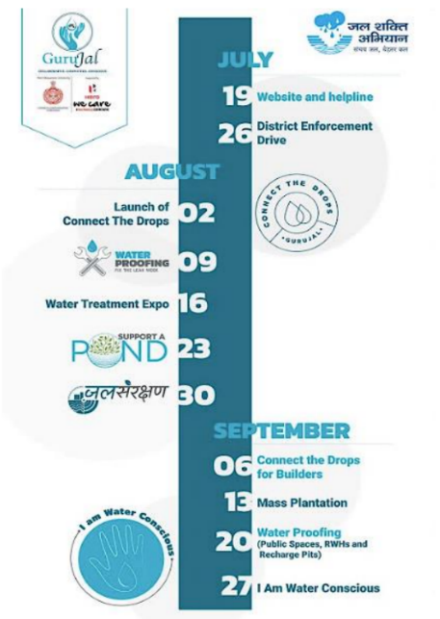
(a) (b)
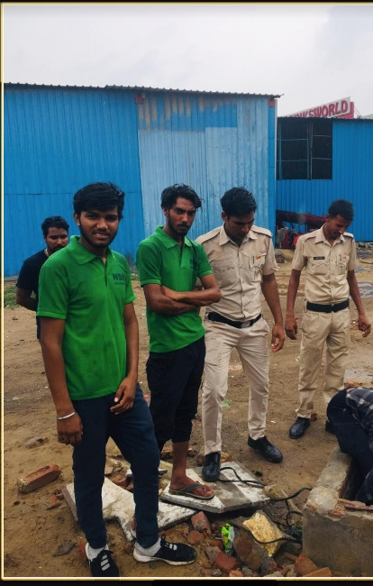

(c) (d) (e)
Figure 1 The Jal Shakti Abhiyan in the Gurugram District was arranged and conducted over a period of two months with various activities and interventions (a) Krishi Vigyan Kendra where officers informed of better irrigation and water management practices at village level. (b) Water Proofing where leaks were repaired in government buildings (c) Event Calendar for GuruJal, the implementation agency for all the water conservation activities in the District (d)&(e) Sealing of illegal borewells and tubewells in the district that extracts groundwater illegally. (Please note that the pictures have not been put in any particular order and do not reflect the interventions listed in that order)
Source of pictures: GuruJal Society, Mini Secretariat Gurugram.

Name of the Case: Jal Shakti Abhiyan Water Conservation through Awareness and Enforcement
Campaigns in Gurugram, Haryana.

Place of Implementation: Gurugram District Implementing Agency: GuruJal Society
Phone No.: +91-124-2331003 Email ID: gurujal.gurugram@gmail.com

The Jal Shakti Abhiyan (JSA) was launched by the Union Jal Shakti Minister in July of 2019 for water conservation campaign that is enforced for each state during the monsoon seasons. During the campaign, officers, groundwater experts and scientists from the Government of India will work together with state and district officials in India’s most water-stressed districts, which includes Gurugram, for water conservation and water resource management by focusing on accelerated implementation of five target intervention. The JSA aims at making water conservation a Jan Andolan through asset creation and extensive communication (Government of India, 2019).
The state of Haryana has 22 districts sub-divided into 119 developmental blocks now. As per the reports of Central Ground Water Board (CGWB), published in 2010, out of 108 development blocks the, 55 blocks were overexploited, 11 critical and 5 semi-critical, that depicts the alarming levels of groundwater over-utilization. Situations have been worsening with an average fall in groundwater levels by 2-5 meters below the surface levels annually despite the fact that more than 15 government departments have ongoing interventions in different capacities which affect water management directly and indirectly. In keeping with the Jal Shakti Abhiyan, was enforced in Gurugram in July 2019 with a dedicated integrated water management initiative with the launch of GuruJal Society in July 2019.
Various events, workshops, training sessions have been conducted by GuruJal as a part of the JSA to make Gurugram a more water conscious district.

Intervention: Gurugram District Enforcement Drive
The objective of this drive was based on water management measures that involves due diligence and strict enforcement to prevent water wastage. The Enforcement Drive was held on the 26th July 2019 which began with 57 different teams comprising of volunteers, officers, police personnel and engineers that became part of the Enforcement Drive. Over 100 police personnel, 10 ITI Plumbing apprentices were trained prior to the drive to check the functionality of Rain Water Harvesting (RWH) Structures.

It was a challenging task to map out the entire district and pin illegal water activities and non-functional RWH systems but the District Administration along with all the teams from Municipal Corporation Gurugram (MCG), Municipal Council Pautadi, Sohna and Municipal Committee Hailey Mandi and Farukh Nagar, Public Health and Engineering Department (PHED), Town and Country Planning Department (DTP) and Ground Water Cell along with GuruJal Team managed this drive effectively and tactfully on such a large scale.

Through this enforcement drive a total of 290 illegal Borewells/Tube wells were sealed. Under the MCG jurisdiction, 126 Borewells/Tube wells in Wards 1-35 were sealed, and more than 76 Borewells/Tube wells were sealed rural areas with 13 in Farukh Nagar Block and 28 in Sohna Block, 23 in Pataudi Block and 13 in rural areas in Gurugram.

This was shortly followed by the launch of the helpline and the GuruJal website that could be used to report water issues, take feedback, suggestions and seek for water related issues throughout the entire district.

Intervention: Krishi Vigyan Kendra Mela
This intervention is an ongoing activity that is hosted by GuruJal across the four blocks of Gurugram District. The first of its kind was carried out on the 30th of August. Interacting at grassroot levels with farmers and conducting workshops was the highlight of this intervention. From this intervention, while GuruJal did propose of water conserving measures to the farmers, it was an equal exchange of knowledge between GuruJal team members and the farmers, learning of the issues that they face and learning of their traditional methods to treat water.
Through this intervention the following have been completed so far –
- Conversion of 150 dried tubewells into recharge pits
- Workshops at 50 Gram Panchayat Centers to promote drip and micro irrigation
- Promotion of organic cropping and introduction of community radios to allow the spread of information easily and readily.
Intervention: Water Proofing
This intervention was based on the objective of leak proofing campuses, public spaces and institutions. The team shall identify all possible sources of water leakages and fixing them to eliminate water wastage. They will also provide an innovative cost-effective design solution to reduce water wastage. The team shall also help the respective institutions in water budgeting so that the respective places can do the interventions to conserve water and be water conscious.
With this intervention, functional Rain Water Harvesting Structure Functionality Checks across the 572 Government schools across the district have been carried out. Only 128 schools out of the 572 had functional Rain water harvesting structures. It estimated that 304 ML per year can be saved. Carrying out this survey was essential to understand the kind of measures to be taken and how the students can be encouraged to save water. This also forms the primary data points which can be further used for engaging with appropriate authorities for the building and fixing these structures.
Intervention: Pataudi Block Water Conservation Plan
Under the Jal Shakti Abhhiyan, Block Water Conservation plans play an integral in water management and formulation of advocacy policy issues. After the wide success of the District Water Conservation Plan by GuruJal for Gurugram, the same water conservation plans are in the process of being drawn up for individual blocks of the district of Gurugram, starting with Pataudi Block. The following are the objectives of the intervention at a block level –
- To reduce illegal water extraction
- To improve the awareness on water crisis
- To share the alternatives of reducing water wastage and promote recycling
- To promote the plantation of native species
- To promote water recharge
- To ensure better compliance to water related rules and regulations

With the active implementation of this intervention, water conservation in the block would be ensured by stopping illegal extraction of ground water by monitoring and checking of licenses for groundwater tubewells and borewells. Moreover, much like already accomplished in Gurugram’s Housing societies, visits would be made to local housing communities in Pataudi block and installation of aerators would be offered free of charge, while educating them about the water conservation benefits. Moreover, as a part of the plan. Leakages in Government buildings will also be fixed.

Achievements
- Involvement of 18+ government bodies for the active enforcement and implementation of water conservation activities across the district.
- Including every possible aspect & every possible stakeholder that affects water and accordingly design solutions
- Holistic, collaborative and focused approach: enabling inter and intra-department support for the implementation of proposed solutions to improve water management scenario in the district Strict and timebound monitoring of water conservation scheme compliance making Gurugram “Water Conscious District”, first in India to do so.
- Replication of District Water Conservation Plans to Block Conservation Water Management Plans, such as the one that is being developed for Pataudi block of Gurugram, which indicates the flexibility and wide range applicability of activities and efforts for water conservation.
Takeaways
- Research and analysis of the existing water initiatives by various government, corporate sponsors and non-government organizations, for their impact and success along with failures, to avoid duplicity of efforts, centralize efforts and incorporate learnings from past projects.
- Research and analysis of the existing water initiatives by various government, corporate sponsors and non-government organizations, for their impact and success along with failures, to avoid duplicity of efforts, centralize efforts and incorporate learnings from past projects.
- Replication of District Water Conservation Plans to Block Conservation Water Management Plans, such as the one that is being developed for Pataudi block of Gurugram, which indicates the flexibility and wide range applicability of activities and efforts for water conservation.
Source: GuruJal Society, Mini Secretariat, Gurugram.

